

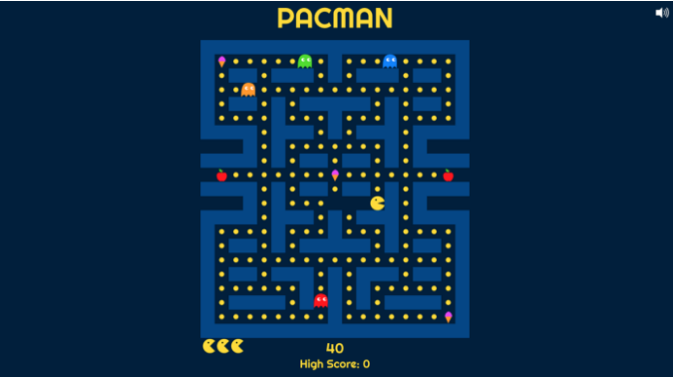

**A User Assistance Document**

Table of Contents

1. What is Pac-Man? 3

2. Before You Start 3

2.1. How to Use This Document? 3

3. Pac-Man Rules 4

3.1. The Game Board 4

3.2. The Controls 5

3.3. The Score Points 5

3.4. The Ghosts 6

4. How to Play Pac-Man? 8

5. General Hints 10

5.1. Special Notes 10

6. References 11

1. What is Pac-Man?

[Pac-Man](https://en.wikipedia.org/wiki/Pac-Man) is a single-player arcade game developed by Namco in 1980. The rule of the game is very simple and that is the reason it is so popular even today.

The main idea of the game is that you are the hero – a yellow circular character – in a maze and you must navigate the maze while eating the dots and fruits, at the same time you have to avoid the ghosts and occasionally eat them. You must do that as quickly as you can, otherwise you will lose the game.

1. Before You Start

This document is for all users who play Pac-Man game, and especially for those who want to improve their gaming skills.

The document applies to the original Pac-Man game and the most available modified versions of it. This document is based on [Pac-Man](https://pacman.live/) website however you can refer this document for Pac-Man games hosted on other platforms as well.

The main purpose of this document is to teach users the general concepts, specific guidelines, and how to play the Pac-Man game.

* 1. How to Use This Document?

Users of different experience levels should use this document at their own pace.

* If you are a beginner at the game, follow the document’s sections in order and read the full document.
* If you consider you have intermediate skills at the game, you may skim over Section 3, Pac-Man Rules.
* If you are an advanced user, you may skip Section 3, Pac-Man Rules completely and directly start from Section 4, How to Play Pac-Man?.

All users should read Section 5, General Hints to get better score in the game.

1. Pac-Man Rules

Currently there are many versions of the Pac-Man game available. As mentioned in the previous section, the most familiar version is the original one. This document discusses the original game.

You can identify the original game as follow:

* Refer to Figure 1 - a representation of the game board/screen
* Notice the point C on the figure
* Now, start the game on your computer or mobile device and move Pac-Man to point C
* If Pac-Man is captured by any ghost at or around point C after some time, it is the original Pac-Man game.

Note: In the modified versions of the game, the characters or the game board may change however the rules of the game are same.

* 1. The Game Board

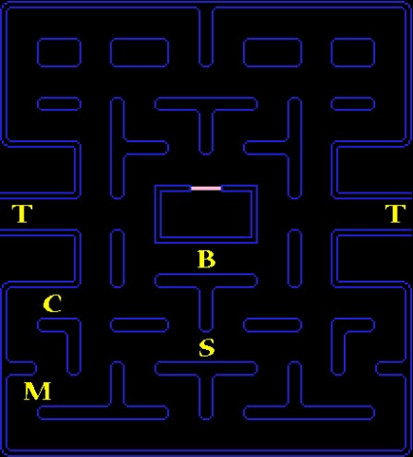

**Figure 1: The Game Board**

Refer the game board or screen shown in Figure 1. The figure shows all the important lines from the actual game. You should recognize all the lines and structure. Some texts and characters are removed for simplicity.

The thick lines show the perimeter of the board or screen. Pac-Man must travel within the perimeter and cannot go any other area. At any time, you can move Pac-Man only in a straight north, south, east, or west direction.

Pac-Man starts each game at the starting point, S. The only point of dis-continuous movement is the tunnel, T. If the Pac-Man or a ghost enters the tunnel, they will re-enter the board from the tunnel entrance on the opposite side of the board, that is the effect of a maze. Pac-Man will stop moving if you try to move it head-on into any of the walls or boundaries.

At the start you get three Pac-Man lives. If your score more than 10,000 points you will get one more life.

* 1. The Controls
     1. When you play on a computer

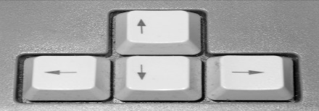You can use the arrow keys or Joystick to control Pac-Man

1. With Arrow Keys: Use the 4 arrow keys to direct Pac-Man through the maze. Press the left, right, up, and down arrow keys to move Pac-man in left, right, up, and down directions respectively.

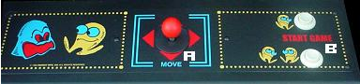

1. With Joystick: Use the 4-way joystick to direct Pac-Man through the maze. To move Pac-Man, hold the Joystick in a direction that you want to move.
   * 1. When you play on a mobile device

Swipe in left, right, up, and down direction that you want Pac-Man to move in the maze.

Note: You can always control the direction of Pac-Man however its speed is automatic and out of your control.

* 1. The Score Points

As the Pac-Man travels the paths in the maze, it consumes the *dots* and *energizers* in the path. *Dot* refers to one of the 240 constant (non-flashing) dots on the board, and an *energizer* is one of the 4 flashing dots. A single dot is worth 10 points and an energizer is worth 50 points, for details refer to Figure 2.

After you consume an energizer on one of the early game boards, there is a short period of time when the ghosts turn blue and flash. They are vulnerable during this time.

If you consume any one of them during this period, they return helplessly to the *ghost pen* – the large square at the center of the board – and you get the points as follow:

* 200 points for the first ghost consumed
* 400 points for the second ghost consumed
* 800 points for the third ghost consumed
* 1,600 points for the fourth ghost consumed

Note: As the game progresses, the vulnerable period of the ghosts gets shorter.

Often you will see different bonus symbols appear at point B in Figure 1. If you consume a bonus symbol during its short presence, you get additional points as shown in Table 1.

|  |  |  |
| --- | --- | --- |
| **Board #** | **Points** | **Bonus Symbol** |
| 1 | 100 | Cherries |
| 2 | 300 | Strawberry |
| 3, 4 | 500 | Peach |
| 5, 6 | 700 | Apple |
| 7, 8 | 1000 | Pineapple |
| 9, 10 | 2000 | Galaxian Man |
| 11, 12 | 3000 | Bell |
| 13 on | 5000 | Key |

**Table 1: Bonus Points**

* + 1. The Perfect Score

The perfect game score is 3,333,360 points, to get that you must consume all bonus fruits, all the ghosts with all energizers, and pass all 255 rounds. This can be extremely hard but as you practice you will improve you game skills.

* 1. The Ghosts

Four ghosts start each board in the *ghost pen*. The ghosts pursue and try to consume the Pac-Man. If they catch Pac-Man you lose one life and the game starts again. If Pac-Man loses all its life lives the game is over.

The ghosts are pink, red, orange, and blue in color, for details refer to Figure 2.

All of them differ in their characteristics. The differences are summarized in the Table 2.

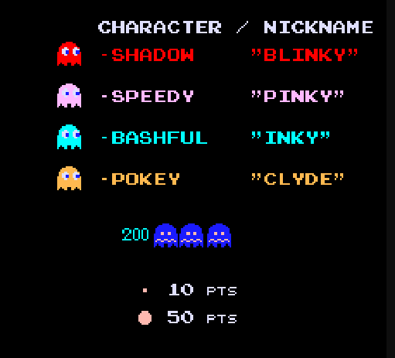

**Figure 2: Ghosts and Points**

|  |  |  |  |  |
| --- | --- | --- | --- | --- |
| **Color** | **Orange** | **Light Blue** | **Pink** | **Red** |
| **Name** | Pokey | Bashful | Speedy | Shadow |
| **Nickname** | Clyde | Inky | Pinky | Blinky |
| **Dangerousness** | Least | Medium | Very | Most |
| **How often it captures the Pac-Man given opportunity** | 20% of the time | 50% of the time | 70% of the time | 90% of the time |

**Table 2: Ghost Characteristics**

Each ghost’s eyes face in the direction of its current travel. As a ghost sees the Pac-Man, it takes action to catch the Pac-Man. The ghosts generally don’t take U-turns unless the Pac-Man consumes an energizer or it’s time for their periodic runs.

The speed of the ghosts is essentially constant. Though there are two major exceptions:

1. During a trip through the tunnel T (refer to Figure 1), the speed of the ghosts decreases
2. When you are near the end of a board, the speed of the ghosts increases.

Note: The red ghost is fastest at this time.

1. How to Play Pac-Man?

As you learn the rules, characters and understand the controls of the Pac-Man game, you can start playing the game.

To play the game on your computer or mobile device, do the steps that follow:

1. Visit the Pac-Man game website: <https://pacman.live/>.
2. Click on ***Click to Play***.
3. 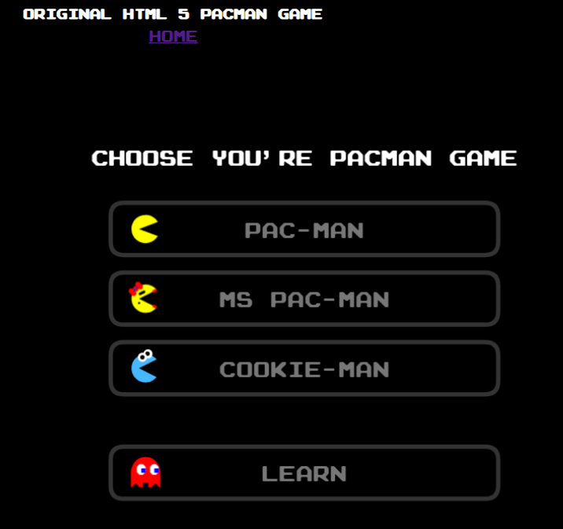Wait until you see the below screen.

Note: Ms Pac-Man and Cookie-Man are the different versions of the Pac-Man game.

You can select ***Learn*** to know more about a ghost’s movement pattern.

1. Select ***PAC-MAN*** *or* ***MS PAC-MAN*** *or* ***COOKIE-MAN*** as per your choice.
2. When you select ***PAC-MAN***, you will see the below screen.

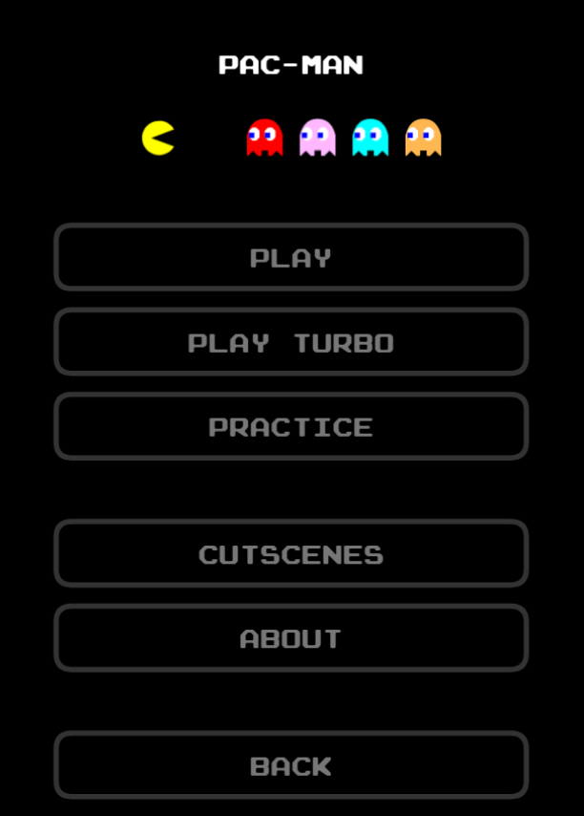

1. If you want Pac-Man to move faster than normal speed, select ***PLAY TURBO.***
2. Select ***PRACTICE*** to do practice of the various levels of the game before you start the actual game.
3. ***CUTSCENES*** are for demonstration purpose of the characters.
4. To know more about the game, select ***ABOUT.***
5. If you want to go back to the previous screen, select ***BACK.***
6. To start the game, select ***PLAY.*** Refer to Section 3, Pac-Man Rules to know the rules of the game.
7. 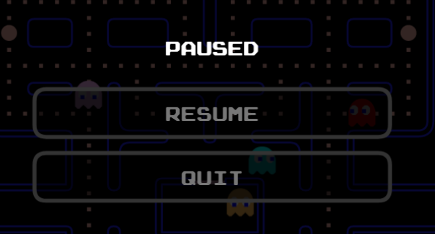Once you start, to pause or quit the game press the *Esc key* or select the ***MENU*** at the bottom of the screen.
8. To quit the game, select ***YES***.

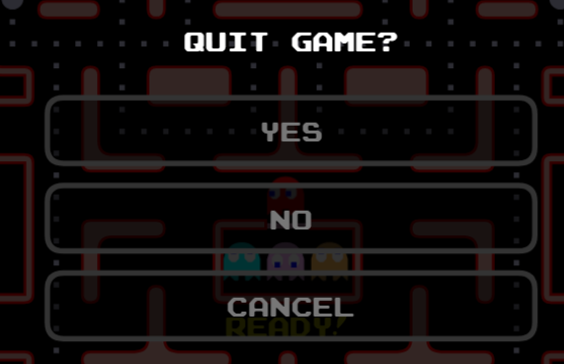

1. General Hints

This section gives helpful hints which can be used many times during the game. Use these hints to get better score at the game.

1. Clear the bottom of the board first as you are more vulnerable in the bottom row and near the two bottom corners.
2. In the tunnel Pac-Man’s speed increases compared to the speed of the ghosts.
3. To lure a ghost to follow Pac-Man, move it quickly towards a ghost and then move quickly away from it.
4. Pac-Man moves faster when the path is empty.
5. Don’t worry much about the orange ghost.
6. Consume *Energizer* only when one or more ghosts are near Pac-Man.
   1. Special Notes

The strategies, patterns, concepts, and guidelines in this document are general instructions. The degree to which you can improve your game depends on several factors:

* Your skills and coordination
* Your total experience with the game
* The amount of time, effort, and practice you put in the game
* Whether you properly apply the guidelines shown in this document.

1. References

If you want to learn more about the Pac-Man game, refer the links that follow:

1. [Pac-Man Doodle – Google](https://www.google.com/logos/2010/pacman10-i.html)
2. [Pac-Man Guide](http://www.classicgaming.cc/classics/pac-man/play-guide)
3. [Pac-Man Advanced](https://www.mariogames.be/Pacman_Advanced_Game)
4. [Pac-Man Pattern](https://tedium.co/2019/11/19/pac-man-patterns-history/)
5. [Pac-Man History](https://www.britannica.com/topic/Pac-Man-1688279)
6. [Ms Pac-Man](https://en.wikipedia.org/wiki/Ms._Pac-Man)