FCS System
Filling capping sorting System
Technical Report
Zahra Malekimoghadam
Harpreet Singh
Instructor: Iakov Romanovski
TPJ653 NAA
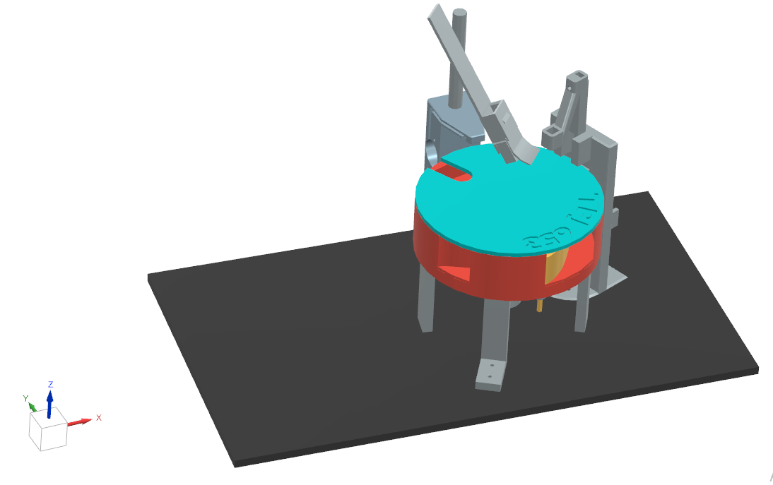
Figure 1

Table of Contents
Abstract 4
Introduction 4
1.1 Project Overview 4
1.2 Training and Learning Objectives 4
Mechanical & Electrical Systems 4
Sensors and Signal Processing 4
PLC Control (CLICK PLC) 4
IoT and Monitoring (Node-RED Dashboard) 5
Commissioning and Troubleshooting 5
1.3 Safety and Operational Responsibilities 5
1.4 Risks and Precautions 5
Background and Research 5
Technical data 5
Design and function 5
3.1System Overview 5
3.2 Function 6
3.3 Sequence Description 6
1. Detection and Positioning: 6
2. Filling Process: 6
3. Capping Process: 6
4. Sorting Operation: 6
5. System Reset: 6
3.4 Filling Module 7
3.5 Capping Module 8
3.6 Sorting Module 8
3.7 System Control and IoT Dashboard 9
3.8 Safety and Power 9
Hardware components and specifications 10
4.1 Mechanical set up 10
4.2 Adjust sensors 10
4.3 Assembly and Alignment 11
4.4 Cable connections 11
Theory of operation 12
1.Timers 12
2.Resistors Used with the Optocoupler (with Values & Formula) 13
13
Product operating instructions 13
Maintenance requirements 14
Future improvement 14
1.Improvements to the Capping System 14
2.Mechanical Design & Prototyping 15
3.PCB 15
4.IoT Dashboard Improvements 15
Conclusion 16
Appendix 17
system block diagram 17
PCB Schematic 17
IOT Dashboard 18
Grafcet 19
Bill Of Material 20
Reference 21

Table of Figures

Figure 1 Title 1
Figure 2 7
Figure 3 inside 7
Figure 4 filling 8
Figure 5 cross section 8
Figure 6 iot 9
Figure 7 power supply 11
Figure 8 flowchart 12
Figure 9 PCB 13
Figure 10 PCB 2 13
Figure 11 SBD 14
Figure 12 BOM 14

Abstract
The Automated Filling, Capping, and Sorting System is a fully integrated mechatronic project designed to replicate an industrial packaging line on a smaller educational scale. Developed as part of the TPJ653 Capstone Project at Seneca Polytechnic, the system demonstrates the practical application of automation, control, and IoT technology in a compact modular setup. Its primary purpose is to automate the sequential process of filling containers with liquid, capping them securely, and sorting them based on color detection, using an integrated CLICK PLC for control and a Node-RED dashboard for data visualization. The system combines multiple engineering disciplines, including mechanical design, electrical wiring, sensor integration, and PLC programming. A rotary indexing table facilitates the transfer of containers between stations. The capacitive sensor detects the presence of a container, the inductive sensor identifies the indexing table’s metal reference for position feedback, and limit switches ensure actuator end-stop safety. A color sensor classifies the product type (black or white liquid) and activates the sorting mechanism accordingly. The PLC processes all input signals and controls output such as motors, and actuators. An IoT-based Node-RED interface displays real-time data, including container counts, system status and bottle customization. The entire system operates on a 24 V DC supply, emphasizing safety, modularity, and educational accessibility

Introduction

1.1 Project Overview
The Automated Filling, Capping, and Sorting System is designed to provide practical, industry-oriented training in automation, control, and IoT-based process monitoring. The system simulates a real production line where containers are automatically filled with liquid, capped, and sorted based on White and Black color.
The project serves as a training platform for developing the following key competencies:
Social competence: teamwork, communication, and collaboration during system design and troubleshooting.
Technical competence: electrical wiring, PLC programming, sensor integration, and IoT dashboard configuration.
Methodological competence: systematic problem solving, process optimization, and data-driven decision-making.

1.2 Training and Learning Objectives
Training activities in this project cover the following topics:

Mechanical & Electrical Systems
- Mechanical assembly of stations (filling, capping, and sorting station)
- Electrical wiring of actuators, relays, and power circuits

Sensors and Signal Processing
- Integration of capacitive, inductive, and limit switch sensors for object detection and verification
- Calibration and testing of through-beam

PLC Control (CLICK PLC)
- Writing ladder logic for sequential operations
- Implementing timer-based logic, interlocks, and fault routines

IoT and Monitoring (Node-RED Dashboard)
- Visualizing process data through MQTT communication
- Monitoring production counts and system status remotely

Commissioning and Troubleshooting
- Systematic commissioning procedures for each station
- Identifying and correcting wiring, logic, or communication faults

1.3 Safety and Operational Responsibilities
To ensure safe and reliable operation, we as team will follow all the safety protocols and accident prevention procedures.

1.4 Risks and Precautions
The system is designed in accordance with standard safety practices. However, potential risks include:
- Electrical hazards from improper wiring or exposed terminals
- Mechanical hazards from moving actuators or rotating parts
- Sensor misalignment leading to unexpected actuator motion
- Water leakage
Faults affecting safety must be corrected immediately before resuming operation.

Background and Research
Automatic Bottle Filling and Capping Machine.” YouTube, uploaded by TECHNICAL ISHWAR, 20 Jan. 2019, Explora CTV 2025-01 EN 15 1920x1080
PLC Based Filling and Sorting Machine Project.” YouTube, uploaded by Mechatronics • Engineering Projects, 12 Mar. 2020 Automatic bottle filling & capping machine controlled by PLC S7-1200
Seneca Polytechnic. “Winter 2024 M08 Project Report.” School of Electronics and Mechanical Engineering Technology,2024, WINTER 24 M08.pdf | School of Electronics & Mechanical Engineering Technology

Technical data
Parameter | Value
Power Supply | 24VDC, 5 A
DI | 8
DO | 8

Design and function

3.1System Overview
Processing in automation generally refers to the sequence of manufacturing or handling operations such as filling, capping, and sorting. In this project, these operations are performed automatically through electromechanical devices controlled by a CLICK PLC.
The Automated Filling, Capping, and Sorting System simulates an industrial packaging process where containers are:
- Detected and positioned accurately
- Filled with a specific liquid (black or white)
- Capped using a Linear Actuator and Gripper for holding the bottles still
- Sorted into designated bins based on color detection.

3.2 Function
- The overall function of the system is to:
- Detect containers using capacitive
- Perform automated filling and capping
- Direct filled containers to the appropriate sorting location.
- The process sequence is controlled by a CLICK PLC using ladder logic. Real-time monitoring and production data (counts, system status) are displayed through a Node-RED IoT dashboard connected via MQTT communication.

3.3 Sequence Description
Each container passes through the following stages:

- Detection and Positioning:
When a container is detected at the input using a capacitive sensor, the PLC initiates the filling sequence.
- Filling Process:
using two peristaltic pumps to fill up the containers.
- Capping Process:
The filled container moves to the capping area, detected by and capacitive Sensor. Linear actuator will grip the container to hold it steady and linear actuator lowers the cap to screw the cap.
- Sorting Operation:
Based on the color, the container is diverted using an electrical actuator (sorting Slider) to the corresponding output chute — one for black containers and another for white containers.
- System Reset:
Once sorting is complete, the conveyor (or indexing mechanism) returns to the initial position and waits for the next container.
The entire cycle repeats automatically if the START condition is met and containers are available at the input.

Figure 2

3.4 Filling Module
The Filling Module consists of a liquid container, two peristaltic pumps and a nozzle for dispensing. The amount of liquid filled is determined by timers. The capacitive sensor ensures the presence of a container before activating the pumps to prevent leakage Safety interlocks are included to disable filling if no container is detected.
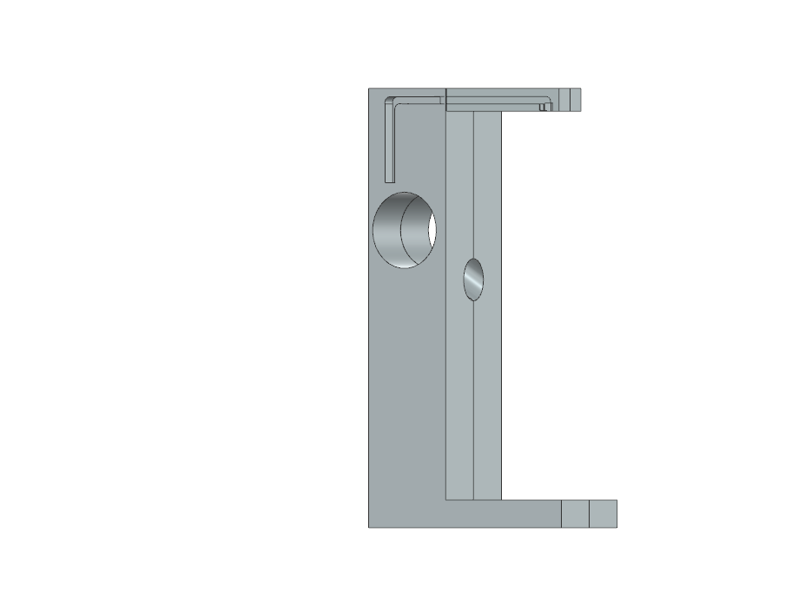
Figure 3 filling

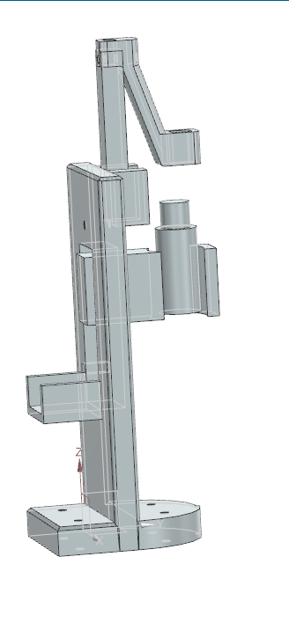
3.5 Capping Module
The filled container moves to the capping area, detected by and capacitive Sensor. Linear actuator will grip the container to hold it steady and linear actuator lowers the cap to screw the cap

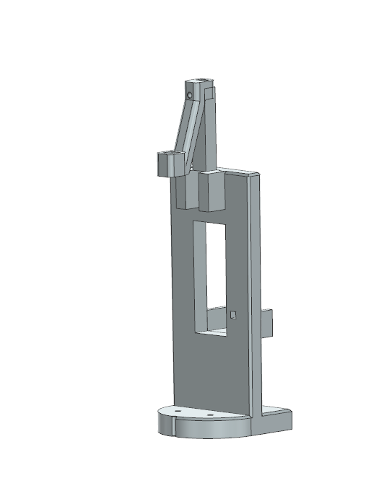

Figure 4 Capping

3.6 Sorting Module
The Sorting Module uses a sensor and a sorting Slider. The sensor identifies the liquid color (black or white), and the sorting slide directs the container to the correct output bin. Each sorting path is monitored by sensors to confirm successful transfer, and the status is displayed on the Dashboard.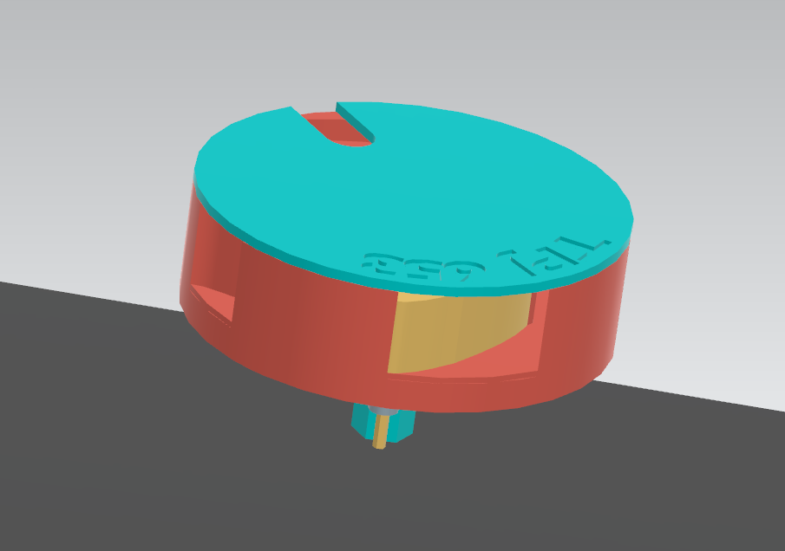

3.7 System Control and IoT Dashboard
The CLICK PLC serves as the central controller for all modules, handling input signals (sensors, switches) and controlling output devices (actuators, motors).
Data such as: System status (RUN/STOP), Cycle count and bottle Customized are published via MQTT protocol and visualized in Node-RED. This allows for remote supervision and easy system diagnostics.
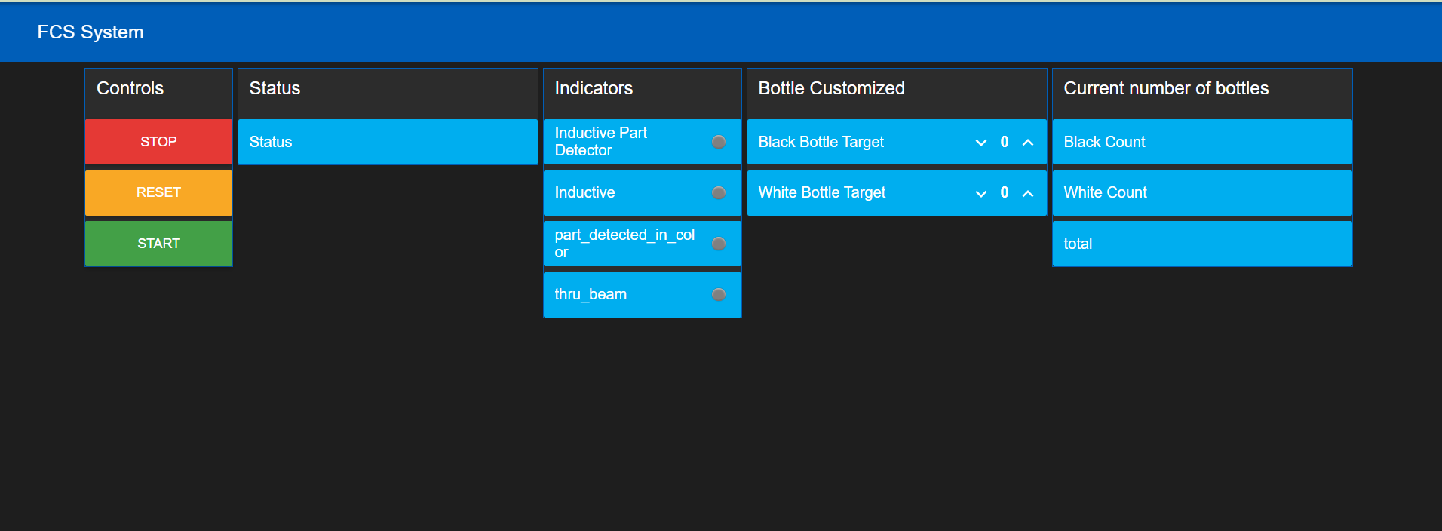

Figure 5 IOT

3.8 Safety and Power
The system operates 24 V DC and includes proper circuit protection (fuses and emergency stop). Electrical and mechanical hazards are minimized through proper wiring, isolation, and grounding.

Hardware components and specifications

4.1 Mechanical set up
The main mechanical components include:
- Base Frame:
Constructed using MDF profile channels to provide strength, modularity, and ease of component mounting.
- Indexing Mechanism:
rotary indexing platform transports containers between stations. It is powered by a DC geared motor and guided by adjustable rails to ensure consistent container positioning.
- Filling Station Structure:
Includes a nozzle holder and container holder.

4.2 Adjust sensors
- Capacitive Proximity Sensor (Filling Station – Container Detection)
The capacitive proximity sensor is used to detect the presence of a container before the filling process begins. When a container is placed under the filling nozzle, the dielectric constant of the object alters the internal capacitance of the sensor, triggering detection. The sensor detects objects regardless of their color, material, or surface finish.
Capacitive proximity sensors are utilized in multiple positions such as material input, filling confirmation, and presence verification.
  - Prerequisites
- The Filling module is fully assembled.
- The capacitive proximity sensor is wired to the CLICK PLC input terminal.
- The 24 V DC power supply is ON.
Execution
- Place an empty container at the Initial position to start the system
- Adjust the sensor-to-container distance until the indicator LED switches ON.
- Ensure that the metal table or nearby components do not falsely trigger the sensor.
- Test the sensor by removing and replacing the container, confirming consistent switching.

- Inductive Proximity Sensor (Rotary Indexing Table – Metal Position Detection)
The inductive proximity sensor is used to determine the rotational position of the rotary indexing table. It detects the metal target plate or screw fixed beneath each indexing position. The sensor outputs a signal each time the metal target aligns with the sensor face, ensuring accurate table positioning for filling, capping, and sorting operations.
  - Prerequisites
- The Rotary Indexing Table module is assembled and operational.
- The inductive proximity sensor is wired correctly to the PLC input terminal.
- The 24 V DC power supply is ON.
  - Execution
- Mount the inductive proximity sensor in its mounting bracket below the indexing table.
- Align the sensor directly below the metal reference screw or plate attached to the underside of the rotating platform.
- Adjust the sensor distance to approximately 2 mm from the metal surface.
- Rotate the table manually to verify that the sensor LED indicator activates only when the metal reference passes over it.
- Confirm stable detection without false triggering between positions.

- Limit Switch (Capping Gripper and sorting station)
Limit switches are used for end-position sensing of the capping actuator or linear transfer arm. They ensure the actuator stops precisely at its upper and lower travel limits.
  - Prerequisites
- The Capping and Transfer modules are assembled and wired.
- Limit switches are connected to the PLC input terminals.
- Power supply is ON.
  - Execution
- Move the actuator to its fully retracted (upper) position.
- Slide the limit switch in the mounting bracket until it activates.
- Tighten the mounting screws.
- Move the actuator to its fully extended (lower) position and adjust the second limit switch accordingly.
- Perform a test run to verify correct activation in both positions.

4.3 Assembly and Alignment
Each module was mechanically assembled using standard fasteners and corner connectors. Components were aligned to ensure:
- Proper sensor detection range
- Smooth movement of actuators
- Accurate positioning of containers during filling and capping
- Reliable transfer between stations without interference.

4.4 Cable connections
- PLC Board and System Connections
  - PLC Board → Station I/O Terminal
  - PLC Board → Control Console
  - PLC Board → Power Supply Unit
  - PC → PLC (Programming)
- Voltage Supply
The entire system operates on 24 V DC (max 5 A) supplied through a regulated DC power supply.
- The power is distributed through the PLC board to all field devices (sensors, and indicators).
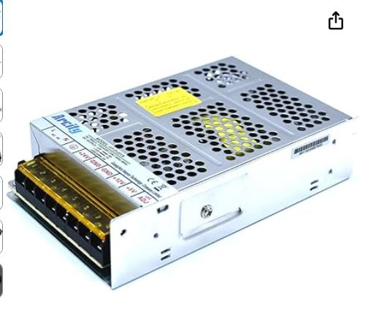
Figure 6 power supply
  - Procedure
- Connect the PC to the PLC via the Ethernet programming cable.
- Switch ON the 24 V DC power supply.
- Verify that the PWR and RUN LEDs on the PLC illuminate.
- Press the STOP/RUN switch to the STOP position before downloading.
- Open the project file
- Select PLC → Connect, then verify successful communication.
- Choose Program → Write to PLC to download the ladder program.
- Once transferred, confirm that the I/O mapping matches the wiring diagram.
- Set the PLC to RUN mode. Observe the status LEDs for each input/output to ensure normal operation.
- Start the Node-RED dashboard and verify MQTT communication for live monitoring of system data (cycle count, process state, sensor status).

Theory of operation

1.Timers
The automated bottle filling and capping system operates through a sequence of sensor-triggered states governed by multiple ON-delay and OFF-delay timers to ensure accurate, safe, and repeatable operation. When a bottle is detected at the entry sensor (X001), the color detection sensor (X002) is enabled, allowing the PLC to determine the liquid type required. This activates OP1 and OP2, which select either the left pump (Y105) or right pump (Y106).
Filling is controlled using timers T10 and T11, each set to approximately 5.5 seconds, ensuring consistent liquid volume. Bottle counting is managed by counters CT2 and CT3,
which compares the current count with the operator-defined setpoint. Once filling is complete, the bottle is transferred to the gripping station. The gripper (Y001) is activated using Timer T2 (5 seconds) to ensure secure holding before capping.
The capping sequence starts when OP6 is enabled. The capper motor (Y104) and capping actuator (Y003) are energized while Timer T3 (17 seconds) ensures adequate tightening time. After capping, the slider motor (Y102) is controlled using Timer T9 (3.5 seconds) and OFF-delay Timer T7 (0.7 seconds) to smoothly discharge the bottle. Additional positioning and homing are controlled by Timers T5, T6, and T8, which manage return motion, delay confirmation, and safety interlocks. After all operations, the system resets internal control bits and prepares for the next production cycle

2.Resistors Used with the Optocoupler (with Values & Formula)
In this project, a 4N35 optocoupler is used to safely isolate the 24 V PLC output from the low-voltage control circuit. A 2.2 kΩ current-limiting resistor is connected in series with the optocoupler input LED to restrict the LED current to a safe operating level of approximately 10 mA.

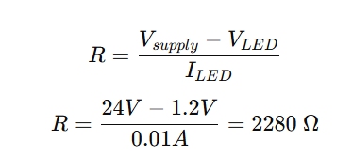

Product operating instructions
Power ON the system and ensure the PLC and all devices are energized. Place empty bottles at the entry point and select the required bottle quantity and liquid type. When a bottle is detected, the system automatically performs color detection, liquid filling using the appropriate pump, gripping, capping, and sliding of the finished bottle to the exit. The system resets automatically after each cycle and is ready for the next bottle. An emergency stop is provided to safely stop the system at any time.

Maintenance requirements
Regular maintenance includes inspecting all mechanical parts for wear, cleaning sensors and guides, checking electrical wiring and PCB connections, backing up the PLC program, and inspecting pumps and tubing for leaks or blockages. Safety devices such as the emergency stop must be tested frequently to ensure reliable operation.

Future improvement
As we worked through this project, we realized there were several areas where we could make things better, and many of those improvements became important turning points in our design.

1.Improvements to the Capping System
We started with the idea of using a press capping mechanism. At first, it seemed simple, but once we began testing, we saw how difficult it was to align the bottle perfectly especially because our original bottles were very small. Even a slight misalignment could cause the cap not to sit properly or the bottle to shake during the process. Because of this, we decided to redesign the entire station. Instead of pressing the cap downward, we switched to a screw-type capping system, which gives us much better control. To make it even more reliable, we added a bottom gripper, so the bottle stays firm and doesn’t rotate when the cap is tightened. We also switched to slightly larger bottles, which are easier for the mechanism to hold and much more stable during the capping.

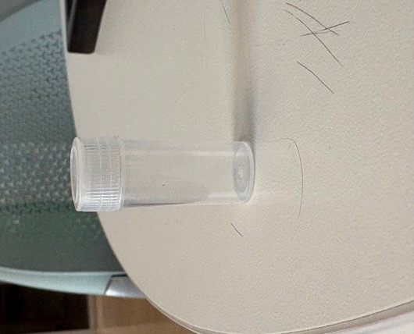 After 1
Before
1

2.Mechanical Design & Prototyping
Our design has gone through a lot of changes. We printed two full prototypes:
The first prototype had issues with clearances, parts not fitting properly, and some mechanical interference. The second prototype showed major improvement most fitting problems were fixed, and the design felt more realistic and reliable. Even with those upgrades, we know the design will continue to improve as we assemble everything physically. Once the system is mounted, we always find new things to adjust small tweaks to part alignment, reinforcing certain areas, making space for wiring, and improving how the components move together.

3.PCB
We also made significant changes to our PCB design. At first, we planned to use a custom PCB for a through-beam sensor. However, after running the cost and component calculations, we realized that purchasing a pre-built through-beam sensor would be more cost-effective than designing a custom board. Because of this, we decided to shift our PCB design to optocoupler board instead. This adjustment not only reduced our overall project cost but also saved us time and minimized potential soldering or alignment errors. It allowed us to focus more on system reliability and sensor performance rather than spending resources on unnecessary PCB complexity.
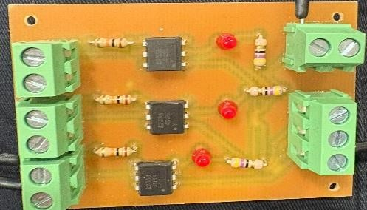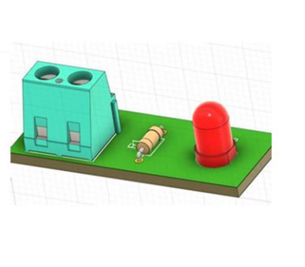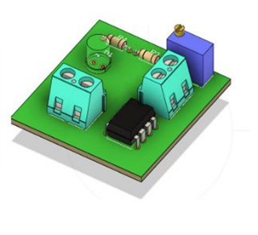

before
After

4.IoT Dashboard Improvements
We also added a customization section that allows the user or operator to set the production quantity such as processing maximum 3 bottles of each liquid and one bottle at time. In addition, we plan to integrate cycle-time monitoring into the IoT dashboard so operators can clearly see how long each full process takes. 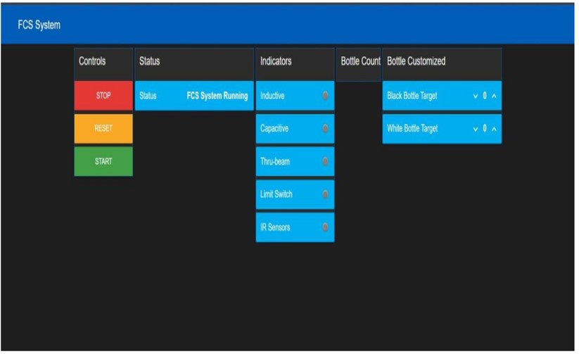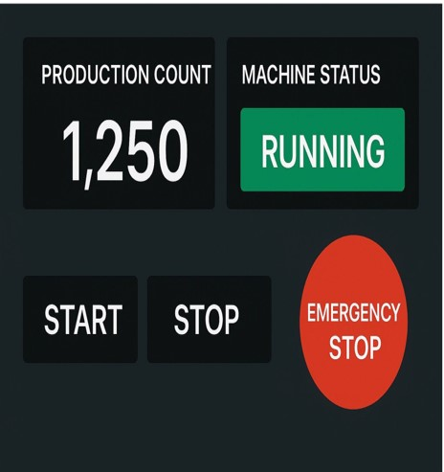
After Before

Conclusion
In this TPJ capstone project, we successfully designed and built an automated filling, capping, and sorting system by combining mechanical design, PLC programming, and IoT integration. Despite challenges with sensor calibration, mechanical alignment, and time management, we improved our design through multiple prototypes and testing. The final system performs reliably, allows operator customization, and communicates with a Node-RED dashboard for monitoring and control. Overall, this project strengthened our technical skills, teamwork, and problem-solving abilities, and provided a solid foundation for future improvements

Appendix

system block diagram
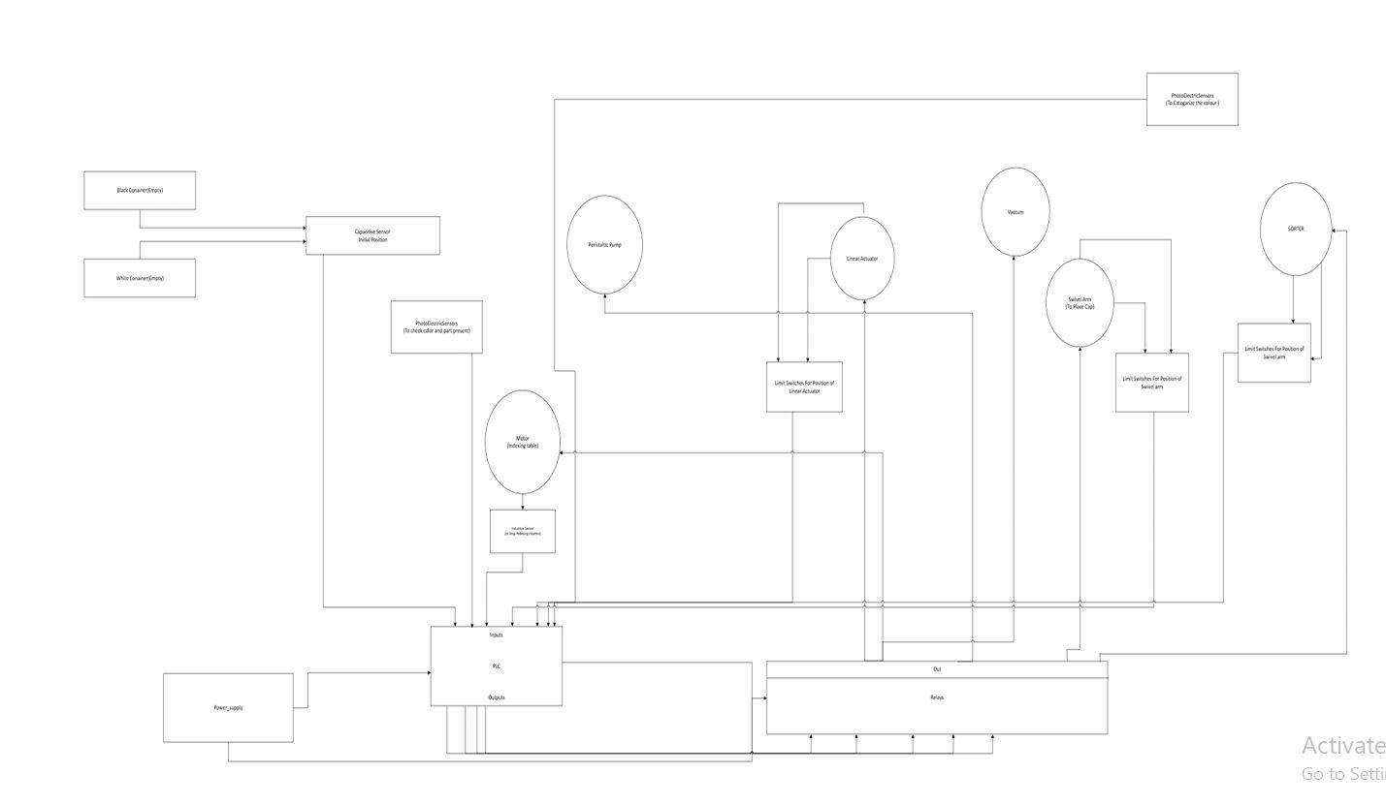

PCB Schematic
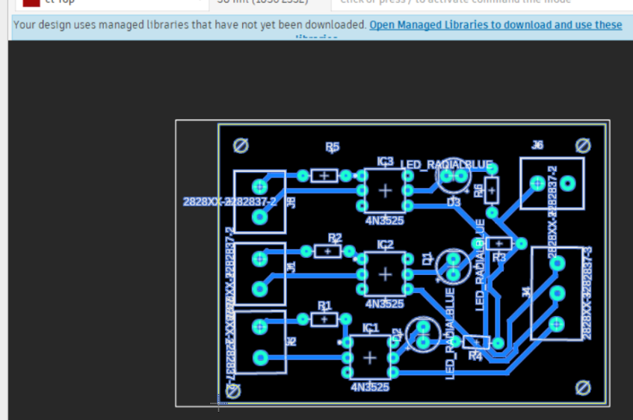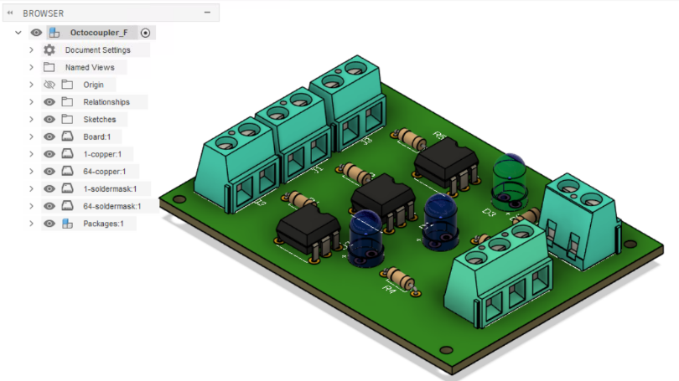
Figure 7 PCB

IOT Dashboard
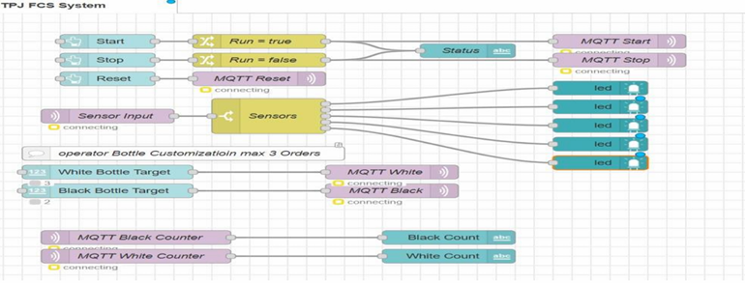
Figure 8 IOT

Grafcet
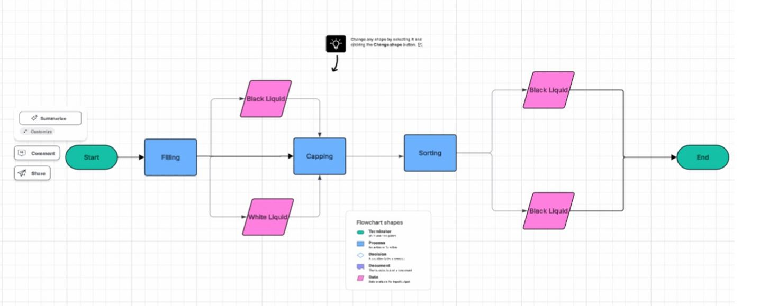

Bill Of Material
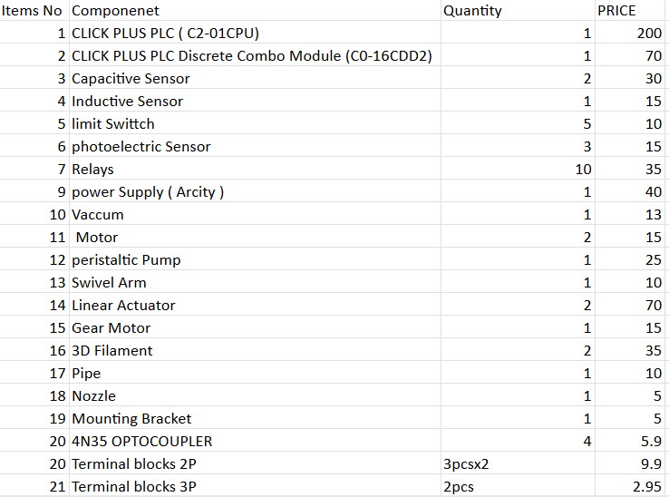
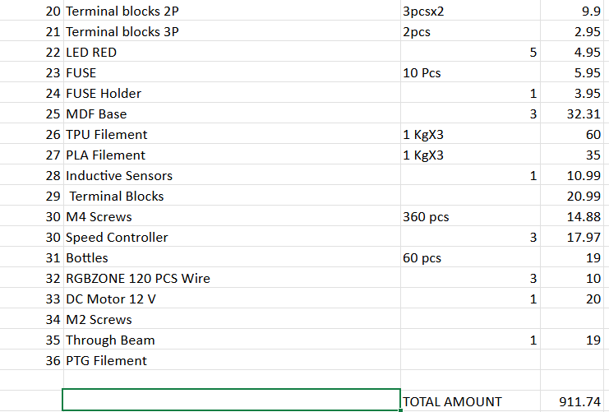
Figure 13 BOM

Reference
Automatic Bottle Filling and Capping Machine.” YouTube, uploaded by TECHNICAL ISHWAR, 20 Jan. 2019, Explora CTV 2025-01 EN 15 1920x1080
• PLC Based Filling and Sorting Machine Project.” YouTube, uploaded by Mechatronics • Engineering Projects, 12 Mar. 2020 Automatic bottle filling & capping machine controlled by PLC S7-1200
• Seneca Polytechnic. “Winter 2024 M08 Project Report.” School of Electronics and Mechanical Engineering Technology,2024, WINTER 24 M08.pdf | School of Electronics & Mechanical Engineering Technology

