Implement program to apply moving average smoothing for data preparation and time series forecasting
EX:No.6
DATE:29/03/25

AIM:
To forecast future shampoo sales using time series analysis by applying Moving Average smoothing and fitting an ARIMA model on the cleaned sales dataset.

ALGORITHM:
- Import required libraries (pandas, numpy, matplotlib.pyplot, statsmodels) for data manipulation, visualization, and ARIMA modeling.
- Load the shampoo sales dataset, rename columns for clarity, convert the 'Month' column to datetime format, and set it as the index of the DataFrame.
- Handle missing data by dropping any rows with null values to ensure a clean time series.
- Apply moving average smoothing on the sales column using a 3-month rolling window to reduce short-term fluctuations and noise.
- Fit an ARIMA model on the smoothed data using specified order parameters (p=2, d=1, q=2) to capture trend and seasonality.
- Forecast the next 10 time steps using the trained ARIMA model and generate predicted future sales values.
- Visualize the results by plotting the original sales data, smoothed series, and the ARIMA forecast to interpret trends and predictions clearly.

CODE:

import pandas as pd
import numpy as np
import matplotlib.pyplot as plt
from statsmodels.tsa.arima.model import ARIM
# Load the dataset
df = pd.read_csv("sales-of-shampoo-over-a-three-ye.csv")
# Clean and prepare data
df.columns = ['Month', 'Sales']
df = df.dropna()
df['Month'] = pd.to_datetime(df['Month'], format='%d-%b', errors='coerce')
df.set_index('Month', inplace=True)
ts = df['Sales']
# Apply Moving Average Smoothing
ts_smoothed = ts.rolling(window=3).mean().dropna()
# Fit ARIMA model on smoothed data
model = ARIMA(ts_smoothed, order=(2, 1, 2))
model_fit = model.fit()
# Forecast next 10 values
forecast = model_fit.forecast(steps=10)

# Plot original, smoothed, and forecasted data
plt.figure(figsize=(10, 6))
plt.plot(ts, label='Original Data')
plt.plot(ts_smoothed, label='Smoothed Data (MA)', color='orange')
plt.plot(pd.date_range(start=ts_smoothed.index[-1], periods=11, freq='M')[1:], forecast,
label='Forecast (ARIMA)', color='red', linestyle='--')
plt.title('Time Series Forecasting with Moving Average and ARIMA')
plt.xlabel('Month')
plt.ylabel('Sales')
plt.legend()
plt.grid(True)
plt.tight_layout()
plt.show()

OUTPUT:
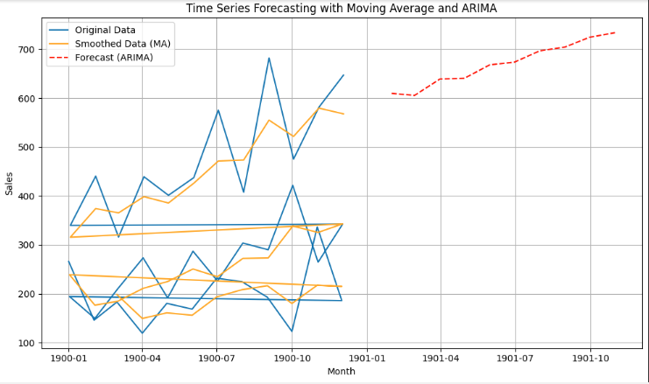

RESULT:
Thus, the program using the time series data implementation has been done successfully.

