**Lab Report**

Title: Final Project Rough Draft

Notice: Dr. Bryan Runck

Author: Jacob Harris

Date: 10/31/2023

Project Repository: [*https://github.com/harr2887/GIS5571*](https://github.com/harr2887/GIS5571)

**Time Spent:** 6 hrs

**Abstract**

For this lab (Lab 2 part 2), I am performing an optimal routing analysis from moving from a predefined starting point and ending point. In order to perform this, I calculate a cost surface for the three counties in the area using slope of the terrain and land cover type as criteria. Furthermore, I perform a sensitivity analysis by changing the weight of each criteria.

**Problem Statement**

In the lab, we need to calculate the optimal routing analysis by computing the least cost path for a person named Dory to travel from her house to a picnic area. Solving this problem via Arcpy’s Optimal Regional Connections function requires reclassifying the slope from DEM data and reclassifying land cover from National Land Cover Data and applying weights to those criteria.

### Table 1. Data

| **#** | **Requirement** | **Defined As** | **(Spatial) Data** | **Attribute Data** | **Dataset** | **Preparation** |
| --- | --- | --- | --- | --- | --- | --- |
| 1 | Land Cover | MN Land Cover | Raster |  | <https://gisdata.mn.gov/dataset/biota-landcover-nlcd-mn-2019> |  |
| 2 | DEM | MN Elevation | Raster | Elevation | <https://gisdata.mn.gov/dataset/elev-30m-digital-elevation-model> |  |
| 3 | Boundary | MN county boundaries | Vector, polygon |  | <https://gisdata.mn.gov/dataset/bdry-counties-in-minnesota> |  |

### 

| **#** | **Title** | **Purpose in Analysis** | **Link to Source** |
| --- | --- | --- | --- |
| 1 | NLCD Land Cover | Land cover criteria for cost surface | https://gisdata.mn.gov/dataset/biota-landcover-nlcd-mn-2019 |
| 2 | MN DEM | Slope criteria for cost surface | https://gisdata.mn.gov/dataset/elev-30m-digital-elevation-model |
| 3 | MN County Boundaries | Extent of cost surface | https://gisdata.mn.gov/dataset/bdry-counties-in-minnesota |

**Methods**

#### Land Cover Reclassifying

While preparing my suitability model, I chose to reclassify the NLCD from its original classification to the following:

'' 1;'' 5;'; 3;'' 5;'' 3;'' 2",

| **Criteria Score** | **Land Cover Type** |
| --- | --- |
| 1 | Developed, Developed, Low Intensity; Developed, Medium Intensity; Developed, High Intensity; Barren Land; Deciduous Forest; Evergreen Forest; Mixed Forest; Shrub/Scrub |
| 2 | Emergent Herbaceous Wetlands |
| 3 | Hay/Pasture; Woody Wetlands |
| 4 |  |
| 5 | Open Water; Cultivated Crops |

For reclassifying land cover, I allocated scores based on my own intuition. For example, I chose the lowest cost for developed land covers since it is easier to walk through places with roads and sidewalk. I identified wetlands as scores 2 and 3 since they will be a bit more difficult but Dora should be used to trudging through water as a fisher. However, open water is most difficult to cross since she would need to swim. Also, cultivated cropland is difficult to walk through since they can be somewhat maze-like.

#### Slope Reclassifying

I also reclassified the DEM slope with the following scores:

| **Criteria Score** | **Slope Range** |
| --- | --- |
| 1 | 0 - 16 |
| 2 | 16 - 32 |
| 3 | 32 - 48 |
| 4 | 48 - 64 |
| 5 | 64 - 79.38319 |

Once again, I allocated scores based on my own intuition with the assumption that larger slopes would be more difficult to walk on. When choosing the specific ranges for each score, I maintained a consistent range, meaning each range of scores is equal in range across the possible slope values. They were found using this function:

# Math to figure out my slope reclassification values

def create_eql_classes(length, max_value):

if length <= 0:

return [] # Return an empty list if the length is non-positive

# Calculate the value to be assigned to each element

value = max_value / length

# Create the list using a list comprehension

result_list = [value * (i + 1) for i in range(length)]

return result_list

#### Sensitivity Analysis

To generate more robust results, I performed a sensitivity analysis on potential criteria weights. In doing so, I can compare/contract resulting statistics from using different weight combinations. For my sensitivity analysis, I chose to test both criteria with each of the following weights: [0.1, 0.2, 0.3, 0.4, 0.5, 0.6, 0.7, 0.8, 0.9]. As customary in suitability analysis, each weight combination sums to one.

While this was not the objective of the assignment, I received an error message when trying to perform the optimal routing analysis:



So I just continued the sensitivity analysis through just suitability analysis instead of optimal routing.

#### Results Generation

After conducting the sensitivity analysis of the suitability weights, I calculated the mean, min, and max of each weighting combination using the function ‘arcpy.GetRasterProperties_management’ and exported the statistics to a csv file by creating a pandas dataframe.

### Figure 1. Project Flow Chart

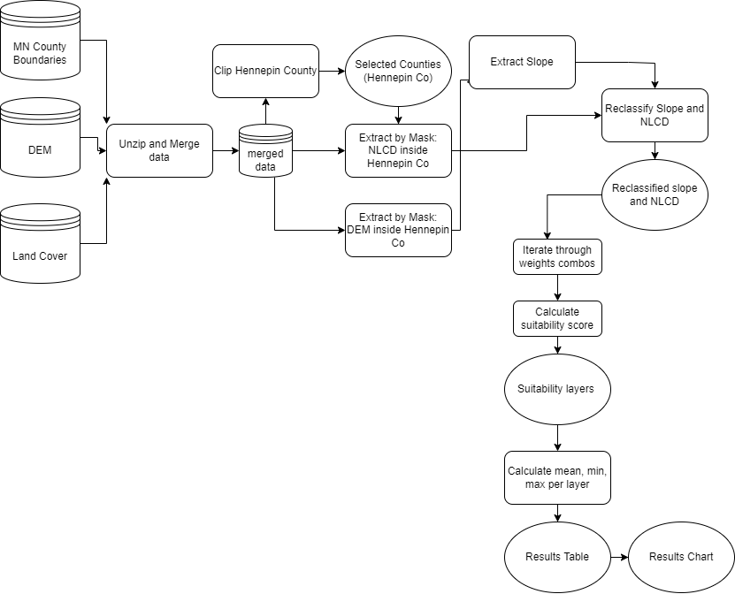

**Results**

Through my sensitivity analysis, I learned that the average mean suitability score decreases as the weight of the land cover criteria increases and the weight of the slope criteria decreases.

### Table 2. Sensitivity Analysis of Mean Suitability Score

| **Criteria and Weight** | **Mean** | **Minimum** | **Maximum** |
| --- | --- | --- | --- |
| Land Cover Weight 0.3, Slope Weight 0.7 | 1.713839 | 1 | 5 |
| Land Cover Weight 0.4, Slope Weight 0.6 | 1.87844 | 1 | 5 |
| Land Cover Weight 0.9, Slope Weight 0.1 | 2.207641 | 1 | 5 |
| Land Cover Weight 0.8, Slope Weight 0.2 | 2.536843 | 1 | 5 |
| Land Cover Weight 0.7, Slope Weight 0.3 | 2.701444 | 1 | 5 |
| Land Cover Weight 0.6, Slope Weight 0.4 | 2.866045 | 1 | 5 |
| Land Cover Weight 0.5, Slope Weight 0.5 | 3.030646 | 1 | 5 |

### Figure 2. Sensitivity Analysis of Mean Suitability Score

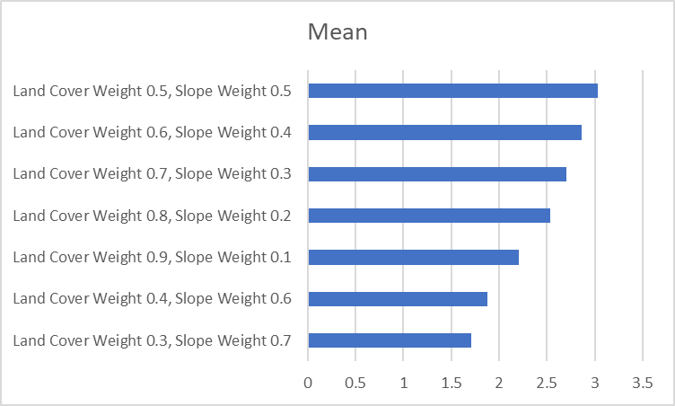

**Results Validation**

While I’m glad I was able to generate some statistics through the suitability analysis, it’s unfortunate that I don’t have any optimal routing analysis to compare the sensitivity analysis with different routes.

**Discussion and Conclusion**

As previously mentioned, I wasn’t able to generate the optimal paths from Dory’s house to the picnic area; However, I’m glad that I was able to compare the knowledge we learned in class about suitability models to still generate some results even though they weren’t specifically optimal routing. After looking at the sensitivity analysis, it appears that having equal weights resulted in the highest mean cost.

**Self-score**

| **Category** | **Description** | **Points Possible** | **Score** |
| --- | --- | --- | --- |
| **Structural Elements** | All elements of a lab report are included **(2 points each)**:  Title, Notice: Dr. Bryan Runck, Author, Project Repository, Date, Abstract, Problem Statement, Input Data w/ tables, Methods w/ Data, Flow Diagrams, Results, Results Verification, Discussion and Conclusion, References in common format, Self-score | 28 | 26 |
| **Clarity of Content** | Each element above is executed at a professional level so that someone can understand the goal, data, methods, results, and their validity and implications in a 5 minute reading at a cursory-level, and in a 30 minute meeting at a deep level **(12 points)**. There is a clear connection from data to results to discussion and conclusion **(12 points)**. | 24 | 24 |
| **Reproducibility** | Results are completely reproducible by someone with basic GIS training. There is no ambiguity in data flow or rationale for data operations. Every step is documented and justified. | 28 | 28 |
| **Verification** | Results are correct in that they have been verified in comparison to some standard. The standard is clearly stated **(10 points)**, the method of comparison is clearly stated **(5 points)**, and the result of verification is clearly stated **(5 points)**. | 20 | 12 |
|  |  | 100 | 90 |