**Lab 2**

**Part A: Single Cycle Processor**

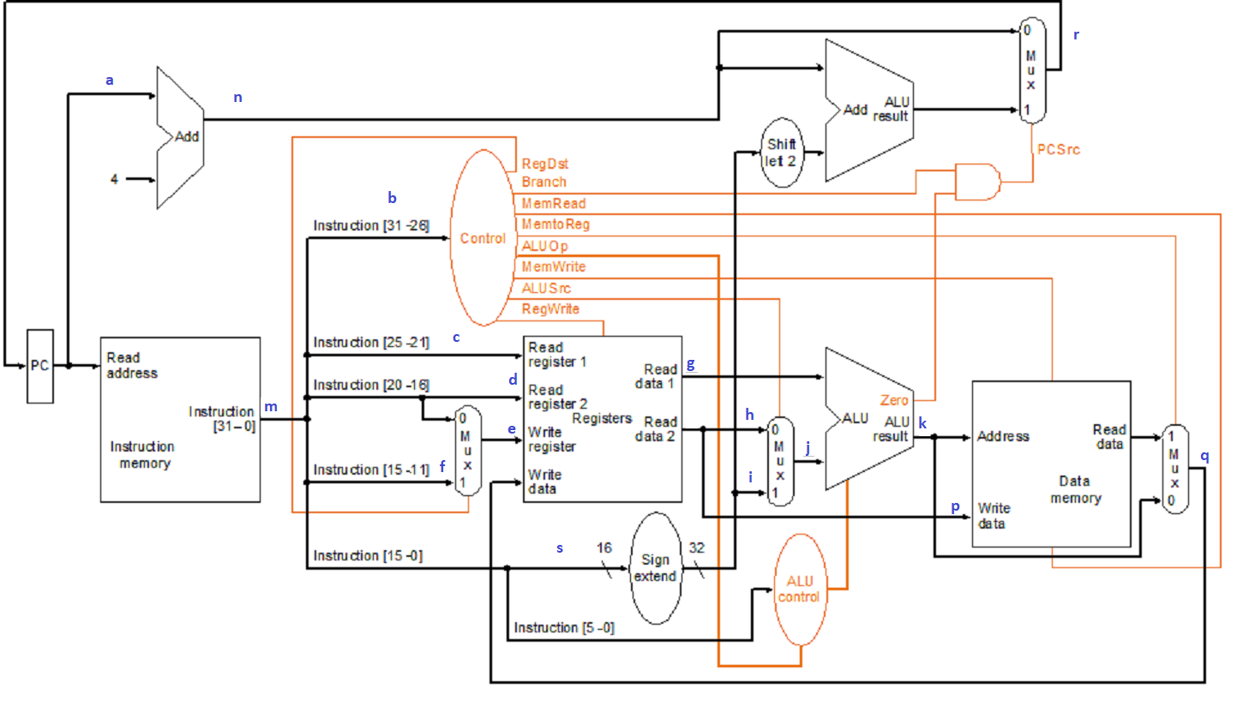

Figure A: Single Cycle Processor Datapath

Run the given Lab2.asm file on MARS simulator. Using the **Tools->MIPS X Ray**, you would be able to see the datapaths of the instructions. Based on the above figure, what will be the values of the followings when the following instructions are executed:

**Hint:**

1. Identify the instruction during the specified cycle.
2. Identify the datapath of the identified instruction, then determine the values of the labels for that datapath.
3. The datapath follows the instruction class datapath, i.e., R/I/J/load/store.
4. If the datapath does not cross through the label, mark it as ‘x’.

|  |  |  |  |
| --- | --- | --- | --- |
| **No.** | **Label** | **Value during cycle 5** | **Value during cycle 7** |
| 1 | a | 0x00400010 | 0x00400018 |
| 2 | b | 001100 | 100000 |
| 3 | c | 10010 | 10101 |
| 4 | d | x | x |
| 5 | e | $s1 | $t1 |
| 6 | f | x | x |
| 7 | g | 0x33 | 0x10010000 |
| 8 | h | x | x |
| 9 | i | 0x000000AA | 0x00000002 |
| 10 | j | 0x000000AA | 0x00000002 |
| 11 | k | 100010 | 0x10010002 |
| 12 | m | 0x325100AA | 0x82A90002 |
| 13 | n | 0x00400014 | 0x0040001c |
| 14 | p | x | x |
| 15 | q | 0x00000022 | 0x00000033 |
| 16 | r | 0x00400014 | 0x0040001c |
| 17 | s | 0xAA | 0x2 |
| 18 | RegDst | 0 | 0 |
| 19 | Branch | 0 | 0 |
| 20 | MemRead | 0 | 1 |
| 21 | MemtoReg | 0 | 1 |
| 22 | ALUOp | And | Add |
| 23 | MemWrite | 0 | 0 |
| 24 | ALUSrc | 1 | 1 |
| 25 | RegWr | 1 | 1 |
| 26 | PCSrc | 0 | 0 |
| 27 | Zero | 0 | 0 |

**Part B: Multi Cycle Processor**

1. Copy the multicycle processor datapath (Figure B), so there are 2 datapath figures.
2. For each figure, assuming Lab2.asm runs on the multicycle processor, draw the datapath AND write the values of the control signals for the following instructions:
   1. Figure 1. Process in cycle 15.
   2. Figure 2. Process in cycle 29.
3. Make sure to:
   1. **label the instruction** for each figure.
   2. **write the corresponding RTL** statement(s) for the instruction during the cycle based on Table 1.
   3. **write the control values** next to the labels in the figure (the name of the control signal - do NOT write the control values in a separate table). There are altogether 12 control values. For the Operation, just write the ALU operation, e.g. ADD, SUB, etc. - not in the format of bit value.
4. Make sure the file format to submit is a PDF file only (ONE file only).



Figure B: Multicycle Processor Datapath

**Hint:**

1. Identify the instruction and the specific process during the specified cycle.
2. Identify the relevant RTL statements, and the datapath of the identified instruction/process.
3. The datapath follows the instruction class datapath, i.e., R/I/J/load/store

Table 1: RTL statements



**Figure 1 – andi $s1, $s2, 0xAA**



**ALUOut = A op B**







**Figure 2 - sb $s4, 1 ($s5)**



**Store: Memory [ALUOut] = B**





