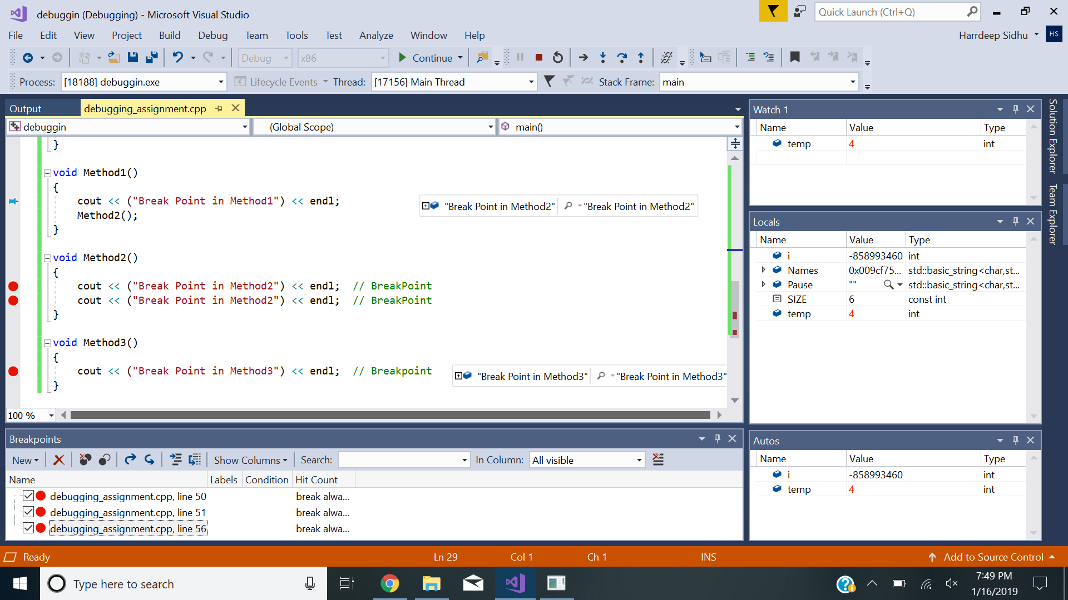

I will probably debug my codes by adding breakpoints when needed as it will help me narrow down my issues.

When you step over, you will run the line that is currently highlighted. So if there is a method in that line, it will run that method. Step into however means that you will be directed to inside the method itself rather than running the code.