THE INDEPENDENT INSTITUTE OF EDUCATION
EMERIS VEGA SCHOOL
GADE7322: Game Development 3B
Part 2 Portfolio of Evidence (PoE)
Planning: Procedural Enemy Waves (Harriet Manda Part)
Individual planning document: adaptive wave spawning strategy
Student Name: Harriet Manda
Student Number: st10252836
Module: GADE7322
Year: 2026
GitHub repository:
https://github.com/harrietaleck/ProceduralGenGade3B
Branch: part2
Word count (body text, excluding headings, captions, table and references): 495

Contents
Overview 3
Scaling difficulty for a consistent challenge 3
Adapting to skill level and play style 4
Determining spawn locations 4
Deciding when to spawn which enemy type 5
Enemy type weighting by detected play style table 6
Reference list 7

Overview
Enemy waves in this tower defence game are produced by a Wave Director (WaveDirector.cpp) instead of a fixed wave table (Manda, 2026e). After every wave it runs a four-step loop: read the player, adapt the difficulty, plan the next wave and choose spawn lanes (Figure 1). Adjusting the game to the player's performance is an established way of keeping players engaged (Mortazavi, Moradi and Vahabie, 2024).
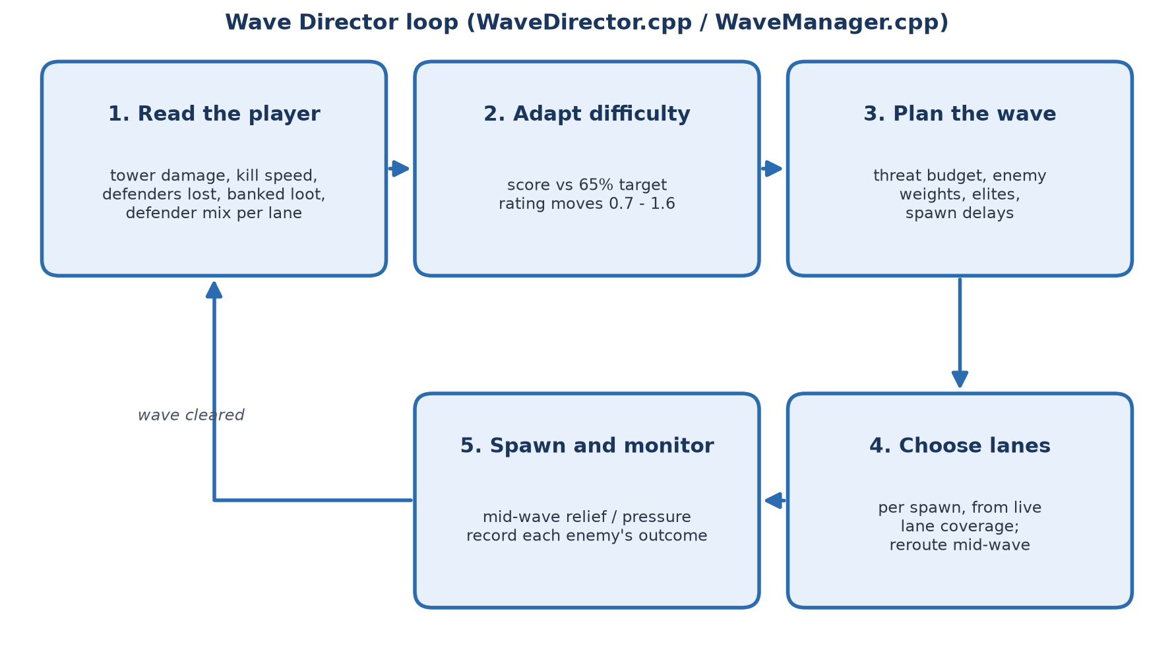
Figure 1: The Wave Director loop that runs between waves (Manda, 2026a)

Scaling difficulty for a consistent challenge
Each wave receives a threat budget that is spent on enemies: a Basic or Wolf costs one point and a Bear costs three. The budget starts at six points and grows by 3.5 points per wave, then is multiplied by a difficulty rating between 0.7 and 1.6 (Figure 2). Enemy health and damage also rise slightly every wave, and the gap between spawns shortens from two seconds towards 0.8 seconds. Escalation is therefore guaranteed, while the rating fits the curve to the individual player.
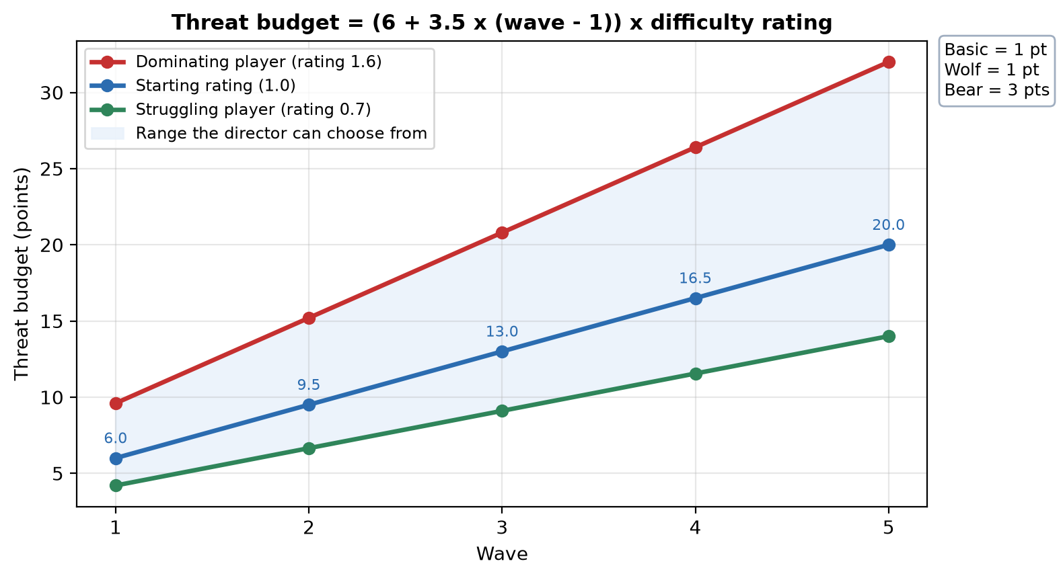
Figure 2: Threat budget per wave for different difficulty ratings (Manda, 2026b)

Adapting to skill level and play style
When a wave is cleared, the director scores the player out of 100%: tower health lost (40%), how far enemies travelled before dying (30%), defenders lost (20%) and unspent loot (10%). The target is 65%, meaning challenged but winning. The rating moves by the gap between the score and this target, so dominant players meet larger, faster and tougher waves, while struggling players face smaller waves with more Basic enemies and earn 20% more loot per kill. Guo, Thawonmas and Ren (2024) argue that difficulty adjustment should serve a clear design goal; here that goal is a consistent challenge. The director also adapts during a wave: if the tower loses 30% of its health, the gaps between remaining spawns become 50% longer, and if the player clears the board early, the next enemy is sent immediately.

Determining spawn locations
Enemies enter at the start of a procedurally generated path, so spawn points change with every map. Before each spawn, the director measures every lane's coverage by adding up the damage of the defenders within range of it (Figure 3). Wolves favour heavily defended lanes because they hunt defenders, whereas Bears, and Basics facing a confident player, favour the weakest lane. Struggling players receive an even rotation across lanes so that a single gap is not punished repeatedly, and wolf packs always share a lane. Mid-wave, Bears and elites can switch to a less defended path found with A* search.
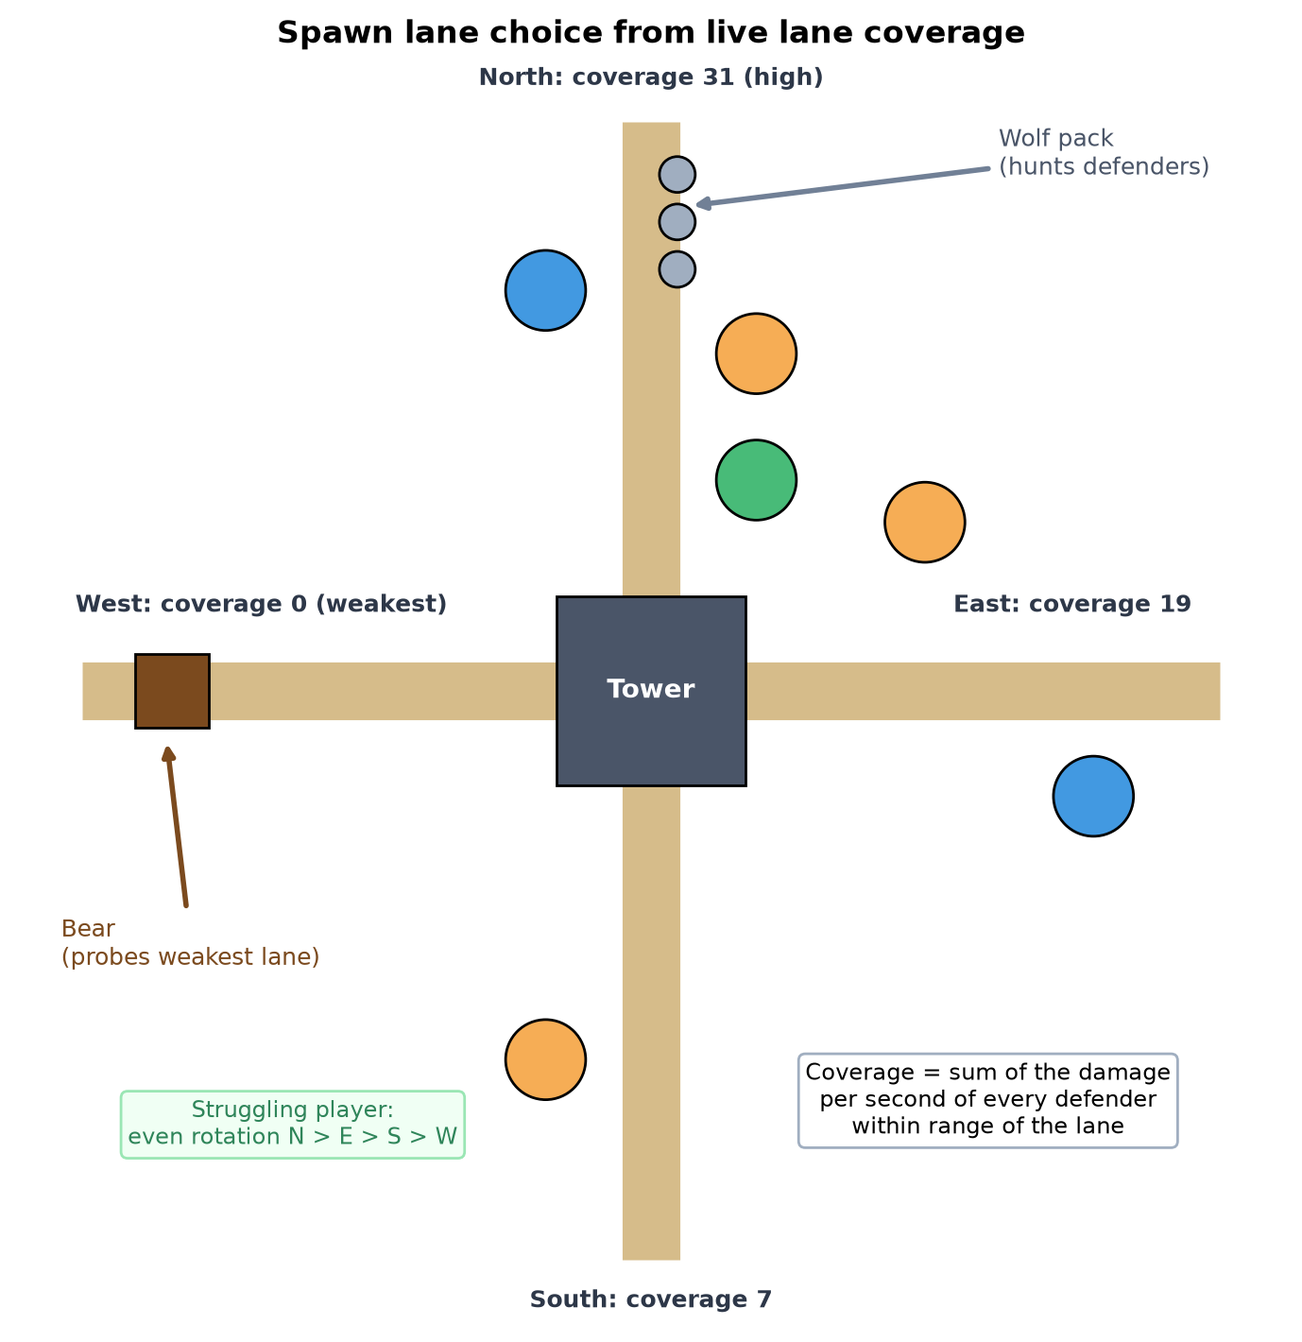
Figure 3: How lane coverage decides where each enemy type enters (Manda, 2026c)

Deciding when to spawn which enemy type
Enemy types are introduced gradually: Basic from wave 1, Wolves from wave 2 and Bears from wave 3, each guaranteed in its first wave. The remaining budget is then spent through weighted random choice, with weights that counter the player's style (Table 1). This follows the idea of an adaptive tower defence wave manager (Hind and Harvey, 2024), but uses readable rules rather than a neural network, so behaviour stays predictable and easy to tune. From wave 3, some enemies spawn as elites whose modifier also counters the player's style. Every wave opens with a Basic enemy, and the random seed combines the map seed with the wave number.

Enemy type weighting by detected play style table
Table 1: Enemy type weighting by detected play style (Manda, 2026d)
Play style the director detects | How the next wave responds | Elite modifier
Defender-heavy (2+ defenders per lane) | More Wolves, which leave the path to hunt defenders | Splitting: breaks into two on death
Long-range focus (40%+ Archers) | More Wolves, whose fast packs outrun slow single shots | Shielded: blocks the first three hits
Area-damage focus (40%+ Bombs) | More Bears, armoured single targets that resist splash damage | Swift: 40% faster
Light defence or tower only | More Bears, which march straight to the tower | Regenerating: heals over time
Struggling (rating below 0.9) | More Basics, even lane rotation, extra loot | Fewer elites
Dominating (rating above 1.1) | Extra Bear weight, enemies target the weakest lane | More elites

Reference list
Guo, Z., Thawonmas, R. and Ren, X., 2024. Rethinking dynamic difficulty adjustment for video game design. Entertainment Computing, [e-journal] 50, 100663. Available at: <https://doi.org/10.1016/j.entcom.2024.100663> [Accessed 2 October 2026].
Hind, D. and Harvey, C., 2024. Using a NEAT approach with curriculums for dynamic content generation in video games. Personal and Ubiquitous Computing, [e-journal]. Available at: <https://doi.org/10.1007/s00779-024-01801-z> [Accessed 2 October 2026].
Manda, H., 2026a. Wave Director loop. [diagram] (Personal Collection). Unpublished.
Manda, H., 2026b. Threat budget per wave for different difficulty ratings. [chart] (Personal Collection). Unpublished.
Manda, H., 2026c. Spawn lane choice from live lane coverage. [diagram] (Personal Collection). Unpublished.
Manda, H., 2026d. Enemy type weighting by detected play style. [table] (Personal Collection). Unpublished.
Manda, H., 2026e. ProceduralGenGade3B (Version part2) [Source code]. Available at: <https://github.com/harrietaleck/ProceduralGenGade3B/tree/part2> [Accessed 2 October 2026].
Mortazavi, F., Moradi, H. and Vahabie, A.-H., 2024. Dynamic difficulty adjustment approaches in video games: a systematic literature review. Multimedia Tools and Applications, [e-journal] 83(35), pp.83227–83274. Available at: <https://doi.org/10.1007/s11042-024-18768-x> [Accessed 2 October 2026].

