THE INDEPENDENT INSTITUTE OF EDUCATION · EMERIS VEGA SCHOOL
GADE7322 · Game Development 3B · Part 3 Portfolio of Evidence
Evolving Blight
A procedurally generated enemy ecosystem that evolves from wave to wave

Individual planning document: custom procedural generation feature
Student | Harriet Manda (st10252836)
Module | GADE7322 Game Development 3B, 2026
Repository | https://github.com/harrietaleck/ProceduralGenGade3B
Branch | part3
Body word count | 493 words (headings, captions, tables, pseudo-code and references excluded)

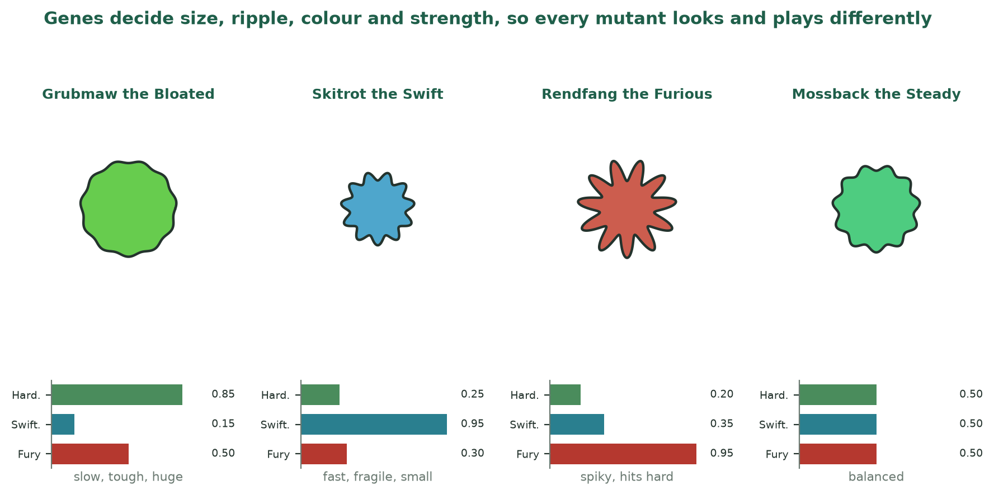

The feature at a glance

Design goal
Replayable variety that always feels fair. Each generation should look and play differently from the last, never exceed its biomass budget, and always be explainable to the player.

Aspect | Decision
Technique | Genetic algorithm: a form of search-based procedural content generation
What is generated | Enemy stats, size, colour, shader motion and a name, all derived from a six-gene genome
When it runs | Once per wave: breed after the wave, hand out genomes as the next wave spawns
What drives selection | How far each enemy travelled along its path before dying (bonus for reaching the tower)
Keeps it fair | Shared biomass budget, capped growth, gene limits and a protected champion
Reproducible | Seeded by the map seed: same map and same play give the same lineages
Where it lives | UEnemyEvolution, FEnemyGenome, AEnemy::ApplyGenome, the Wave Manager and the HUD
How it is checked | Four automated tests plus play-testing across several waves

1 Concept and research basis
Evolving Blight replaces fixed enemy types with a population that evolves while the player plays. Every enemy carries a genome of six genes, and after each wave the enemies that travelled furthest breed the next generation, so the Blight adapts to the player's defence (Figure 1). Evolutionary search is a recognised family of procedural content generation (Maleki and Zhao, 2024; Togelius, et al., 2024). It has generated tower defence waves by scoring candidates on damage to the base and distance walked (Wattanapornprom, et al., 2024), while neural waves left players reporting no discernible difference from human-designed ones (Hind and Harvey, 2024). A genetic algorithm was chosen for readable, testable, tunable rules. Adapting challenge often improves engagement (Mortazavi, Moradi and Vahabie, 2024), yet outcomes are mixed unless it serves a clear design goal (Guo, Thawonmas and Ren, 2024), stated above as fair, replayable variety.
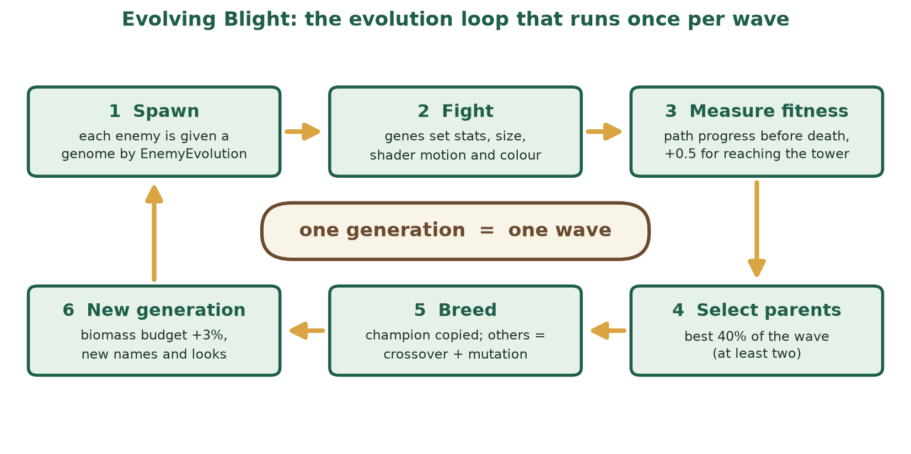
Figure 1: The evolution loop that runs once per wave (Manda, 2026a)

2 The genome and its biomass budget
Six genes lie between 0 and 1. Hardiness, Swiftness and Fury set health, speed and damage and share a biomass budget, so strength in one gene costs the others (Table 1, Figure 2). Girth, Pulse and Hue only change appearance. Every multiplier equals 1.0 at a gene value of 0.5, so an average genome behaves like the original enemy. The budget grows 3% per generation up to a cap, raising pressure gently without creating unbeatable enemies.
Table 1: Genome specification: what each gene does
Gene | Controls | Gameplay effect | Visible as
Hardiness | Health | Max health x (0.5 + Hardiness) | none (a tank looks heavy through Girth)
Swiftness | Speed | Move speed x (0.6 + 0.8 Swiftness) | faster shader ripple
Fury | Damage | Attack damage x (0.5 + Fury) | brighter emissive glow
Girth | Size | Body scale x (0.75 + 0.5 Girth) | bigger or smaller body
Pulse | Ripple | none (looks only) | vertex displacement amplitude 3 to 14 units
Hue | Colour | none (looks only) | type colour rotated by up to 30 degrees

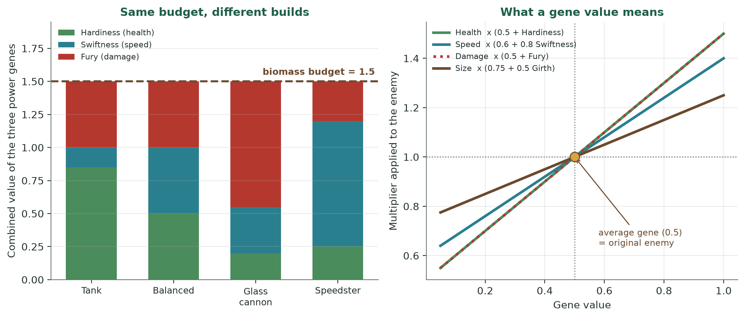
Figure 2: Equal biomass can buy very different builds, and every gene value maps to a clear multiplier (Manda, 2026b)

3 Selection, crossover and mutation
Fitness is path progress before death, plus 0.5 for reaching the tower. A genetic algorithm applies selection, crossover and mutation to a population, and keeping diversity is a recognised concern (Alhijawi and Awajan, 2024). Therefore the best 40% become parents, the champion is copied unchanged, and every other child uses uniform crossover with a 25% chance of mutating each gene (Table 2, Figure 3). Generated enemies should differ yet stay good (Viana, Pereira and Toledo, 2022), so mutation never stops and generation zero is random. Moderate populations performed best in earlier tower defence work, which suits waves of six to fourteen enemies (Wattanapornprom, et al., 2024).
Table 2: Evolution parameters, all editable in the editor without recompiling
Parameter | Value | Reason
Starting biomass | 1.5 | an even 0.5 / 0.5 / 0.5 split of the three power genes
Biomass growth | +3% per generation, capped at 2.1 | rising pressure that can never run away
Fitness | progress 0 to 1, +0.5 if it reached the tower | rewards getting further and finishing the job
Parents | best 40% of the wave, at least two | enough selection pressure while keeping a gene pool
Champion | best enemy copied unchanged | a bad mutation can never lose the best design
Crossover | uniform: each gene from either parent | mixes builds without needing gene order
Mutation | 25% per gene, change of up to 0.15 | steady variety without destroying a good build
Loot | x (0.7 + 0.5 x power rating) | danger pays, so tougher mutants are worth fighting

Pseudo-code for the two moments evolution runs
ON SPAWN (for each enemy):
if first enemy of this generation: genome = champion (unchanged)
else: A, B = two random parents
gene = A.gene or B.gene # uniform crossover
with 25% chance per gene: gene += random(-0.15, +0.15)
if Hardiness + Swiftness + Fury > biomass: scale all three down
name = start(strongest gene) + ending + epithet(second strongest)

ON WAVE END:
fitness = progress + (0.5 if it reached the tower)
sort enemies by fitness; parents = top 40% (at least 2); champion = best
generation += 1; biomass = min(2.1, 1.5 x 1.03 ^ generation)

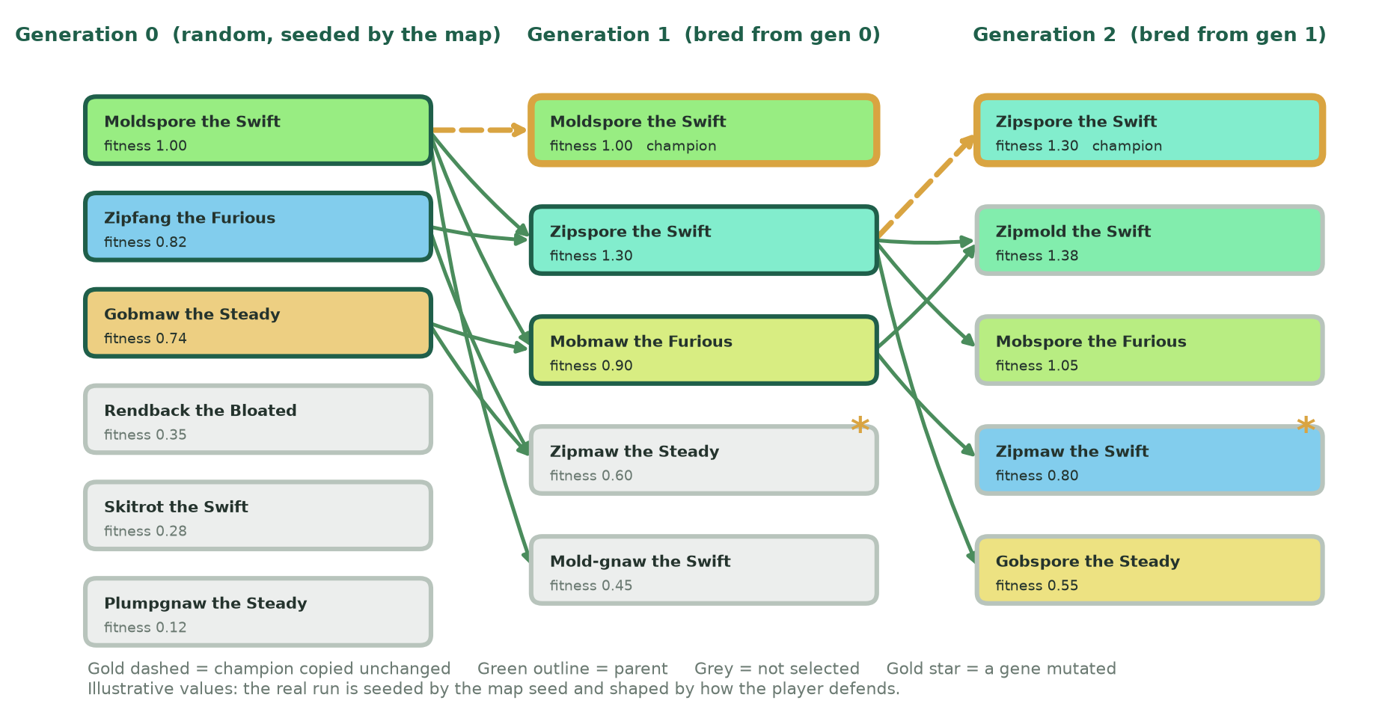
Figure 3: How a lineage develops: the champion survives, parents cross, and mutations add variety (Manda, 2026c)

4 Appearance and player feedback
Genes are made visible. Girth scales the body, while Pulse and Swiftness drive the amplitude and speed of a vertex displacement shader through World Position Offset (Epic Games, [s.a.]). Hue rotates the type colour by up to 30 degrees, so Wolves and Bears stay recognisable (Figure 4). Each genome is named from its two strongest genes, and the HUD announces the generation and champion (Figure 5).
Figure 4: Four example mutants: genes decide size, ripple, colour and strength (Manda, 2026d)
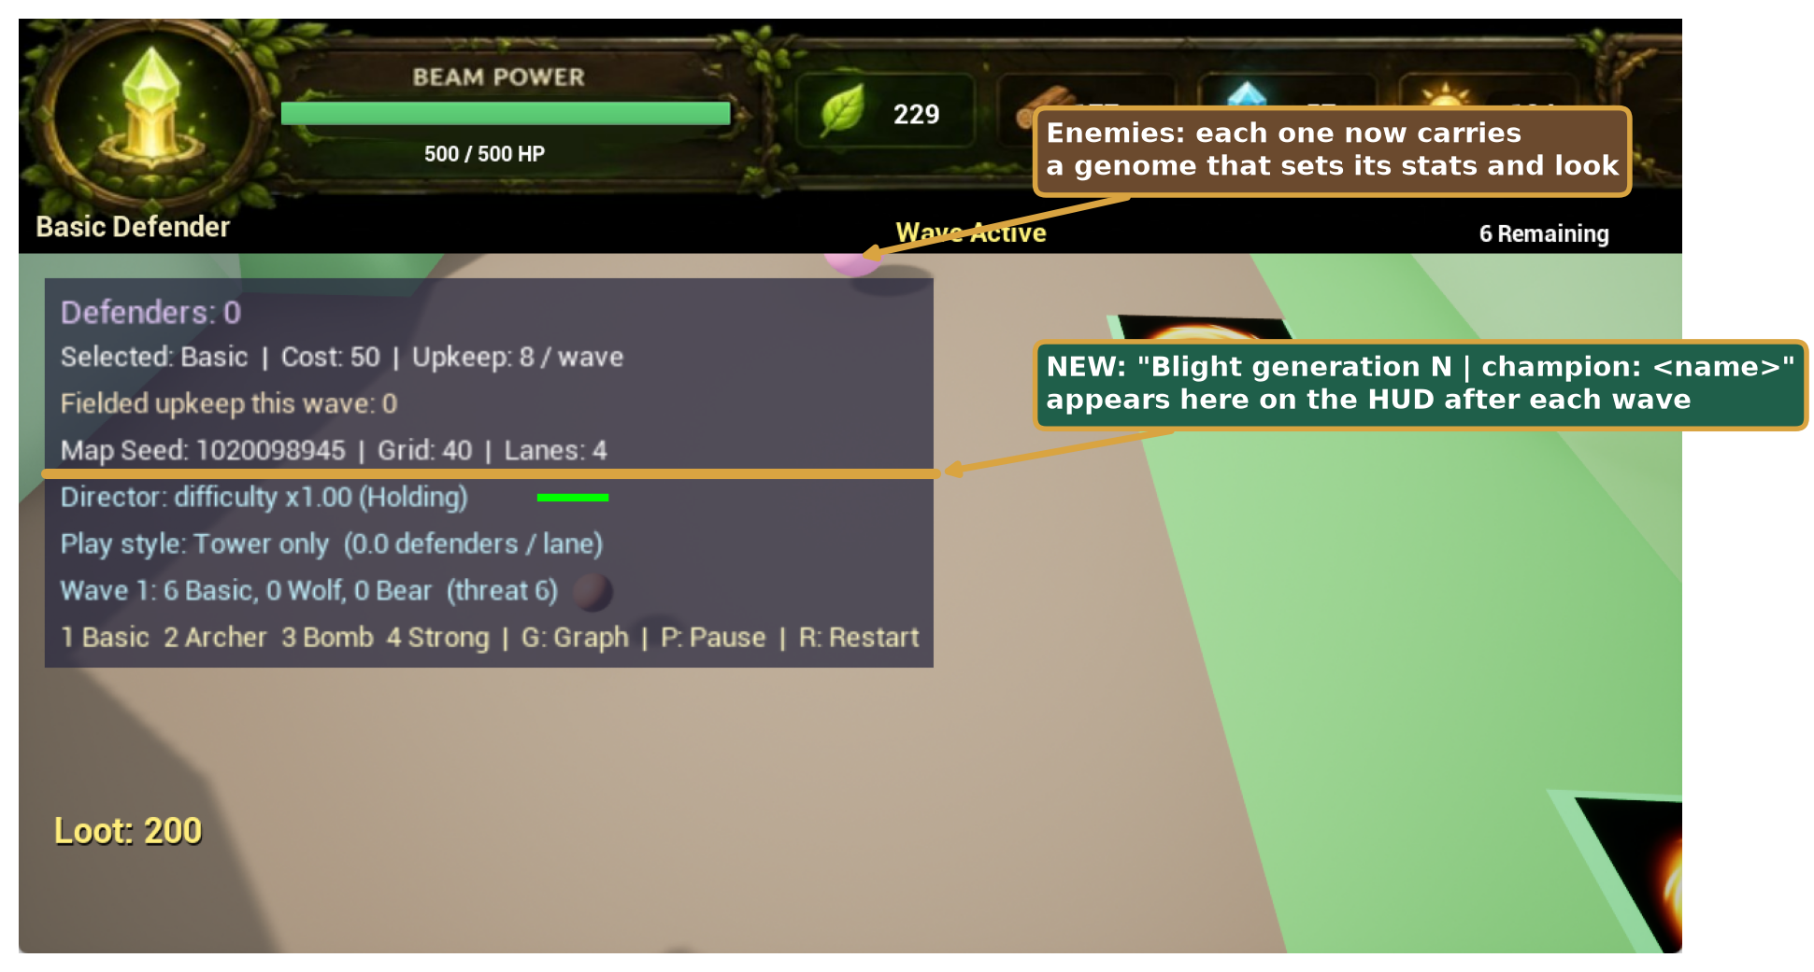
Figure 5: The existing game with the two places the feature will appear (own screenshot, annotated) (Manda, 2026e)

5 Integration, testing and balance
A new EnemyEvolution object sits beside the Wave Director, the Wave Manager requests a genome at every spawn and reports every outcome, and the enemy applies it (Figures 6 and 7). The director's threat budget stays valid because the biomass budget keeps average power stable, and stronger genomes drop more loot. Evolution is seeded by the map seed, so identical maps and play reproduce identical lineages. Four automated tests check budget limits, reproducibility, champion preservation and selection pressure (Table 3), and play-testing judges fairness against the design goal. Table 4 lists risks. Known limit: save files do not store lineages (Manda, 2026h).
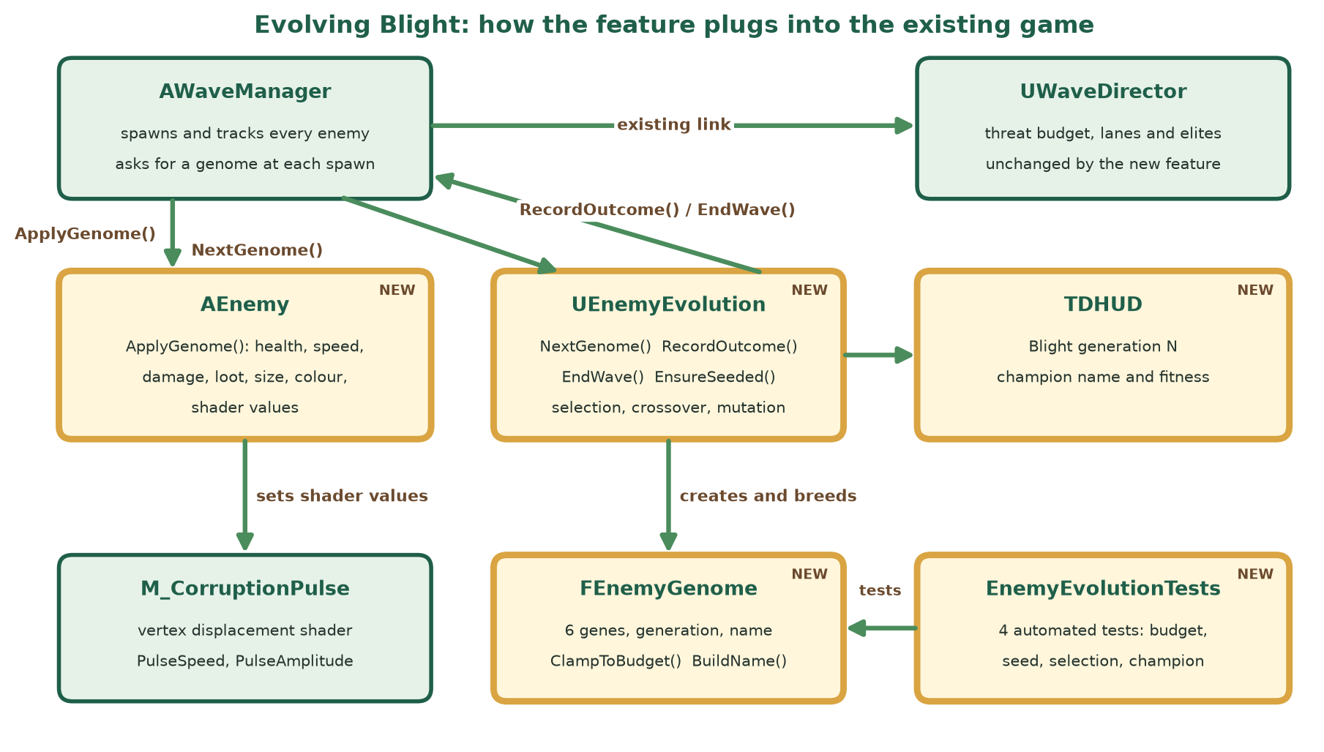
Figure 6: How the feature plugs into the existing code (Manda, 2026f)
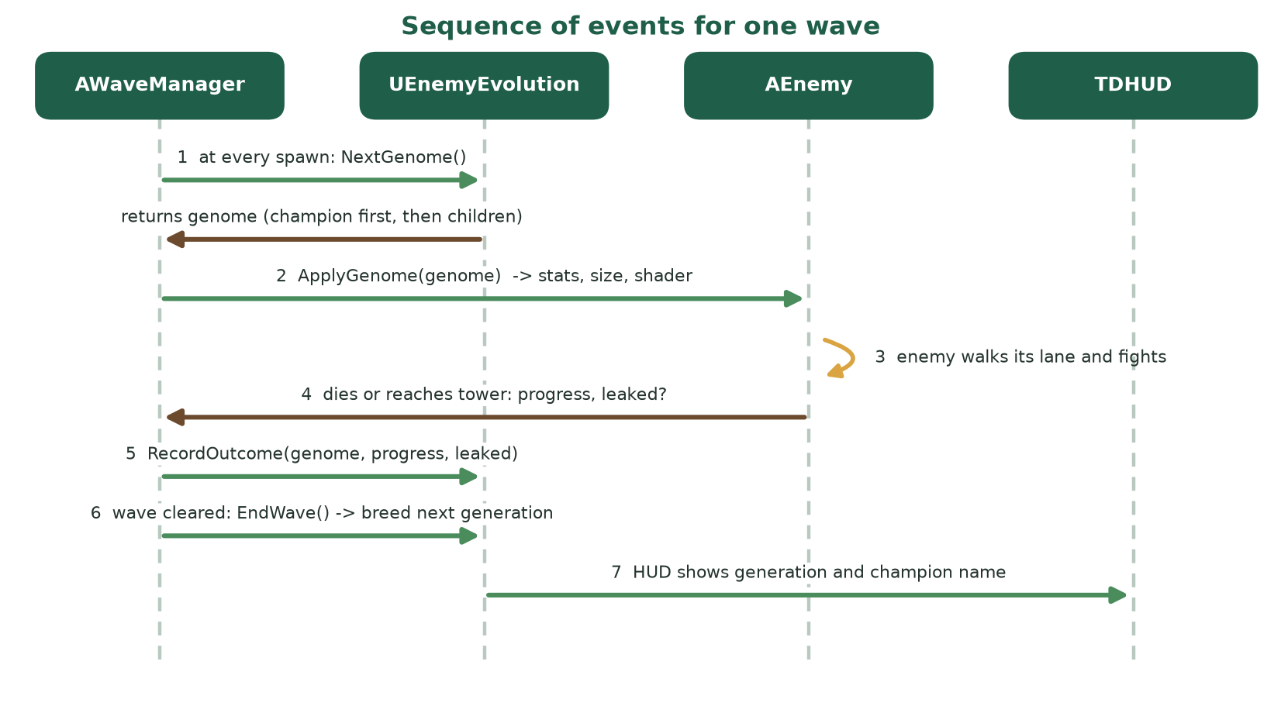
Figure 7: Sequence of events for one wave (Manda, 2026g)
Table 3: Test plan and prototype results
Automated test | What it proves | Pass condition | Prototype result
Genomes respect the biomass budget | no genome can exceed the shared budget | 25 seeds x 12 generations x 14 enemies stay within budget and gene limits | Passed
Same seed gives the same Blight | runs are reproducible and testable | identical genomes for equal seeds, different for different seeds | Passed
Evolution climbs towards what survives | selection really changes the population | mean Swiftness rises by more than 0.08 over 8 generations | Passed: 0.46 to 0.94
Champion survives unchanged | elitism and map reset work | first genome of a generation equals the champion; a new seed resets | Passed

Table 4: Risks and mitigations
Risk | Why it matters | Mitigation
Runaway difficulty | enemies could become unbeatable | shared biomass budget, 2.1 cap, gene limits
Loss of variety | the population could converge on one design | constant mutation, random generation zero, looks-only genes
Unreadable enemy types | players must still tell Wolf from Bear | Hue limited to 30 degrees around the type colour
Feels unfair or random | players need to understand why enemies change | named champion on the HUD, loot scales with danger
Hard to test | random systems hide bugs | seeded randomness and four automated tests
Lineages lost on resume | save files do not store the population | documented limit; a restored match starts a fresh Blight

Reference list
Alhijawi, B. and Awajan, A., 2024. Genetic algorithms: theory, genetic operators, solutions, and applications. Evolutionary Intelligence, [e-journal] 17(3), pp.1245-1256. Available at: <https://doi.org/10.1007/s12065-023-00822-6> [Accessed 6 November 2026].
Epic Games, [s.a.]. Material inputs in Unreal Engine 5.8 documentation. [online] Available at: <https://dev.epicgames.com/documentation/en-us/unreal-engine/material-inputs-in-unreal-engine> [Accessed 6 November 2026].
Guo, Z., Thawonmas, R. and Ren, X., 2024. Rethinking dynamic difficulty adjustment for video game design. Entertainment Computing, [e-journal] 50, p.100663. Available at: <https://doi.org/10.1016/j.entcom.2024.100663> [Accessed 6 November 2026].
Hind, D. and Harvey, C., 2024. Using a NEAT approach with curriculums for dynamic content generation in video games. Personal and Ubiquitous Computing, [e-journal] 28(3-4), pp.629-641. Available at: <https://doi.org/10.1007/s00779-024-01801-z> [Accessed 6 November 2026].
Maleki, M.F. and Zhao, R., 2024. Procedural content generation in games: a survey with insights on emerging LLM integration. Proceedings of the AAAI Conference on Artificial Intelligence and Interactive Digital Entertainment, [e-journal] 20(1), pp.167-178. Available at: <https://doi.org/10.1609/aiide.v20i1.31877> [Accessed 6 November 2026].
Manda, H., 2026a. Evolution loop. [Personal drawing]. [s.l.]: Unpublished.
Manda, H., 2026b. Biomass budget and gene multipliers. [Personal drawing]. [s.l.]: Unpublished.
Manda, H., 2026c. Illustrative lineage over three generations. [Personal drawing]. [s.l.]: Unpublished.
Manda, H., 2026d. Four example mutants. [Personal drawing]. [s.l.]: Unpublished.
Manda, H., 2026e. The existing game with the feature locations marked. [Personal screenshot]. [s.l.]: Unpublished.
Manda, H., 2026f. Architecture of the Evolving Blight feature. [Personal drawing]. [s.l.]: Unpublished.
Manda, H., 2026g. Sequence of events for one wave. [Personal drawing]. [s.l.]: Unpublished.
Manda, H., 2026h. ProceduralGenGade3B (Version part3) [Source code]. Available at: <https://github.com/harrietaleck/ProceduralGenGade3B/tree/part3> [Accessed 6 November 2026].
Mortazavi, F., Moradi, H. and Vahabie, A.-H., 2024. Dynamic difficulty adjustment approaches in video games: a systematic literature review. Multimedia Tools and Applications, [e-journal] 83(35), pp.83227-83274. Available at: <https://doi.org/10.1007/s11042-024-18768-x> [Accessed 6 November 2026].
Togelius, J., Khalifa, A., Earle, S., Green, M.C. and Soros, L., 2024. Evolutionary machine learning and games. In: W. Banzhaf, P. Machado and M. Zhang, eds. Handbook of evolutionary machine learning. Singapore: Springer, pp.715-737. Available at: <https://doi.org/10.1007/978-981-99-3814-8_25> [Accessed 6 November 2026].
Viana, B.M.F., Pereira, L.T. and Toledo, C.F.M., 2022. Illuminating the space of enemies through MAP-Elites. 2022 IEEE Conference on Games (CoG). Beijing, China, 21-24 August 2022. Piscataway, NJ: IEEE, pp.17-24. Available at: <https://doi.org/10.1109/CoG51982.2022.9893621> [Accessed 6 November 2026].
Wattanapornprom, W., Satsuk, C., Sirisakornsakul, T., Jamornthawuch, T., Rodkaew, Y. and Susutti, W., 2024. Automating tower defense game level design with evolutionary algorithms. 2024 28th International Computer Science and Engineering Conference (ICSEC). Khon Kaen, Thailand, 6-8 November 2024. Piscataway, NJ: IEEE, pp.1-6. Available at: <https://doi.org/10.1109/ICSEC62781.2024.10770629> [Accessed 6 November 2026].

