-- 632525 任务 11~13点任务超时完成

2023-06-17 13点：

202306171300-00000632525

application_1684325517623_11489072

-、Tasks:112801

-、Input Size / Records: 3.3 TiB / 1282261603

-、Shuffle Write Size / Records: 12.2 GiB / 150035717

-、Task Deserialization Time ： max 30min median:4ms

2023-06-16 13点：

202306161300-00000632525

application_1684325517623_11172901

-、Tasks:109731

-、Input Size / Records: 3.1 TiB / 1209131114

-、Shuffle Write Size / Records: 16.7 GiB / 216160625

-、Task Deserialization Time ： max 9s median:5ms

**2023-06-17 13点：**

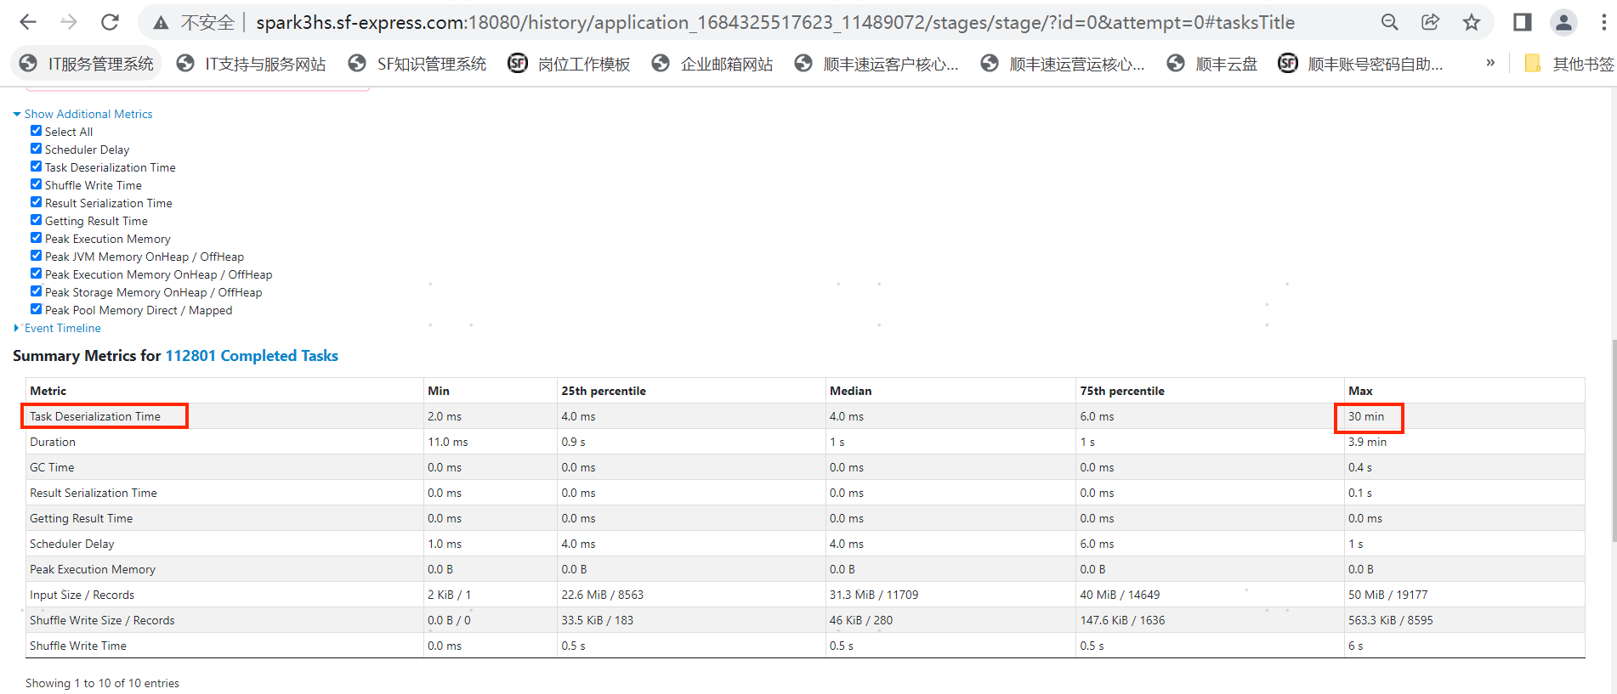

**2023-06-16 13点：**

