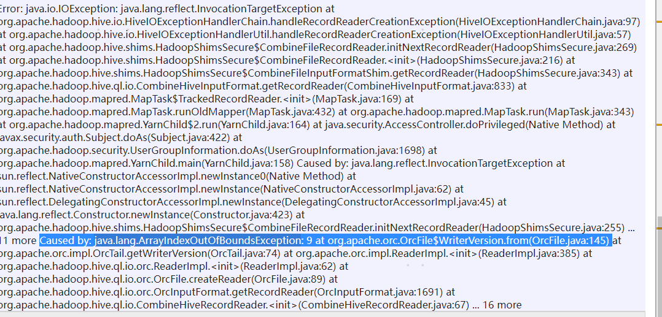

Error: java.io.IOException: java.lang.reflect.InvocationTargetException at org.apache.hadoop.hive.io.HiveIOExceptionHandlerChain.handleRecordReaderCreationException(HiveIOExceptionHandlerChain.java:97) at org.apache.hadoop.hive.io.HiveIOExceptionHandlerUtil.handleRecordReaderCreationException(HiveIOExceptionHandlerUtil.java:57) at org.apache.hadoop.hive.shims.HadoopShimsSecure$CombineFileRecordReader.initNextRecordReader(HadoopShimsSecure.java:269) at org.apache.hadoop.hive.shims.HadoopShimsSecure$CombineFileRecordReader.<init>(HadoopShimsSecure.java:216) at org.apache.hadoop.hive.shims.HadoopShimsSecure$CombineFileInputFormatShim.getRecordReader(HadoopShimsSecure.java:343) at org.apache.hadoop.hive.ql.io.CombineHiveInputFormat.getRecordReader(CombineHiveInputFormat.java:833) at org.apache.hadoop.mapred.MapTask$TrackedRecordReader.<init>(MapTask.java:169) at org.apache.hadoop.mapred.MapTask.runOldMapper(MapTask.java:432) at org.apache.hadoop.mapred.MapTask.run(MapTask.java:343) at org.apache.hadoop.mapred.YarnChild$2.run(YarnChild.java:164) at java.security.AccessController.doPrivileged(Native Method) at javax.security.auth.Subject.doAs(Subject.java:422) at org.apache.hadoop.security.UserGroupInformation.doAs(UserGroupInformation.java:1698) at org.apache.hadoop.mapred.YarnChild.main(YarnChild.java:158) Caused by: java.lang.reflect.InvocationTargetException at sun.reflect.NativeConstructorAccessorImpl.newInstance0(Native Method) at sun.reflect.NativeConstructorAccessorImpl.newInstance(NativeConstructorAccessorImpl.java:62) at sun.reflect.DelegatingConstructorAccessorImpl.newInstance(DelegatingConstructorAccessorImpl.java:45) at java.lang.reflect.Constructor.newInstance(Constructor.java:423) at org.apache.hadoop.hive.shims.HadoopShimsSecure$CombineFileRecordReader.initNextRecordReader(HadoopShimsSecure.java:255) ... 11 more Caused by: java.lang.ArrayIndexOutOfBoundsException: 9 at org.apache.orc.OrcFile$WriterVersion.from(OrcFile.java:145) at org.apache.orc.impl.OrcTail.getWriterVersion(OrcTail.java:74) at org.apache.orc.impl.ReaderImpl.<init>(ReaderImpl.java:385) at org.apache.hadoop.hive.ql.io.orc.ReaderImpl.<init>(ReaderImpl.java:62) at org.apache.hadoop.hive.ql.io.orc.OrcFile.createReader(OrcFile.java:89) at org.apache.hadoop.hive.ql.io.orc.OrcInputFormat.getRecordReader(OrcInputFormat.java:1691) at org.apache.hadoop.hive.ql.io.CombineHiveRecordReader.<init>(CombineHiveRecordReader.java:67) ... 16 more

**解决：**

https://www.jianshu.com/p/2f77cf00b53c