Hao Chen

Udacity Artificial Intelligence

Heuristic Analysis

Custom_score 1 is similar to the Improved_score where it outputs a score equal to the difference in the number of moves available to the two players. However, if your available move is 2 more than your opponents available moves, you start to chase after your opponent, having a heuristic formula own_moves-2*opp_moves.

Custom_score 2 is also a score based implementation of heuristics. Since each corner moves are less desirable than the center moves, each player’s score is calculated by 2 times its available center moves plus 1 times its available corner move. Then we return the score difference between the two players.

Custom_score 3 is a combination of custom_score 1 + custom_score 2. Each player’s score is calculated by 2 times its available center moves plus 1 times its available corner move. In addition, if the player’s available moves are 2 more than the opponent’s moves, then the player can start chasing after the opponent, returning a heuristic formula own_moves-2*opp_moves.

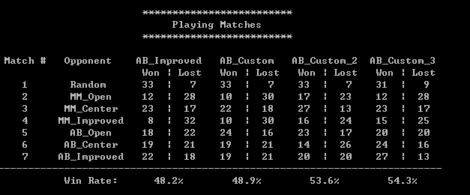

By increasing the number of matches to 20 and running the tournaments.py, I concluded that heuristic 3 outperformed Improved_score and worked the best. By comparing my result with ones on the forum, I see that my laptop’s CPU is also slower than the average, causing a ~50% win ratio for Improved_score. Lastly, the only way to really know the best evaluation function is to try lots of variances in them and see which one works the best.