Hao Chen

Udacity Artificial Intelligence

Heuristic Analysis

There are several optimal plans for problems 1 to 3. As an example shown below, the optimal plan lengths for problem 1, 2, 3 are 6,9,12 actions respectively.

Problem1: Problem2: Problem3:

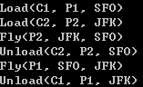 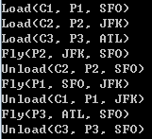 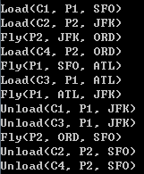

Next, I compare and contrast non-heuristic search result metrics (optimality, time elapsed, number of node expansions) for Problems 1, 2, and 3. The searches I analyzed are breadth first search, depth first search, and uniformed cost search. Detail performances are shown below.

Problem1:

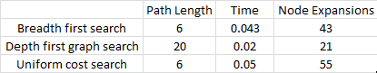

Problem2:

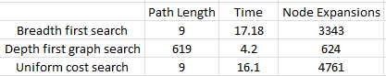

Problem 3:

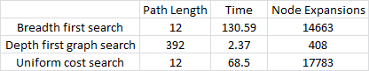

Lastly, I compared and contrast heuristic search result metrics using A\* with the "ignore preconditions" and "level-sum" heuristics for Problems 1, 2, and 3.

Problem1:



Problem2:



Problem3:



In conclusion, for non-heuristic search planning, breadth first search and uniform cost search yield an optimal action plan. However, depth first graph search is the fastest and uses the least memory (node expansions). For heuristic search planning, both heuristics yield to an optimal action. A\* search with ignore precondition heuristic is faster. On the other hand, A\* search with level sum heuristic uses the least amount of memory. By comparing all the heuristics, we see that A\* search with ignore precondition would be the best solution for the air cargo problem.

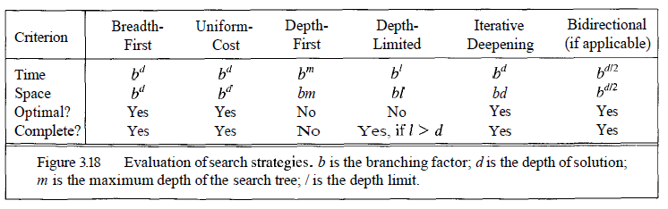[1]

[1] Artifical Intellegence: A Modern Approach. S. Russel. P. Norvig. Chapter 3: Solving problems by searching