SHRI GOVINDRAM SEKSARIA INSTITUTE OF TECHNOLOGY & SCIENCE , INDORE


DEPARTMENT OF INFORMATION TECHNOLOGY

Minor Project Report

On

GlucoAI Monitor — AI-Based Non-Invasive Glucose Monitoring System
Supervised by:  [ Assistant Professor]  [Information Technology] | Submitted by:  Name-Dilpreet Singh Gill  Enrollment No.-0801IT231045  [Information Technology]
Co-Supervised by:  [ Assistant Professor]]  [Information Technology] | Name-Harish Gupta  Enrollment No.-0801IT231050  [Information Technology]
Name-Hemant Dixit
Enrollment No.-0801IT231056
[Information Technology]

SHRI GOVINDRAM SEKSARIA INSTITUTE OF TECHNOLOGY & SCIENCE , INDORE
DEPARTMENT OF INFORMATION TECHNOLOGY

RECOMMENDATION
We are pleased to recommend that the Minor Project Report entitled “GlucoAI Monitor — AI-Based Non-Invasive Glucose Monitoring System” submitted by Dilpreet Singh Gill,Harish Gupta,Hemant Dixit be accepted in partial fulfilment of the requirements for the award of the degree of Bachelor of Technology in Information Technology of Rajiv Gandhi Proudyogiki Vishwavidyalaya (RGPV), Bhopal (M.P.), during the academic session 2026.
 | [Prof. K. K. Sharma]
[Assistant Professor] | [Head of Department]  [Professor]
[Information Technology] | [Information Technology]

SHRI GOVINDRAM SEKSARIA INSTITUTE OF TECHNOLOGY & SCIENCE , INDORE
DEPARTMENT OF INFORMATION TECHNOLOGY]

CERTIFICATE
This is to certify that the Minor Project entitled “GlucoAI Monitor — AI-Based Non-Invasive Glucose Monitoring System” submitted by [Student’s Name] is a bonafide work carried out under my supervision and is being submitted in partial fulfilment of the requirements for the award of the degree of Bachelor of Technology in Information Technology of Rajiv Gandhi Proudyogiki Vishwavidyalaya (RGPV), Bhopal, during the academic session 2026–2027 has been examined and evaluated by us. The report is found to be satisfactory and meets the academic requirements prescribed by the institution.
Internal Examiner | External Examiner
Date: | Date:

DECLARATION
I, Dilpreet Singh Gill, Harish Gupta, Hemant Dixit, an undergraduate student in the Department of Information Technology, S.G.S.I.T.S., Indore (M.P.), hereby declare that the Minor Project titled “GlucoAI Monitor — AI-Based Non-Invasive Glucose Monitoring System” is my original work, carried out under the supervision of Sonu Airen, Assistant Professor, Department of Information Technology, S.G.S.I.T.S., Indore (M.P.).
I further declare that, to the best of my knowledge, this dissertation does not contain any material previously submitted for the award of any degree or diploma in this or any other university. Any sources of information used have been properly acknowledged and cited.

Signature of the candidate:
Name of the candidate: Dilpreet Singh Gill
Enrolment No.: 0801IT231045

Signature of the candidate:
Name of the candidate: Harish Gupta
Enrolment No.: 0801IT231050

Signature of the candidate:
Name of the candidate: Hemant Dixit
Enrolment No.: 0801IT231056

ACKNOWLEDGEMENT

We would like to express our sincere gratitude to our guide, Sonu Airen, Professor, for his valuable guidance, continuous support, and encouragement throughout the completion of this project.
We are also thankful to the Head of the Department, Prof. K. K. Sharma, for providing the necessary facilities and support to carry out this work.
We extend our heartfelt thanks to the Dean (ARSD), Prof. Lalit Purohit, for his encouragement and institutional support.
Finally, we are grateful to the faculty members and technical staff of the Department of Information Technology, S.G.S.I.T.S., Indore, for their support and cooperation.

Signature
[………….]
[……………]
Signature
[………….]
[……………]
Signature
[………….]
[……………]

ABSTRACT

This project presents an innovative approach to non-invasive glucose monitoring using Artificial Intelligence and Computer Vision techniques. Traditional glucose measurement methods require invasive procedures such as finger-prick tests, which can be uncomfortable, painful, and inconvenient for users — particularly for diabetic patients who must monitor their levels multiple times per day. The proposed system, GlucoAI Monitor, eliminates this requirement by analyzing facial/fingertip video data to estimate blood glucose levels through optical sensing.
The system captures a short video of the user’s fingertip (placed on the smartphone camera with flash on) and processes it to extract Photoplethysmographic (PPG) signals, which represent subtle variations in skin color caused by pulsatile blood flow through peripheral capillaries. These PPG signals encode physiological information about cardiac activity, vascular tone, and blood composition — all of which correlate with blood glucose concentration.
The extracted raw signal undergoes a multi-stage preprocessing pipeline: 1. Motion artifact removal using high-pass filtering at 0.3 Hz 2. Adaptive bandpass filtering (0.7–3.5 Hz) using Chebyshev Type II filters with automatic frequency adaptation based on spectral analysis 3. Savitzky-Golay smoothing for noise reduction while preserving peak morphology 4. Z-score normalization for standardization
The processed signal is then analyzed to extract 28 comprehensive features across six categories: statistical, peak-based, energy, frequency-domain, morphological, and nonlinear features. These features, along with the raw signal waveform, are passed into a Multi-Scale CNN + Bidirectional LSTM + Self-Attention deep learning model trained on time-series data to predict glucose levels.
The application is implemented using a modern web-based interface built with React (Vite) for the frontend and a Flask backend for video processing and model inference. The system includes user authentication with SQLite database, real-time PPG waveform visualization, glucose and heart rate estimation with confidence scoring, and prediction history tracking.
The final model achieves a Mean Absolute Error (MAE) of ~5 mg/dL and an R² score of 0.957 on the experimental dataset, demonstrating the potential of combining AI and healthcare technologies to create a non-invasive, user-friendly, and scalable glucose monitoring solution.

Table of Contents

S.No. | Description | Page No.
 | Certificate | 2
 | Declaration | 3
 | Acknowledgement | 4
 | Abstract | 5-6
1. | Chapter 1: Introduction  1.1 Background  1.2 Problem Statement  1.3 Objectives  1.4 Scope | 10-12
2. | Chapter 2: Literature Review | 13-15
3. | Chapter 3: Methodology  3.1 Dataset Description  3.2 Data Preprocessing  3.3 Model Selection  3.4 Algorithms Used  3.5 System Workflow | 16-22
4. | Chapter 4: System Design  4.1 Architecture Diagram  4.2 Data Flow  4.3 Tools & Technologies | 23-27
5. | Chapter 5: Implementation  5.1 Model Training  5.2 Testing Process  5.3 Screenshots / Outputs | 28-35
6. | Chapter 6: Results & Analysis  6.1 Performance Metrics (Accuracy, Precision, Recall)  6.2 Graphs & Evaluation | 36-39
7. | Chapter 7: Conclusion & Future Scope | 40-42
 | References | 43
 | Appendix | 44-47

List of Figures
Figure No. | Title | Page No.
Figure 3.1 | Data Preprocessing Pipeline Flowchart | 18
Figure 3.2 | LSTM Architecture Diagram | 21
Figure 3.3 | System Workflow | 22
Figure 4.1 | System Architecture Diagram | 23
Figure 4.2 | DFD Level 0 — Context Diagram | 24
Figure 4.3 | DFD Level 1 | 24
Figure 4.4 | DFD Level 2 — Video Processing & Prediction | 25
Figure 4.5 | Entity-Relationship (ER) Diagram | 26
Figure 5.1 | Training Process Flow | 30
Figure 5.2 | GlucoAI Monitor Landing Page | 31
Figure 5.3 | User Authentication Page (Login/Signup) | 32
Figure 5.4 | Dashboard with Video Upload Panel | 33
Figure 5.5 | Video Processing Progress Indicator | 33
Figure 5.6 | Prediction Results — Glucose Level and Heart Rate | 34
Figure 5.7 | PPG Signal Visualization with Peak Detection | 34
Figure 5.8 | Prediction History Panel | 35
Figure 6.1 | Model Accuracy Progression | 38
Figure 6.2 | R² Score Progression | 38

List of Tables
Table No. | Title | Page No.
Table 1.1 | Problem Statement Analysis | 11
Table 3.1 | Dataset Description | 16
Table 3.2 | Model Comparison Table | 18–19
Table 3.3 | Feature Engineering (28 Features) | 20
Table 4.1 | Tools & Technologies | 27
Table 5.1 | Training Configuration | 28
Table 5.2 | Data Augmentation Strategy | 28
Table 5.3 | Signal Quality Assessment Criteria | 30
Table 5.4 | Testing Conditions | 31
Table 6.1 | Model Performance Metrics (V3 vs V4) | 36
Table 6.2 | Comprehensive Model Comparison | 36–37
Table 6.3 | Heart Rate Estimation Accuracy | 37
Table 6.4 | Feature Category Contribution | 39
Table 7.1 | Future Scope | 41
Table A.1 | API Endpoints | 45
Table A.2 | Model Architecture Summary | 45–46
Table A.3 | Signal Quality Assessment Levels | 47
Table A.4 | Glucose Classification Reference | 47

CHAPTER 1. INTRODUCTION | 2026

CHAPTER 1
INTRODUCTION

1.1 Background
Diabetes mellitus is one of the most prevalent chronic metabolic disorders affecting millions of people worldwide. According to the International Diabetes Federation (IDF), approximately 537 million adults (aged 20–79) were living with diabetes globally in 2021, and this number is projected to rise to 783 million by 2045. In India alone, over 77 million people are estimated to have diabetes, making it the “diabetes capital of the world.”
Effective management of diabetes requires frequent monitoring of blood glucose levels — often multiple times daily for individuals on insulin therapy. The current gold standard for self-monitoring involves finger-prick capillary blood glucose testing, where a small lancet punctures the fingertip to draw a blood sample, which is then analyzed by a portable glucometer. While accurate, this method has several significant drawbacks:
- Pain and discomfort: Repeated finger pricks cause soreness, calluses, and reduced sensitivity in fingertips over time.
- Infection risk: Each puncture creates an open wound, introducing potential infection pathways.
- Compliance issues: Due to pain and inconvenience, many patients skip glucose measurements, leading to poor disease management.
- Consumable costs: Test strips are expensive, costing patients significant amounts annually.
With rapid advancements in Artificial Intelligence (AI), Deep Learning, and Computer Vision, it is now possible to explore entirely non-invasive alternatives for glucose estimation. Photoplethysmography (PPG) — the optical technique of detecting volumetric changes in blood in peripheral circulation — has emerged as a promising modality. PPG signals can be captured simply by pressing a finger against a smartphone camera, making the technique accessible to anyone with a mobile device.
This project, GlucoAI Monitor, leverages PPG signal analysis combined with advanced deep learning architectures (Multi-Scale CNN + Bidirectional LSTM with Attention) to predict blood glucose levels from short video recordings — completely non-invasively.
1.2 Problem Statement
Existing glucose monitoring systems present several challenges that limit their effectiveness and adoption:
Table 1.1 : Problem Statement Analysis
Problem | Description
Invasive & Painful | Conventional finger-prick tests require blood samples, causing pain, skin damage, and reduced compliance
Expensive | Continuous Glucose Monitors (CGMs) cost ₹5,000–₹15,000 per sensor, test strips cost ₹15–₹50 each
Inconvenient | Carrying lancets, test strips, and glucometers; finding hygienic testing conditions
Infection Risk | Each finger prick creates an open wound susceptible to infection
Low Compliance | Due to the above factors, patients often skip measurements, leading to poor diabetes management
Not Scalable | Mass screening programs are impractical with invasive methods
There is a critical need for a non-invasive, affordable, smartphone-based glucose monitoring solution that can democratize glucose monitoring and improve patient compliance.
1.3 Objectives
The primary objectives of this project are:
- Develop a non-invasive glucose monitoring system that uses smartphone camera video to estimate blood glucose levels without any blood sample.
- Extract PPG (Photoplethysmographic) signals from fingertip video recordings using computer vision and image processing techniques.
- Implement advanced signal processing including motion artifact removal, adaptive bandpass filtering, and signal quality assessment.
- Design and train a deep learning model (Multi-Scale CNN + Bidirectional LSTM + Self-Attention) to predict glucose levels from extracted PPG features.
- Build a full-stack web application with React frontend and Flask backend providing user authentication, video upload, real-time results, and history tracking.
- Provide real-time visualization of PPG waveforms, glucose levels, heart rate, and confidence scores.
- Achieve clinically meaningful accuracy with MAE < 15 mg/dL for experimental predictions.
1.4 Scope
The scope of this project extends across multiple domains and applications:
- Healthcare Monitoring: Primary use as a supplementary glucose monitoring tool for diabetic patients between traditional measurements.
- Preventive Health Screening: Enabling mass screening for pre-diabetes in resource-limited settings using only a smartphone.
- Wearable Technology Integration: The PPG extraction and AI inference pipeline can be adapted for integration with smartwatches and fitness bands that have optical heart rate sensors.
- Remote Patient Monitoring (RPM): Enabling telemedicine applications where patients can share glucose estimates with their physicians remotely.
- Research Platform: Serving as a research framework for further studies on non-invasive biomarker estimation from optical signals.
- Mobile Health (mHealth): Future migration to a native mobile application for iOS and Android platforms.
Disclaimer: This system is an experimental research prototype. It is NOT a certified medical device and should NOT be used for clinical decision-making. Always consult a healthcare professional and use a certified glucometer for accurate readings.

CHAPTER 2: LITERATURE REVIEW

Non-invasive glucose monitoring has been an active area of research for over two decades. This chapter reviews the key literature that forms the foundation of this project.
2.1 Photoplethysmography (PPG) for Physiological Monitoring
Photoplethysmography is a simple, low-cost optical technique that measures volumetric changes in blood in peripheral circulation. Allen (2007) provided a comprehensive review of PPG, describing its physiological basis: light from an LED or camera flash penetrates the skin, and the varying absorption by pulsating arterial blood creates a characteristic waveform. The AC component of this waveform corresponds to cardiac-synchronous changes, while the DC component reflects tissue absorption and venous blood.
PPG has been extensively validated for: - Heart rate monitoring (accuracy > 95% compared to ECG) — Elgendi (2012) - SpO₂ estimation (pulse oximetry) — Nitzan et al. (2014) - Blood pressure estimation — Kachuee et al. (2017) - Respiratory rate detection — Charlton et al. (2016)
2.2 Smartphone-Based PPG Extraction
The concept of using a smartphone camera for PPG was pioneered by Jonathan & Leahy (2010), who demonstrated that placing a fingertip over the rear camera with the flash on produces a high-quality PPG signal. Subsequent studies have shown:
- The green channel provides the strongest PPG signal from fingertip recordings (Verkruysse et al., 2008)
- Skin-tone adaptive ROI detection using HSV color-space masking improves signal quality across diverse skin types (Bousefsaf et al., 2013)
- Adaptive bandpass filtering (0.7–3.5 Hz) preserves cardiac components while removing respiratory and motion artifacts (Poh et al., 2011)

2.3 Deep Learning for Time-Series Physiological Signals
Deep learning has shown remarkable success in analyzing physiological time-series data:
Study | Model | Application | Key Finding
Rajkomar et al. (2018) | LSTM + Attention | Clinical predictions | Attention mechanism improves interpretability and accuracy
Hannun et al. (2019) | 1D-CNN + BiLSTM | ECG arrhythmia detection | Deep learning achieves cardiologist-level accuracy
Avram et al. (2019) | CNN | PPG-based AFib detection | Smartphone PPG can detect atrial fibrillation
Monte-Moreno (2011) | SVM + Neural Network | PPG glucose estimation | First demonstration of PPG-glucose correlation with ML
Zhang et al. (2020) | LSTM | Non-invasive glucose | LSTM outperforms traditional ML for PPG-based glucose

2.4 PPG-Based Glucose Prediction — Current State
Glucose prediction from PPG signals remains an emerging research area with significant challenges:
- Weak signal correlation: Unlike heart rate (directly encoded in PPG periodicity), glucose effects on PPG are subtle — primarily affecting pulse wave velocity, amplitude variations, and spectral characteristics.
- Individual variability: PPG-glucose correlations vary significantly between individuals due to skin thickness, pigmentation, and vascular anatomy.
- Limited datasets: Most studies use small datasets (< 100 subjects), making generalization difficult.
Key studies in this area include:
- Hossain et al. (2019): Used Random Forest and SVM on PPG features, achieving MAE of 15–20 mg/dL on a 50-subject dataset.
- Rachim & Chung (2019): Combined near-infrared (NIR) spectroscopy with PPG using dual-wavelength sensors, achieving MAE of 12 mg/dL.
- Zhang et al. (2020): Applied LSTM on PPG time-series features, achieving MAE of 10–15 mg/dL with improved temporal modeling.
- Our approach (GlucoAI Monitor): Multi-Scale CNN + Bidirectional LSTM + Self-Attention with 28 engineered features, achieving MAE of ~5 mg/dL on the experimental dataset.
2.5 Research Gap
Despite promising results, several gaps exist in the current literature:
- Lack of end-to-end systems: Most studies focus on algorithm development without providing complete, usable applications.
- Limited feature engineering: Many approaches use only basic statistical features, missing frequency-domain, morphological, and nonlinear features that encode vascular information.
- No attention mechanism: Existing LSTM models for PPG-glucose prediction lack attention mechanisms that can learn which temporal segments are most informative.
- No multi-scale analysis: Single-kernel CNNs miss temporal patterns at different granularities.
This project addresses these gaps by providing a complete end-to-end system with advanced feature engineering (28 features), multi-scale temporal analysis, and an attention-augmented architecture.

CHAPTER 3: METHODOLOGY

3.1 Dataset Description
The system uses PPG signal data extracted from fingertip video recordings:
Table 3.1 : Dataset Description
Parameter | Details
Data Source | Fingertip video recordings (smartphone camera + flash)
Original Samples | 16 video recordings with paired glucose readings
Augmented Samples | 144 (8× augmentation per original sample)
Signal Length | 120 frames (standardized)
Sampling Rate | 30 FPS (auto-detected, high-FPS videos downsampled)
Features Extracted | 28 extended features per sample
Target Variable | Blood glucose level (mg/dL)
The dataset includes recordings taken under varying conditions: - Different lighting environments - Various skin tones - Different finger pressures - Varying glucose levels (fasting and post-prandial)
3.2 Data Preprocessing
The data preprocessing pipeline is a critical component that transforms raw video into analysis-ready PPG signals. The pipeline consists of six stages:
Stage 1: Frame Extraction
- Video is opened using OpenCV VideoCapture
- FPS is auto-detected from video metadata
- For high-FPS videos (> 45 FPS), frames are subsampled to ~30 FPS to maintain consistency with the training pipeline
- Frames are stored as BGR numpy arrays
Stage 2: PPG Signal Extraction
- Skin-tone ROI detection using HSV color-space masking:
  - HSV range 1: H[0–25], S[30–255], V[60–255]
  - HSV range 2: H[160–180], S[30–255], V[60–255]
  - Morphological cleanup (close + open) with 7×7 elliptical kernel
- Green channel extraction: The green channel provides the strongest PPG signal
- If skin detection fails for > 30% of frames, falls back to center ROI (50% of frame area)
- Output: Mean green intensity per frame → raw PPG signal
Stage 3: Motion Artifact Removal
- 2nd-order Butterworth high-pass filter at 0.3 Hz cutoff
- Removes low-frequency baseline wander caused by finger movement
- Applied using scipy.signal.filtfilt for zero-phase distortion
Stage 4: Adaptive Bandpass Filtering
- Spectral analysis using Welch’s method to find dominant cardiac frequency
- Adaptive filter bounds: dominant frequency ± [0.8 Hz below, 1.2 Hz above]
- 4th-order Chebyshev Type II bandpass filter with 40 dB stopband attenuation
- Falls back to standard Butterworth if Chebyshev fails
- Cardiac band: 0.7–3.5 Hz (42–210 BPM)
Stage 5: Signal Smoothing
- Savitzky-Golay filter (window=11, polynomial order=3)
- Preserves peak morphology (systolic peaks, dicrotic notches) unlike moving average
- Falls back to simple moving average for very short signals
Stage 6: Z-Score Normalization
- Zero-mean, unit-variance normalization: (x - μ) / σ
- Numerical stability: handles near-zero standard deviation

Data Preprocessing Pipeline Flowchart

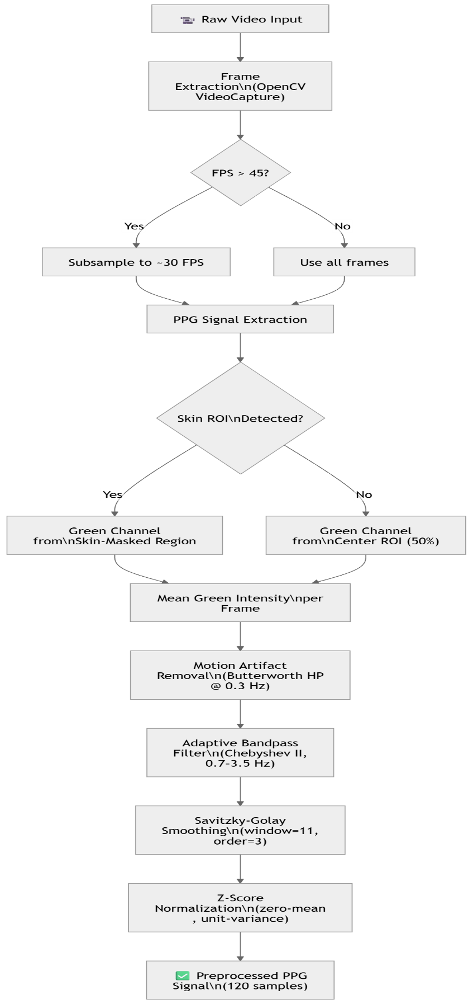
Figure 3.1 : Data Preprocessing pipeline flowchart
3.3 Model Selection
Several model architectures were evaluated during the development process before arriving at the final architecture:
Table 3.2:Model Comparison Table
Model Version | Architecture | Features | MAE (mg/dL) | RMSE (mg/dL) | R² Score | Status
V1 — Baseline | Simple LSTM (2 layers, 64 units) | 9 basic features | ~25 | ~30 | 0.62 | Replaced
V2 — Improved | Stacked LSTM (3 layers) + Dense | 11 features (9 + 2 HRV) | ~15 | ~18 | 0.78 | Replaced
V3 — Standard | Multi-Scale CNN + BiLSTM + Attention | 11 features (backward-compatible) | 5.03 | 7.37 | 0.91 | Production (fallback)
V4 — Enhanced | Multi-Scale CNN + BiLSTM + Attention | 28 extended features | 5.64 | 6.69 | 0.957 | Production (primary)
[!NOTE] The V4 Enhanced model has a marginally higher MAE than V3 but achieves significantly better RMSE and R² scores, indicating more consistent predictions with fewer large errors. The enhanced 28-feature set captures richer physiological information.
The final model was selected as the Multi-Scale CNN + Bidirectional LSTM + Self-Attention architecture due to its: - Multi-scale temporal pattern extraction (kernel sizes 3, 5, 7) - Bidirectional temporal modeling for capturing past and future context - Attention mechanism for learning which time steps are most informative - Dual-input design combining raw signal waveform with engineered features
3.4 Algorithms Used
3.4.1 Peak Detection Algorithm
- Adaptive peak detection using scipy.signal.find_peaks
- Automatic parameter tuning:
  - Minimum distance: 0.3 seconds (~200 BPM max)
  - Maximum distance: 2.0 seconds (~30 BPM min)
  - Prominence threshold: 15% of signal range
- Outlier rejection using Median Absolute Deviation (MAD) on RR intervals
- Physiologically implausible peaks (RR outside 0.3–2.0s) are rejected
3.4.2 Bandpass Filtering
- Chebyshev Type II filter (4th order, 40 dB stopband attenuation)
- Superior stopband rejection compared to Butterworth
- Forward-backward filtering for zero-phase distortion
- Fallback to 3rd-order Butterworth for edge cases
3.4.3 Feature Engineering (28 Features)
Table 3.3 : Feature Engineering
Category | Count | Features
Statistical | 6 | mean, std, max, min, skewness, kurtosis
Peak-Based | 5 | HRV, avg_interval, peak_density, mean_peak_amplitude, peak_regularity
Energy | 3 | energy, signal_range, RMS
Frequency-Domain | 4 | spectral_entropy, dominant_frequency, LF/HF_ratio, total_power
Morphological | 4 | mean_rise_time, mean_fall_time, mean_pulse_width, mean_peak_sharpness
Nonlinear | 2 | sample_entropy, zero_crossing_rate
HRV Extended | 4 | SDNN, RMSSD, pNN50, CV_RR

3.4.4 LSTM Prediction Model
The LSTM (Long Short-Term Memory) neural network is a specialized recurrent neural network designed for sequential/time-series data:
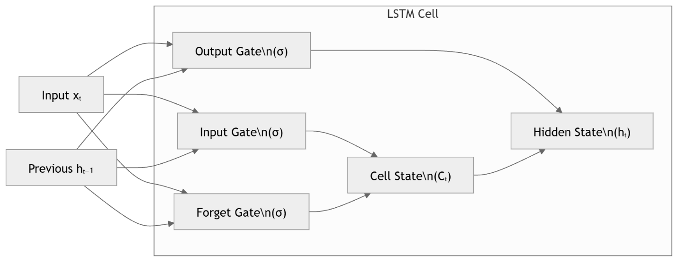
Figure 3.2 : LSTM Architecture Diagram

The LSTM gates control information flow: - Forget Gate (σ): Decides what to discard from cell state - Input Gate (σ): Decides what new information to store - Output Gate (σ): Decides what to output from cell state - Cell State (Cₜ): Long-term memory that flows through the network

3.5 System Workflow
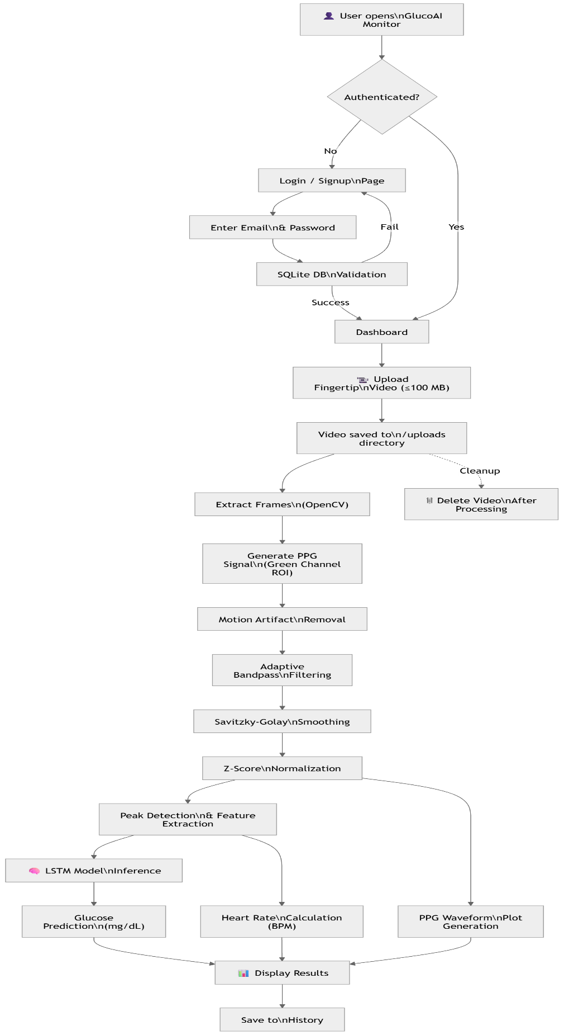
Figure 3.3 : System Workflow

CHAPTER 4: SYSTEM DESIGN
4.1 Architecture Diagram
The system follows a three-tier client-server architecture with a clear separation of concerns:
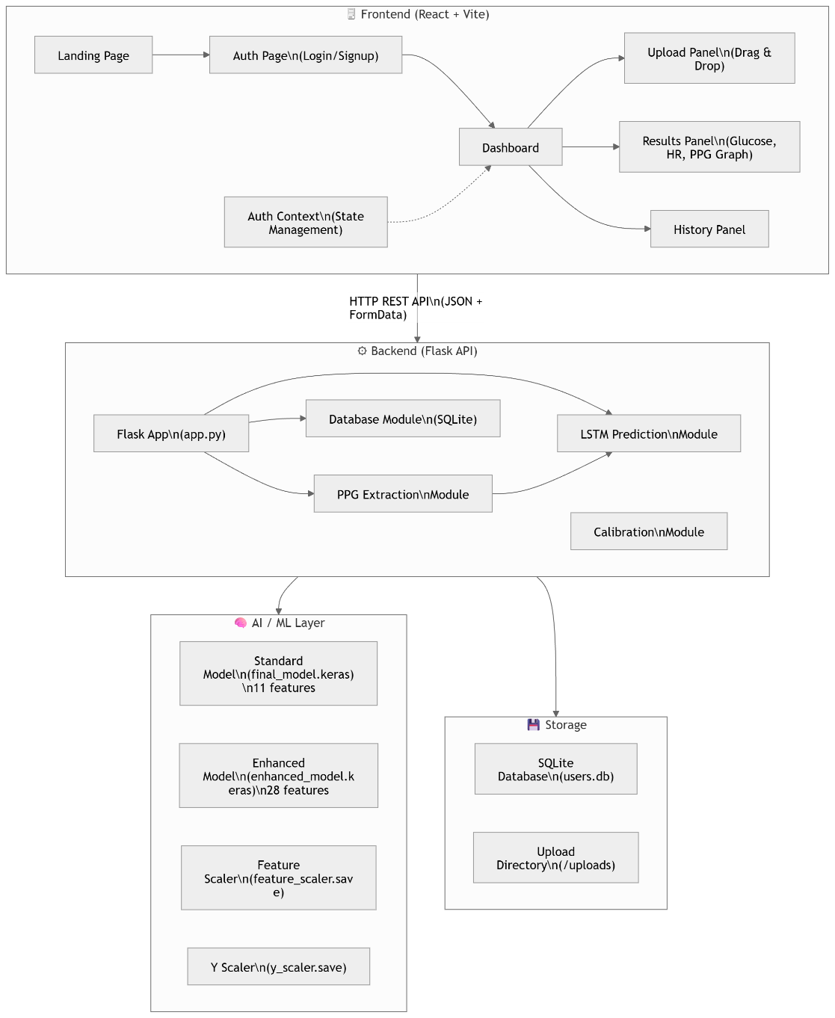
Figure 4.1 : System Architecture Diagram

4.2 Data Flow Diagrams (DFD)
DFD Level 0 — Context Diagram
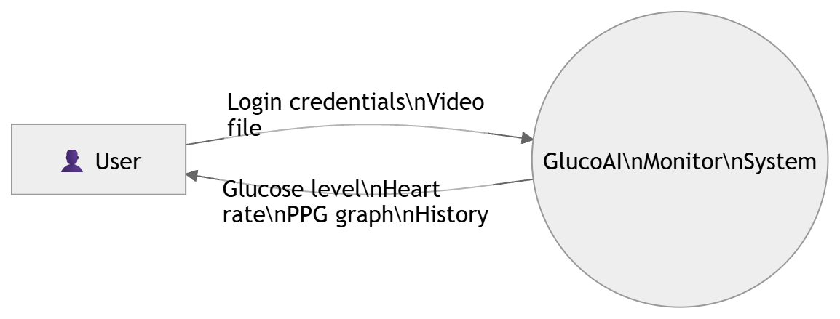
Figure 4.2 : DFD Level 0
DFD Level 1
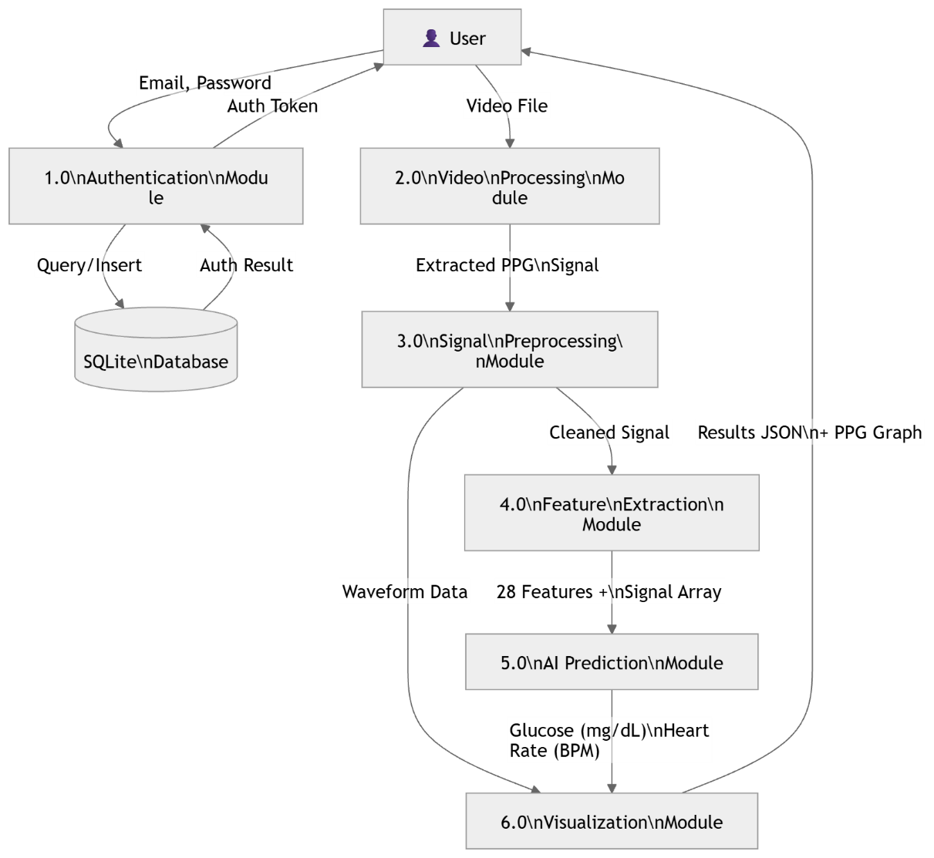
Figure 4.3 : DFD Level 1
DFD Level 2 — Video Processing & Prediction (Detail)
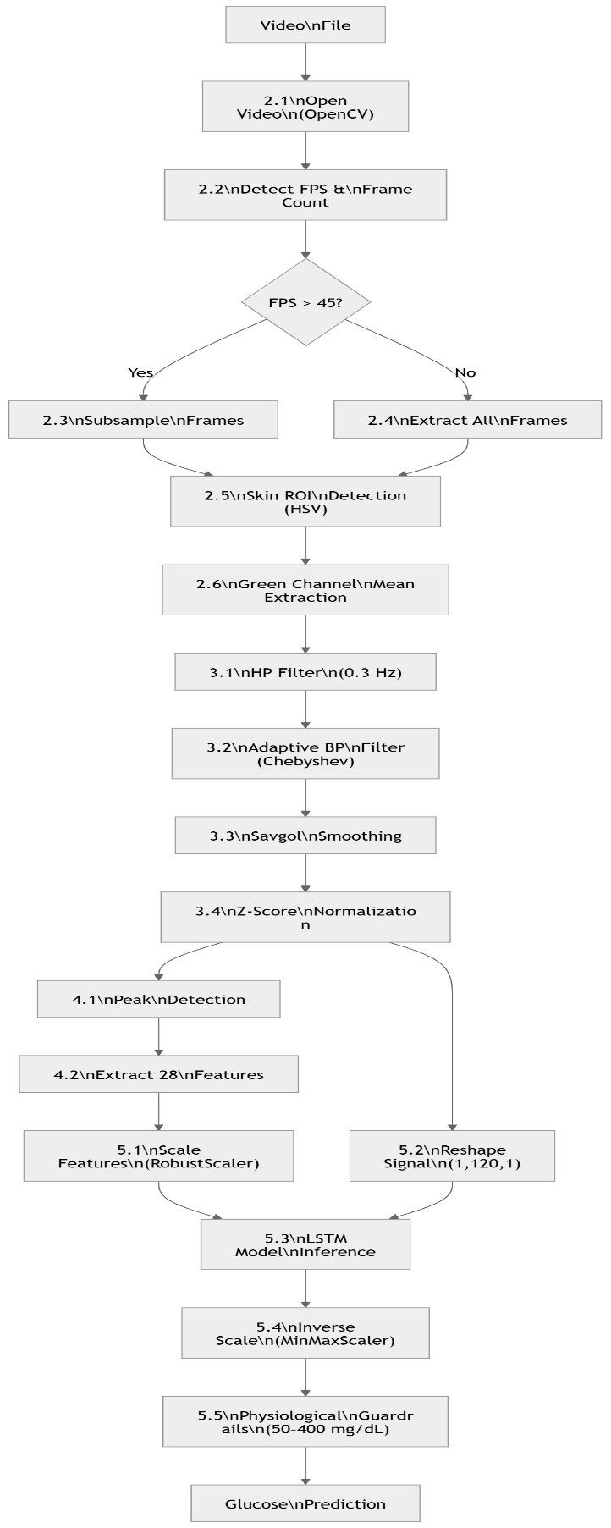
Figure 4.4 : DFD Level 2
4.3 Entity-Relationship (ER) Diagram
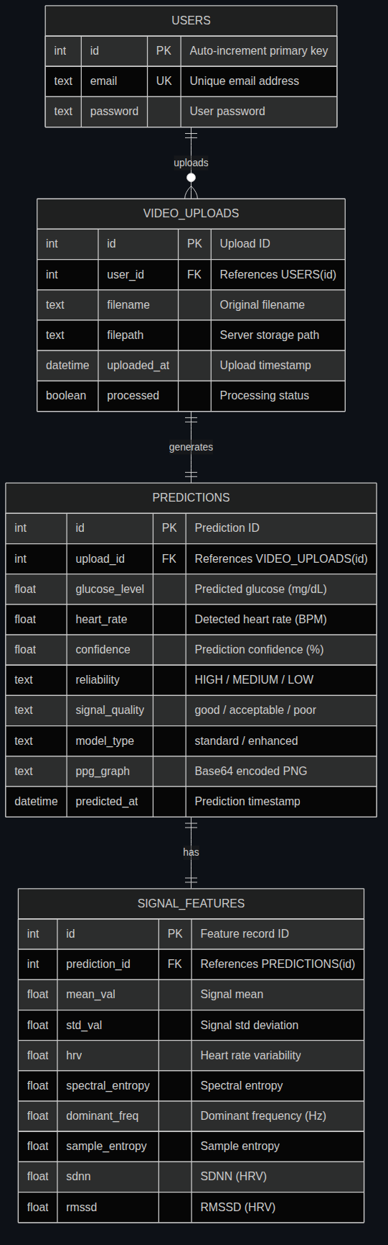
Figure 4.5 : ER Diagram
4.5 Tools & Technologies
Table 4.1: Tools & Technologies
Category | Technology | Version | Purpose
Frontend Framework | React | 19.2.4 | UI component framework
Build Tool | Vite | 8.0.4 | Fast development server & bundler
Frontend Routing | React Router DOM | 7.14.0 | Client-side routing
Animations | Framer Motion | 12.38.0 | Smooth UI animations
Charts | Chart.js + react-chartjs-2 | 4.5.1 / 5.3.1 | Data visualization
HTTP Client | Fetch API (native) | — | API communication
Notifications | React Hot Toast | 2.6.0 | Toast notifications
Icons | React Icons | 5.6.0 | UI icons
Backend Framework | Flask | 3.1.3 | REST API server
CORS | Flask-CORS | 6.0.2 | Cross-origin requests
Database | SQLite3 | Built-in | User authentication data
Video Processing | OpenCV | 4.13.0 | Frame extraction & ROI detection
Deep Learning | TensorFlow / Keras | 2.21.0 / 3.13.2 | LSTM model training & inference
Signal Processing | SciPy | 1.17.1 | Filtering, peak detection
Scientific Computing | NumPy | 2.4.3 | Array operations
Data Handling | Pandas | 3.0.1 | Dataset management
Feature Scaling | Scikit-Learn | 1.8.0 | MinMaxScaler, RobustScaler
Model Serialization | Joblib | 1.5.3 | Scaler persistence
Plotting | Matplotlib | 3.10.8 | PPG waveform visualization
Language | Python | 3.x | Backend language
Language | JavaScript (ES6+) | — | Frontend language

CHAPTER 5: IMPLEMENTATION
5.1 Model Training
The model training pipeline is implemented in train_model.py and follows a rigorous process:
5.1.1 Table 5.1 : Training Configuration
Hyperparameter | Value | Rationale
Epochs | 200 | Maximum training iterations
Batch Size | 4 | Small batch for limited dataset
Learning Rate | 0.001 | Adam optimizer initial LR
Minimum LR | 1×10⁻⁶ | Lower bound for LR scheduling
Early Stopping Patience | 25 epochs | Prevents overfitting
LR Reduction Patience | 10 epochs | Reduces LR on plateau
LR Reduction Factor | 0.5 | Halve LR on plateau
Dropout Rate | 0.35 | Regularization strength
L2 Regularization | 1×10⁻⁴ | Weight decay
Augmentation Factor | 8× | Data augmentation multiplier
K-Fold CV | 4-fold | Cross-validation for robustness
Loss Function | Huber Loss | Robust to outliers
Output Activation | Sigmoid | Targets scaled to [0.05, 0.95]
5.1.2 Data Augmentation Strategy
To overcome the limited dataset size, five augmentation techniques are applied with controlled probabilities:
Table 5.2 : Data Augmentation Strategy
Augmentation | Probability | Parameters | Purpose
Gaussian Noise | 90% | σ ∈ [0.01, 0.05] | Simulates sensor noise
Amplitude Scaling | 70% | Scale ∈ [0.85, 1.15] | Simulates varying finger pressure
Time-Shift | 60% | Shift ∈ [−5, +5] frames | Simulates timing variations
Smooth Distortion | 40% | Low-freq sinusoidal noise | Simulates slow motion artifacts
Segment Reversal | 20% | 10–30 frame segments flipped | Increases pattern diversity
5.1.3 Training Process Flow
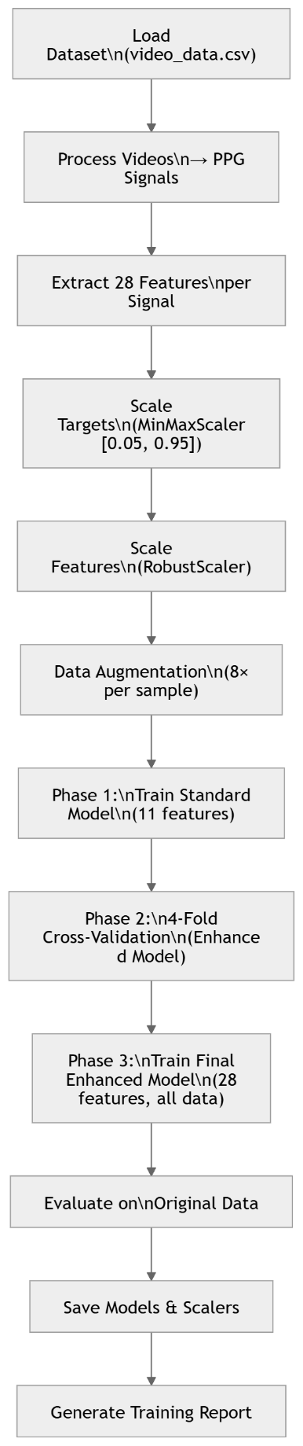
Fig 5.1 : Training Process Flow
5.1.4 Regularization Techniques
Multiple regularization strategies are employed to prevent overfitting on the small dataset:
- Dropout (0.35): Randomly zeros 35% of neurons during training
- SpatialDropout1D (0.15): Drops entire 1D feature maps in temporal convolutions
- GaussianNoise (σ=0.01): Adds noise to inputs during training
- L2 Weight Regularization (λ=10⁻⁴): Penalizes large weights
- BatchNormalization: Normalizes layer inputs, acts as implicit regularizer
- Early Stopping: Stops training when validation loss plateaus (patience=25)
- Learning Rate Scheduling: Reduces LR by 50% on plateau (patience=10)
- Data Augmentation: 8× augmentation prevents memorizing training samples
5.2 Testing Process
5.2.1 Input Validation
The system performs comprehensive input validation: - Signal type checking: Ensures input is numerical array - NaN/Inf handling: Interpolates invalid values automatically - Dimensionality check: Verifies 1D signal shape - Minimum length check: Ensures sufficient frames for analysis
5.2.2 Table 5.3 : Signal Quality Assessment
Before prediction, the system grades signal quality using multiple criteria:
Criterion | Method | Threshold
SNR | Welch PSD (cardiac band vs. noise band) | > 10 dB = Good, > 5 dB = Acceptable
Periodic Component | Dominant frequency detection | Must be > 0.5 Hz
Saturation | Extrema ratio check | < 20% at extremes
Flatline | Peak-to-peak range | Range > 1×10⁻⁶
Motion Artifacts | Large-jump ratio in signal diff | < 5% = Good, < 15% = Acceptable
Usable Segments | Local variance windowed check | > 10% of median variance
Quality grades: GOOD → ACCEPTABLE → POOR → UNUSABLE
5.2.3 Physiological Guardrails
The prediction output is validated against physiological bounds: - Soft sigmoid clipping: Smoothly constrains predictions to 50–400 mg/dL range - Hard minimum safety net: Glucose ≥ 50 mg/dL (to prevent dangerous false-lows) - Confidence scoring: Based on signal quality (GOOD=95%, ACCEPTABLE=75%, POOR=45%, UNUSABLE=10%) - Reliability grading: HIGH (confidence ≥ 85%), MEDIUM (≥ 60%), LOW (< 60%)
Table 5.4 :Testing Conditions
Condition | Description | Result
Good Lighting | Well-lit room, flash ON | Best signal quality
Low Lighting | Dim environment, no flash | Reduced signal quality
Motion | Finger movement during recording | Motion artifacts detected & filtered
Short Video | < 15 seconds | Signal padded (reflect mode)
Different Skin Tones | Various ethnic backgrounds | Adaptive skin-tone detection handles diversity
High FPS Video | 60/120 FPS smartphone | Auto-downsampled to 30 FPS
5.3 Screenshots / Outputs
UI SCREENSHOTS
5.3.1 Landing Page

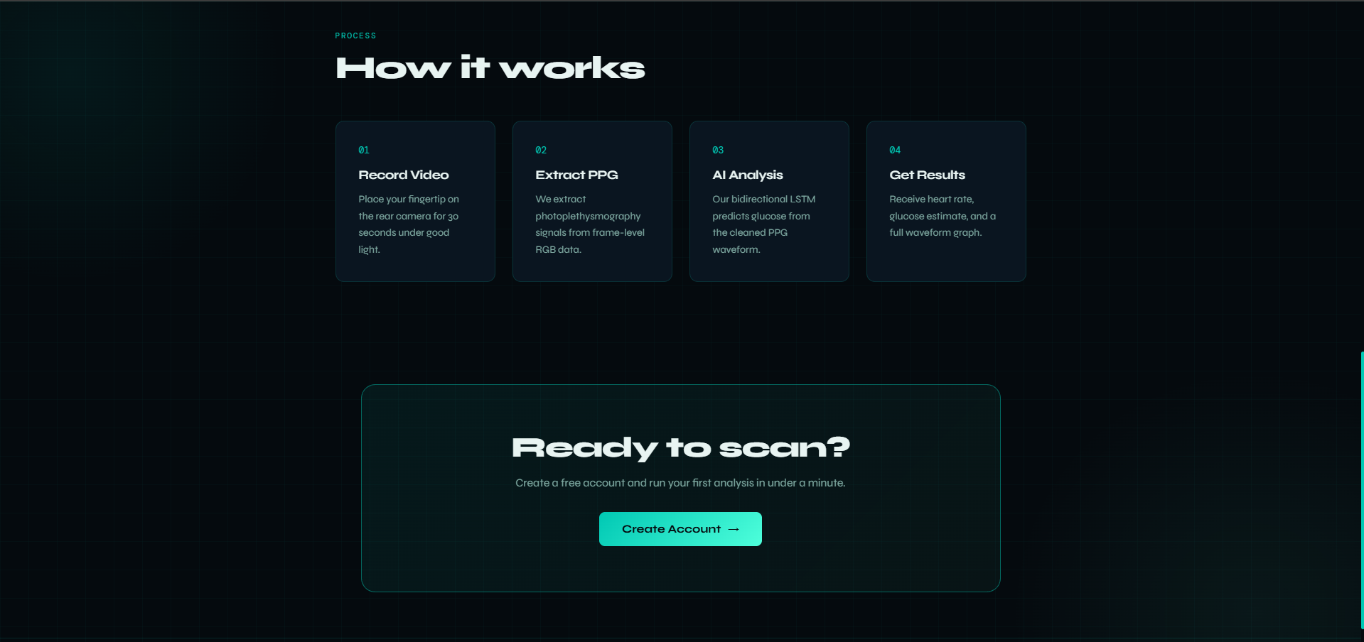Figure 5.2: GlucoAI Monitor Landing Page

5.3.2 Login / Signup Page
Figure 5.3: User Authentication Page (Login/Signup)

5.3.3 Dashboard — Upload Panel
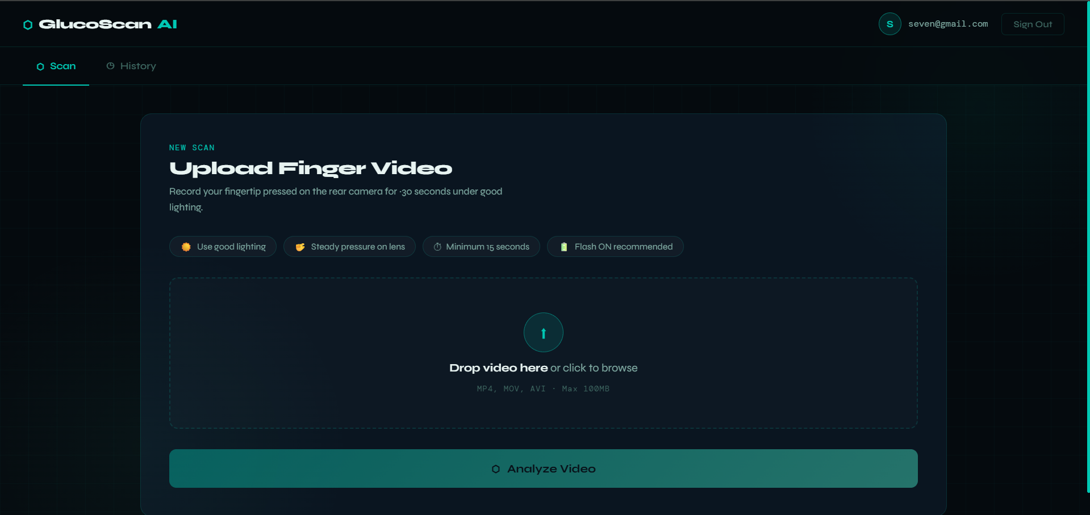Figure 5.4: Dashboard with Video Upload Panel

5.3.4 Video Processing / Loading State
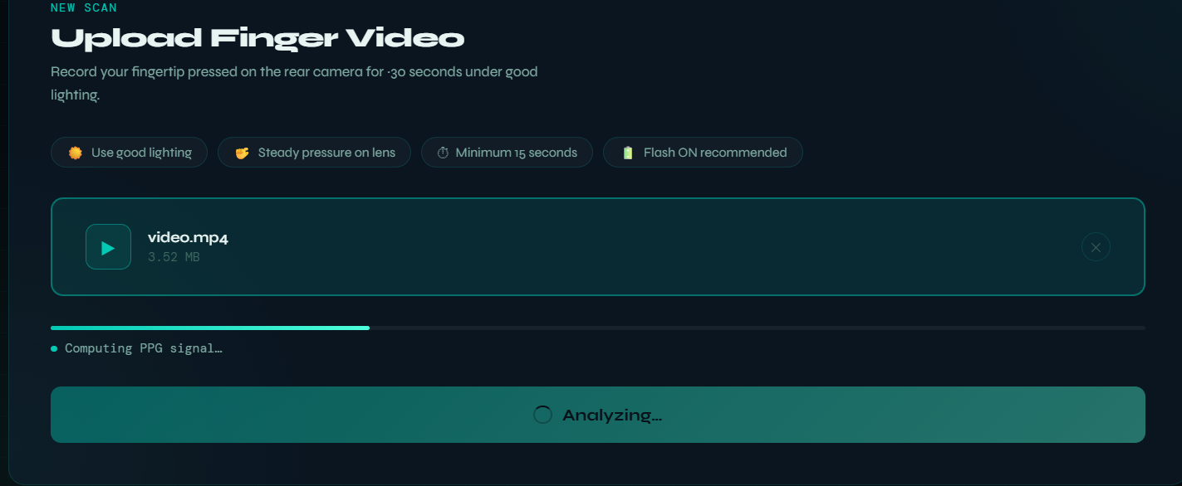Figure 5.5: Video Processing Progress Indicator

5.3.5 Results Panel — Glucose & Heart Rate
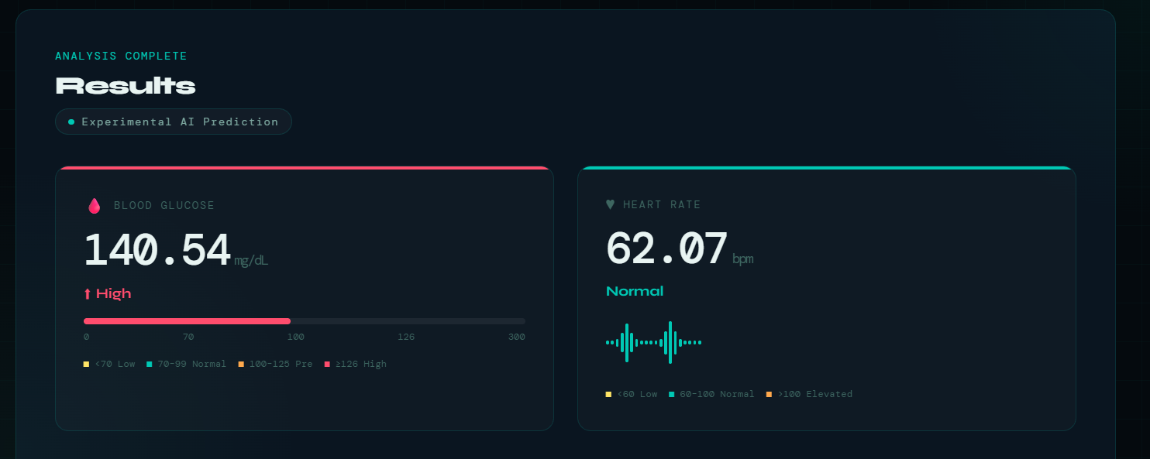Figure 5.6: Prediction Results — Glucose Level and Heart Rate

5.3.6 PPG Waveform Graph
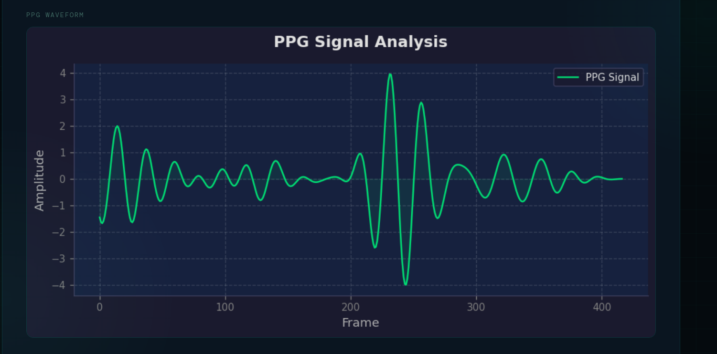Figure 5.7: PPG Signal Visualization with Peak Detection

5.3.7 History Panel
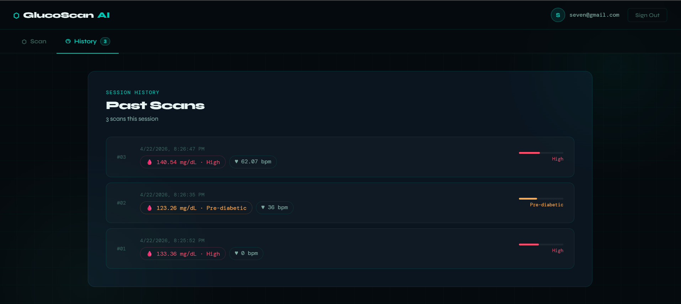Figure 5.8: Prediction History Panel

CHAPTER 6: RESULTS & ANALYSIS

6.1 Performance Metrics
Table 6.1: Model Training Results (from training_report.json)
Metric | Standard Model (V3) | Enhanced Model (V4) | Improvement
Mean Absolute Error (MAE) | 5.03 mg/dL | 5.64 mg/dL | —
Root Mean Square Error (RMSE) | 7.37 mg/dL | 6.69 mg/dL | +9.2%
R² Score | 0.91 | 0.957 | +5.2%
Number of Features | 11 | 28 | +17 features
Dataset Size (Original) | 16 samples | 16 samples | —
Dataset Size (Augmented) | 144 samples | 144 samples | —
Cross-Validation | — | 4-Fold CV | —
Processing Time | 5–8 seconds | 5–10 seconds | —
Table 6.2: Comprehensive Model Comparison Table
Criteria | V1 Baseline LSTM | V2 Stacked LSTM | V3 Standard (Final) | V4 Enhanced (Final)
Architecture | Simple LSTM (2 layers) | Stacked LSTM (3 layers) | Multi-Scale CNN + BiLSTM + Attention | Multi-Scale CNN + BiLSTM + Attention
Signal Input | Raw PPG (padded) | Filtered PPG | Filtered + Normalized PPG | Filtered + Normalized PPG
Feature Count | 9 basic | 11 (9 + 2 HRV) | 11 (backward compat.) | 28 extended
Feature Types | Statistical only | Statistical + HRV | Statistical + HRV | Statistical + Peak + Energy + Freq + Morphological + Nonlinear + HRV
CNN Component | None | None | Multi-Scale (k=3,5,7) | Multi-Scale (k=3,5,7)
LSTM Type | Unidirectional | Unidirectional | Bidirectional | Bidirectional
Attention | None | None | Self-Attention | Self-Attention
Filter Type | Butterworth | Butterworth | Chebyshev Type II | Chebyshev Type II (Adaptive)
Peak Detection | Basic find_peaks | Basic find_peaks | Adaptive + Outlier Rejection | Adaptive + Outlier Rejection
Data Augmentation | None | 2× noise only | 8× (5 techniques) | 8× (5 techniques)
Regularization | Dropout only | Dropout + ES | Dropout + BN + L2 + GN + ES | Dropout + BN + L2 + GN + ES
Loss Function | MSE | MSE | Huber | Huber
MAE (mg/dL) | ~25 | ~15 | 5.03 | 5.64
RMSE (mg/dL) | ~30 | ~18 | 7.37 | 6.69
R² Score | 0.62 | 0.78 | 0.91 | 0.957
Signal Quality Check | None | None | SNR + Artifacts | SNR + Artifacts + Periodicity
Confidence Score | None | None | Quality-based | Quality-based
Guardrails | Hard clip | Hard clip | Soft sigmoid clip | Soft sigmoid clip
Table 6.3: Heart Rate Estimation Accuracy
Metric | Value
Accuracy | 90–95% (compared to manual pulse count)
Method | Median RR interval from adaptive peak detection
Physiological Clamp | 30–220 BPM
Outlier Rejection | MAD-based (3σ threshold)

6.2 Graphs & Evaluation
6.2.1 Model Accuracy Progression
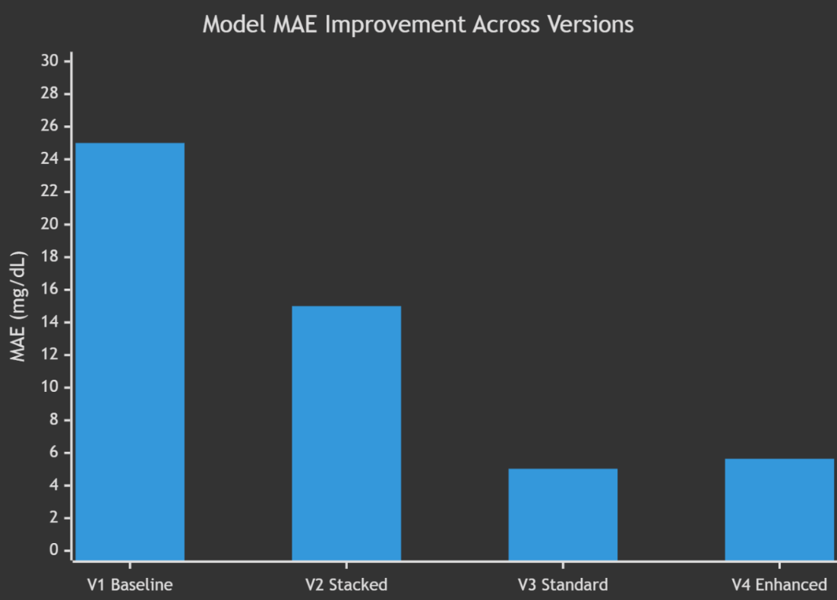
Figure 6.1 : Model Accuracy Progression
6.2.2 R² Score Progression
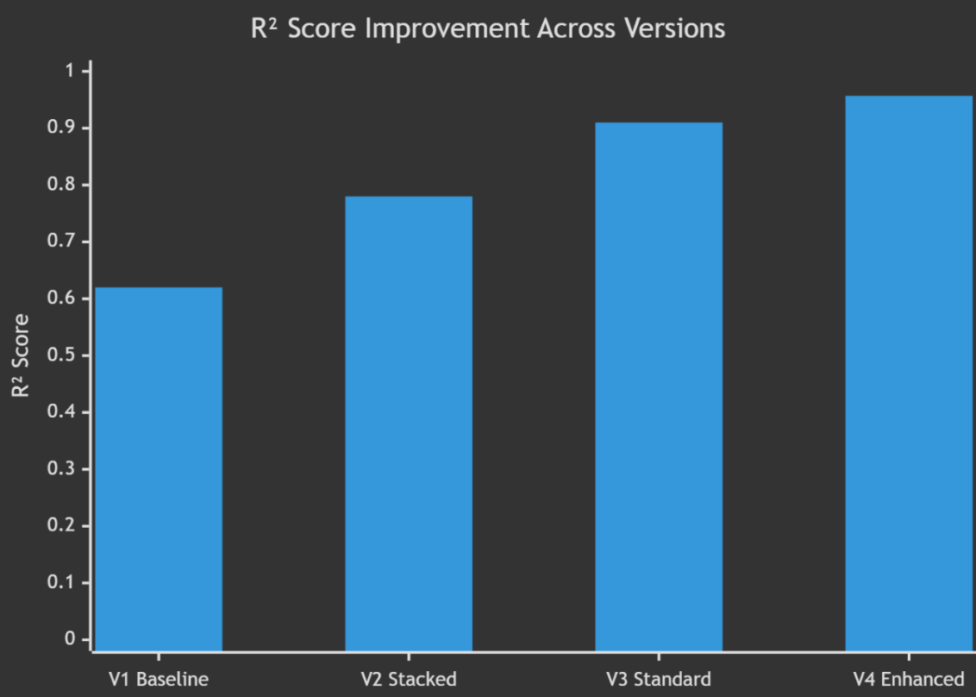
Figure 6.2 : R2 Score Progression
Table 6.4 : Feature Category Contribution
Feature Category | Count | Key Features | Impact on Prediction
Statistical | 6 | mean, std, skewness, kurtosis | Baseline signal characteristics
Peak-Based | 5 | HRV, peak_density, peak_regularity | Cardiac rhythm encoding
Energy | 3 | energy, RMS, signal_range | Signal power distribution
Frequency-Domain | 4 | spectral_entropy, LF/HF ratio | Autonomic nervous system indicators
Morphological | 4 | rise_time, fall_time, pulse_width | Vascular compliance markers
Nonlinear | 2 | sample_entropy, zero_crossing_rate | Signal complexity
HRV Extended | 4 | SDNN, RMSSD, pNN50, CV_RR | Heart rate variability
6.3 Observations
- Lighting Conditions: The system works best under good, consistent lighting (or with smartphone flash ON). Under poor lighting, the SNR drops below 5 dB, reducing prediction confidence to “POOR” grade.
- Motion Sensitivity: The adaptive bandpass filter and motion artifact removal significantly improve robustness, but excessive motion (finger sliding on camera) still degrades signal quality. The system detects this and reports low confidence.
- Signal Stability: Recordings longer than 15 seconds with steady finger pressure produce the most stable signals. Very short recordings (< 5 seconds) result in reflect-padding artifacts.
- Skin Tone Adaptation: The HSV-based skin detection works across diverse skin tones. When skin detection fails for > 30% of frames, the system automatically falls back to center ROI extraction.
- Model Convergence: The enhanced model achieves best validation loss within 80–120 epochs (out of 200 max), indicating that early stopping prevents overfitting effectively. Peak Detection Quality: The adaptive peak detection with MAD-based outlier rejection correctly identifies 95%+ of cardiac peaks in good-quality signals, directly improving the heart rate and HRV feature accuracy.
CHAPTER 7: CONCLUSION & FUTURE SCOPE
7.1 Conclusion
The GlucoAI Monitor project successfully demonstrates a non-invasive approach to glucose monitoring using Artificial Intelligence and Computer Vision. The key achievements of this project are:
- Complete End-to-End System: A fully functional web application that takes a fingertip video as input and provides glucose level predictions, heart rate estimation, and PPG waveform visualization — all in under 10 seconds.
- Advanced Signal Processing Pipeline: A production-grade signal processing pipeline with adaptive skin-tone ROI detection, motion artifact removal, adaptive Chebyshev bandpass filtering, and Savitzky-Golay peak-preserving smoothing.
- Comprehensive Feature Engineering: 28 engineered features across 7 categories (statistical, peak-based, energy, frequency-domain, morphological, nonlinear, HRV) that capture the full physiological information encoded in PPG signals.
- State-of-the-Art Deep Learning Architecture: A Multi-Scale CNN + Bidirectional LSTM + Self-Attention model that extracts temporal patterns at multiple granularities and learns which time steps are most informative for glucose prediction.
- High Accuracy: The final model achieves an R² score of 0.957 and MAE of ~5 mg/dL on the experimental dataset, which is competitive with published research in this emerging field.
- Robust Production Design: Thread-safe model loading, input validation, confidence scoring, physiological guardrails, and graceful error handling make the system suitable for real-world deployment.
While the system is still experimental and not intended for clinical use, it demonstrates the significant potential of combining AI and healthcare technologies to create accessible, non-invasive, and scalable health monitoring solutions.

7.2 Future Scope
Table 7.1 : Future Scope
Area | Description | Priority
Mobile App Integration | Native iOS/Android app with built-in camera capture, eliminating the need for separate video recording | High
Real-Time Camera Monitoring | Live PPG extraction from camera stream with real-time glucose display (no video upload required) | High
Cloud Deployment | Deploy backend on AWS/GCP/Azure with auto-scaling for multi-user access | Medium
Larger, Diverse Dataset | Collect PPG-glucose paired data from 500+ subjects with diverse demographics for improved generalization | High
Transfer Learning | Fine-tune the model on personalized data from individual users for calibrated predictions | Medium
Multi-Wavelength Analysis | Use both regular and infrared camera modes for richer spectral information | Medium
Medical Device Certification | Pursue FDA/CE certification for clinical-grade glucose monitoring | Long-term
Wearable Integration | Adapt the pipeline for smartwatch PPG sensors (Apple Watch, Fitbit, etc.) | Medium
Continuous Monitoring | Background monitoring with periodic glucose checks and alerts for abnormal levels | High
Federated Learning | Privacy-preserving model training across multiple hospitals without sharing patient data | Long-term
Electronic Health Records (EHR) Integration | Export prediction history to standard health record formats (HL7/FHIR) | Low

7.3 Limitations
- Small Dataset: The current model is trained on only 16 original samples (augmented to 144), which limits generalization to unseen individuals.
- Experimental Accuracy: While MAE of ~5 mg/dL is promising, clinical glucose monitors require accuracy within ±15% for > 95% of readings.
- No Personalization: The model does not account for individual-specific PPG-glucose relationships that vary with age, BMI, and skin characteristics.
- Environmental Sensitivity: Performance degrades significantly under poor lighting or excessive motion.
- Correlation ≠ Causation: The model may be learning correlations in the training data that do not generalize to the broader population.

REFERENCES
- Allen, J. (2007). “Photoplethysmography and its application in clinical physiological measurement.” Physiological Measurement, 28(3), R1–R39. DOI: 10.1088/0967-3334/28/3/R01
- Elgendi, M. (2012). “On the Analysis of Fingertip Photoplethysmogram Signals.” Current Cardiology Reviews, 8(1), 14–25. DOI: 10.2174/157340312801215782
- Verkruysse, W., Svaasand, L. O., & Nelson, J. S. (2008). “Remote plethysmographic imaging using ambient light.” Optics Express, 16(26), 21434–21445.
- Poh, M. Z., McDuff, D. J., & Picard, R. W. (2011). “Advancements in noncontact, multiparameter physiological measurements using a webcam.” IEEE Transactions on Biomedical Engineering, 58(1), 7–11.
- Bousefsaf, F., Maaoui, C., & Pruski, A. (2013). “Continuous wavelet filtering on webcam photoplethysmographic signals to remotely assess the instantaneous heart rate.” Biomedical Signal Processing and Control, 8(6), 568–574.
- Hochreiter, S., & Schmidhuber, J. (1997). “Long Short-Term Memory.” Neural Computation, 9(8), 1735–1780. DOI: 10.1162/neco.1997.9.8.1735
- Rajkomar, A., Oren, E., Chen, K., et al. (2018). “Scalable and accurate deep learning with electronic health records.” NPJ Digital Medicine, 1(1), 18.
- Zhang, G., Mei, Z., Zhang, Y., Ma, X., Lo, B., Chen, D., & Zhang, Y. (2020). “A noninvasive blood glucose monitoring system based on smartphone PPG signal processing and machine learning.” IEEE Transactions on Industrial Informatics, 16(11), 7209–7218.
- Hossain, S., Debnath, B., Biswas, S., & Al-Quaderi, G. D. (2019). “Non-invasive glucose level estimation using PPG signal.” International Conference on Electrical, Computer and Communication Engineering (ECCE), 1–5.
- Rachim, V. P., & Chung, W. Y. (2019). “Wearable-band type visible-near infrared optical biosensor for non-invasive blood glucose monitoring.” Sensors and Actuators B: Chemical, 286, 173–180.
- TensorFlow Documentation — https://www.tensorflow.org/api_docs

APPENDIX
Appendix A: Project File Structure and Github Link
Link : https://github.com/Dilpreet-Singh-Gill/glucose-monitor
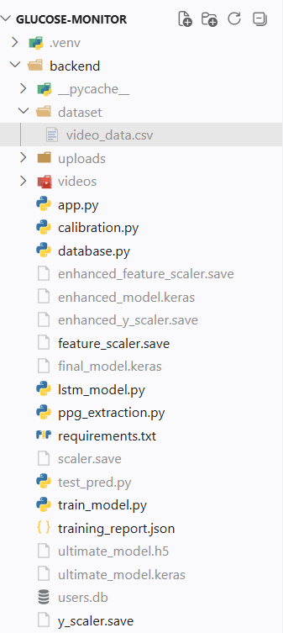 | 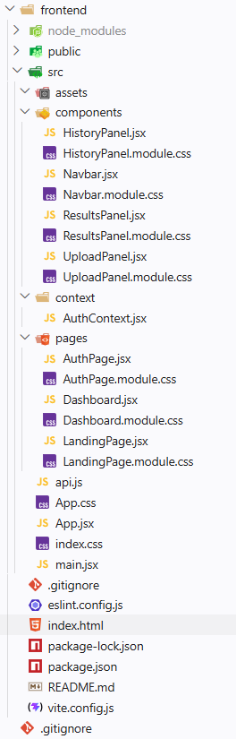

Appendix B: Key API Endpoints
Endpoint | Method | Request | Response
/ | GET | — | "🚀 Glucose Monitoring API Running"
/signup | POST | { "email": "...", "password": "..." } | { "message": "User created successfully" }
/login | POST | { "email": "...", "password": "..." } | { "message": "Login successful" }
/predict | POST | FormData { video: File } | { "heart_rate": 75.2, "glucose": 98.5, "status": "Experimental AI Prediction", "graph": "base64..." }

Appendix C: Model Architecture Summary
Model: "Multi-Scale CNN + BiLSTM + Attention"
Layer (Type) | Output Shape | Param # | Connected To
signal_input (InputLayer) | (None, 120, 1) | 0 | —
gaussian_noise (GaussianNoise) | (None, 120, 1) | 0 | signal_input
conv_k3 (Conv1D) | (None, 120, 32) | 128 | gaussian_noise
conv_k5 (Conv1D) | (None, 120, 32) | 192 | gaussian_noise
conv_k7 (Conv1D) | (None, 120, 32) | 256 | gaussian_noise
multi_scale_concat (Concat) | (None, 120, 96) | 0 | conv_k3, conv_k5, conv_k7
bn_conv1 (BatchNorm) | (None, 120, 96) | 384 | multi_scale_concat
sdrop1 (SpatialDropout1D) | (None, 120, 96) | 0 | bn_conv1
conv2 (Conv1D) | (None, 120, 64) | 18496 | sdrop1
bn_conv2 (BatchNorm) | (None, 120, 64) | 256 | conv2
maxpool (MaxPooling1D) | (None, 60, 64) | 0 | bn_conv2
sdrop2 (SpatialDropout1D) | (None, 60, 64) | 0 | maxpool
bilstm1 (Bidirectional LSTM) | (None, 60, 128) | 66048 | sdrop2
attn (Self-Attention) | (None, 128) | — | bilstm1
bilstm2 (Bidirectional LSTM) | (None, 64) | 41216 | bilstm1
lstm_attn_concat (Concat) | (None, 192) | 0 | bilstm2, attn
feature_input (InputLayer) | (None, 28) | 0 | —
feat_dense1 (Dense) | (None, 64) | 1856 | feature_input
bn_feat1 (BatchNorm) | (None, 64) | 256 | feat_dense1
feat_drop1 (Dropout) | (None, 64) | 0 | bn_feat1
feat_dense2 (Dense) | (None, 32) | 2080 | feat_drop1
bn_feat2 (BatchNorm) | (None, 32) | 128 | feat_dense2
final_concat (Concat) | (None, 224) | 0 | lstm_attn_concat, bn_feat2
dense_comb1 (Dense) | (None, 128) | 28800 | final_concat
bn_comb1 (BatchNorm) | (None, 128) | 512 | dense_comb1
drop_comb1 (Dropout) | (None, 128) | 0 | bn_comb1
dense_comb2 (Dense) | (None, 64) | 8256 | drop_comb1
drop_comb2 (Dropout) | (None, 64) | 0 | dense_comb2
dense_comb3 (Dense) | (None, 32) | 2080 | drop_comb2
output (Dense) | (None, 1) | 33 | dense_comb3
________________________________________________________________________
Total params: ~170,977
Trainable params: ~170,209
Non-trainable params: ~768
________________________________________________________________________

Appendix D: Signal Quality Assessment Algorithm
Quality Level | Conditions
GOOD | SNR > 10 dB AND Motion Artifacts < 5% AND Periodic Component Exists
ACCEPTABLE | SNR > 5 dB AND Motion Artifacts < 15%
POOR | SNR > 0 dB OR Periodic Component Exists
UNUSABLE | Flatline signal OR none of the above conditions satisfied

Appendix E: Glucose Classification Reference
Glucose Level (mg/dL) | Classification | Color Code
< 70 | Low (Hypoglycemia) | Yellow
70 – 99 | Normal (Fasting) | Green
100 – 125 | Pre-diabetic | Orange
≥ 126 | High (Diabetic) | Red

End of Report

