AWS Database:

My API server allows for easy access to connect to and manipulate the data within the AWS Database. In the client-controller, storage-controller, and cloudComputing-controller there are all 4 CRUD methods available for use along with other methods such as add, which searches for clients with a particular ID. A new client may be added through the procedures-controller which accesses the procedure defined in SQL as sp_NewClient. To find all of the services and costs related to a client ID one may use the method portfolio defined in the ViewsController class.

* Path Name: Get
* Path: http://localhost:8049/api/v1/client/:id
* Description: Call this route to see client with provided the ClientID

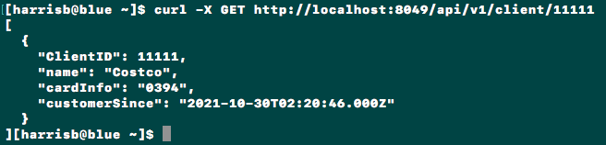

* Path Name: Put
* Path: http://localhost:8049/api/v1/client/:id
* Description: Call this route to update a Client’s information with the provided ClientID



* Path Name: Post
* Path: http://localhost:8049/api/v1/procedure/newClient
* 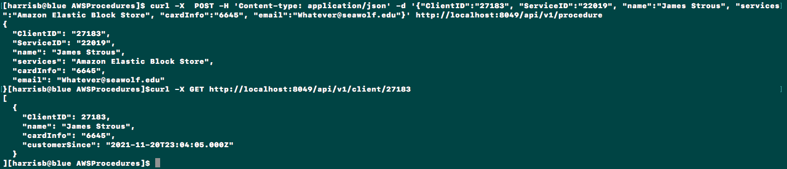Description: Call this route to add a new client
* Path Name: Get
* Path: http://localhost:8049/api/v1/cloudComputing/
* Description: Call this route to see all the cloud computing services purchased by clients

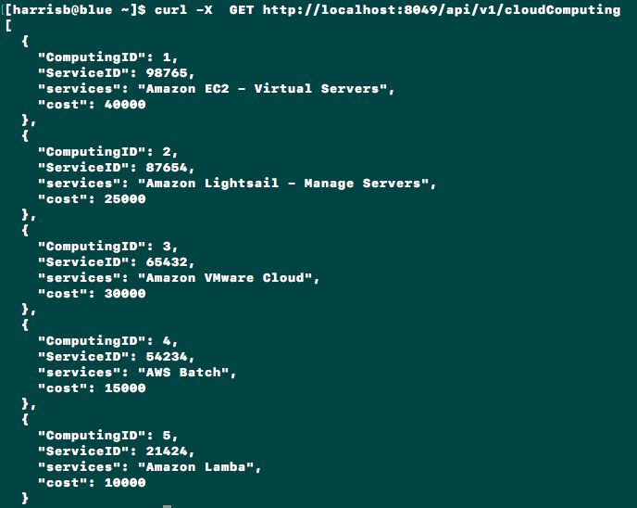

* Path Name: Delete
* Path: http://localhost:8049/api/v1/cloudComputing/:id
* Description: Call this route to delete the cloud computing services purchased by the client with the provided the ServiceID



* Path Name: Get
* Path: http://localhost:8049/api/v1/storage/:id
* Description: Call this route to see the storage services purchased by the client with the provided the ServiceID

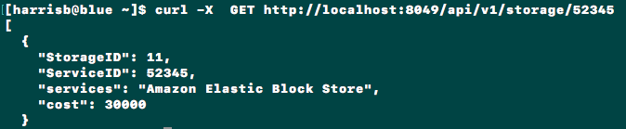

* Path Name: Delete
* Path: http://localhost:8049/api/v1/ storage /:id
* Description: Call this route to delete the storage services purchased by the client with the provided the ServiceID



* Path Name: Get
* Path: http://localhost:8049/api/v1/portfolio/:id
* Description: Call this route to show all of the services and costs related to a given client ID.

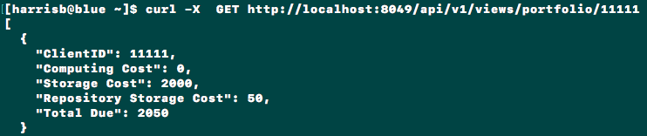

* Path Name:
* Path: http://localhost:8049/api/v1/views/displayServices
* Description: Call this route to use a view to show all of the sevices provided by AWS

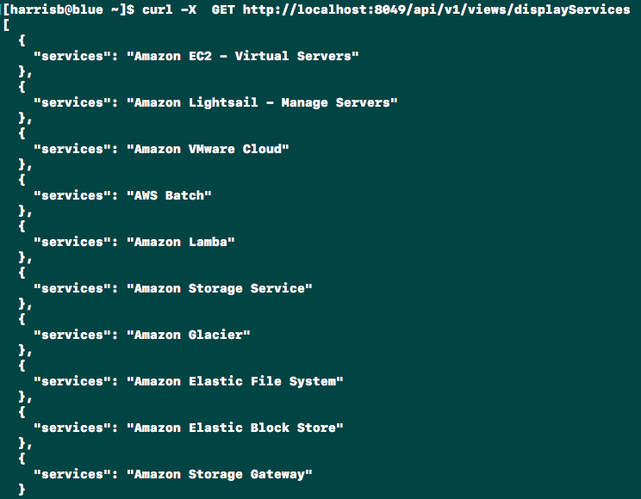

Grading

* 50 PTS - Routers, route paths, and controller methods
* 10 PTS - Properly formated default route
* 20 PTS - Report
* 10 PTS - It runs!
* 10 PTS - Code Style
  + Does your API structure make sense and is it laid out well?
  + Are your controller methods clear and concise?
  + Did you comment your code?
  + Did you delete your node modules folder?

Submission

* Delete your node_modules folder.
* Compress your project and submit it in a folder called: <lastName>_<firstInitial>_P2
* Submit your report separately!
  + Do not place it inside of the compressed folder!