[Ultimate AWS Certified Solutions Architect Associate 2025](https://www.udemy.com/course/aws-certified-solutions-architect-associate-saa-c03/)

Section 1. Course Introduction - AWS Certified Solutions Architect Associate

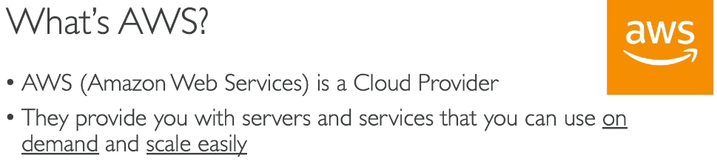

1. Creating an AWS Account

<https://aws.amazon.com> > “create account” > Sign up for AWS - Root user email address > [harrisdevelops@gmail.com](mailto:harrisdevelops@gmail.com) > AWS account name - harrisdevelops > Verify email address > root user password (M.%1hy)> Free Plan

>

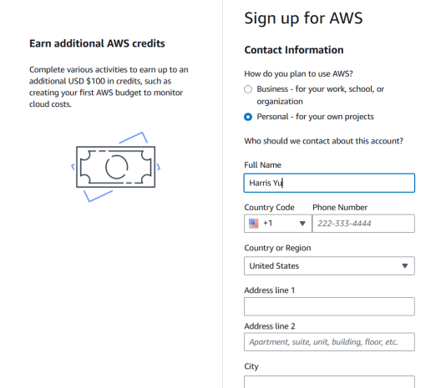

> 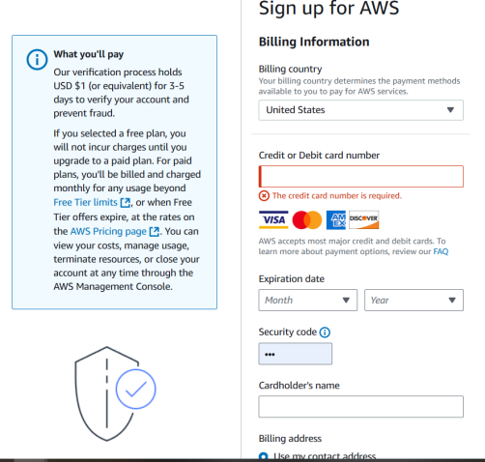(refunded immediately)

>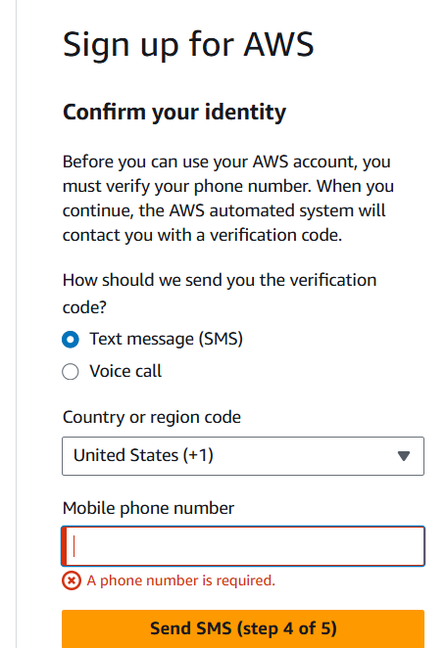> 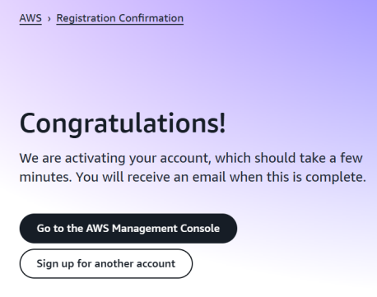

> 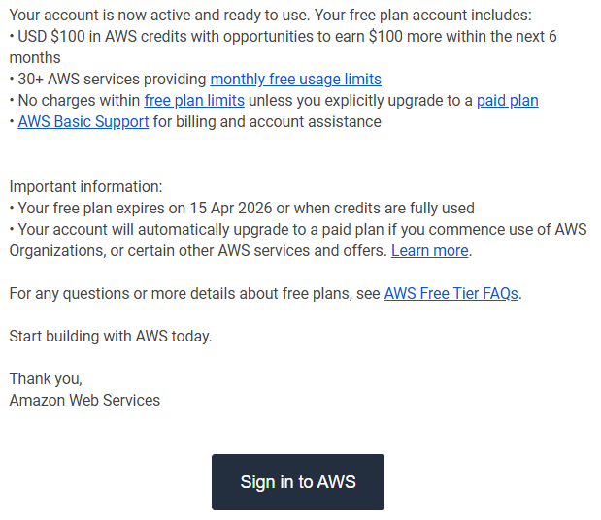

> If you don't see this page, just sign out & click on Sign in to console.

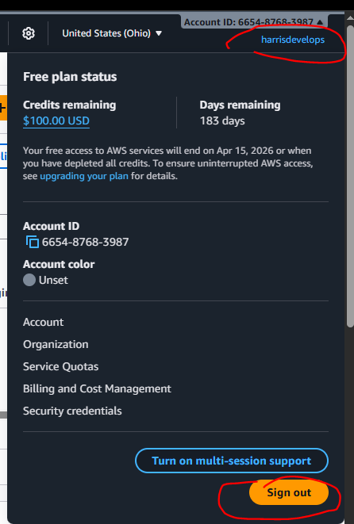>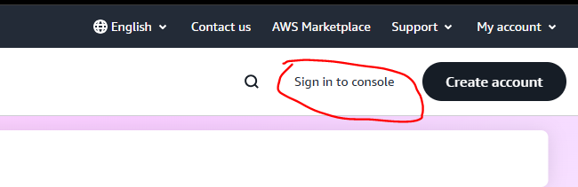>

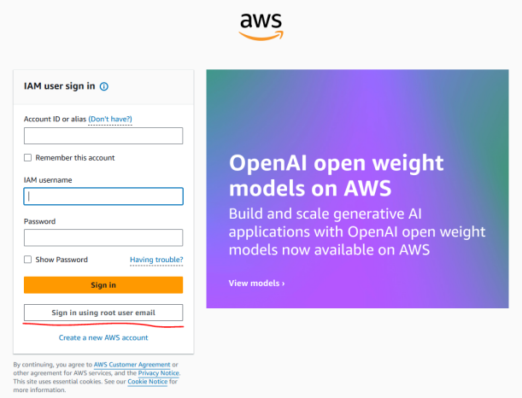>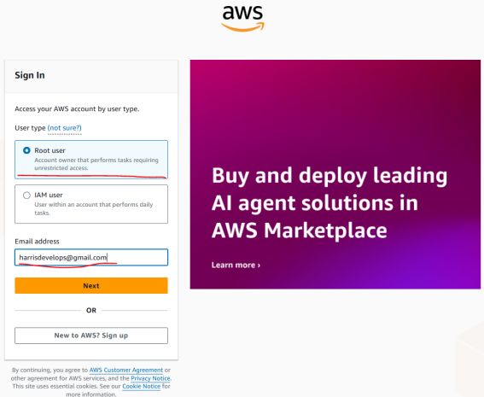>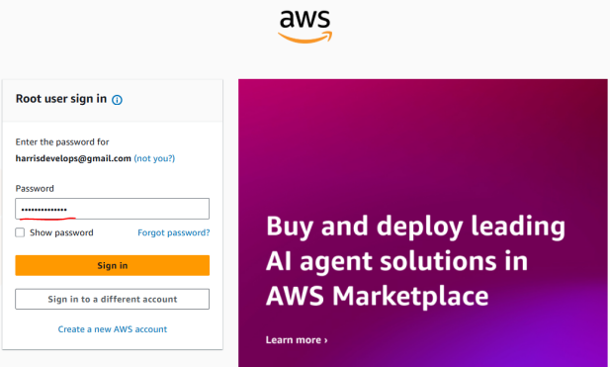>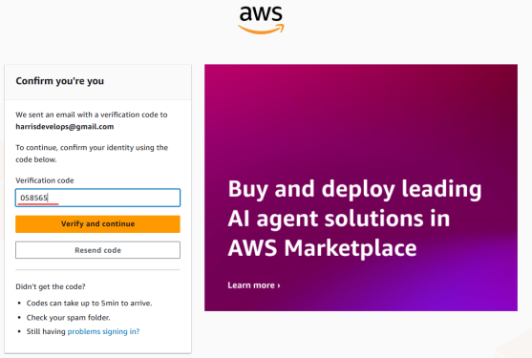>

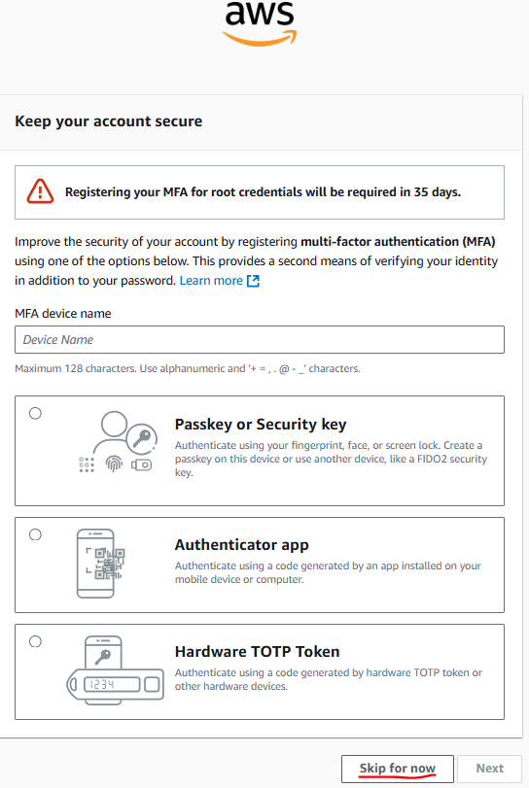>

Section 3. Getting started with AWS