NBA Players With Lower Early Workload After Injury Have Fewer Subsequent Injury-Related Absences
A Four-Season Longitudinal Landmark Cohort Study
[AUTHOR NAMES]
[AFFILIATIONS]
Corresponding author: [NAME, ADDRESS, EMAIL]
Running title: Early postinjury workload restoration in the NBA
Article type: Original Research / Longitudinal Observational Cohort
Data window: 2021-22 through 2024-25 NBA seasons; injury episodes and preinjury baselines were reconstructed longitudinally across season boundaries.
Submission note: authorship, affiliations, ethics determination, funding, conflicts, and repository fields remain placeholders for study-team confirmation.
Summary:
- Key question: After an NBA player returns from injury, does bringing his minutes back more slowly reduce the chance of another injury-related absence?
- Players whose minutes returned more slowly had fewer injury-related absences afterward.
- This was not explained by player role or usual playing time.
- It was not explained by how severe or what type of injury they had.
- It was not explained by scheduled rest games.
- It was not explained by whether minutes increased smoothly from game to game.
- The result still held when players were compared with themselves across different injuries.
- The association was stronger for new injuries elsewhere in the body than for recurrence of the original injury.
- Returning to full minutes faster did not clearly improve later performance per minute.
- Limitation: teams have private medical information that could influence both minutes and later injury risk.

ABSTRACT
Importance: Medical clearance marks a return to participation, not necessarily a return to a player's usual competitive workload. In professional basketball, teams can restore minutes quickly or conservatively, use scheduled recovery games, and alter starting roles, but public evidence has not established how early postinjury playing-time restoration relates to subsequent injury.
Objective: To determine whether early playing-time restoration after documented time-loss injury is associated with subsequent injury-related absence in National Basketball Association (NBA) players, and to test whether player role, injury severity, scheduled rest, ramp shape, or recurrence of the original injury explains the association.
Design, Setting, and Participants: Retrospective longitudinal cohort study linking official NBA injury-report information with player-game, schedule, travel, and performance data from 2021-22 through 2024-25. Player chronologies were reconstructed continuously across seasons. The primary three-played-game landmark included 1,230 return-to-play episodes among 578 players.
Exposure: The primary exposure was cumulative workload deficit during the first three completed played games after return, normalized to each player's preinjury minutes. Larger deficit represented more conservative restoration. A secondary schedule-aware Early Return Workload averaged the fraction of baseline minutes accumulated over the first N scheduled games, assigning 0 minutes to planned rest/recovery games. Ramp Deviation separately quantified trajectory irregularity.
Main Outcomes and Measures: The primary outcome was unplanned injury-related absence within 30 days after the landmark. Models adjusted for age, baseline minutes, games missed, initial injury body part and diagnosis, prior injuries, season, schedule/travel, cross-season return, and baseline provenance. Sensitivity analyses included fine clinical fixed effects, augmented inverse-probability weighting, overlap weighting, within-player conditional logistic regression, 1,000 player-cluster bootstraps, survival analysis, leave-one-season/team-out analyses, falsification outcomes, prediction validation, and later performance.
Results: Among 1,230 landmark episodes, 492 (40.0%) were followed by an unplanned injury-related absence within 30 days. More conservative three-game restoration was associated with lower subsequent injury odds (adjusted OR, 0.75 per +0.5 workload deficit; 95% CI, 0.64-0.88; P<.001). Fine injury-type/severity adjustment produced OR 0.75, and the expanded within-player analysis produced OR 0.67 (95% CI, 0.52-0.85). Higher schedule-aware Early Return Workload was associated with higher injury odds over 3 scheduled games (OR, 1.16 per +10 percentage points; 95% CI, 1.08-1.26) and 5 scheduled games (OR, 1.12; 95% CI, 1.02-1.22). Ramp Deviation was not independently associated after workload adjustment (OR, 1.09 per +10 points; 95% CI, 0.95-1.24). The primary association was present for anatomically different second injuries (OR, 0.74; 95% CI, 0.61-0.89), especially different-body injuries within the same broad anatomical region (OR, 0.71; 95% CI, 0.54-0.94), but not same-body recurrence or exact recurrence proxies. Continuous Early Return Workload was not associated with later per-minute scoring, assisting, rebounding, shooting efficiency, or plus-minus in the performance cohort.
Conclusions and Relevance: Among NBA rotation players who completed the early return period, lower early competitive playing-time exposure was consistently associated with lower subsequent injury-related absence. The association reflected workload amount more than smoothness of the ramp and was clearer for anatomically different second injuries than for recurrence of the index injury. These observational data support treating return to play and return to full workload as distinct clinical-management phases, but they do not define a universal minutes threshold or replace examination, imaging, rehabilitation, functional testing, practice-load data, or clinician judgment.
Keywords: NBA; basketball; return to play; workload; injury; load management; longitudinal cohort; landmark analysis; subsequent injury; sports medicine

KEY POINTS
- Question: After an NBA player is cleared to compete, does the amount or shape of early playing-time restoration relate to subsequent injury-related absence?
- Finding: Lower early competitive workload was consistently associated with lower subsequent injury-related absence after accounting for player role, injury severity/type, cross-season return, scheduled rest, repeated injuries within the same player, and multiple robustness analyses. Ramp smoothness itself did not explain the association.
- Meaning: Return to play and return to usual competitive workload should be treated as separate decisions. Minutes can provide a simple external-load signal, but they should complement, not replace, the much richer medical information available to team clinicians.

INTRODUCTION
Return to sport is not a single yes-or-no event. Modern return-to-sport frameworks describe a continuum from participation to sport and ultimately to performance, with decisions shaped by tissue recovery, functional capacity, athlete goals, sport demands, and tolerance of risk.[1-3] That distinction is easy to see in professional basketball. A player may be medically cleared to enter a game while still being far from his usual competitive role. For the medical and performance staff, clearance therefore begins another question: how much basketball should the player be exposed to during the first games back?
Workload is biologically plausible as one part of that decision, but the literature is more complicated than the common phrase "too much, too soon." Consensus statements emphasize monitoring training and competition load,[4] while methodologic critiques warn that workload-injury research is vulnerable to poorly defined causal questions, arbitrary time windows and thresholds, time-at-risk problems, and confirmation bias.[5-7] Basketball adds another difficulty: game minutes are only one visible component of external load. They do not capture accelerations, decelerations, contacts, practice repetitions, rehabilitation work, sleep, soreness, strength, or internal physiological response.[8,9] A statistically useful minutes signal would therefore need to remain informative despite these limitations and should not be mistaken for a complete injury-risk model.
NBA studies have described the epidemiology of injury and the relationship between game load, schedule, rest, and selected diagnoses.[10-18] Higher game load has been associated with injury in some public-data analyses,[13] whereas schedule effects have been inconsistent.[14] Using the league injury and illness database, Herzog and colleagues recently found no reduction in subsequent injury among players who missed regular-season games for rest or load management.[15] Diagnosis-specific studies have reported higher preinjury minutes before Achilles tendon rupture[16] and an association between post-ACL-reconstruction workload and rerupture,[17] while ankle sprain remains one of the most common NBA injuries.[18] These studies are clinically important, but they address season-level rest, workload before a specific catastrophic injury, or a single diagnosis. They do not directly answer the routine postinjury question of how quickly normal game minutes should be restored once a player is already back.
A credible analysis of that question must resolve several ambiguities before interpreting an association. A 35-minute starter and a 15-minute reserve face different absolute loads. A return after 3 games missed and a return after 30 games missed represent different clinical contexts. A planned recovery game is not the same as an unplanned new injury, yet ignoring it also understates total competitive restriction. A smooth 20-to-25-to-30-minute progression and an irregular 35-to-0-to-30-minute sequence can have similar average exposure but very different shapes. Finally, a later absence may represent recurrence of the original injury or a new injury elsewhere. These distinctions are important clinically and statistically.
We therefore reconstructed four NBA seasons as continuous player histories rather than independent seasons and used a landmark design so early workload was observed before outcome follow-up. We first asked whether player role and injury severity explain how teams restore minutes. We next tested whether total early workload remained associated with subsequent injury after those factors were controlled. We then separated workload amount from ramp shape and scheduled rest, classified subsequent injuries by anatomical relation to the index injury, and challenged the result with within-player, weighting, resampling, influence, falsification, survival, and prediction analyses. Finally, we examined later performance to place a possible health association in the context of the competitive decisions teams actually make.

METHODS

Study Design and Data Sources
We performed a retrospective longitudinal observational cohort study of NBA injury-report and player-game data covering the 2021-22 through 2024-25 seasons. The analytic pipeline linked official NBA injury-report information with player game logs, box scores, team schedules, home/road and back-to-back (B2B) indicators, travel proxies, age, starting status when available, and performance variables. The cleaned longitudinal player-game master contained 158,822 player-team scheduled-game rows. The validated source injury extraction contained 2,589 injury-related time-loss episodes. Reporting was prepared with the STROBE framework in mind.[35]
The final reconstruction ordered all available games continuously by player across the four-season window. An injury beginning late in one season could therefore link to a return in the next season, and an early-season injury could use legitimate preinjury games from the preceding season. This correction recovered 157 cross-season returns overall and 138 primary-eligible cross-season returns. Calendar days to competitive return were retained descriptively, but for cross-season episodes they were not interpreted as biological healing duration because part of the interval can occur during the offseason. Games missed, cross-season status, same-season days out, and the initial injury descriptor were used to represent severity and chronology.

Injury Episodes, Initial Diagnosis, and Meaningful Return
An index time-loss episode required at least 2 consecutive scheduled games not played because of injury. Illness, personal reasons, suspension, coaching decisions, roster status, G League assignment, and other noninjury reasons were not index injuries. Meaningful return to play was the first subsequent appearance of at least 5 minutes. The primary analysis required at least 5 preceding played games and a preinjury baseline of at least 10 minutes per game, focusing inference on rotation players for whom a 5-minute return is not itself an unusually large workload.
The player-specific preinjury baseline was the median minutes played across up to the 10 preceding played games. Games from the previous season were allowed when necessary and baseline provenance was retained for sensitivity analysis. We also calculated preinjury game-to-game minute variability. Because a long injury can be described first by an acute diagnosis and later by rehabilitation terminology, recurrence classification used the first documented index body part, laterality, and diagnosis class rather than the modal descriptor across the entire absence.

Primary Three-Played-Game Workload Exposure and Landmark
The primary exposure was cumulative workload deficit across the first 3 completed played games after meaningful return. For each game, the workload ratio was minutes played divided by the player-specific preinjury baseline; deficit was max(0, 1 - workload ratio). The three deficits were summed. A value of 0 represented at least baseline minutes in all 3 games, whereas a value of 1.0 could represent, for example, three games averaging approximately two-thirds of baseline. Larger values therefore represented more conservative restoration.
To prevent future events from helping define the exposure, the primary analysis used a three-played-game landmark.[31] Players had to complete the first 3 played games without an intervening unplanned injury-related absence. Outcome follow-up began only after the third played game, and the primary cohort required 30 days of remaining regular-season observation. This estimand therefore applies to players who successfully reached the three-game landmark; early failures before the landmark were examined separately.

Schedule-Aware Early Return Workload
Played-game workload deliberately describes minutes on nights a player actually appears, but it does not represent the full competitive-management strategy. We therefore defined schedule-aware Early Return Workload over the first N scheduled team games as 100/N times the sum of min(Mi/B, 1), where B is the player-specific baseline and Mi is minutes in scheduled game i. A planned rest/recovery game contributes 0 minutes. Each played game is capped at 100% of baseline so playing above usual minutes does not create more than one full game of restored workload. Lower values represent lower total early competitive dose. Three-, 5-, 7-, and 10-game windows were examined, with 3- and 5-game windows emphasized because longer landmarks condition on progressively longer injury-free survival.

Ramp Shape
Because two players can accumulate the same average workload with very different game-to-game trajectories, workload amount and ramp shape were analyzed separately. The most intuitive shape measure was Ramp Deviation: the root-mean-square deviation, in percentage points of baseline, between the observed workload sequence and the straight line connecting the first and final workloads in the 5-game window. A value of 0 represents a perfectly straight trajectory. Additional shape metrics included proportion of nondecreasing transitions, cumulative backtracking, excess total variation, curvature/second-difference "jerk," concentration of the total increase in one large jump, timing of increases, and a composite graduality score. Shape models were repeated after adjustment for total 5-game Early Return Workload.

Planned Rest and Schedule Context
Explicit management/recovery sits were identified from injury-report text containing management, recovery, reconditioning, return to competition, maintenance, rehabilitation, conditioning, or rest. A broader planned-recovery proxy additionally identified selected same-body injury-coded B2B sits bracketed by played games. Planned sits counted as 0 minutes in scheduled Early Return Workload but were excluded from the primary unplanned-injury outcome. We analyzed planned sits using overlap weighting and player-level bootstrap. Generic B2B exposure was examined in a within-episode case-crossover analysis comparing games immediately preceding injury with earlier preinjury games. Return-game home/road and B2B status were retained as exploratory context variables.

Outcomes and Anatomical Classification
The primary outcome was the first unplanned injury-related absence within 30 calendar days after the three-game landmark. A qualifying event required a scheduled game not played because of injury and could not satisfy the planned-management definitions above. We use the term injury-related absence rather than reinjury because public reports cannot establish tissue-level recurrence.
The first qualifying event was classified relative to the initial index injury as exact same body part/laterality/diagnosis; same body part but different laterality or diagnosis; different body part within the same broad anatomical region; different broad region; or unclassified. This approach was informed by subsequent-injury frameworks that distinguish recurrence from other injuries after an index event.[22-24] Same-region versus different-region different-body outcomes were exploratory measures of anatomical proximity, not proof of biomechanical relatedness.

Covariates and Statistical Analysis
Primary logistic models used player-clustered robust standard errors because players could contribute multiple episodes. The expanded covariate set included age at return; continuous baseline minutes; log-transformed games missed; same-season time out where applicable; prior eligible injury episodes; recent same-body injury within 90 days; initial injury region and diagnosis; season; return-game home and B2B status; travel; cross-season return; and baseline provenance. We also fit fine body-part and diagnosis fixed-effects models and body-part/diagnosis cell models with games missed.
Player role was described using clinically intuitive baseline-minute groups of 10-<20, 20-<30, and >=30 minutes per game. Alternative 10-<18/18-<26/26-<34/>=34 groups, empirical quartiles, continuous interaction, usual starter/bench status, and starters returning from the bench were used as sensitivities. Injury severity was stratified by 2-3, 4-7, 8-15, and >=16 games missed. We report interaction tests rather than interpreting subgroup significance patterns as evidence of effect modification.
For a secondary <80% versus >=80% mean played-game workload contrast, we estimated standardized risks using cross-fitted augmented inverse-probability weighting (AIPW) and overlap weighting.[30,32] This dichotomy was not used to define the cohort and is presented only as an interpretable sensitivity analysis, not a recommended clinical threshold. We also estimated conditional logistic models within players with multiple informative episodes, 1,000 player-cluster bootstrap distributions, leave-one-season and leave-one-team analyses, and an approximate E-value for unmeasured confounding.[33]
Survival sensitivity followed the 5-scheduled-game cohort for up to 90 days; Early Return Workload was modeled continuously in Cox regression and Kaplan-Meier curves described empirical workload quartiles. Player-grouped 5-fold cross-validation and temporal validation in 2024-25 assessed discrimination and calibration of workload alone, clinical variables alone, and combined models. These prediction analyses were explicitly secondary; an exposure can be associated at the population level without accurately predicting which individual player will be injured.
Falsification outcomes included illness, personal/rest/suspension absence, broad noninjury absence, and hand/finger injury. For later performance, we created a conditional cohort that remained injury-free through 10 played games. Early workload was defined before the performance window; points, assists, rebounds, plus-minus per 36 minutes, true shooting, and minutes per game were measured in played games 6-10 and adjusted for corresponding preinjury performance. This survivor analysis was not treated as a causal risk-benefit comparison.
Benjamini-Hochberg false-discovery-rate (FDR) correction was applied within logically related exploratory families.[34] The three-played-game workload association was the central inferential result. Role thresholds, exact injury subgroups, ramp shape, return context, transition pairs, prediction, and performance analyses were secondary or exploratory. We did not choose thresholds or formulas solely because they produced the smallest P value. Analyses were performed in Python with pandas, NumPy, SciPy, statsmodels, scikit-learn, and lifelines.

Ethics and Data Governance
The study used publicly available professional sports records and did not access private team medical records or intervene in care. [AUTHORS: insert applicable institutional review board exemption/not-human-subjects determination.] Derived analytic files and version-controlled code should be archived to the extent permitted by source terms before submission.

RESULTS

1. Longitudinal Reconstruction Captured Cross-Season Returns and Wide Clinical Heterogeneity
Continuous player chronology identified 2,261 injury episodes with meaningful return and 1,838 primary-eligible RTP episodes. The reconstruction recovered 157 cross-season returns overall, including long-recovery ACL/knee, Achilles, back surgery/recovery, and other cases that a season-bounded pipeline could not link. The final three-played-game landmark contained 1,230 episodes among 578 players, including 132 cross-season returns; 492 episodes (40.0%) were followed by an unplanned injury-related absence within 30 days (Figure 1; Table 1).
Mean age was 27.2 years (SD 4.4), mean preinjury baseline playing time was 26.4 minutes/game (SD 7.5), and median games missed was 4 (IQR 2-8). Ankle and knee injuries were most common, and sprain, soreness, strain, and contusion were the most frequent diagnosis classes. The first three played games averaged 23.3, 24.6, and 24.6 minutes, respectively, but relative exposure varied substantially within every player-role and injury-severity group (Table 1). The visible heterogeneity raised the first alternative explanation for any workload association: perhaps teams simply restrict lower-minute players or players returning from more severe injuries.

2. Player Role and Injury Severity Influenced Management but Did Not Explain the Workload Association
Baseline minutes were themselves associated with subsequent injury risk (adjusted OR, 1.13 per +5 baseline minutes; P=.006), confirming that a high-minute starter and a lower-minute reserve should not be treated as equivalent risk populations. Nevertheless, workload estimates remained below 1 in the clinically interpretable 10-<20, 20-<30, and >=30 minute groups, and the global workload-by-role interaction was not significant (P=.25). The continuous baseline-minutes interaction was also null. Alternative cut points and empirical quartiles produced variable subgroup estimates but no stable monotonic interaction pattern after multiplicity correction (Figure 2; Supplementary Figure S2).
Longer time-loss injuries were managed more conservatively. Mean workload during the first three played games declined across increasing games-missed groups, yet the workload-by-severity interaction was not significant (P=.31). Fine body-part + diagnosis + games-missed adjustment yielded OR 0.75 (95% CI, 0.64-0.88), and body-part/diagnosis cell adjustment yielded OR 0.73 (95% CI, 0.63-0.86). The clearest adequately powered injury-specific estimate was ankle sprain (n=223; OR, 0.51; 95% CI, 0.33-0.80; FDR q=.014), while most other exact injury groups were imprecise (Table 2; Supplementary Figure S4).
Cross-season status did not materially modify the association (interaction P=.43). Restricting to episodes whose baseline was entirely within the injury season yielded OR 0.84 (95% CI, 0.71-0.99), and restricting to same-season returns with same-season baselines yielded OR 0.82 (95% CI, 0.68-0.98). Thus, role, injury severity, diagnosis, and cross-season reconstruction clearly affected how returns looked, but none supplied a sufficient explanation for the central workload signal. The next question was whether early workload itself remained associated with later injury when exposure was defined before outcome follow-up.

3. Lower Early Competitive Workload Was Associated With Lower Subsequent Injury-Related Absence
In the primary landmark model, each +0.5 increase in cumulative three-played-game workload deficit (more conservative restoration)-was associated with 25% lower odds of an unplanned injury-related absence (OR, 0.75; 95% CI, 0.64-0.88; P<.001; FDR q=.002) (Figure 3; Table 3). Sequential covariate adjustment changed the estimate little, from OR 0.70 unadjusted to 0.75 after role, severity, injury type/history, season, schedule, and cross-season variables were added.
The schedule-aware analysis pointed in the same direction while explicitly counting recovery games as 0 minutes. Each +10 percentage points of 3-game Early Return Workload was associated with higher injury odds (OR, 1.16; 95% CI, 1.08-1.26; P<.001); the corresponding 5-game estimate was OR 1.12 (95% CI, 1.02-1.22; P=.013). Associations weakened in longer natural landmark windows, although direct window comparison is complicated because each longer landmark selects players who remain injury-free longer. In the 5-game cohort, spline testing did not support a sharp nonlinear threshold (P=.32).
For the secondary dichotomous contrast, cross-fitted AIPW estimated standardized 30-day risks of 25.0% for episodes averaging <80% of baseline across the first three played games versus 43.3% for episodes at >=80% (risk difference, -18.3 percentage points; 95% CI, -27.4 to -9.3). Overlap weighting estimated 28.1% versus 41.9%. These absolute-risk estimates make the magnitude easier to interpret, but the 80% division was not selected as a treatment threshold and should not be used as one.
The survival analysis provided a complementary time-to-event view. Injury-free survival separated across 5-game Early Return Workload quartiles over 90 days; the most conservative and fastest-restoration quartiles differed by log-rank P<.00001, and the continuous Cox model yielded HR 1.08 per +10 workload points (95% CI, 1.04-1.13). The association therefore did not depend solely on a binary 30-day endpoint. Yet Early Return Workload is an average: two players can average the same workload with very different trajectories. That left a more specific hypothesis: can the apparent effect actually be explained by how smooth or gradual the ramp is?

4. Total Early Workload, Not Ramp Smoothness or a Specific Rest-Day Rule, Best Matched the Observed Association
Ramp shape did not explain the workload association. After adjustment for total 5-game Early Return Workload, greater Ramp Deviation was not significantly associated with injury (OR, 1.09 per +10 percentage points; 95% CI, 0.95-1.24; P=.21). Nondecreasing transitions, cumulative backtracking, curvature/jerk, single-jump concentration, and a distributed-increase graduality score were also null. Out-of-player AUC was 0.578 for clinical variables + workload, 0.571 after adding the full shape feature set, and 0.490 for shape variables alone. The data therefore support the amount of early competitive workload more strongly than a particular smooth staircase or gradual curve (Figure 4; Supplementary Figure S13).
Planned recovery days were common enough to matter to exposure measurement, and treating them as 0 minutes preserved the schedule-aware workload association. However, planned sits did not show an independent protective effect after overlap weighting: the player-bootstrap median risk difference for any later unplanned injury was +5.3 percentage points (95% interval, -6.0 to +15.6), and for different-body injury it was -0.8 points (95% interval, -10.8 to +8.8). Thus, a rest day can lower total competitive dose without being demonstrated as a beneficial intervention by itself.
Generic B2B exposure was similarly unconvincing in within-episode case-crossover analyses. The previously observed return-game B2B signal also weakened after longitudinal reconstruction; return-game B2B was null (OR, 1.21; P=.27), and home return was only nominally favorable (OR, 0.74; P=.021; return-context FDR q=.127). These schedule findings were therefore moved to the supplement. Once shape and rest-day strategy were unable to account for the main association, the next uncertainty was biological: did lower workload mainly relate to recurrence of the original injury, or to new injuries elsewhere?

5. The Association Was Clearer for Anatomically Different Second Injuries Than for Recurrence
Exact same body/side/diagnosis recurrence was uncommon: 59 of 1,230 landmark episodes (4.8%). Another 81 episodes (6.6%) had a same-body event with a different side or diagnosis. By contrast, 174 episodes (14.1%) had an anatomically different injury within the same broad region and 130 (10.6%) had an anatomically different injury in a different broad region; 48 events (3.9%) were unclassified and 738 episodes (60.0%) had no qualifying 30-day event. This distribution is consistent with the broader sports-injury literature, where subsequent injuries are often different from the index injury rather than exact recurrences.[22-24]
The primary workload association was present for anatomically different second injury (OR, 0.74; 95% CI, 0.61-0.89; P=.001) but not same-body recurrence (OR, 0.91; 95% CI, 0.74-1.13) or exact recurrence (OR, 1.00; 95% CI, 0.73-1.38) (Figure 5; Table 3). Within the different-body events, the exploratory same-region endpoint produced OR 0.71 (95% CI, 0.54-0.94; P=.016; FDR q=.032), while different-region injury was weaker and imprecise (OR, 0.81; 95% CI, 0.64-1.01; P=.065).
Recent same-body injury history behaved differently from workload. A same-body injury in the preceding 90 days was associated with approximately twice the odds of another same-body recurrence (OR, 2.11; 95% CI, 1.31-3.40; FDR q=.006) but not with overall second-injury risk; workload-by-recent-history interaction was null. This pattern suggests that prior local injury and early workload may be marking different components of postinjury vulnerability.
The anatomical findings should not be overinterpreted as proof of compensation. No specific body-part transition survived exact hypergeometric FDR correction. Hamstring-to-foot and calf-to-ankle transitions were descriptively enriched but not significant after multiplicity correction; lower-extremity different-body injuries were only 54.9% ipsilateral (P=.24 vs 50%), and no hamstring-to-Achilles or calf-to-Achilles events occurred. The same-region signal is therefore compatible with shared regional demands or incomplete restoration of the kinetic system, but it cannot establish tissue co-injury, altered biomechanics, or a causal compensation chain without clinical and biomechanical data.
A final concern remained: perhaps persistent unmeasured differences between players, teams, or seasons were generating the association. We therefore turned to analyses designed to challenge its stability rather than explain its mechanism.

6. The Association Persisted Within Players and Across Teams, Seasons, and Resampling
Within-player conditional logistic regression restricted comparison to 192 players who contributed 667 informative multiple RTP episodes with outcome variation. The deficit-only estimate was OR 0.73 (95% CI, 0.59-0.90); after adding time-varying role, injury severity/history, and return context, the estimate strengthened to OR 0.67 (95% CI, 0.52-0.85; P=.001). This analysis conditions out every stable player characteristic by design, including many persistent differences in anatomy, style of play, career role, and baseline susceptibility.
All 1,000 player-cluster bootstrap estimates for the primary association were below 1, with a median near 0.75. Leave-one-season-out estimates ranged approximately 0.74-0.76, and leave-one-team-out estimates approximately 0.72-0.79. The approximate E-value was 1.99 for the point estimate and 1.53 for the confidence limit closest to the null. These results make a single season, franchise, or small group of players unlikely explanations, although they cannot rule out time-varying unmeasured clinical confounding.
Falsification outcomes were generally null for illness, personal/rest/suspension absence, and hand/finger injury. A broad noninjury composite was nominally associated in the opposite direction but did not survive FDR correction. Prediction analyses were deliberately less impressive: player-grouped AUC was 0.554 for 5-game Early Return Workload alone, 0.574 for clinical variables, and 0.582 for the combined model; temporal 2024-25 AUCs were 0.533, 0.584, and 0.585. The workload signal is therefore more useful as an epidemiologic and management association than as a high-accuracy individual prediction tool (Figure 6; Supplementary Figures S10-S11).
With the association surviving these challenges, the remaining practical uncertainty was whether a more conservative return carried an observable basketball-performance cost.

7. Faster Early Restoration Was Not Associated With Broad Later Per-Minute Performance Advantages
The performance cohort contained 990 episodes among 551 players who remained injury-free through 10 played games. Continuous 5-game Early Return Workload was not associated with later points/36, assists/36, rebounds/36, true shooting, or plus-minus/36 after adjustment for corresponding preinjury performance. Higher early workload strongly tracked later minutes per game, which is expected because team decisions about role and readiness influence both early and later playing time (Figure 7).
The most restricted binary <80% group later scored 0.97 fewer points/36 (95% CI, -1.62 to -0.31; FDR q=.017) and 0.25 fewer assists/36 (q=.049) than the >=80% group. Because restriction was not randomized, this could reflect persistent symptoms, clinical readiness, role changes, or a true competitive tradeoff. The data therefore do not establish that conservative restoration is performance-neutral, but neither do they show a broad later efficiency benefit from faster continuous restoration. This uncertainty reinforces why workload decisions are joint medical-performance decisions rather than a single injury-prevention optimization problem.

DISCUSSION

Principal Findings
This study followed one practical question through a sequence of increasingly specific tests. First, NBA teams clearly restore playing time differently according to player role and injury severity. Second, those factors did not explain the central association: players exposed to lower early competitive workload had lower subsequent injury-related absence. Third, the signal was about workload amount rather than the smoothness of the ramp; no tested shape metric added independent information after total early workload was known. Fourth, scheduled rest could be represented as 0 competitive minutes without erasing the association, but rest days themselves were not independently protective. Fifth, the association was clearer for anatomically different second injuries than for recurrence of the index injury, with an exploratory concentration in second injuries within the same broad anatomical region. Finally, the result persisted within players, across teams and seasons, under resampling and measured-confounding analyses, while remaining a modest individual predictor. Together, these findings support a simple conceptual separation: medical clearance determines whether an athlete can participate; early workload restoration determines how much competition is reintroduced after clearance.

What This Adds to Prior Return-to-Sport and Workload Literature
Return-to-sport consensus work has long argued that return is a continuum and a risk-management decision rather than a binary clearance event.[1-3] ACL rehabilitation guidance makes this distinction particularly explicit: return to training and return to competition require progressive, criteria-based restoration of function, strength, mechanics, and sport exposure, and completion of rehabilitation is not identical to unrestricted competition.[20] The PAASS framework for lateral ankle sprain similarly emphasizes pain, ankle impairments, athlete perception, sensorimotor control, and sport-specific functional performance rather than time alone.[19] Hamstring literature shows both the difficulty of standardizing return criteria and the clinical importance of the early postreturn period, when a substantial proportion of recurrences occur.[21] Our analysis does not replace these frameworks. It adds a population-level game-exposure observation after the point at which those clinical decisions have already permitted competition.
The broader load literature provides both biological motivation and a warning against overinterpretation. The IOC consensus recognized competition and training load as one component of injury risk,[4] but subsequent methodologic work emphasized that workload associations are highly sensitive to the causal question, exposure definition, time-at-risk, window selection, discretization, and injury definition.[5-7] Those concerns directly shaped this study. We used a landmark so the exposure preceded follow-up, retained a continuous primary metric, avoided choosing a "best" clinical threshold, separated scheduled workload from ramp shape, compared several windows, and showed prediction performance rather than inferring it from association. The result is narrower than a prescription but stronger than a simple correlation between minutes and injury.

How the Findings Fit With Prior NBA Evidence
NBA injury epidemiology consistently identifies lower-extremity problems, particularly ankle and knee injuries, as major contributors to time loss.[10-12,18] Prior NBA workload studies have asked different questions. Lewis reported associations between accumulated game load and injury risk,[13] whereas Teramoto and colleagues found schedule relationships that were not uniform across injury types.[14] Using the league medical database, Herzog and colleagues found that missing games for rest or load management did not reduce subsequent injury risk.[15] That negative finding is compatible with ours: we also found no independent protective effect from planned sit games. Our finding instead concerns the total amount of competitive workload restored after a documented injury, not whether a healthy or recovering player misses an isolated game.
Diagnosis-specific NBA studies also provide context. Workload after ACL reconstruction has been associated with rerupture in a small NBA cohort,[17] and higher short-term workload has been reported before NBA Achilles rupture.[16] Our broader cohort does not reproduce those mechanisms directly; severe ACL/Achilles returns remain uncommon even after cross-season reconstruction. The clearest injury-specific estimate in our data was ankle sprain, a common diagnosis for which clinical experts recommend multidomain assessment before full return.[18,19] The contribution of the present study is therefore not to replace diagnosis-specific rehabilitation with one universal minutes rule. It is to show that a similar early workload signal can be detected across a heterogeneous set of ordinary NBA time-loss injuries after extensive adjustment for diagnosis and severity.

Why Anatomically Different Second Injuries May Matter
The distinction between recurrence and subsequent injury is clinically important. Systematic reviews show that many injuries occurring after an index injury are different in site or nature rather than exact recurrences, and the SIC-2.0 framework was designed specifically to avoid reducing all postindex events to "reinjury."[22-24] Previous lower-limb injury can also predict later injury at a different lower-limb site.[22] Our finding that workload was associated more clearly with different-body than same-body events fits this literature and argues against describing the primary endpoint as failed healing of the original tissue.
The same-region signal offers a possible, but deliberately limited, medical interpretation. An injured athlete returns not only with a healing tissue but with a whole kinetic system that may have changed during pain, unloading, rehabilitation, and deconditioning. Nearby joints and muscle-tendon units can share sport demands, and regional strength, neuromuscular control, range of motion, and movement strategies are central to clinical return decisions.[19,20] However, our data cannot show that one structure was compensating for another. We observed no reliable specific transition after multiplicity correction and no clear ipsilateral preference. A later calf, ankle, foot, knee, or hip report may be mechanically related to the index injury, coincidental, or influenced by unmeasured contact and exposure. The appropriate conclusion is regional postinjury vulnerability as a hypothesis for prospective biomechanical study, not proof of a compensation mechanism.

Implications for NBA Medical and Performance Management
The most practical implication is procedural rather than prescriptive: teams should treat "returned to play" and "returned to usual game workload" as separate milestones. A clearance date alone discards information that is visible in the first several games. Tracking each player's minutes relative to his own normal role-and counting planned recovery games as 0 competitive minutes-provides a simple external-load record that can be discussed alongside symptoms, examination, imaging, rehabilitation milestones, strength and power testing, movement quality, practice tolerance, sleep, travel, and player preference.
The results do not justify a universal 80% rule, a mandatory number of restricted games, or a requirement for a mathematically smooth staircase. The shape analyses are particularly important here: 20-to-25-to-30 minutes was not shown to be safer because it is visually smoother than another sequence with the same total early workload. Similarly, planned rest days lowered total competitive workload but were not independently protective after weighting. A reasonable team use of these findings would therefore be to monitor cumulative early game exposure and ask why a player is being restored rapidly, rather than to implement a rigid formula.
For general managers and coaches, this distinction may also clarify communication with medical staff. A player can be available without being ready for his normal role. The relevant decision is not simply "play or sit," but how much competitive demand to reintroduce while the athlete continues to regain sport-specific capacity. The performance analysis reinforces that this is a tradeoff rather than a one-variable optimization problem. Faster restoration did not produce a broad later per-minute efficiency advantage, but highly restricted players also tended to have lower later scoring and assisting, likely reflecting a mixture of readiness, role, and possibly performance cost. The medical and competitive objectives should therefore be optimized together, with clinical readiness remaining primary.

Relevance to the WNBA, NCAA, and Other Basketball Leagues
The conceptual distinction between return to participation and return to workload is likely relevant beyond the NBA, but the numerical estimates should not be transported unchanged. Professional women's basketball has its own injury epidemiology and return patterns; WNBA players returning after ACL reconstruction have shown substantial early reductions in games, starts, minutes, and performance before recovery over longer follow-up.[25,26] NCAA men's and women's basketball surveillance likewise identifies ankle and knee injuries as major problems and shows higher injury rates in competition than practice.[27,28] Female basketball also has distinct external and internal load evidence and sex-specific clinical considerations.[29]
These leagues differ in schedule density, season length, travel, roster size, substitution patterns, practice volume, medical resources, age, sex, and injury biology. NCAA players may accumulate a larger share of meaningful load in practice than NBA minutes can reveal; WNBA scheduling and recovery windows differ from the NBA; and ACL-related risk is especially important in female athletes. The appropriate next step is therefore external validation of the same concepts: relative early competitive workload, scheduled rest as zero game exposure, recurrence versus subsequent injury-with league-specific baselines and richer medical/training data rather than direct adoption of NBA coefficients.

Performance, Prediction, and What the Workload Signal Cannot Do
A useful workload association does not imply an accurate injury forecast. Injury is multifactorial, and our best combined models had modest AUC. That is consistent with the broader workload-methodology literature, which cautions against turning population associations into individual prescriptions.[5-7] The same caution applies to performance. Our continuous workload metric did not predict superior later per-minute efficiency, while later minutes were strongly related to early workload. Those patterns likely reflect the latent clinical and coaching information that public data cannot see: a team that believes a player is fully ready will both play him more now and be more likely to play him more later.

Strengths and Limitations
Strengths include use of official injury-report information rather than inferring injury from zero-minute stretches; continuous player chronology across four seasons; explicit recovery of cross-season injuries and prior-season baselines; use of the initial injury descriptor for recurrence classification; player-specific workload normalization; separate played-game and scheduled-game exposures; planned-rest adjudication; separation of workload amount from ramp shape; landmarking to preserve temporal order; detailed player-role and injury-severity analyses; within-player conditional comparisons; 1,000 player-cluster bootstraps; measured-confounding weighting; influence, falsification, survival, and prediction analyses; and explicit separation of recurrence from anatomically different subsequent injury.
The limitations are equally important. Public injury reports are not electronic medical records. They can misclassify diagnosis, severity, tissue, mechanism, laterality, continuation, and clinical readiness; a reported later injury is not necessarily a physician-confirmed new injury. We had no imaging, examination, surgery detail beyond public reports, rehabilitation milestones, strength or range-of-motion measures, patient-reported symptoms, psychological readiness, practice participation, wearable tracking, accelerations/decelerations, contact load, sleep, or internal physiological load. Teams almost certainly use many of these data when choosing minutes, creating confounding by indication that no public-data model can eliminate.
Minutes are therefore a proxy for competitive external workload, not total load. The primary three-game landmark conditions on surviving the first three played games and does not describe players injured before that point. Cross-season reconstruction improves severe-injury coverage but offseason calendar days do not equal biological recovery time, and role can change between seasons. Starting status was incomplete in one source season. Planned-rest classification depends on public wording. The performance cohort further conditions on remaining injury-free through 10 played games. Multiple secondary analyses were exploratory despite FDR control, and subgroup estimates for severe tears were underpowered. Finally, the study is observational and cannot establish that prescribing lower minutes would cause the observed reduction in injury-related absence.

Next Steps
The most informative next study would be a prospective multi-team cohort or pragmatic trial in which an individualized early-workload plan is specified before return, while team clinicians simultaneously collect diagnosis-specific readiness measures, practice and rehabilitation load, optical or wearable external load, internal load, and player-reported recovery. Such a design could test whether modifying early competitive workload changes injury outcomes, identify which diagnoses or readiness states benefit most, and quantify any performance cost. Until then, the present estimates should be used to support monitoring and prospective testing, not as mandatory clinical thresholds.

CONCLUSION
Among NBA rotation players who completed the early postinjury return period, lower early competitive playing-time exposure was consistently associated with lower subsequent injury-related absence. The signal persisted after detailed adjustment for player role, injury severity and type, cross-season return, scheduled rest, and repeated observations within the same player; it was related to total early workload rather than a smooth ramp shape and was clearer for anatomically different second injuries than for recurrence of the index injury. These findings support treating medical clearance and restoration of usual competitive workload as distinct phases of return management. They do not replace diagnosis-specific clinical assessment or justify a universal minutes threshold, but they provide a simple, visible workload signal that teams can integrate with the much richer medical information used in real-world return-to-play decisions.

DECLARATIONS
Ethics approval: [TO BE CONFIRMED BY AUTHORS.] The study used publicly available, noninterventional professional sports records. Insert the applicable IRB exemption/not-human-subjects determination before submission.
Consent to participate: Not applicable, subject to local ethics determination.
Funding: [INSERT FUNDING OR "No external funding."]
Conflicts of interest: [INSERT AUTHOR DISCLOSURES.]
Author contributions: [INSERT CRediT CONTRIBUTIONS.]
Data availability: Source data were derived from publicly available NBA injury reports and public game/box-score sources. Derived analytic datasets and code should be archived to the extent permitted by source terms before submission.
Code availability: [INSERT PUBLIC REPOSITORY/DOI AFTER ARCHIVING.]

REFERENCES
1. Ardern CL, Glasgow P, Schneiders A, et al. 2016 Consensus statement on return to sport from the First World Congress in Sports Physical Therapy, Bern. Br J Sports Med. 2016;50(14):853-864. doi:10.1136/bjsports-2016-096278.
2. Dijkstra HP, Pollock N, Chakraverty R, Ardern CL. Return to play in elite sport: a shared decision-making process. Br J Sports Med. 2017;51(5):419-420. doi:10.1136/bjsports-2016-096209.
3. Shrier I. Strategic Assessment of Risk and Risk Tolerance (StARRT) framework for return-to-play decision-making. Br J Sports Med. 2015;49(20):1311-1315. doi:10.1136/bjsports-2014-094569.
4. Soligard T, Schwellnus M, Alonso JM, et al. How much is too much? (Part 1) International Olympic Committee consensus statement on load in sport and risk of injury. Br J Sports Med. 2016;50(17):1030-1041. doi:10.1136/bjsports-2016-096581.
5. Impellizzeri FM, Menaspa P, Coutts AJ, Kalkhoven J, Menaspa MJ. Training Load and Its Role in Injury Prevention, Part I: Back to the Future. J Athl Train. 2020;55(9):885-892. doi:10.4085/1062-6050-500-19.
6. Impellizzeri FM, McCall A, Ward P, Bornn L, Coutts AJ. Training Load and Its Role in Injury Prevention, Part 2: Conceptual and Methodologic Pitfalls. J Athl Train. 2020;55(9):893-901. doi:10.4085/1062-6050-501-19.
7. Shrier I, Wang C, Stokes T, Trejo Vargas J, Stovitz SD, Steele RJ. Causal effects, workload and injury risk: the importance of specifying the research question. J Sci Med Sport. 2022;25(7):574-578. doi:10.1016/j.jsams.2022.03.018.
8. Petway AJ, Freitas TT, Calleja-Gonzalez J, Medina Leal D, Alcaraz PE. Training load and match-play demands in basketball based on competition level: a systematic review. PLoS One. 2020;15(3):e0229212. doi:10.1371/journal.pone.0229212.
9. Chan CC, Yung PSH, Mok KM. The relationship between training load and injury risk in basketball: a systematic review. Healthcare (Basel). 2024;12(18):1829. doi:10.3390/healthcare12181829.
10. Mack CD, Herzog MM, Maak TG, et al. Epidemiology of injuries among National Basketball Association players: 2013-2014 through 2018-2019. Sports Health. 2025;17(3):585-593. doi:10.1177/19417381241258482.
11. Drakos MC, Domb B, Starkey C, Callahan L, Allen AA. Injury in the National Basketball Association: a 17-year overview. Sports Health. 2010;2(4):284-290. doi:10.1177/1941738109357303.
12. Allahabadi S, Su F, Lansdown DA. Systematic review of orthopaedic and sports medicine injuries and treatment outcomes in Women's National Basketball Association and National Basketball Association players. Orthop J Sports Med. 2021;9(2):2325967120982076. doi:10.1177/2325967120982076.
13. Lewis M. It's a hard-knock life: game load, fatigue, and injury risk in the National Basketball Association. J Athl Train. 2018;53(5):503-509. doi:10.4085/1062-6050-243-17.
14. Teramoto M, Cross CL, Cushman DM, Maak TG, Petron DJ, Willick SE. Game injuries in relation to game schedules in the National Basketball Association. J Sci Med Sport. 2017;20(3):230-235. doi:10.1016/j.jsams.2016.08.020.
15. Herzog MM, Brink A, Gondalia R, et al. The relationship between games missed for rest or load management and injury in the National Basketball Association, 2014-15 through 2022-23. Sports Med. 2026;56:2313-2323. doi:10.1007/s40279-026-02457-w.
16. Kumar V, Sang L, David W, Pandya N. Short-term workload patterns before Achilles tendon rupture in National Basketball Association players. Orthop J Sports Med. 2026;14(7):23259671261463385. doi:10.1177/23259671261463385.
17. Khalil LS, Matar RN, Rahman T, Franovic S, Abbas MJ, Hessburg L, Mehran N, Okoroha KR. Effect of workload after anterior cruciate ligament reconstruction on rerupture rates in NBA players. Orthop J Sports Med. 2020;8(11):2325967120964467. doi:10.1177/2325967120964467.
18. Herzog MM, Mack CD, Dreyer NA, et al. Ankle sprains in the National Basketball Association, 2013-2014 through 2016-2017. Am J Sports Med. 2019;47(11):2651-2658. doi:10.1177/0363546519864678.
19. Smith MD, Vicenzino B, Bahr R, et al. Return to sport decisions after an acute lateral ankle sprain injury: introducing the PAASS framework-an international multidisciplinary consensus. Br J Sports Med. 2021;55(22):1270-1276. doi:10.1136/bjsports-2021-104087.
20. Kotsifaki R, Korakakis V, King E, et al. Aspetar clinical practice guideline on rehabilitation after anterior cruciate ligament reconstruction. Br J Sports Med. 2023;57(9):500-514. doi:10.1136/bjsports-2022-106158.
21. van der Horst N, van de Hoef S, Reurink G, Huisstede B, Backx F. Return to play after hamstring injuries: a qualitative systematic review of definitions and criteria. Sports Med. 2016;46(6):899-912. doi:10.1007/s40279-015-0468-7.
22. Toohey LA, Drew MK, Cook JL, Finch CF, Gaida JE. Is subsequent lower limb injury associated with previous injury? A systematic review and meta-analysis. Br J Sports Med. 2017;51(23):1670-1678. doi:10.1136/bjsports-2017-097500.
23. Toohey LA, Drew MK, Fortington LV, Finch CF, Cook JL. An updated subsequent injury categorisation model (SIC-2.0): data-driven categorisation of subsequent injuries in sport. Sports Med. 2018;48(9):2199-2210. doi:10.1007/s40279-018-0879-3.
24. Bitchell CL, Varley-Campbell J, Robinson G, Stiles V, Mathema P, Moore IS. Recurrent and subsequent injuries in professional and elite sport: a systematic review. Sports Med Open. 2020;6:58. doi:10.1186/s40798-020-00286-3.
25. Deitch JR, Starkey C, Walters SL, Moseley JB. Injury risk in professional basketball: a comparison of Women's National Basketball Association and National Basketball Association athletes. Am J Sports Med. 2006;34(7):1077-1083. doi:10.1177/0363546505285383.
26. Tramer JS, Khalil LS, Ziedas A, Mehran N, Okoroha KR. Return to play and performance in the Women's National Basketball Association after anterior cruciate ligament reconstruction. Orthop J Sports Med. 2020;8(9):2325967120947078. doi:10.1177/2325967120947078.
27. Morris SN, Chandran A, Lempke LB, Boltz AJ, Robison HJ, Collins CL. Epidemiology of injuries in National Collegiate Athletic Association men's basketball: 2014-2015 through 2018-2019. J Athl Train. 2021;56(7):681-687. doi:10.4085/1062-6050-436-20.
28. Lempke LB, Chandran A, Boltz AJ, Robison HJ, Collins CL, Morris SN. Epidemiology of injuries in National Collegiate Athletic Association women's basketball: 2014-2015 through 2018-2019. J Athl Train. 2021;56(7):674-680. doi:10.4085/1062-6050-466-20.
29. Power CJ, Fox JL, Dalbo VJ, Scanlan AT. External and internal load variables encountered during training and games in female basketball players according to playing level and playing position: a systematic review. Sports Med Open. 2022;8:107. doi:10.1186/s40798-022-00498-9.
30. Hernan MA, Robins JM. Using big data to emulate a target trial when a randomized trial is not available. Am J Epidemiol. 2016;183(8):758-764. doi:10.1093/aje/kwv254.
31. Dafni U. Landmark analysis at the 25-year landmark point. Circ Cardiovasc Qual Outcomes. 2011;4(3):363-371. doi:10.1161/CIRCOUTCOMES.110.957951.
32. Thomas LE, Li F, Pencina MJ. Overlap weighting: a propensity score method that mimics attributes of a randomized clinical trial. JAMA. 2020;323(23):2417-2418. doi:10.1001/jama.2020.7819.
33. VanderWeele TJ, Ding P. Sensitivity analysis in observational research: introducing the E-value. Ann Intern Med. 2017;167(4):268-274. doi:10.7326/M16-2607.
34. Benjamini Y, Hochberg Y. Controlling the false discovery rate: a practical and powerful approach to multiple testing. J R Stat Soc Series B. 1995;57(1):289-300.
35. von Elm E, Altman DG, Egger M, Pocock SJ, Gotzsche PC, Vandenbroucke JP. The Strengthening the Reporting of Observational Studies in Epidemiology (STROBE) statement. Lancet. 2007;370:1453-1457. doi:10.1016/S0140-6736(07)61602-X.

Table 1. The longitudinal landmark cohort spans distinct player roles, injury types, and early return strategies.
Characteristic | Overall | 10-<20 MPG | 20-<30 MPG | ≥30 MPG
Cohort and player characteristics
Episodes, n | 1230 | 295 | 462 | 473
Players, n | 578 | 201 | 289 | 235
Age at return, mean (SD), y | 27.2 (4.4) | 27.2 (4.6) | 27.1 (4.3) | 27.3 (4.3)
Usual starter, n (%) [available seasons] | 570 (61.4%) | 22 (9.4%) | 197 (58.6%) | 351 (97.8%)
Cross-season return, n (%) | 132 (10.7%) | 26 (8.8%) | 50 (10.8%) | 56 (11.8%)
Baseline uses prior-season game(s), n (%) | 140 (11.4%) | 43 (14.6%) | 56 (12.1%) | 41 (8.7%)
Preinjury workload
Baseline minutes/game, mean (SD) | 26.4 (7.5) | 15.8 (2.8) | 25.5 (2.8) | 34.0 (2.4)
Preinjury 10-game minutes SD, mean (SD) | 6.0 (2.3) | 6.3 (2.2) | 6.2 (2.1) | 5.6 (2.4)
Index injury and time away
Games missed, median (IQR) | 4.0 (2.0-8.0) | 4.0 (2.0-9.0) | 4.0 (2.0-8.0) | 4.0 (2.0-7.0)
Calendar days to competitive return, median (IQR) | 10.0 (6.0-24.0) | 12.0 (6.0-26.0) | 10.0 (6.0-27.0) | 10.0 (5.0-22.0)
Body part: ankle, n (%) | 279 (22.7%) | 71 (24.1%) | 103 (22.3%) | 105 (22.2%)
Body part: knee, n (%) | 223 (18.1%) | 52 (17.6%) | 88 (19.0%) | 83 (17.5%)
Body part: back, n (%) | 88 (7.2%) | 29 (9.8%) | 31 (6.7%) | 28 (5.9%)
Body part: hamstring, n (%) | 87 (7.1%) | 20 (6.8%) | 33 (7.1%) | 34 (7.2%)
Body part: foot, n (%) | 72 (5.9%) | 15 (5.1%) | 29 (6.3%) | 28 (5.9%)
Body part: calf, n (%) | 61 (5.0%) | 12 (4.1%) | 21 (4.5%) | 28 (5.9%)
Body part: hip, n (%) | 56 (4.6%) | 16 (5.4%) | 16 (3.5%) | 24 (5.1%)
Body part: adductor/groin, n (%) | 58 (4.7%) | 7 (2.4%) | 26 (5.6%) | 25 (5.3%)
Body part: hand/finger, n (%) | 51 (4.1%) | 9 (3.1%) | 17 (3.7%) | 25 (5.3%)
Diagnosis: sprain, n (%) | 359 (29.2%) | 92 (31.2%) | 136 (29.4%) | 131 (27.7%)
Diagnosis: soreness, n (%) | 299 (24.3%) | 63 (21.4%) | 125 (27.1%) | 111 (23.5%)
Diagnosis: strain, n (%) | 160 (13.0%) | 32 (10.8%) | 61 (13.2%) | 67 (14.2%)
Diagnosis: contusion, n (%) | 123 (10.0%) | 35 (11.9%) | 33 (7.1%) | 55 (11.6%)
Diagnosis: fracture, n (%) | 40 (3.3%) | 16 (5.4%) | 14 (3.0%) | 10 (2.1%)
Diagnosis: surgery/recovery, n (%) | 16 (1.3%) | 3 (1.0%) | 8 (1.7%) | 5 (1.1%)
Diagnosis: tear, n (%) | 9 (0.7%) | 1 (0.3%) | 4 (0.9%) | 4 (0.8%)
Early return workload
RTP played game 1: minutes, mean (SD) | 23.3 (8.7) | 15.9 (6.2) | 21.6 (6.9) | 29.7 (6.9)
RTP played game 1: % baseline, mean (SD) | 90.0 (29.6) | 102.3 (42.8) | 85.0 (25.8) | 87.1 (19.1)
RTP played game 2: minutes, mean (SD) | 24.6 (9.1) | 16.5 (7.7) | 23.1 (7.2) | 31.1 (6.5)
RTP played game 2: % baseline, mean (SD) | 94.8 (33.3) | 106.2 (52.3) | 90.7 (27.7) | 91.5 (18.2)
RTP played game 3: minutes, mean (SD) | 24.6 (9.3) | 16.1 (7.1) | 23.3 (7.7) | 31.2 (6.6)
RTP played game 3: % baseline, mean (SD) | 94.7 (32.3) | 103.9 (47.7) | 92.0 (30.5) | 91.7 (18.1)
RTP games 1-3 mean: % baseline, mean (SD) | 93.2 (25.6) | 104.1 (37.7) | 89.2 (22.8) | 90.1 (14.6)
3-game cumulative workload deficit, median (IQR) | 0.32 (0.10-0.65) | 0.31 (0.07-0.69) | 0.38 (0.13-0.77) | 0.29 (0.10-0.54)
5-game Early Return Workload, mean (SD) [5-scheduled-game cohort] | 81.9 (17.4) | 78.1 (20.8) | 81.3 (16.9) | 84.8 (15.0)
≥1 planned/recovery sit in first 5 team games, n (%) | 99 (9.1%) | 11 (4.2%) | 38 (9.3%) | 50 (11.8%)
30-day outcomes after three-game landmark
Unplanned injury-related absence, n (%) | 492 (40.0%) | 104 (35.3%) | 173 (37.4%) | 215 (45.5%)
Anatomically different second injury, n (%) | 352 (28.6%) | 77 (26.1%) | 118 (25.5%) | 157 (33.2%)
Same-body recurrence proxy, n (%) | 140 (11.4%) | 27 (9.2%) | 55 (11.9%) | 58 (12.3%)
Exact same body/side/diagnosis, n (%) | 59 (4.8%) | 10 (3.4%) | 26 (5.6%) | 23 (4.9%)
Values are mean (SD), median (IQR), or n (%) unless otherwise stated. The 10-<20, 20-<30, and >=30 MPG columns are descriptive player-role groups, not effect thresholds. Starter percentage uses episodes with starter data available. The 5-game Early Return Workload and planned-rest rows use the eligible 5-scheduled-game cohort as their denominator. Calendar days to competitive return can include offseason time for cross-season episodes and should not be interpreted as biological healing duration.
Table 2. Common injury diagnoses differed in time loss and return workload, motivating injury-specific and severity adjustment.
Index injury | Episodes, n | Baseline min/game, mean (SD) | Games missed, median (IQR) | RTP game 1 min, mean (SD) | RTP game 3 min, mean (SD) | 5-game Early Return Workload, mean (SD) | 30-d unplanned injury, n (%)
Ankle sprain | 223 | 25.8 (7.7) | 4.0 (2.0-6.0) | 23.6 (8.9) | 24.4 (9.7) | 82.7 (18.0) | 87 (39.0%)
Knee soreness | 88 | 26.9 (7.0) | 3.0 (2.0-9.0) | 22.8 (9.0) | 24.2 (8.7) | 81.2 (18.8) | 41 (46.6%)
Hamstring strain | 41 | 26.0 (8.1) | 6.0 (4.0-13.0) | 20.0 (8.0) | 22.3 (8.1) | 79.0 (16.1) | 14 (34.1%)
Ankle soreness | 39 | 27.6 (6.5) | 3.0 (2.5-6.0) | 23.7 (9.1) | 24.2 (10.1) | 81.9 (16.4) | 15 (38.5%)
Knee sprain | 37 | 25.7 (7.1) | 6.0 (4.0-14.0) | 22.5 (7.8) | 23.1 (9.6) | 80.7 (17.5) | 14 (37.8%)
Calf strain | 33 | 26.8 (7.6) | 8.0 (4.0-10.0) | 22.6 (8.1) | 23.3 (10.1) | 76.5 (17.9) | 12 (36.4%)
Adductor groin strain | 33 | 28.3 (7.0) | 5.0 (3.0-8.0) | 23.9 (7.9) | 26.1 (9.8) | 82.9 (19.0) | 7 (21.2%)
Knee contusion | 32 | 25.5 (8.2) | 3.0 (2.0-7.0) | 24.1 (8.5) | 24.8 (10.0) | 84.5 (17.6) | 13 (40.6%)
Back unknown | 29 | 23.9 (8.4) | 4.0 (2.0-4.0) | 20.4 (9.2) | 24.9 (10.0) | 82.1 (16.5) | 11 (37.9%)
Back soreness | 28 | 24.3 (6.8) | 3.0 (2.0-4.0) | 20.2 (5.7) | 21.7 (8.5) | 80.6 (19.9) | 14 (50.0%)
Foot soreness | 28 | 25.4 (7.1) | 3.0 (2.0-5.2) | 22.9 (8.9) | 24.8 (10.5) | 81.7 (18.6) | 11 (39.3%)
Knee unknown | 26 | 25.7 (8.1) | 4.0 (2.0-8.0) | 20.1 (9.3) | 22.9 (8.0) | 78.2 (15.8) | 14 (53.8%)
Injury labels combine the initial reported body part and diagnosis class. These descriptive rows are not independent causal subgroup analyses. Early Return Workload is schedule-aware and assigns 0 minutes to planned rest/recovery games. Less common injuries and full body-part x diagnosis counts are reported in the Supplement.
Table 3. Key inferential tests progressively distinguish total early workload from confounding, ramp shape, recurrence, and anatomical proximity.
Section | Analysis | N | Events | Effect (95% CI) | P value | Interpretation / scale
Primary association | Played-game cumulative workload deficit | 1230 | 492 | 0.75 (0.64-0.88) | <.001 | Odds ratio per +0.5 deficit; larger deficit = more conservative workload
Clinical confounding | Fine injury-type + severity adjustment | 1230 | 492 | 0.75 (0.64-0.88) | <.001 | Odds ratio per +0.5 deficit
Clinical confounding | Body-part/diagnosis cells + severity adjustment | 1230 | 492 | 0.73 (0.63-0.86) | <.001 | Odds ratio per +0.5 deficit
Within-player | Expanded conditional logistic model | 667 | 320 | 0.67 (0.52-0.85) | 0.001 | Odds ratio per +0.5 deficit; stable player characteristics conditioned out
Schedule-aware workload | 3-game scheduled Early Return Workload | 1238 | 490 | 1.16 (1.08-1.26) | <.001 | Odds ratio per +10 percentage points; scheduled rest/recovery game = 0 minutes
Schedule-aware workload | 5-game scheduled Early Return Workload | 1092 | 425 | 1.12 (1.02-1.22) | 0.013 | Odds ratio per +10 percentage points; scheduled rest/recovery game = 0 minutes
Ramp shape | Ramp Deviation after workload adjustment | 1092 |  | 1.09 (0.95-1.24) | 0.212 | Odds ratio per +10 percentage points of deviation from a straight-line trajectory
Outcome specificity | Anatomically different second injury | 1230 | 352 | 0.74 (0.61-0.89) | 0.001 | Odds ratio per +0.5 deficit
Outcome specificity | Same-body recurrence proxy | 1230 | 140 | 0.91 (0.74-1.13) | 0.404 | Odds ratio per +0.5 deficit
Outcome specificity | Exact same body/side/diagnosis recurrence | 1230 | 59 | 1.00 (0.73-1.38) | 0.982 | Odds ratio per +0.5 deficit
Anatomical proximity | Different-body injury in same anatomical region | 1230 | 178 | 0.71 (0.54-0.94) | 0.016 | Odds ratio per +0.5 deficit; exploratory
Anatomical proximity | Different-body injury in different anatomical region | 1230 | 174 | 0.81 (0.64-1.01) | 0.065 | Odds ratio per +0.5 deficit; exploratory
Effects are odds ratios unless otherwise stated. The primary played-game exposure is scaled per +0.5 cumulative workload deficit, so OR <1 indicates lower odds with more conservative restoration. Schedule-aware Early Return Workload is scaled per +10 percentage points, so OR >1 indicates higher odds with greater restored workload. Ramp Deviation is exploratory and measures trajectory irregularity after controlling total workload. Anatomical-proximity analyses were exploratory and FDR-corrected within their family.
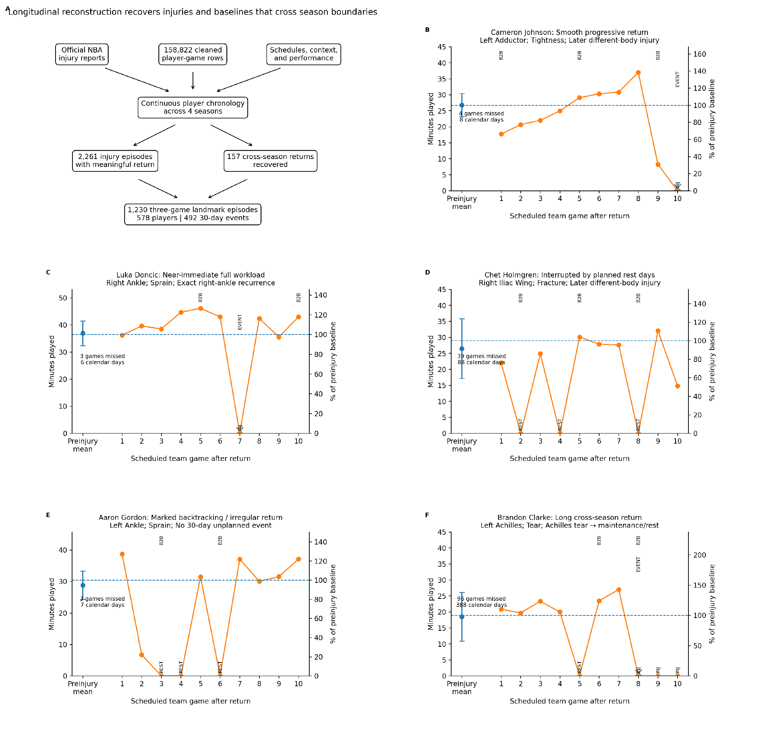
Figure 1. Longitudinal reconstruction captures clinically distinct return-to-play trajectories, including cross-season injuries. A, Continuous chronology links official injury reports, game data, schedules, and performance across four seasons rather than truncating episodes at season boundaries. B-F, Representative trajectories were selected to illustrate visibly different return shapes: smooth progressive restoration, near-immediate full workload with exact recurrence, planned-rest interruption, marked backtracking/irregularity, and a long cross-season return. The preinjury point shows the preceding 10-game mean with variability; the dashed line marks the player-specific baseline. Left axes show raw minutes and right axes the same minutes as percent of baseline. Scheduled rest/recovery games appear at 0 minutes. Calendar days to competitive return can include offseason time and are not equivalent to biological healing duration.
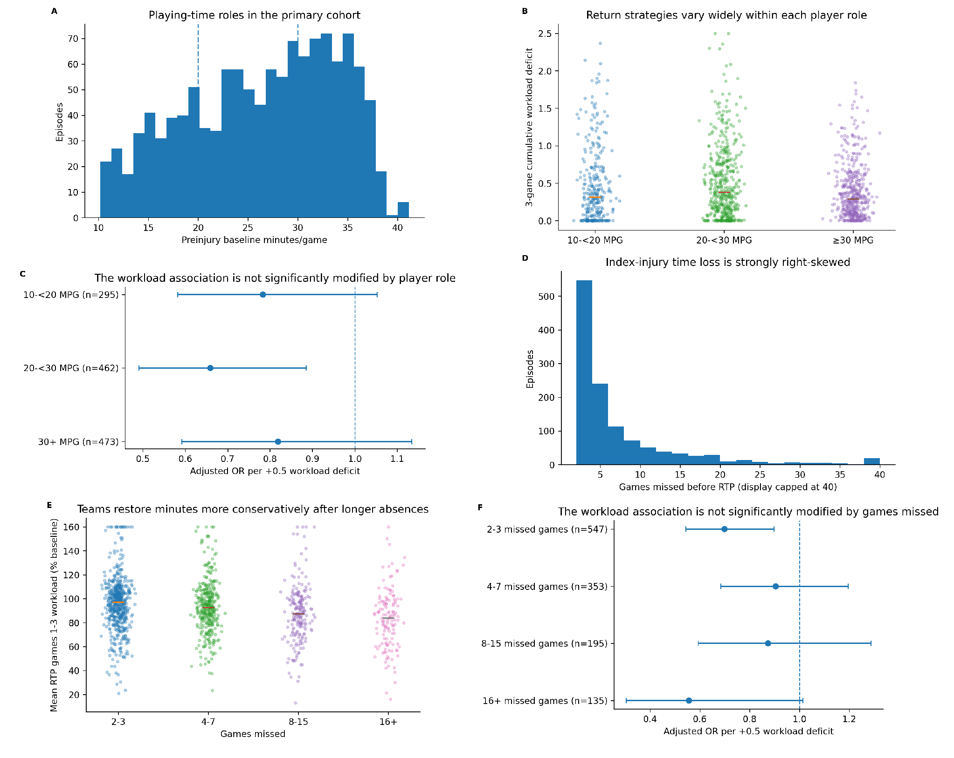
Figure 2. Player role and injury severity influence how minutes are restored but do not explain the workload association. A, Baseline-minutes distribution using clinically interpretable 10-<20, 20-<30, and >=30 MPG groups. B, Individual episode workload deficits by role group. C, Adjusted workload estimates across role groups; the global interaction is not significant. D, Distribution of games missed. E, Individual early workload by games-missed group, showing more conservative restoration after longer absences. F, Adjusted workload estimates across severity groups; the global interaction is not significant. Strip plots show individual episodes with a median marker rather than boxplots.
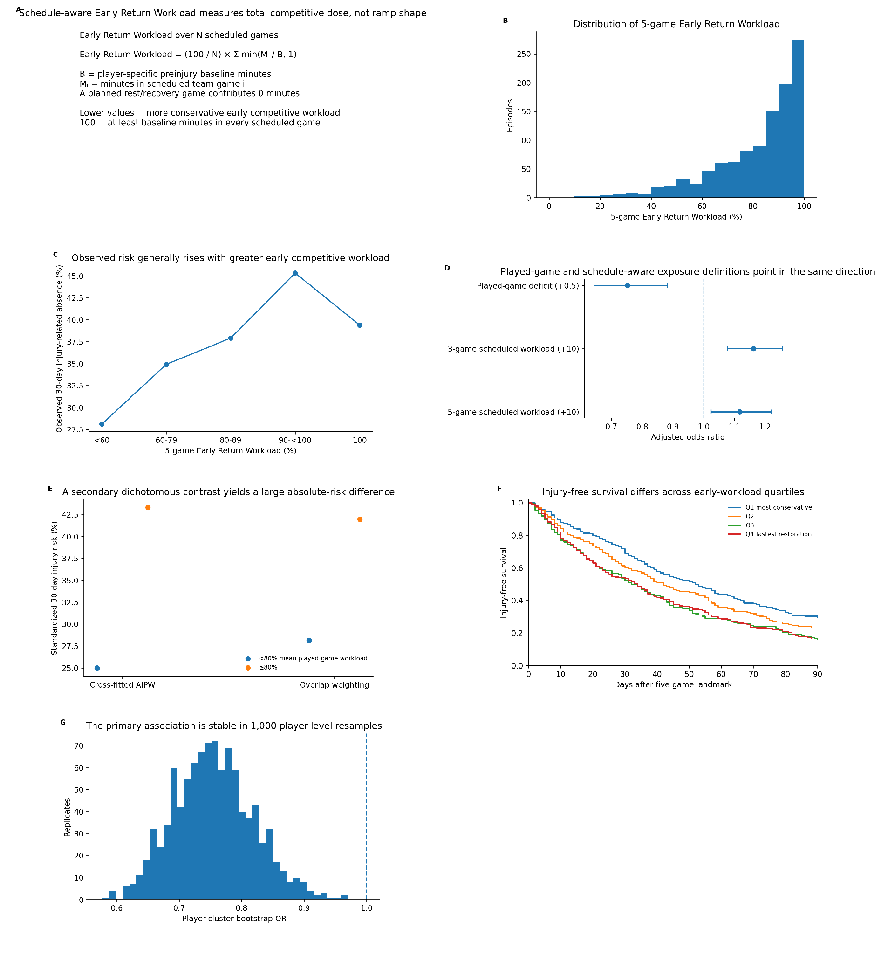
Figure 3. Lower early competitive workload is associated with lower subsequent injury-related absence across complementary exposure definitions. A, Definition of schedule-aware Early Return Workload; planned rest/recovery games count as 0 minutes and each played game is capped at 100% of baseline. B, Distribution of 5-game Early Return Workload. C, Observed 30-day risk across workload bands; no band is proposed as a clinical threshold. D, Adjusted played-game and scheduled-game exposure estimates. E, Standardized risks from cross-fitted AIPW and overlap weighting for the secondary <80% versus >=80% mean played-game contrast. F, Kaplan-Meier injury-free survival by Early Return Workload quartile over 90 days. G, Distribution of 1,000 player-cluster bootstrap estimates for the primary played-game association.
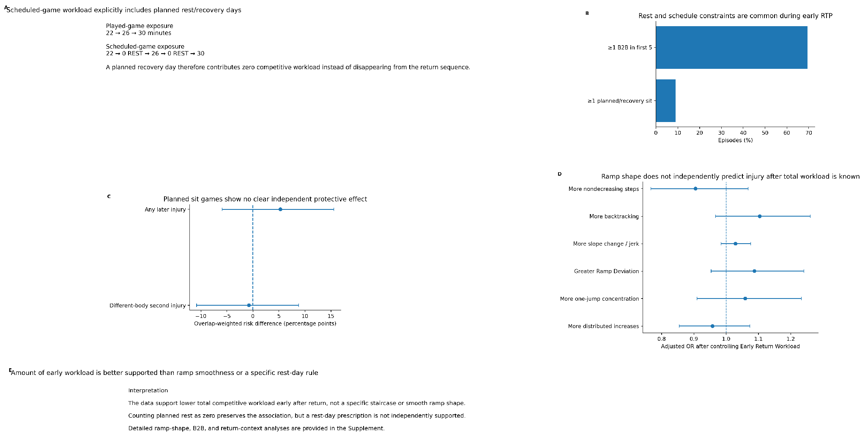
Figure 4. Total early competitive workload is better supported than ramp smoothness or a specific rest-day rule. A, Played-game exposure omits nonplayed scheduled games, whereas schedule-aware exposure counts planned recovery as 0 minutes. B, Frequency of B2B exposure and planned/recovery sits in the early return window. C, Overlap-weighted risk differences show no clear independent protective effect of planned sits. D, Ramp-shape metrics-including monotonicity, backtracking, slope change, Ramp Deviation, one-jump concentration, and distributed increases-are null after total Early Return Workload is controlled. E, Interpretation. Detailed shape and weighting diagnostics are provided in Supplementary Figures S7 and S13.
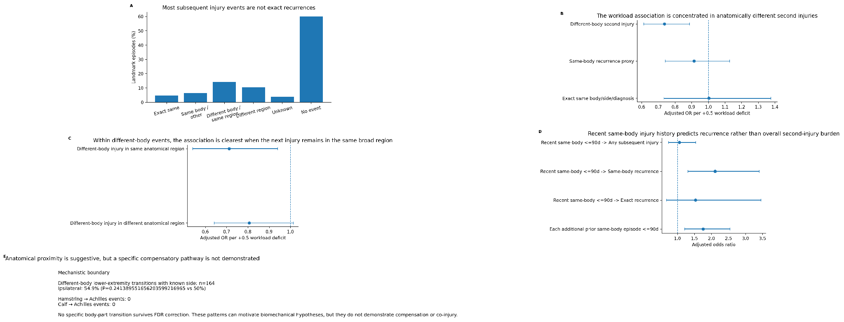
Figure 5. The workload association is clearer for anatomically different second injuries than for recurrence of the index injury. A, Classification of the first 30-day unplanned injury event. B, Adjusted workload estimates for different-body injury, same-body recurrence, and exact same-body/side/diagnosis recurrence. C, Recent same-body injury history predicts same-body recurrence, a distinct risk dimension from early workload. D, Player-cluster bootstrap stability for any unplanned injury and different-body second injury. E, Exploratory anatomical proximity: same-region different-body injury shows the clearer association, while specific compensatory chains are not established. Full transition and laterality analyses are in Supplementary Figure S9.
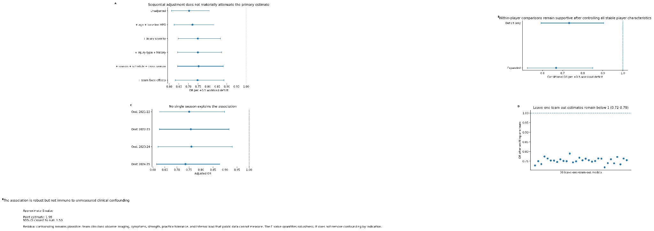
Figure 6. The primary association remains stable under increasingly stringent attempts to explain it away. A, Sequential covariate adjustment. B, Within-player conditional logistic regression, which conditions out stable player characteristics. C-D, Leave-one-season and leave-one-team influence analyses. E, Player-cluster bootstrap distribution. F, Approximate E-value sensitivity to unmeasured confounding. Prediction, calibration, and falsification analyses are provided in Supplementary Figures S10-S11.
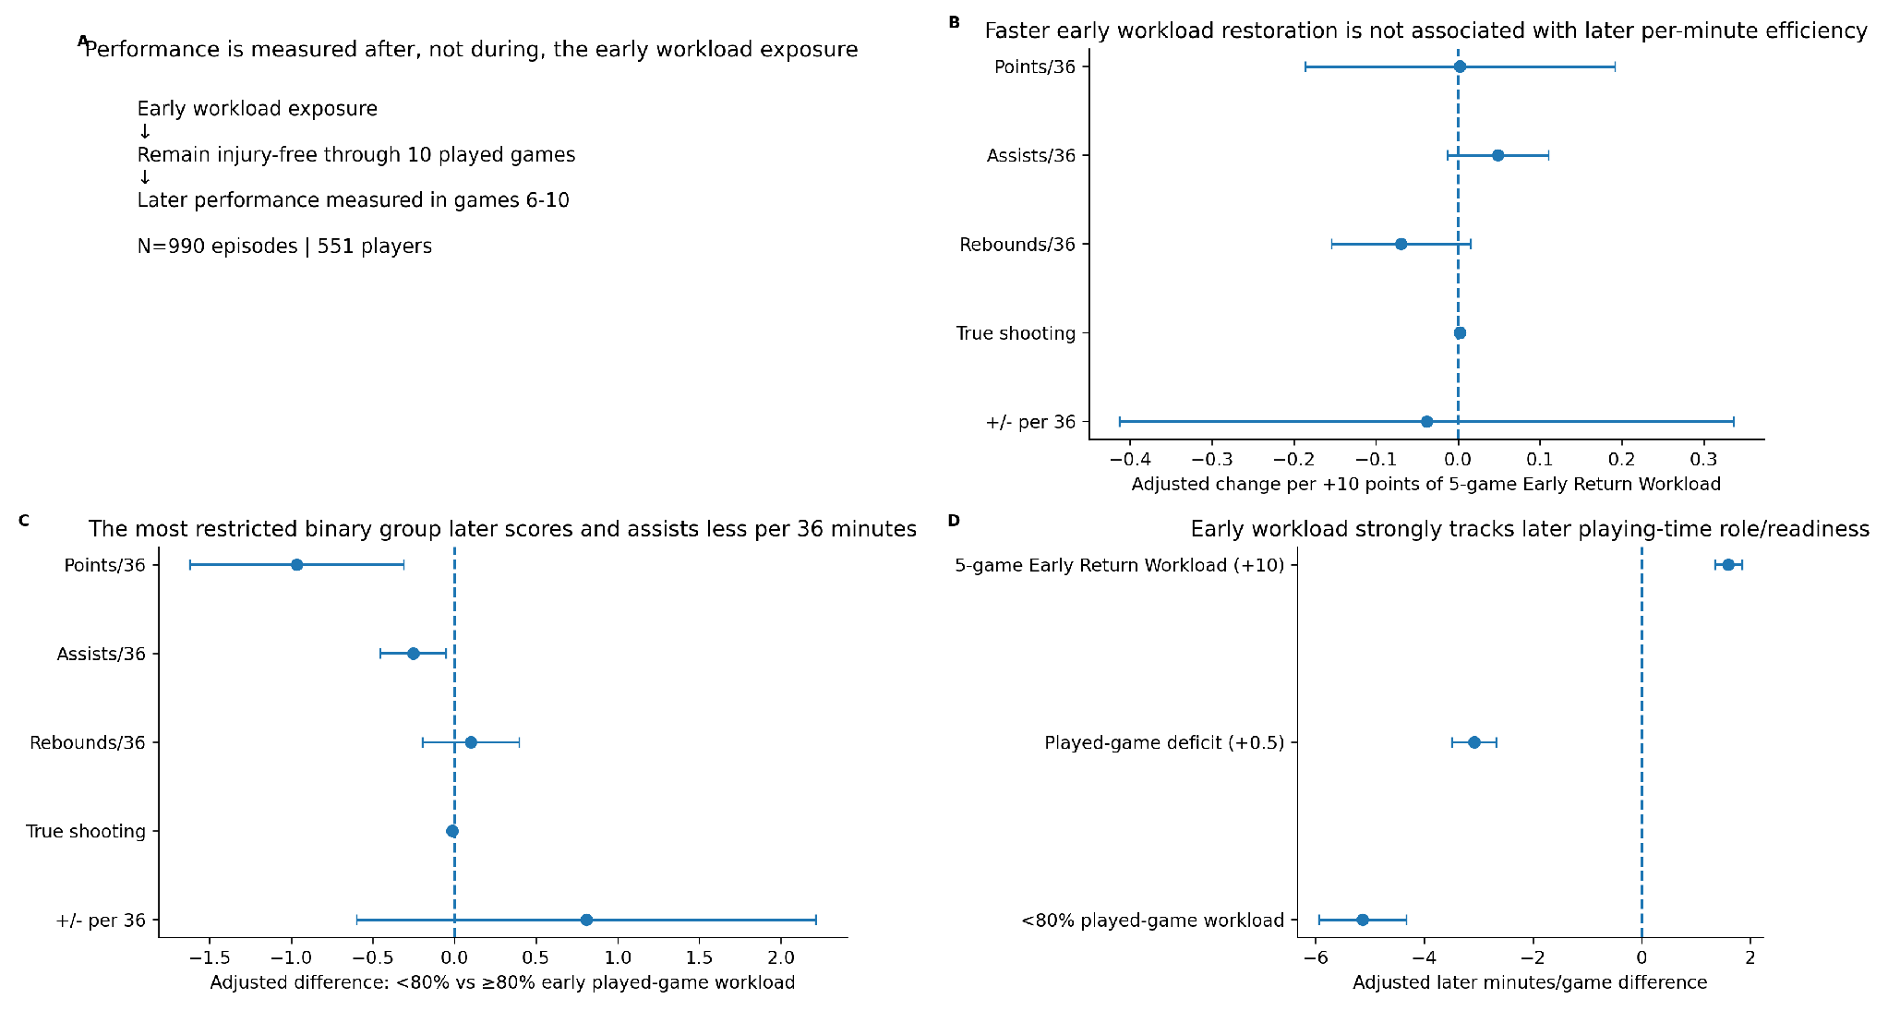
Figure 7. Early workload is strongly related to later playing-time role but not to broad later per-minute efficiency. A, Performance analysis design: workload exposure precedes performance measurement in games 6-10 among players injury-free through 10 played games. B, Continuous 5-game Early Return Workload is not associated with later points/36, assists/36, rebounds/36, true shooting, or plus-minus/36 after corresponding preinjury performance adjustment. C, Early workload strongly tracks later minutes per game, consistent with latent readiness and role. D, Interpretation: conservative restoration may involve readiness or competitive tradeoffs, but the observational data do not establish a causal performance cost. Individual performance-change strip plots are in Supplementary Figure S12.

