Supplement to: NBA Players With Lower Early Workload After Injury Have Fewer Subsequent Injury-Related Absences
Expanded methods, cohort audits, sensitivity analyses, and complete secondary results

SUPPLEMENTARY METHODS

Longitudinal Episode Reconstruction
All player-game rows were ordered chronologically by player across the full four-season window. Consecutive injury-coded nonplayed scheduled games were linked into time-loss episodes even when the sequence crossed a season boundary. Meaningful return was the first subsequent appearance of at least 5 minutes. Cross-season status, baseline provenance, team changes, and persistence of the index injury descriptor were retained for sensitivity analysis. Calendar days to competitive return were not used as continuous biological-severity measures for cross-season injuries because offseason days may occur after medical recovery.

Initial Injury Descriptor and Subsequent Injury Classification
Index body part, laterality, diagnosis class, and region were taken from the first injury-report descriptor. A modal descriptor was retained during development but was not used in final recurrence definitions because acute diagnoses can evolve into rehabilitation labels. Subsequent events were classified using report-visible anatomy rather than clinical adjudication; thus exact recurrence is a proxy, not tissue-confirmed reinjury. Same-region and different-region different-body categories were exploratory approximations to anatomical proximity.

Early Return Workload and Ramp Shape
Schedule-aware Early Return Workload over N team games was 100/N times the sum of min(Mi/B,1), where B is the player-specific preinjury minutes baseline and Mi is minutes in scheduled team game i. Planned rest/recovery games were assigned 0 minutes. Ramp Deviation was 100 times the root-mean-square deviation between the observed game-level relative workload sequence and the straight line connecting the first and final workloads. Additional shape features captured monotonicity, backtracking, excess variation, curvature/jerk, jump concentration, and timing/distribution of increases. Shape models were estimated both alone and after total workload adjustment.

Planned Rest and Schedule Analyses
Explicit planned recovery/management sits were identified from report terms including management, recovery, reconditioning, return to competition, maintenance, rehabilitation, conditioning, or rest. A broader probable B2B management proxy required a same-body injury-coded B2B sit bracketed by played games. Overlap weighting used measured player role, injury severity/history, schedule, and context variables. Generic B2B timing was examined with within-episode case-crossover models.

Statistical Hierarchy
The central inferential analysis was the three-played-game cumulative workload-deficit model in the corrected longitudinal cohort. Schedule-aware workload, role thresholds, starter status, exact injury subgroups, ramp shape, return context, transition pairs, prediction, and performance were secondary or exploratory. Benjamini-Hochberg FDR correction was applied within logical analysis families. No threshold, window, or shape formula was promoted because it yielded the smallest P value.

SUPPLEMENTARY TABLES
Table S1. Longitudinal cohort construction and analysis denominators.
Cohort stage | N | Definition / note
Original validated injury-related time-loss episodes | 2,589 | Source injury extraction
Longitudinal injury episodes with meaningful return | 2,261 | Return >=5 min; season boundary allowed
Primary-eligible longitudinal RTP episodes | 1,838 | >=5 preinjury played games; baseline >=10 MPG
Primary-eligible cross-season returns | 138 | Index injury and meaningful return in different seasons
Primary episodes using prior-season baseline game(s) | 152 | Allows early-season baseline reconstruction
Three-played-game landmark with complete 30-day follow-up | 1,230 | Primary analysis cohort
Unique players in primary landmark | 578 | Players may contribute multiple episodes
30-day unplanned injury-related absences | 492 | Primary outcome
Five-scheduled-game cohort with complete 30-day follow-up | 1,092 | Secondary schedule-aware analysis
Meaningful RTP is the first appearance of at least 5 minutes. The longitudinal correction is treated as a data-structure correction rather than an outcome-driven sensitivity because season truncation systematically prevents cross-season linkage.
Table S2. Alternative baseline-playing-time definitions show that apparent role heterogeneity is not stable across cut points.
Definition family | Stratum / interaction | N | Events | Effect (95% CI) | P | FDR q
role_10-20-30 | 10-<20 | 295 | 104 | 0.78 (0.58-1.05) | .105 | .157
role_10-20-30 | 20-<30 | 462 | 173 | 0.66 (0.49-0.88) | .006 | .017
role_10-20-30 | 30+ | 473 | 215 | 0.82 (0.59-1.13) | .229 | .229
role_interactions | 10-20-30 global interaction | 1230 | 492 |  | .250 | .250
role_10-18-26-34 | 10-<18 | 213 | 71 | 0.79 (0.54-1.16) | .232 | .309
role_10-18-26-34 | 18-<26 | 334 | 125 | 0.63 (0.44-0.93) | .018 | .063
role_10-18-26-34 | 26-<34 | 447 | 184 | 0.73 (0.55-0.97) | .032 | .063
role_10-18-26-34 | 34+ | 236 | 112 | 1.23 (0.73-2.08) | .436 | .436
role_interactions | 10-18-26-34 global interaction | 1230 | 492 |  | .049 | .148
role_quartiles | Q1 | 308 | 113 | 0.75 (0.55-1.01) | .054 | .072
role_quartiles | Q2 | 307 | 105 | 0.60 (0.39-0.92) | .019 | .072
role_quartiles | Q3 | 306 | 128 | 0.73 (0.53-1.00) | .052 | .072
role_quartiles | Q4 | 309 | 146 | 1.03 (0.65-1.63) | .891 | .891
role_interactions | quartiles global interaction | 1230 | 492 |  | .167 | .250
The main manuscript uses 10-<20, 20-<30, and >=30 MPG for clinical readability. Alternative equal-width and quartile definitions are sensitivity analyses. Interaction tests, not subgroup P values, determine evidence of effect modification.
Table S3. Starter/bench status and return-from-bench analyses.
Analysis | N | Events | Effect (95% CI) | P
Workload x usual starter | 929 | 360 | 0.90 (0.64-1.26) | .537
Usual bench | 359 | 126 | 0.80 (0.59-1.09) | .165
Usual starter | 570 | 234 | 0.73 (0.57-0.93) | .011
Usual starter returned from bench | 570 | 234 | 0.77 (0.46-1.27) | .301
Usual starter returned from bench + workload | 570 | 234 | 1.01 (0.57-1.77) | .974
Starter information is unavailable for one source season. Returning a usual starter from the bench is interpreted as a descriptive conservative-management phenotype rather than an independently protective intervention.
Table S4. Injury-severity strata and fine clinical adjustment.
Family | Analysis | N | Events | Effect (95% CI) | P | FDR q
severity_gamesmiss | 2-3 missed games | 547 | 238 | 0.70 (0.54-0.90) | .005 | .026
severity_gamesmiss | 4-7 missed games | 353 | 151 | 0.90 (0.68-1.20) | .480 | .495
severity_gamesmiss | 8-15 missed games | 195 | 60 | 0.87 (0.59-1.29) | .495 | .495
severity_gamesmiss | 16+ missed games | 135 | 43 | 0.55 (0.30-1.01) | .055 | .139
severity_gamesmiss | Games-missed group interaction | 1230 | 492 |  | .308 | .495
clinical_fixed_effects | Fine body-part + diagnosis + games missed | 1230 | 492 | 0.75 (0.64-0.88) | <.001 | <.001
clinical_fixed_effects | Body/dx cells + games missed | 1230 | 492 | 0.73 (0.63-0.86) | <.001 | <.001
The body-part/diagnosis fixed-effect and cell models directly address confounding from comparing clinically dissimilar injuries.
Table S5. Cross-season and prior-season-baseline sensitivity analyses.
Analysis | N | Events | Effect (95% CI) | P
Played3 workload x cross-season return | 1230 | 492 | 1.18 (0.78-1.81) | .434
5-game Early Return Workload × cross-season return | 1092 | 425 | 1.03 (0.80-1.31) | .840
Baseline entirely in injury season | 1090 | 446 | 0.84 (0.71-0.99) | .035
Same-season return and baseline | 960 | 391 | 0.82 (0.68-0.98) | .030
Cross-season reconstruction broadens severe-injury coverage. Restricting to same-season returns and baselines preserves the primary direction.
Table S6. Early Return Workload windows and ramp-shape analyses.
Analysis | N | Effect (95% CI) | P
Early Return Workload-3 per +10 points | 1238 | 1.16 (1.08-1.26) | <.001
Early Return Workload-5 per +10 points | 1092 | 1.12 (1.02-1.22) | .013
Early Return Workload-7 per +10 points | 981 | 1.06 (0.97-1.16) | .179
Early Return Workload-10 per +10 points | 803 | 1.07 (0.97-1.17) | .164
Shape: Net slope, +10 percentage-points/game | 1092 | 0.95 (0.78-1.16) | .598
Shape: Monotonic transitions, +25 percentage points | 1092 | 0.90 (0.77-1.07) | .236
Shape: Backtracking, +25% baseline-minutes | 1092 | 1.10 (0.97-1.26) | .144
Shape: Excess variation, +25% baseline-minutes | 1092 | 1.04 (0.98-1.11) | .219
Shape: Curvature, +25% baseline-minutes | 1092 | 1.03 (0.98-1.08) | .210
Shape: Linear-fit RMSE, +10% baseline | 1092 | 1.11 (0.94-1.32) | .209
Shape: Endpoint-line RMSE, +10% baseline | 1092 | 1.09 (0.95-1.24) | .212
Shape: Jump concentration, +0.25 HHI | 966 | 1.06 (0.91-1.23) | .459
Shape: Graduality score, +25 points | 966 | 0.96 (0.85-1.07) | .459
Shape: Increase timing, +1 game later | 966 | 1.14 (0.97-1.34) | .112
Shape: Shape composite, +1 SD smoother | 966 | 0.86 (0.69-1.07) | .181
Longer natural landmarks select progressively different survivor cohorts. Shape estimates are adjusted for total 5-game Early Return Workload; none supports a specific smooth-ramp prescription.
Table S7. Planned-rest overlap-weight balance.
Covariate | SMD before weighting | SMD after overlap weighting
age_return | 0.267 | 0.006
baseline_minutes | 0.401 | 0.012
games_missed | 0.475 | 0.036
prior_injury_episodes | -0.002 | -0.000
recent_samebody | 0.267 | 0.005
return_b2b | -0.245 | -0.003
return_home | -0.175 | -0.005
return_travel_km | 0.190 | 0.004
cross_season_return | -0.069 | -0.007
baseline_uses_prior_season | 0.079 | 0.000
Absolute standardized mean differences near zero after weighting indicate excellent balance in measured numeric determinants of planned-rest selection.
Table S8. Corrected return-context estimates.
Return-context analysis | N | Events | Effect (95% CI) | P | FDR q
Return game at home | 1230 | 492 | 0.74 (0.58-0.96) | .021 | .127
Return game on B2B | 1230 | 492 | 1.21 (0.86-1.68) | .274 | .411
Second played RTP game at home | 1230 | 492 | 0.92 (0.71-1.19) | .508 | .610
Third played RTP game at home | 1230 | 492 | 0.97 (0.77-1.23) | .827 | .827
Second played RTP game on B2B | 1230 | 492 | 1.28 (0.90-1.82) | .172 | .411
Third played RTP game on B2B | 1230 | 492 | 0.83 (0.61-1.12) | .220 | .411
Return context is exploratory. The earlier B2B signal weakened after longitudinal reconstruction and no return-context estimate remains significant after family FDR correction.
Table S9. Recent-injury history and anatomical-proximity analyses.
Analysis | N | Events | Effect (95% CI) | P | FDR q
Recent same-body <=90d -> Any subsequent injury | 1230 | 492 | 1.06 (0.73-1.53) | .759 | .759
Recent same-body <=90d -> Same-body recurrence | 1230 | 140 | 2.11 (1.31-3.40) | .002 | .006
Recent same-body <=90d -> Exact recurrence | 1230 | 59 | 1.53 (0.68-3.46) | .305 | .407
Each additional prior same-body episode <=90d | 1230 | 140 | 1.76 (1.21-2.54) | .003 | .006
Different-body injury in same anatomical region | 1230 | 178 | 0.71 (0.54-0.94) | .016 | .032
Different-body injury in different anatomical region | 1230 | 174 | 0.81 (0.64-1.01) | .065 | .065
Recent same-body history primarily stratifies recurrence risk. Same-region different-body injury is exploratory; no specific biomechanical relation can be inferred from public report anatomy.
Table S10. Player-cluster bootstrap summaries.
Analysis | valid | Median OR | 2.5th percentile | 97.5th percentile | prop_lt1 | prop_gt1
Three-game workload deficit — any unplanned injury | 1000 | 0.753 | 0.639 | 0.889 | 100.0% | 0.0%
Three-game workload deficit — different-body second injury | 1000 | 0.735 | 0.604 | 0.855 | 100.0% | 0.0%
5-game Early Return Workload — any unplanned injury | 1000 | 1.119 | 1.023 | 1.241 | 0.5% | 99.5%
5-game Early Return Workload — different-body second injury | 1000 | 1.122 | 1.016 | 1.263 | 1.4% | 98.6%
Bootstrap replicates resampled players rather than episodes to preserve within-player clustering.
Table S11. Prediction validation demonstrates modest discrimination.
Validation | Model | n | events | AUC | brier
grouped_5fold | 5-game Early Return Workload only | 1092 | 425 | 0.554350471822912 | 0.235765213059423
grouped_5fold | clinical only | 1092 | 425 | 0.5743998588940823 | 0.2388468619084904
grouped_5fold | clinical plus 5-game Early Return Workload | 1092 | 425 | 0.582100714348708 | 0.2382270609371707
grouped_5fold | clinical plus uncapped 5-game workload | 1092 | 425 | 0.5832507275773878 | 0.2375699557354724
temporal_2024-25 | 5-game Early Return Workload only | 262 | 110 | 0.5327153110047846 | 0.2468438661038474
temporal_2024-25 | clinical only | 262 | 110 | 0.5843301435406699 | 0.2450009935005518
temporal_2024-25 | clinical plus 5-game Early Return Workload | 262 | 110 | 0.5846291866028708 | 0.246421824102983
temporal_2024-25 | clinical plus uncapped 5-game workload | 262 | 110 | 0.5945574162679427 | 0.2446842929759076
Prediction is presented to distinguish population-level association from individual injury forecasting. Player grouping prevents the same player from appearing in both training and validation folds.
Table S12. Later performance sensitivity models.
Outcome | Exposure | N | Estimate (95% CI) | P | FDR q
points36 | 5-game Early Return Workload +10 | 990 | 0.003 (-0.186 to 0.191) | .979 | .979
points36 | Played3 deficit +0.5 | 990 | -0.333 (-0.691 to 0.024) | .068 | .152
points36 | <80% played3 workload | 990 | -0.966 (-1.619 to -0.312) | .004 | .017
assists36 | 5-game Early Return Workload +10 | 990 | 0.049 (-0.013 to 0.110) | .120 | .216
assists36 | Played3 deficit +0.5 | 990 | -0.126 (-0.235 to -0.016) | .024 | .072
assists36 | <80% played3 workload | 990 | -0.253 (-0.454 to -0.052) | .014 | .049
rebounds36 | 5-game Early Return Workload +10 | 990 | -0.069 (-0.154 to 0.016) | .109 | .216
rebounds36 | Played3 deficit +0.5 | 990 | 0.075 (-0.079 to 0.229) | .338 | .405
rebounds36 | <80% played3 workload | 990 | 0.100 (-0.196 to 0.396) | .507 | .571
ts | 5-game Early Return Workload +10 | 990 | 0.002 (-0.002 to 0.007) | .337 | .405
ts | Played3 deficit +0.5 | 990 | -0.008 (-0.017 to 0.000) | .056 | .143
ts | <80% played3 workload | 990 | -0.012 (-0.030 to 0.005) | .169 | .277
plusminus36 | 5-game Early Return Workload +10 | 990 | -0.038 (-0.413 to 0.336) | .841 | .891
plusminus36 | Played3 deficit +0.5 | 990 | 0.382 (-0.377 to 1.141) | .324 | .405
plusminus36 | <80% played3 workload | 990 | 0.807 (-0.598 to 2.213) | .260 | .390
mpg | 5-game Early Return Workload +10 | 990 | 1.597 (1.348 to 1.845) | <.001 | <.001
mpg | Played3 deficit +0.5 | 990 | -3.081 (-3.490 to -2.673) | <.001 | <.001
mpg | <80% played3 workload | 990 | -5.133 (-5.943 to -4.323) | <.001 | <.001
Performance was measured in played games 6-10 among episodes injury-free through 10 played games and adjusted for corresponding preinjury performance. This is a conditional survivor analysis, not a causal risk-benefit comparison.

SUPPLEMENTARY FIGURES
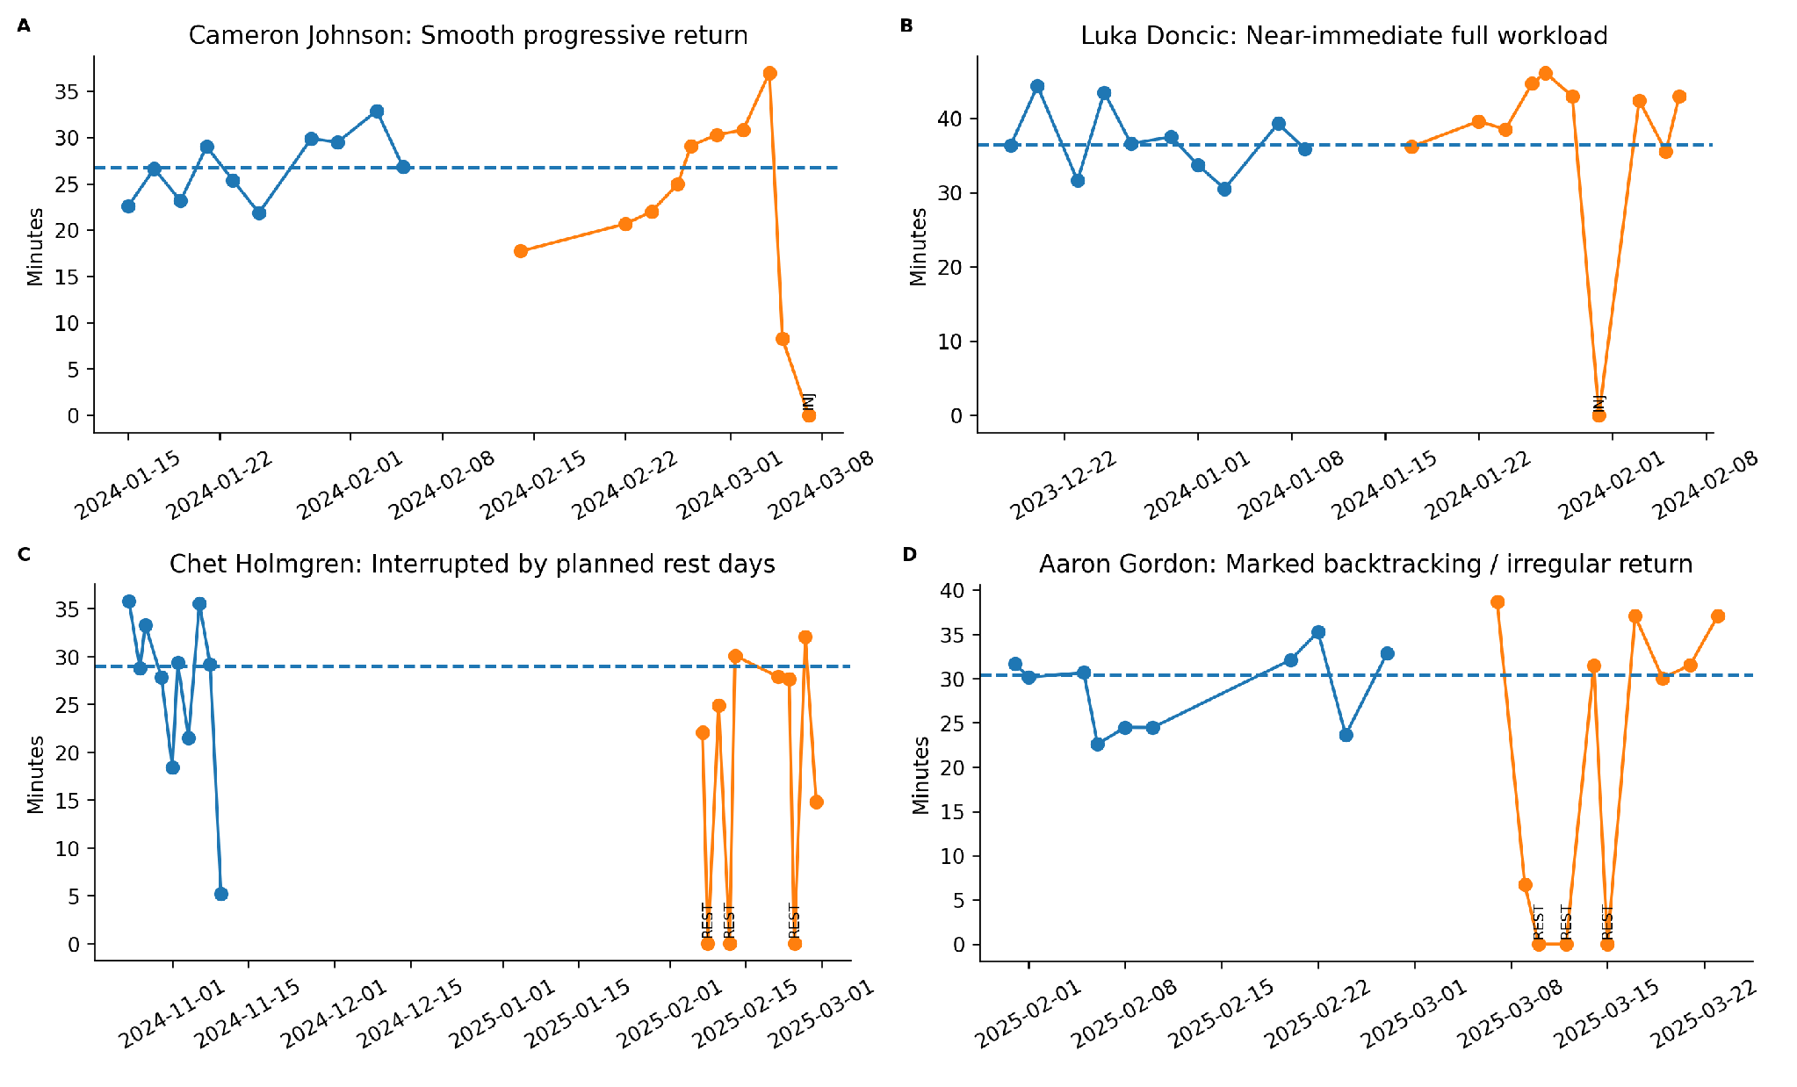
Figure S1. Calendar-time views of representative return trajectories. Calendar spacing emphasizes the difference between elapsed time and scheduled-game sequence; offseason time is descriptive and not biological healing duration.
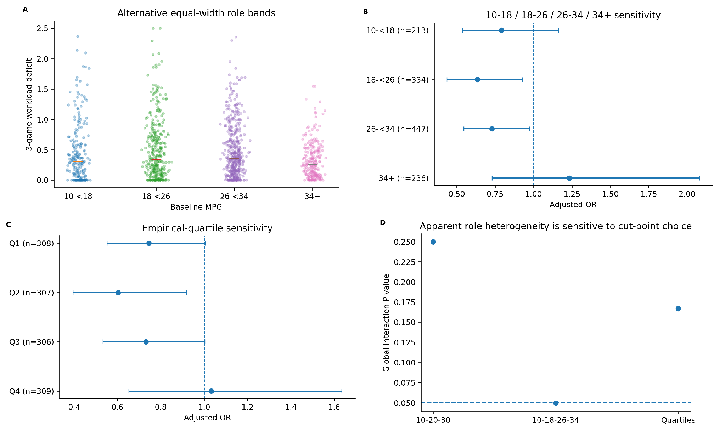
Figure S2. Player-role conclusions do not depend on a single set of minutes cut points. Alternative 10-18/18-26/26-34/34+ groups, empirical quartiles, and interaction tests are shown.
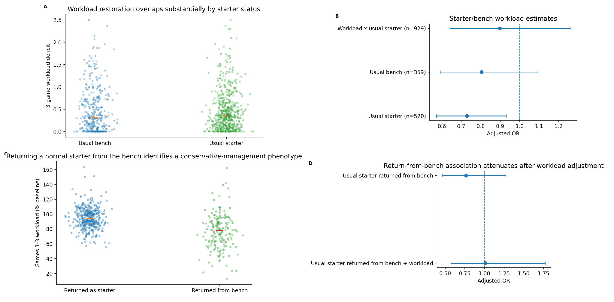
Figure S3. Starter/bench status describes management context but does not establish a distinct workload effect. Strip plots show individual return workloads and starters who initially returned from the bench.
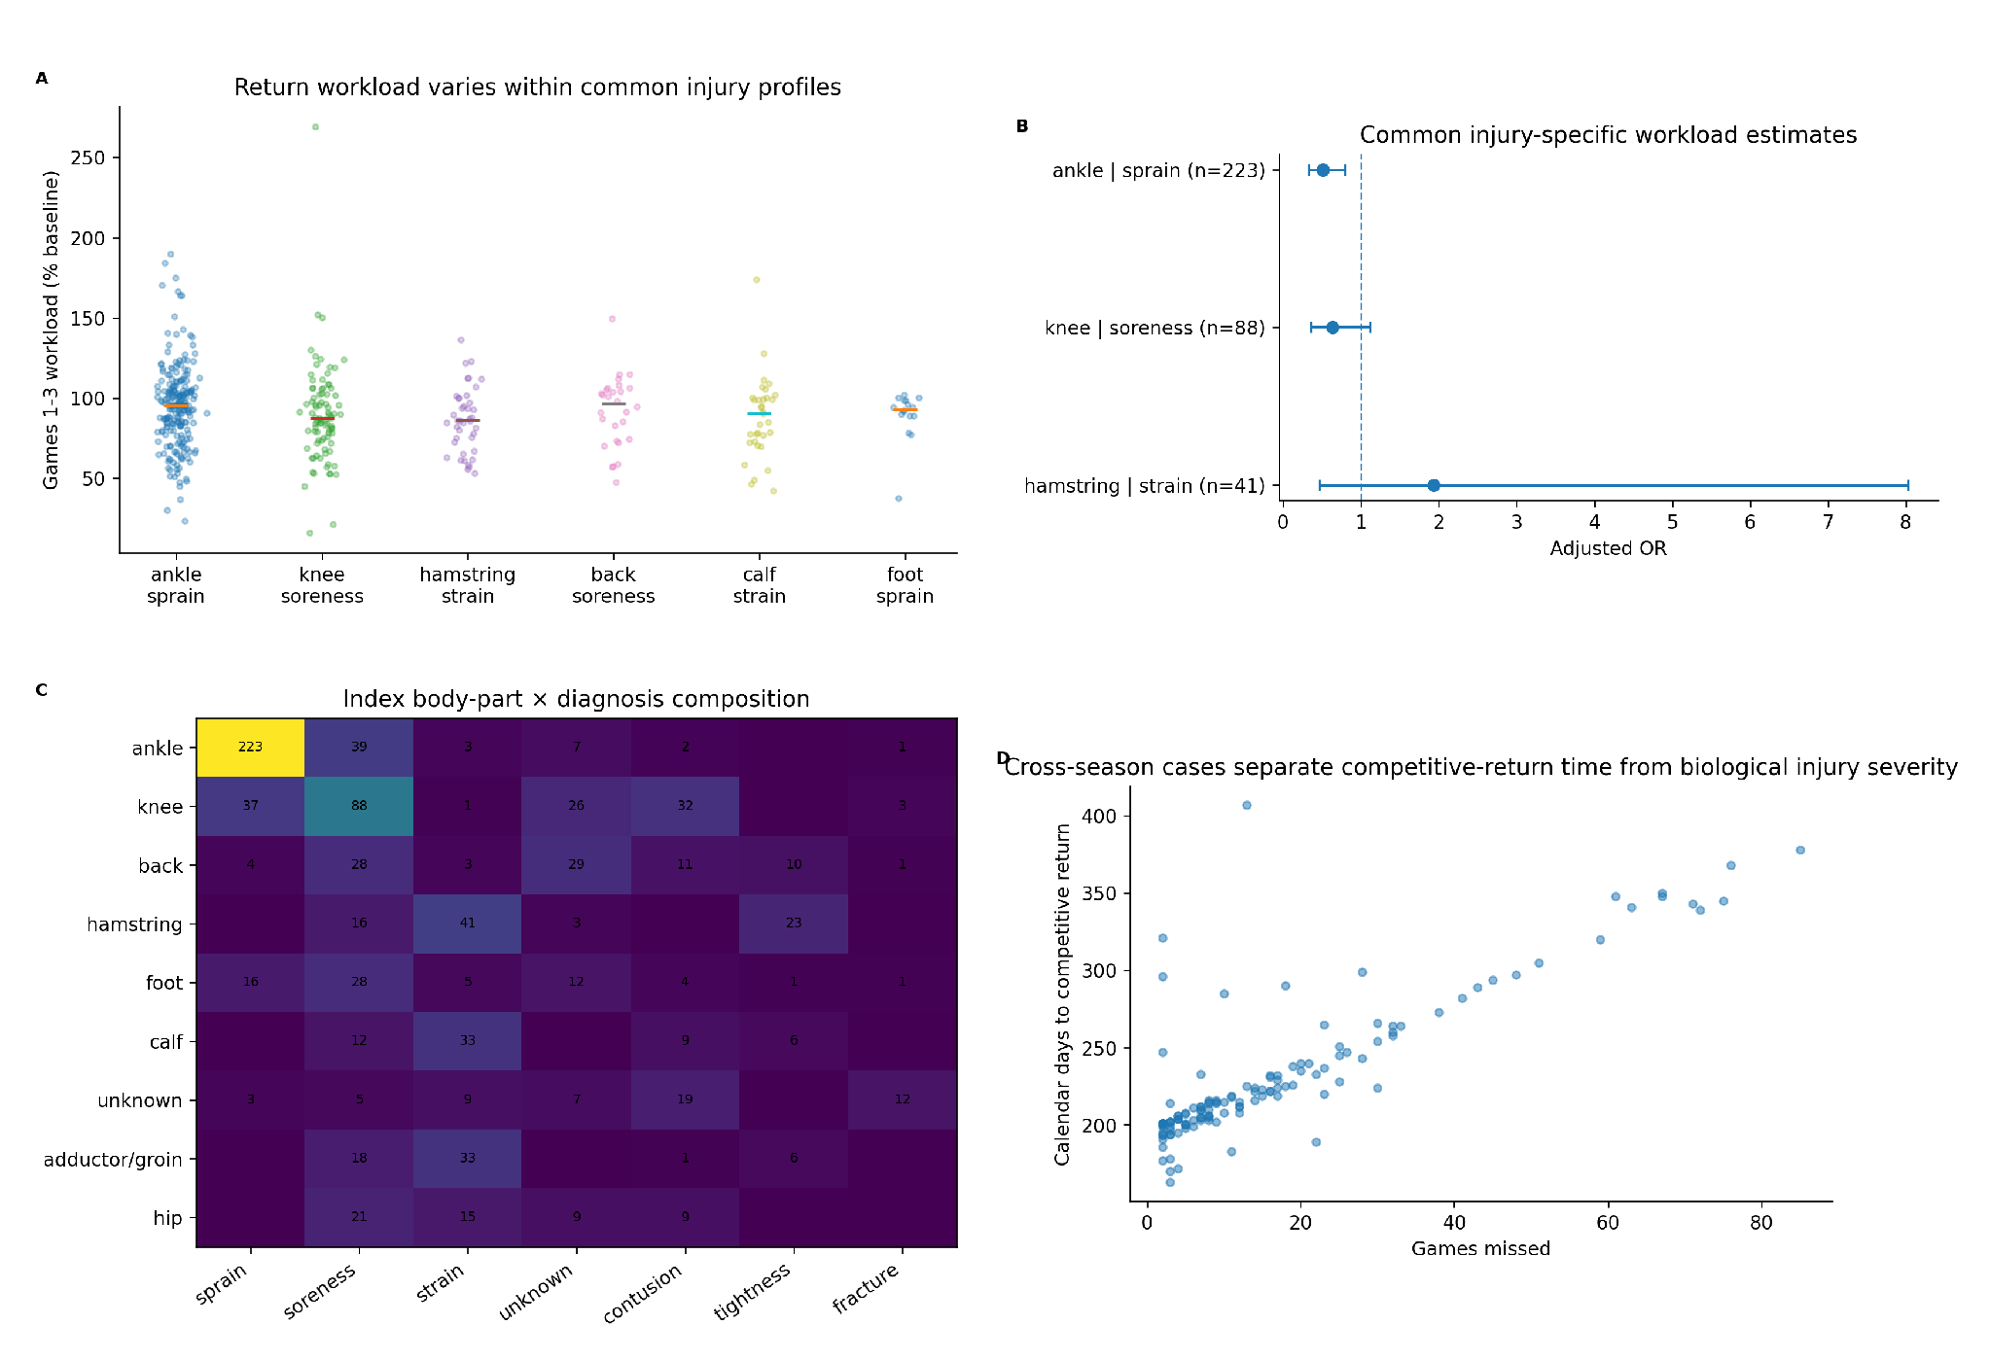
Figure S4. Workload restoration varies within common diagnoses, and cross-season reconstruction expands the long-injury tail. The body-part x diagnosis heatmap shows the composition of the primary cohort.
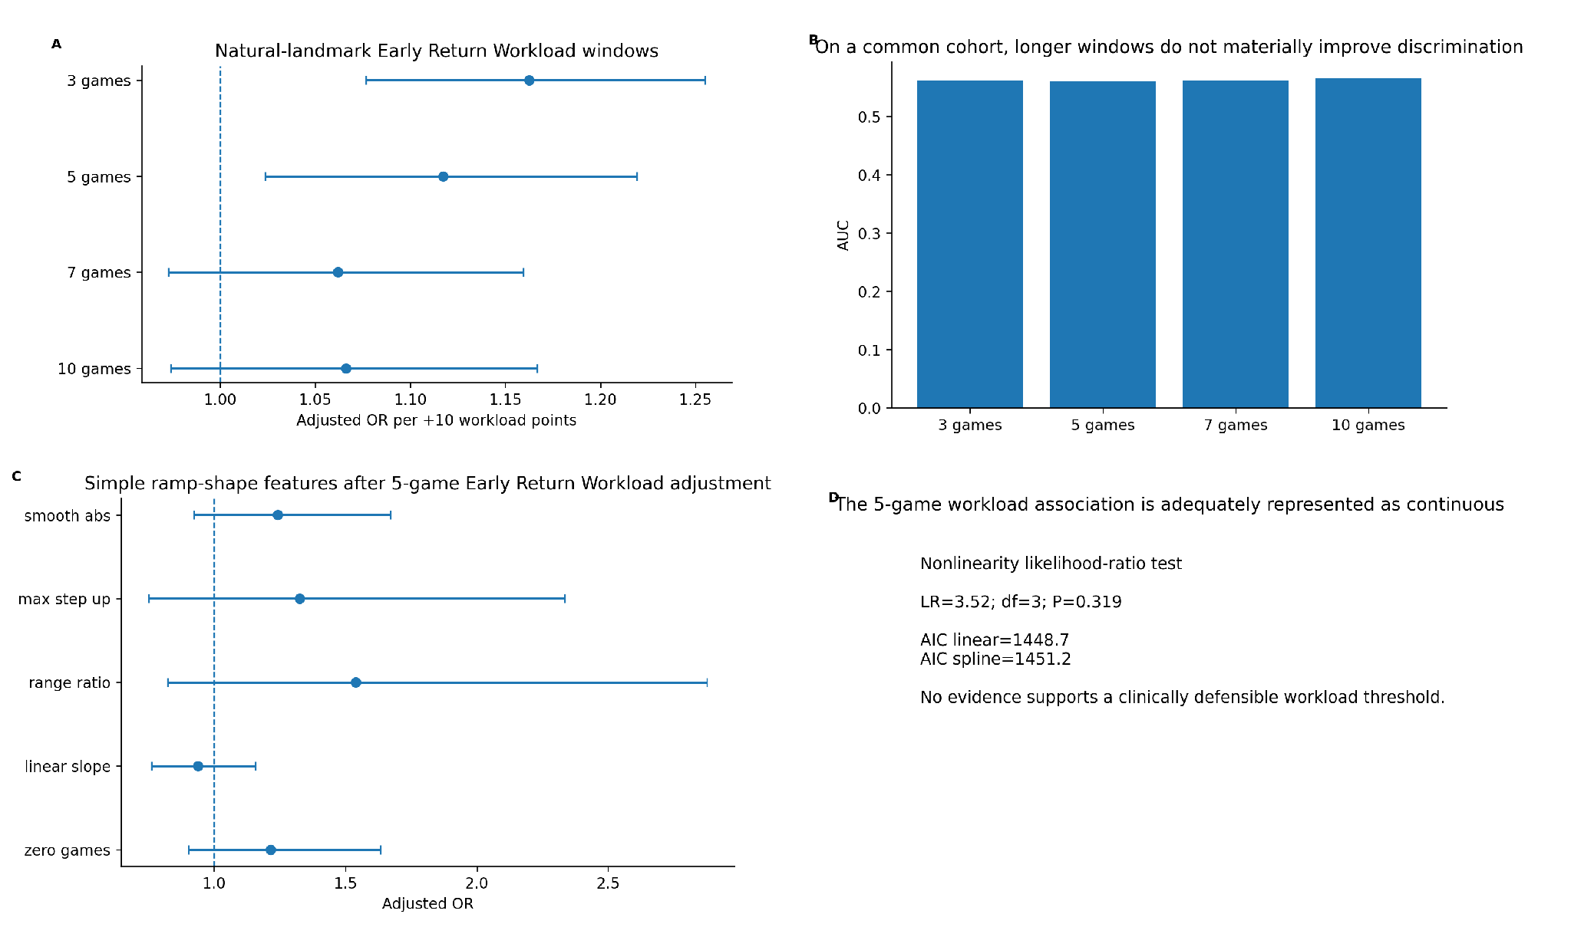
Figure S5. Alternative Early Return Workload windows and common-cohort comparisons do not support a unique optimized window or threshold. Longer landmarks increasingly condition on remaining injury-free.
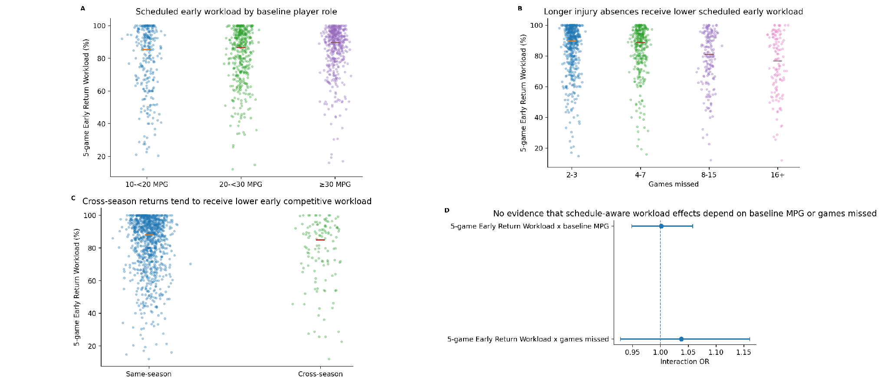
Figure S6. Individual Early Return Workload distributions by baseline role, games missed, and cross-season status. Interaction tests are null despite clear differences in how teams manage these groups.
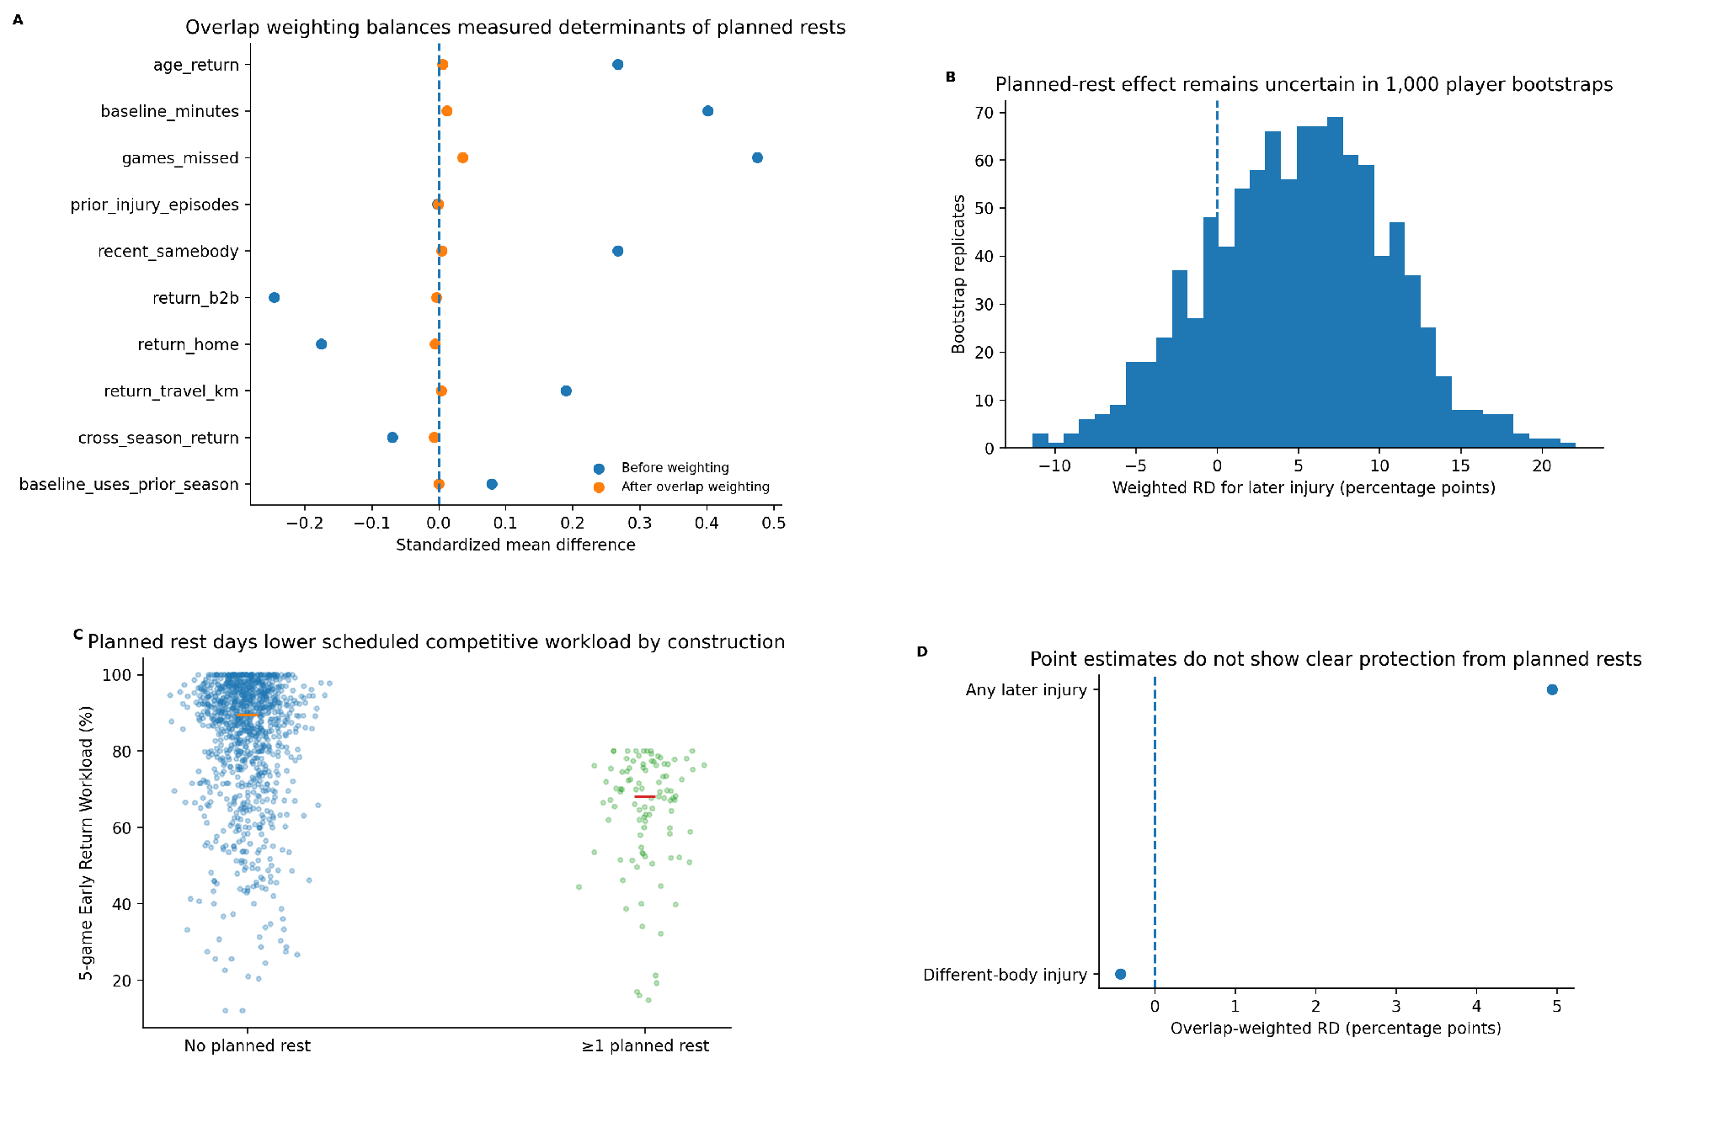
Figure S7. Planned-rest sensitivity analysis. Overlap weighting balances measured determinants of planned-rest selection; bootstrap risk differences remain imprecise and do not show clear independent protection.
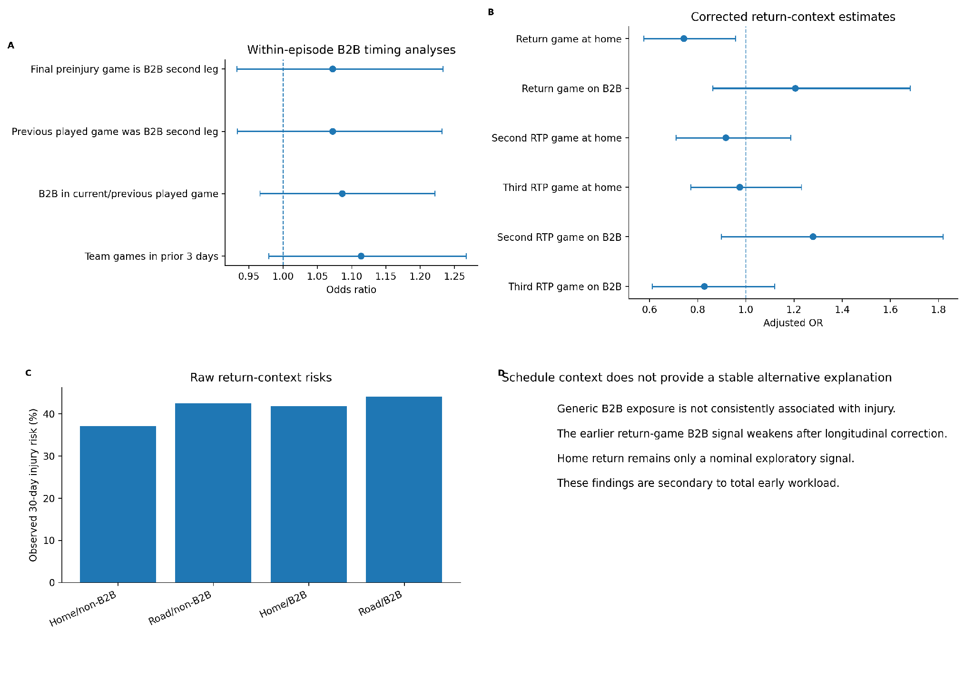
Figure S8. B2B and return-game context are secondary. Generic B2B timing is null in case-crossover analysis, and corrected return-context estimates do not survive family multiplicity correction.
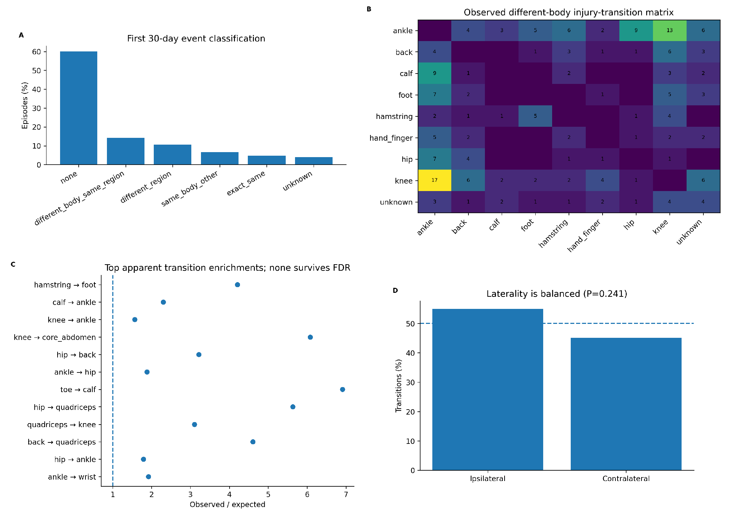
Figure S9. Secondary-injury transition screen. No specific body-part transition survives FDR correction and lower-extremity laterality is approximately balanced, arguing against a demonstrated specific compensation chain.
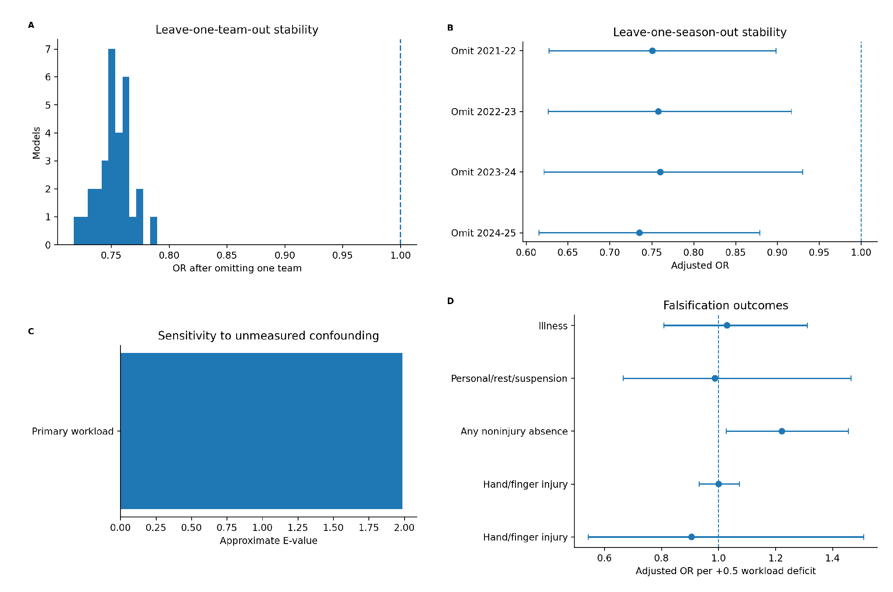
Figure S10. Influence, unmeasured-confounding sensitivity, and falsification analyses. The primary estimate is stable across team/season exclusions, while most falsification outcomes are null.
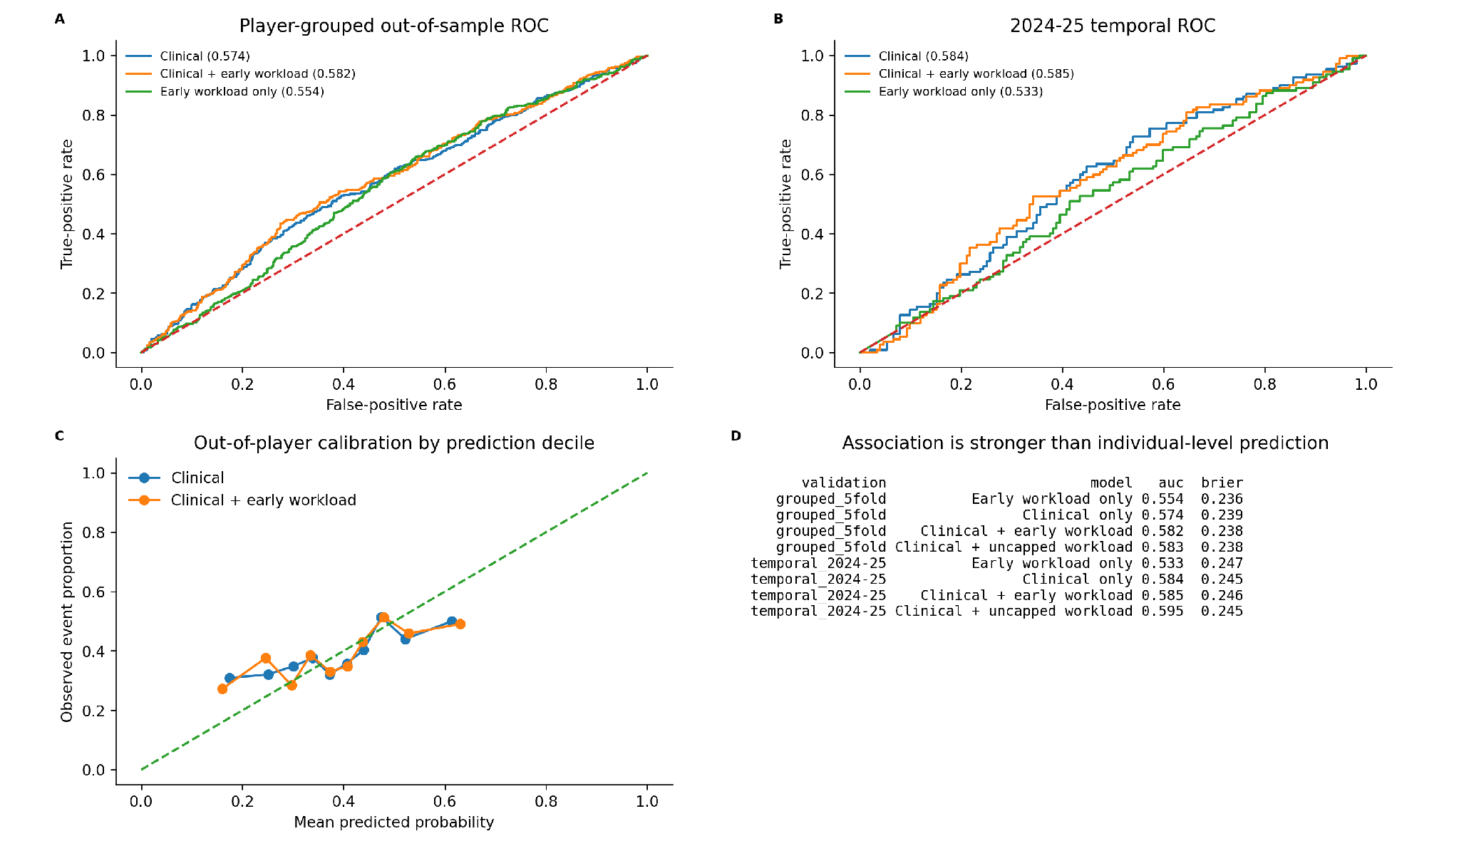
Figure S11. Prediction and calibration. Early Return Workload adds only modest discrimination beyond clinical variables in player-grouped and temporal validation.
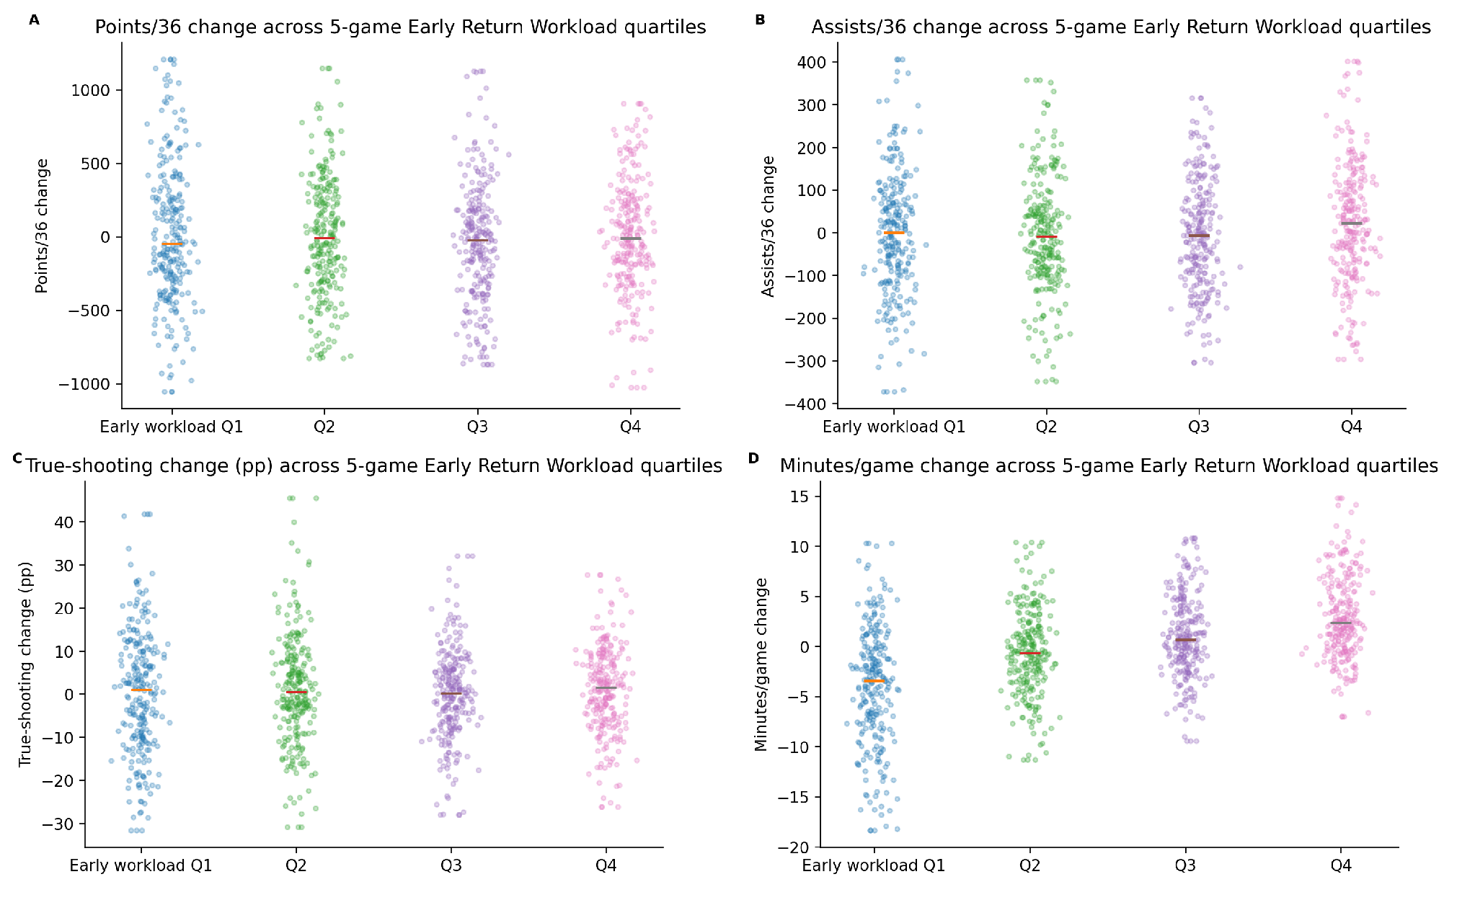
Figure S12. Individual later performance changes across Early Return Workload quartiles. Strip plots display episode-level variation rather than hiding it inside summary boxes.
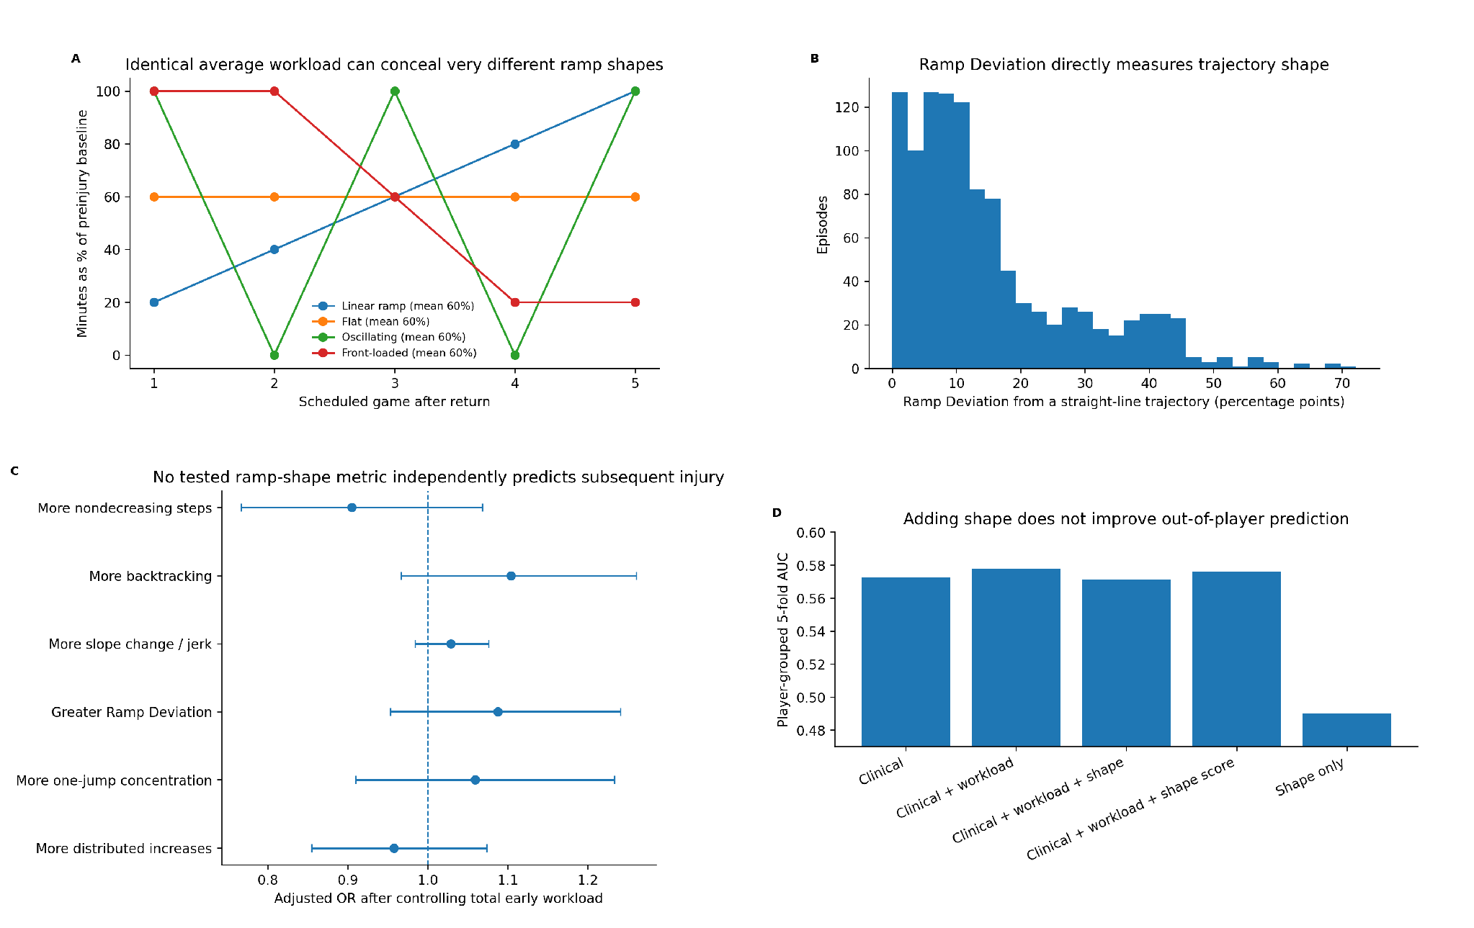
Figure S13. Total workload and ramp shape are distinct constructs. Identical average workloads can have very different trajectories; Ramp Deviation and other shape metrics do not independently predict injury after total Early Return Workload is controlled, and adding shape does not improve out-of-player prediction.

SUPPLEMENTARY REFERENCES
References are numbered according to the main manuscript.

