**Detail of Each Version**

Version 1.0

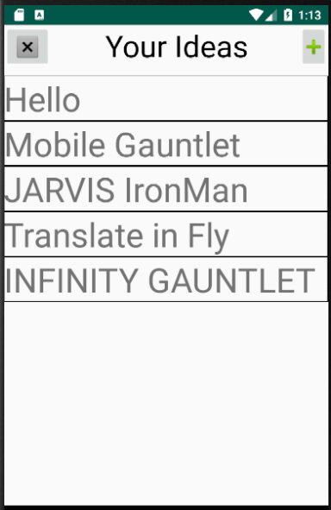MainActivity

Add Activity

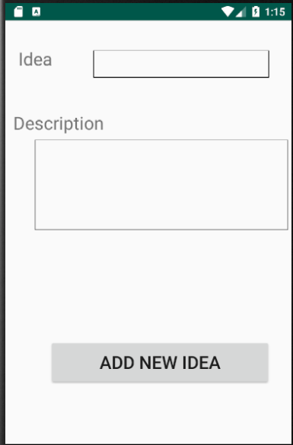

Functionality:

1. Adding Idea name and Description on Right Corner Plus button
2. Storing those ideas on SharedPreferences
3. Can Erase All Data with X button on Left Corner
4. Can Edit by pressing the idea name

Main Problem:

1. ScrollView that is used only can contain 13 ideas, more than 13 will crash the app
2. Delete all ideas is implemented but delete for a single idea is not yet implemented