Detail of Each Version
Version 1.0
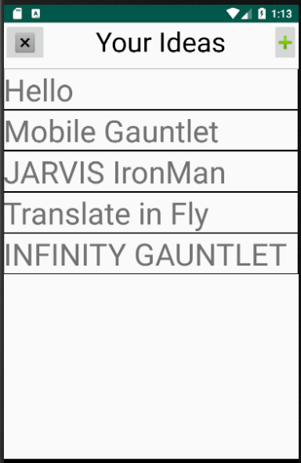
MainActivity

Add Activity
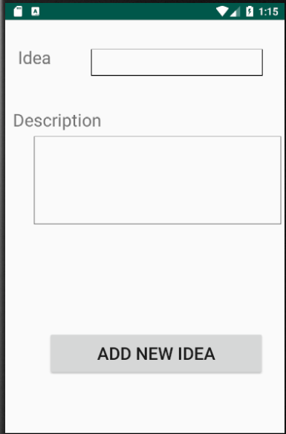
Functionality:
- Adding Idea name and Description on Right Corner Plus button
- Storing those ideas on SharedPreferences
- Can Erase All Data with X button on Left Corner
- Can Edit by pressing the idea name

Main Problem:
- ScrollView that is used only can contain 13 ideas, more than 13 will crash the app
- Delete all ideas is implemented but delete for a single idea is not yet implemented

