- Introduction
Hello and welcome to ELEC 2120 – Linear Signals and Systems Lab. Half of our experiments will be based on the Mathworks program Matlab. This is a high-level coding language intended to make matrix-based mathematics much easier. This lab procedure will begin with the basics of the program and the coding language. If you need assistance with the download and installation process, speak to your TA. This lab begins assuming you have the program successfully installed. This lab procedure is also written based on the PC application. Mac users may see things slightly differently, though the majority of functionality is the same.

Firstly, to open double click on or press enter after highlighting this icon (yours may not have trees in the background):


Figure 1: Matlab Desktop Icon

The first screen that appears is below in Figure 2. There are three main points of interest that are highlighted in Figure 3.

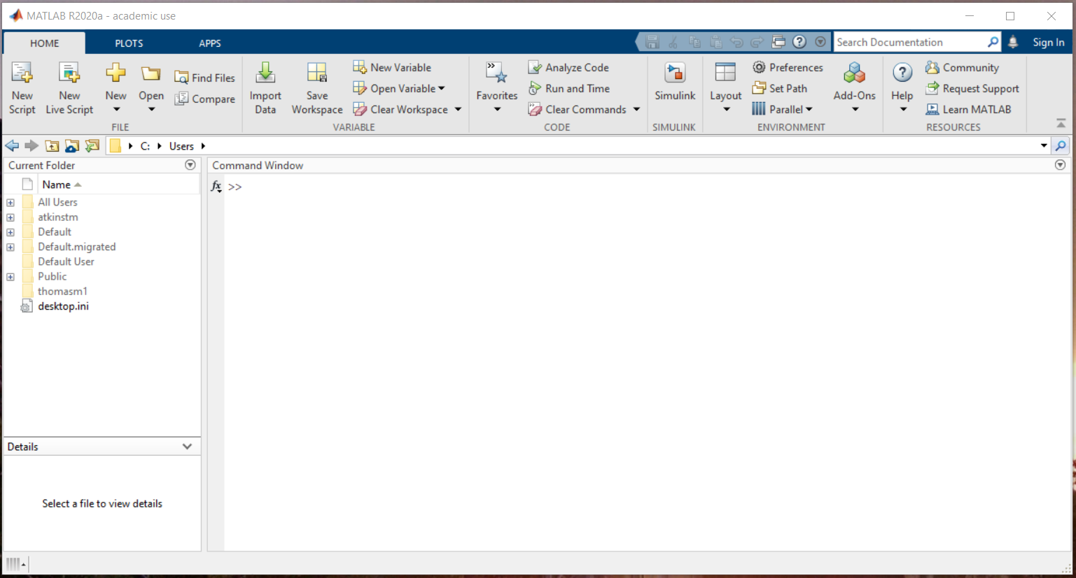
Figure 2: Opening Matlab User Interface

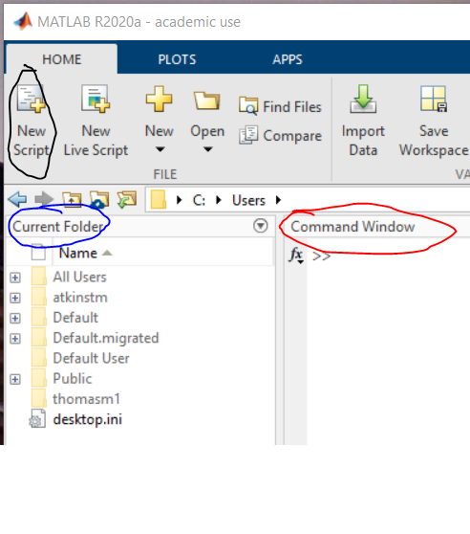
Figure 3: Opening User Interface Emphasis

In Red, the command window is pointed out. The command window is essentially a fancy calculator. This is where commands are entered individually to carry out different functions. The commands range from simple things like 2+2 to complex calculations like the fast fourier transform. The limitation of the Command Window is that every line must be entered manually. To create a set of commands that will all be run sequentially the user must create a script.

The Home tab at the top contains many functions, but the main interest in this lab is the New Script button. This allows the user to create the script mentioned prior.

Next, in blue, is the Current Folder menu. This shows the folder that Matlab is “looking at” to know what scripts to run. If you want to run a script like “LabOneELEC2120” it must be inside the current folder. More practically, Matlab will only be able to run files that are listed in this box.

Lastly, shown in figure 4, is the Workspace. The Workspace is usually on the right side of the screen, but sometimes doesn’t appear until opening a script. This is where variables are saved after being named in the command window or a script that has been run.

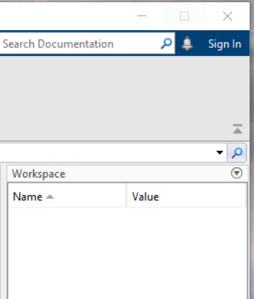
Figure 4: Workspace
- Using Variables
Most programming languages work using variables. Variables make the job of the coder or scientist easier when running multiple tests to determine an equation or model’s behavior. Variables make it possible to change a number, say a resistance, at the beginning of a script that calculates the behavior of an amplifier and see how that one resistance changes the whole circuit. If a number is inserted directly into an equation instead of as a variable, this is called hard-coding.

To create a decimal based variable, meaning a variable that holds a specific numeric value, the following command is used where “x” can be any combination of letters and numbers and “y” can be any numeric value. Note: the variable name must start with a letter, not a number.

x = y

The limitations are as follows:
- The name must come first (be on the left side of the equals sign)
- The name must begin with a letter
- Matlab is case sensitive. “Y” does not equal “y”

For example, to define a variable named “X” as being equal to the value 3, the code would be as follows:

x = 3

This can be written in the command window to see the result below:

>> x = 3

x =

3

Note: anything following the two carrots “>>” is typed by the user. The lines following are the Matlab generated results. In addition, the workspace now contains the variable named x with the value 3.

When performing calculations in Matlab it is important to note that the four main mathematical symbols all work as expected. “+” for addition, “-“ for subtraction, “*” for multiplication, and “/” for division. Each can be used with numerical values or variables to determine results of the calculation.

One last thing about variables is the variable “ans.” The variable “ans” is automatically generated when a simple expression is called. This applies in scripts as well as the command window. See below.

>> 3+3

ans =

6

After writing several lines of code in the command window, the window can become cluttered. Use the command “clc” to clear the command window. The command “clear” can be used to delete all the variables saved in the workspace. Both commands should be used at the beginning of scripts to ensure there aren’t any old variable values that interfere with the running of the current program.

When there is a series of calculations that need to be performed in a certain order repeatedly, it is helpful to create a script. It is important to note that Matlab will execute the commands in the code sequentially from top to bottom and left to right. Click on the “New Script” button highlighted in Figure 3 to open the Editor window. The default view with the editor window open is shown in Figure 5. The user can move these windows to fit any configuration desired.

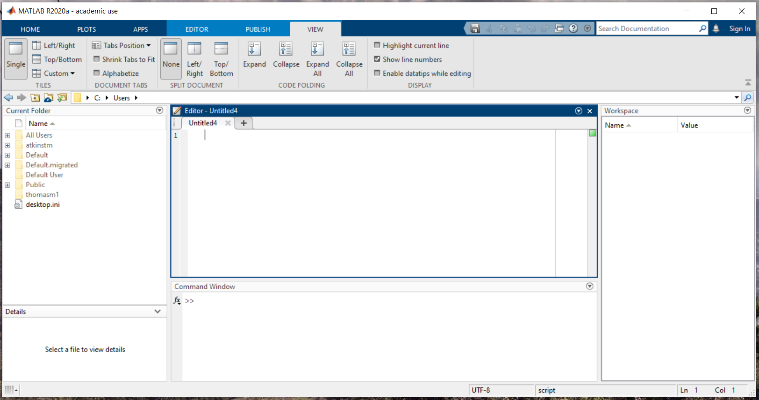
Figure 5: Basic GUI with Editor Open

Remember the current folder window? The first thing to note with a new script is that it should be saved where desired (perhaps an ELEC2120 Folder?) and the current folder should be changed to reflect where the script was saved. An easy way to select the folder where a script is saved is to click the “Run” button under the green arrow on the top bar. PC users can also press F5 on the keyboard to run scripts. When Matlab attempts to run the script that is not in the Current Folder or “path” the program offers the option to change to the folder the script is saved in or add the folder to the current path as shown in Figure 6. Typically, it is best to select Change Folder.

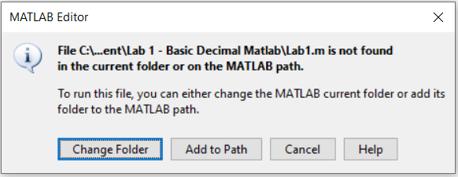
Figure 6: Script not in Current Folder
When a script gets long, it can be difficult to remember what variables mean. One way to help mitigate this is to come up with some system of naming for the program. A simple example of this is if a program is calculating the volume of tanks A,B,C, and D, the variable names could be VolumeA, VolumeB, etc.

Another way to help keep track of variables is using comments. When a percent sign “%” is added to a script, anything following the percent sign that falls in that line of the code is not acted on by the program. The comment is purely there for the reader. The program being run by Matlab will skip to the next line when it “sees” a percent sign. Anything that is commented will show up green. An example is seen below.

inv(A) %This line calculates the inverse of A

Code can be broken into sections that can be run individually using two percent signs followed by a space and then the title of the section “%% Title”. Matlab codes can be run as a whole, or section by section. This will be explained more in a later lab. An example is seen below.

%% Part 1
inv(A) %This line calculates the inverse of A

%% Part 2
inv(B)

- Matrix Building
A major benefit of Matlab over a simple calculator is the ease of use when working with matrices. This is the basic intent of Matlab as a program. A matrix is essentially a set of arrays, so arrays will be explored first. There are a few basic syntaxes needed to form arrays. As shown below, a basic array is formed using brackets “[ ]”. This is the same as a one row matrix with two columns. Either a comma or a space can be used to signify different entries in a row.

>> x = [3,4]

x =

3 4

Again, a space will work the same.
>> x = [3 4]

x =

3 4

To make a two-row matrix with one column, or a vertical array with two entries, use a semicolon rather than a comma or space to separate entries.
>> x = [3;4]

x =

3
4

An easier way to write an array is to use the first number, a colon, and then the ending number as shown below. This will result in an array that increments by one between the starting and ending points.
>> B = [1:6]

B =

1 2 3 4 5 6

If a step size that is different than 1 is desired, the step size can be defined between the starting and stopping values with colons in between each of the three numbers as seen below. This example uses a step size of 0.5.
>> C = [1:0.5:3]

C =

1.0000 1.5000 2.0000 2.5000 3.0000

Matlab automatically indexes or gives a position value to every entry in an array. In other words, the first entry of C can be written as C(1). When put into Matlab, the following result is attained:
>> C(1)

ans =

1

If the user wants multiple values of the array C, the different values can be separated by commas. For example, if the user only wanted the half values of C, the following code could be used (condensed to fit):
>> C(2),C(4)

ans =

1.5000

ans =

2.5000

If the user instead wanted both values to shown in an array, brackets could be used around the command as seen below.
>> [C(2),C(4)]

ans =

1.5000 2.5000

Lastly, if the user wanted to remove the whole entries from the matrix C, the following code could be used as it redefines the variable C to be the array of only the half entries:
>> C = [C(2),C(4)]

C =

1.5000 2.5000

This approach of array indexing helps with finding specific values in large sets of data. Perhaps there is an array of values that are the voltages of a capacitor at different times. The voltage directly before and after a switch closing could be found using array indexing.
Next, to move from arrays to matrices we need to define two arrays within the same brackets. To make a two by two matrix with two rows and two columns, the following code is used.
>> x = [1 2 ; 3 4]

x =

1 2
3 4

There are a few specific commands in matlab for specific types of matrices like all ones or all zeros. The command “ones(n)” will give an n x n matrix of ones. This means that it will have n rows and n columns. This is demonstrated below.
>> ones(3)

ans =

1 1 1
1 1 1
1 1 1

The same can be done with the command “zeros(n)” for a matrix filled with zeros.
>> zeros(2)

ans =

0 0
0 0

Lastly for an identity matrix, the command “eye(n)” can be used as seen below
>> eye(4)

ans =

1 0 0 0
0 1 0 0
0 0 1 0
0 0 0 1

If a non-square matrix is desired from any of these commands, using two different values inside the parentheses will achieve this. Note: Matlab works with row first, then column. An old professor named Dr. Hung used to say to think RC Cola. Row then Column. For a 2 row, 3 column matrix of ones the code is below.
>> ones(2,3)

ans =

1 1 1
1 1 1

The same RC cola approach can be applied to the system of indexing we discussed before. If the user needed to define the bottom value of the leftmost column to be 2, it could be done as follows:
>> ans(2,1) = 2

ans =

1 1 1
2 1 1

Note the fact that the answer still shows the whole matrix. Also note that this uses the variable “ans” simply because the user has not yet defined a variable and Matlab used the automatically generated option.
Lastly, if the need arises to replace an entire column or row, that can be done by using a colon in place of a value. The colon in this sense means “all.” So, to replace all the top row with the number 3, the user would use the code below.
>> ans(1,:) = 3

ans =

3 3 3
2 1 1

Again, it truly helps to think of the syntax as “variable ans, row 1, column all” to remember what the operation is.

- Matrix Math
Lastly, matrix arithmetic can be done in Matlab. Addition and subtraction are as simple as putting individual elements with their corresponding elements in the other matrix and performing the operation. Using the matrices A and B below, this is demonstrated. Note the when the matrix addition is performed, the top left value of A is added to the top left value of B. These are the same rules that apply in linear algebra.
>> A = ones(2)

A =

1 1
1 1

>> B = eye(2)

B =

1 0
0 1

>> C = A+B

C =

2 1
1 2

The same is true with subtraction as shown below.
>> D = A-B

D =

0 1
1 0

Where it gets messy is with multiplication and division. The base setting for Matlab is to do multiplication using the dot product method. This is demonstrated below. Note that the values in B have now changed.
>> A = ones(2)

A =

1 1
1 1

>> B = [1 2 ; 3 4]

B =

1 2
3 4

>> E = A*B

E =

4 6
4 6

If the user needs each individual element of the matrix to be multiplied by its corresponding element in the other matrix, say top left multiplied by top left, this is called an element-wise matrix multiplication. The element-wise multiplication is achieved by placing a period before the star symbol as seen below.
>> F = A.*B

F =

1 2
3 4

Now remember from linear algebra that matrix division is not possible. What happens is the multiplication of the inverse of a matrix. In Matlab there are quite a few ways to carry this out. The first is to multiply the dividend by the inverse of the divisor, or the “top number” by the inverse of the “bottom number.” The inverse of a matrix can be found by using the command “inv().”

>> G = A*inv(B)

G =

-0.5000 0.5000
-0.5000 0.5000
A shorthand way of writing this is with the slash key “/.” An interesting note is that you can use forward or backward slash for this, but the top of the slash points to the variable that will have the inverse taken of it. So the two statements below are true.

>> A*inv(B) = A/B
>> inv(A)*B = A\B

- Conclusion

If there are any commands in this document that need more explanation the “help” command is very useful. It’s demonstrated along with its result below.

>> help inv
inv Matrix inverse.
inv(X) is the inverse of the square matrix X.
A warning message is printed if X is badly scaled or
nearly singular.

See also SLASH, pinv, cond, condest, lsqnonneg, lscov.

Documentation for inv
Other functions named inv

The See also section, Documentation heading, and Other functions named inv heading all provide links to what they describe. This is a great way to learn the language better. In addition, using Google to search an unfamiliar command or to describe something that would be a helpful command can help tremendously. That’s how to discover new things Matlab can do that surprise even the most veteran coders.

- Submission

For this lab, the student will need to prepare report for their ePortfolio and submit link to Canvas. The ePortfolio report should include the following sections.

Introduction:
This section should include a brief introduction to the lab including the objectives of the lab.

Procedure:
This section should include the following:
- Completed answer sheet on ePortfolio (Questions 1 – 5 of Lab 1: Basic Decimal Matlab Answer Sheet).
- Completed Matlab code in the “.m” file format (that Matlab automatically saves as) uploaded to as an attachment to ePortfolio page.

Conclusion:
Feedback (Questions 6 – 8 of Lab 1: Basic Decimal Matlab Answer Sheet).

Any questions can be answered during the student’s normal lab time.

- Exercises

Using the editor in Matlab, make a Script that does what is described by the numbered statements. Write your answers to the questions in the answer sheet provided in the Lab 1 file on Canvas. Let the TA know if you have questions or we can help in any way. Please turn in both the answer sheet for the questions, and the “.m” file that contains your code on your ePortfolio. Be sure that your script does each of these commands sequentially. Also be sure this is in a script and not just the command window.

The Matlab Script should:
- Clear the command window
- Clear the workspace
Question 1: Why do we clear the command window and workspace at the beginning of a script?
- Define a variable to be equal to 3
- Define a new variable to be equal to 6
- Define a third variable to be equal to the sum of the first two. (addition)
- Define a fourth variable to be equal to the product of the first two. (multiplication)
- Define a fifth variable to be equal to the second variable minus the first. (difference)
- Define a sixth variable to be equal to the second variable divided by the first. (division)
Question 2: Why would we use variables instead of just using the numbers, which is called hard-coding?
Question 3: Think about what system would you personally use to organize your variables and remember what each means? Give a few examples with explanations of what they mean.
- Create a new section and title it “Matrix Math”
- Define a new variable to be an array from the number 1 to 10 that includes only the whole numbers between 1 and 10.
- Show a second way to define a new variable to be an array from 1 to 10 that includes only the whole numbers between 1 and 10.
Question 4: How can array indexing be beneficial?
- Define a new variable for the matrix shown below.
$$\left[\begin{matrix}1 & 2 \\ 3 & 4\end{matrix}\right]$$

- Define a new variable using the eye() command for the matrix shown below. (Try typing help(eye) into the command window if you need assistance)
$$\left[\begin{matrix}1 & 0 \\ 0 & 1\end{matrix}\right]$$

- Define a new variable to be the sum of the variables created in steps 12 and 13.
- Define a new variable to be the product of the variables defined in steps 12 and 13.
- Define a new variable to be the element-wise product of the variables defined in steps 12 and 13.
- Define a new variable to be the difference of the first matrix minus the second in steps 12 and 13.
- (Remember your linear algebra) Define a new variable to be the matrix equivalent of dividing the variable from step 13 by the variable from step 12.
- Define a new variable and show a second way to perform step 18.
- Write your name in a comment at the end of the script.
Question 5: In your opinion, would the automatically generated variable ans or a user-defined variable be more useful in writing scripts?

Feedback:
What went well?
What didn’t go well?
How would you improve the lab?

Congratulations! You’ve finished your first lab for the semester. We expect to receive the Matlab script .m file that you generated in this lab along with a file that contains your answers to the five questions and your feedback on this lab on your ePortfolio.

This will be due on Canvas by the end of your lab section.

Thanks,
Thomas

