**INFO330 Final Exam – Winter 2024**

## **Instructions**

This exam is take-home. It will be released on Tuesday, March 12 at 8AM and must be turned in through Canvas by **Tuesday, March 12 at 6PM PT**. **No exceptions will be made for late exams.** If you experience any technical difficulties uploading through Canvas by the deadline, you should email your completed exam to your instructors prior to the deadline to avoid penalty. Please plan accordingly.

This exam is designed to take 2 hours to complete. In that time, please answer each question below to the best of your ability. You may use the classroom server to test and refine your queries, though please work in your own databases. There are 131 points available on this exam, but it will be scored out of a total of 125 points (in other words, 6 points of extra credit are available here in this exam in addition to the 25 points of extra credit available from the 4 extra credit assignments in Canvas).

Please print your name, sign, and date the following statement before uploading your complete exam:

*I attest that I did not communicate with anyone other than the instructors about the questions on this final exam, and that all work is my own.*

Name: *__________________________*

Signature: *__________________________*

Date: *__________________________*

## **PART 1: SQL (50 pts total)**

Please answer each of the following questions by writing a SQL query unless otherwise specified. Each query should run on a table with a matching schema; in other words, syntax matters!

Here is the premise for the problems in this part:

King County Metro is deploying a new system to manage the public transit system, specifically buses and bus routes. The system has *drivers* that drive *buses* on certain *routes* with *stations* that the route might stop at. Each station has an attribute covered that describes whether it is covered from the weather (i.e., rain). Each route consists of a series of stations, in order.

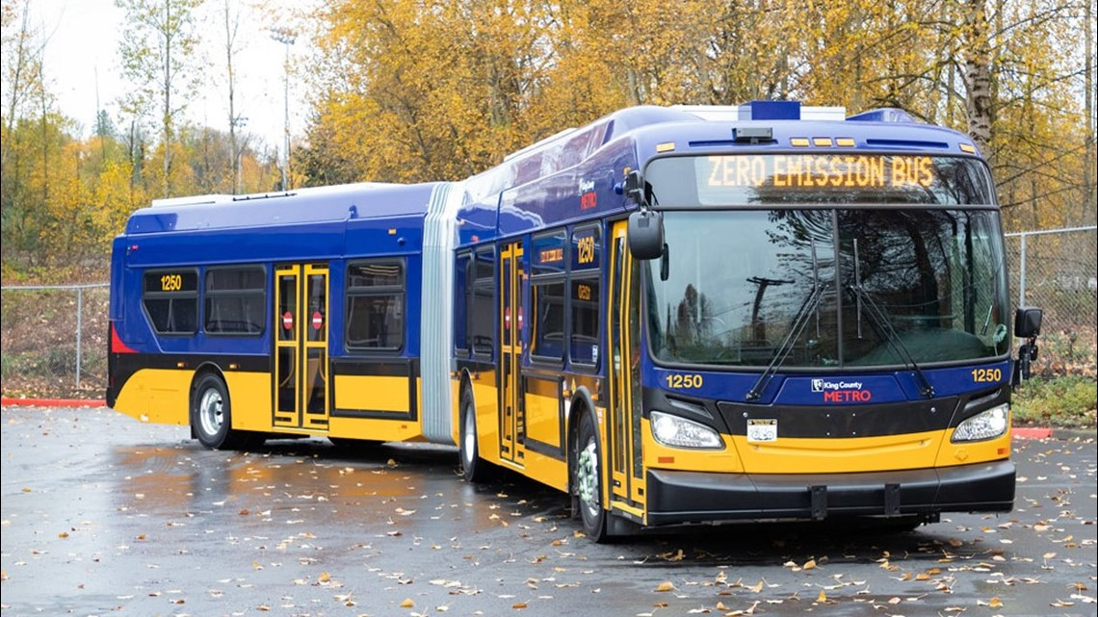

Here's a proposed schema:

Bus(bid, electrified, year)

Route(rid, name, type, electrified, description)

Station(sid, name, addr, lat, long, covered)

Stops(rid, sid, stop_order)

BusAssignment(bid, rid, start_date, end_date)

* In the *Bus* table, each bus is uniquely identified by a surrogate bus ID (bid). It includes attributes such as whether the bus is electrified, a boolean value indicating if it runs on electricity, and the year of manufacture. Both ‘electrified’ and ‘year’ always have values.
* In *Route*, each bus route is uniquely identified by a surrogate route ID (rid). The attribute ‘name’ is a string name for the route; ‘type’ is a string describing the type of route and can only take on the values “local”, “express”, “commuter”, or “night”; ‘electrified’ is a boolean value indicating whether the route is served by electrified buses; and ‘description’ is a free text description about the route, containing information such as its destination or major landmarks it passes through. The attributes ‘name’, ‘type’, and ‘electrified’ are available for all routes, but ‘description’ may not be.
* Each station in the *Station* table is uniquely identified by a surrogate station ID (sid) and is associated with a station ‘name’ as a descriptive text string, and ‘address’, which stores its street address. Latitude (lat) and longitude (long) are decimal numbers that provide the geographic coordinates of the station. A boolean attribute called ‘covered’ indicates whether the station provides shelter from weather conditions. The attributes ‘name’, ‘address’, ‘lat’, and ‘long’ are always specified.
* The *Stops* table defines the sequence of stops along each bus route. It records the relationship between routes (identified by rid) and stations (identified by sid) and specifies the order in which buses stop at each station. The ‘stop_order’ attribute is an integer specifying which stop along the route a station is (e.g., order 1 means this is the first stop on the route, order 10 means it is the 10th stop) and must be specified.
* The *BusAssignment* table records the assignment of buses to specific routes within defined time periods. Buses (identified by bid) are assigned to operate on routes (identified by rid) during a specified timeframe. The attributes ‘bid’, ‘rid’, and ‘start_date’ are always specified. If the ‘end_date’ is NULL, this means the bus is currently in service on that route.
* ‘bid’, ‘rid’, and ‘sid’ are integers

1. (5 pts) I have not specified a primary key for the BusAssignment table. What attribute or set of attributes makes sense as primary key and why?
2. (10 pts) Write the sequence of SQL statements necessary to create the tables above. Include primary key, key, foreign key, NULL constraints, and/or CHECK constraints if they are needed. Please make sure to implement the primary key you’ve specified in your answer to question 1.
3. (5 pts) A route and bus are *incompatible* if they disagree on electrified status (e.g., an electrified bus is servicing a non-electrified route or a non-electrified bus is servicing an electrified route. Write a query to return the bus ids (bid) currently in service that are running on incompatible routes.
4. (10 pts) A route is *weatherproof* if *all* of the stations on its route are covered. Write a query that returns a list of route ids (rid) that are weatherproof. Your query should return the unique route ids associated with only stations that are covered.
5. A proper route with N stations should have exactly N entries in the Stops table and no order value is duplicated. An *inconsistent* route is one where (i) the route doesn’t start at order=1, (ii) the same order number is duplicated, or (iii) it skips an order number.   
     
   (a) (5 pts) Write a query to return the unique route ids (rid) for all inconsistent routes that violate (i), where the route doesn’t start with a station at order=1.  
     
     
     
     
     
     
     
     
     
     
     
   (b) (5 pts) Write a query to return the unique route ids (rids) for all inconsistent routes that violate (ii), where the same order number is duplicated. You could think of this as checking whether the number of order numbers is the same as the unique number of order numbers associated with each route.  
     
     
     
     
     
     
     
     
     
     
   (c) (5 pts) Write a query to return the unique route ids (rid) for all inconsistent routes that violate (iii), where the route skips an order number. You could think of this as checking whether the smallest order number associated with the route is 1 and the largest order number associated with the route is the same as the number of unique order numbers on the route.  
     
     
     
     
     
     
     
     
     
     
     
     
   (d) (5 pts) Write a query that combines results from your queries from (a), (b), and (c) to return all unique route ids (rids) that are inconsistent for any of the three reasons, along with three additional boolean columns called ‘incorrect_start’, ‘duplicate_order’, and ‘skips_number’ that correspond to whether each of (a), (b), and/or (c) are violated. Include your queries from (a), (b), and (c) as CTEs, followed by the main query to construct the output table. Note: some routes may be inconsistent in multiple ways.   
     
   Here are some example rows that could appear in the resulting table:  
     
    rid incorrect_start duplicate_order skips_number  
    2 FALSE TRUE TRUE  
    19 TRUE FALSE FALSE

## **PART 2: ERDs and Relational Schema (41 pts total)**

1. (8 pts) King County Metro has proposed some changes to the schema, and provided the following ER diagram of a new relationship. Driver is a new entity set representing employees who drive buses, and is connected to the Bus entity set by the drives relationship. did is an integer primary key, name is the driver’s name represented as a string, and dob is their birthdate (none of these can be NULL). Write additional CREATE TABLE statements to create new table(s) based on the content in this ER diagram. You can choose to modify the CREATE TABLE statement for the existing Bus table if you believe it needs to be modified; otherwise, it will be assumed to be unchanged from what you provided in problem 2. The tables Route, Station, Stops, and BusAssignment can be assumed unchanged from what you provided in problem 2.    
     
   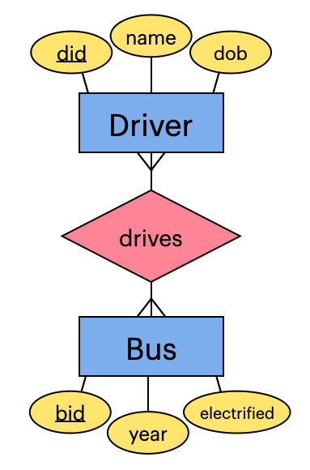
2. Two ERD snippets are shown below.   
     
   A diagram of a driver

   Description automatically generated A diagram of a bus route

   Description automatically generated  
    (i) (ii)  
     
   (a) (8 pts) Describe what (i) and (ii) each mean and how the two diagrams differ, both in turns of what is represented in the ERD and in plain language (e.g., what are the implications of the cardinalities?). Focus on articulating the differences.   
     
     
     
     
     
     
     
     
     
     
     
     
     
     
     
     
     
     
     
     
   (b) (5 pts) Which one do you think is a better reflection of the real world scenario and why?
3. (20 pts) Imagine you are given data in a spreadsheet called equipment_reservation with the following columns (there is no actual spreadsheet; you don’t need it to complete this problem):  
     
   (name, status, gym, address, equipment, type, trainer, date)  
     
   You are also given the following functional dependencies for these attributes:  
     
   **equipment→type**(each piece of equipment has a specific type)  
   **gym, type→trainer**(each gym has one specialist trainer for each type of equipment)  
   **name→status** (each member has a specific status)  
   **gym→address**(each gym has a specific address)  
     
   Decompose equipment_reservation into BCNF. In your final answer, make sure to indicate the key(s) of each relation. If you show your work, you are more likely to earn partial credit in case of mistakes!

## **PART 3: Query Evaluation & Optimization (28 pts total)**

1. You are given the following RA query plan (P0) for the Metro scenario:  
     
   A diagram of a bus assignment

   Description automatically generated  
     
     
     
     
     
   (a) (2pt) Does the following plan produce the same result as P0? If not, why not?  
   A diagram of a problem

   Description automatically generated  
     
     
     
     
     
     
   (b) (2pt) Does the following plan produce the same result as P0? If not, why not?  
     
   A diagram of a bus accident

   Description automatically generated  
     
     
   (c) (2pt) Does the following plan produce the same result as P0? If not, why not?  
   A diagram of a diagram

   Description automatically generated  
     
      
     
     
     
   (d) (2 pt) Of the plans that produce the same results, which one or ones are most efficient and why?
2. Cardinality estimation: consider the following schema:  
     
   CREATE TABLE Pizza (  
    pid int PRIMARY KEY,  
    type VARCHAR(50),  
    size int,  
    price MONEY  
   );  
     
   CREATE TABLE PizzaOrder (  
    order_id int,  
    pid int REFERENCES Pizza(pid),  
    quantity int,  
    PRIMARY KEY (order_id, pid)  
   );  
     
   You are given the following RA diagram and statistics about the data:  
     
   A diagram of a mathematical equation

   Description automatically generated  
     
   T(Pizza) = 100  
   T(PizzaOrder) = 10000  
   V(Pizza, type) = 25  
   V(Pizza, size) = 4  
   V(PizzaOrder, order_id) = 8000  
   V(PizzaOrder, pid) = 100  
      
   Please answer the following (show your work to get partial credit):  
     
   (a) (4 pt) Describe in plain language what the RA query does:  
     
     
     
     
   (b) (4 pt) What is V(Pizza, pid)?  
     
     
     
     
   (c) (4 pt) What is the expected number of tuples at (c) in the RA query?  
     
     
     
     
   (d) (4 pt) What is the expected number of tuples at (d) in the RA query?  
     
     
     
     
   (e) (4 pt) What is the expected number of tuples at (e) in the RA query?

## **PART 4: Concepts (12 pts total)**

For each statement below, indicate whether it is true or false (2 pt each)

1. (T/F) If R(A, B, C, D) satisfies the functional dependencies AB → C and C → A then C is a key.
2. (T/F) If R(A, B, C, D) satisfies the functional dependencies A → B and B → C and C → D, then D is a key.
3. (T/F) If R(A, B, C, D) satisfies the functional dependencies A → B and B → C and C → D and D → A, then D is a key.
4. (T/F) The query optimizer may choose a different algorithm for a join depending on statistics about the data, such as number of tuples in a table or number of unique values in an attribute.
5. (T/F) A table can have more than one clustered index, but only one unclustered index.
6. (T/F) An index is clustered when the physical table is sorted by the same attributes as are included in the index.