Serial — Implementation Plan (v0)
Grid-based prototype • Web (TypeScript + Canvas) • February 14, 2026

1. Game concept
Serial is a “big data” city simulation game. A city contains many people (target scale: 20,000), represented as dots on a map. They follow daily routines, move through the city, and interact. One person is secretly a serial killer.
Initial scope for the first iteration:
- Single-player, real-time simulation in the browser
- Small grid-based city + 10 agents
- Player can monitor/inspect any individual agent
- Plan anticipates future server-authoritative multiplayer

2. UI + architecture alignment (mockup)
The prototype UI is intentionally abstract: a tile map with colored dots for people, plus an inspection panel showing an agent’s current state and recent events.
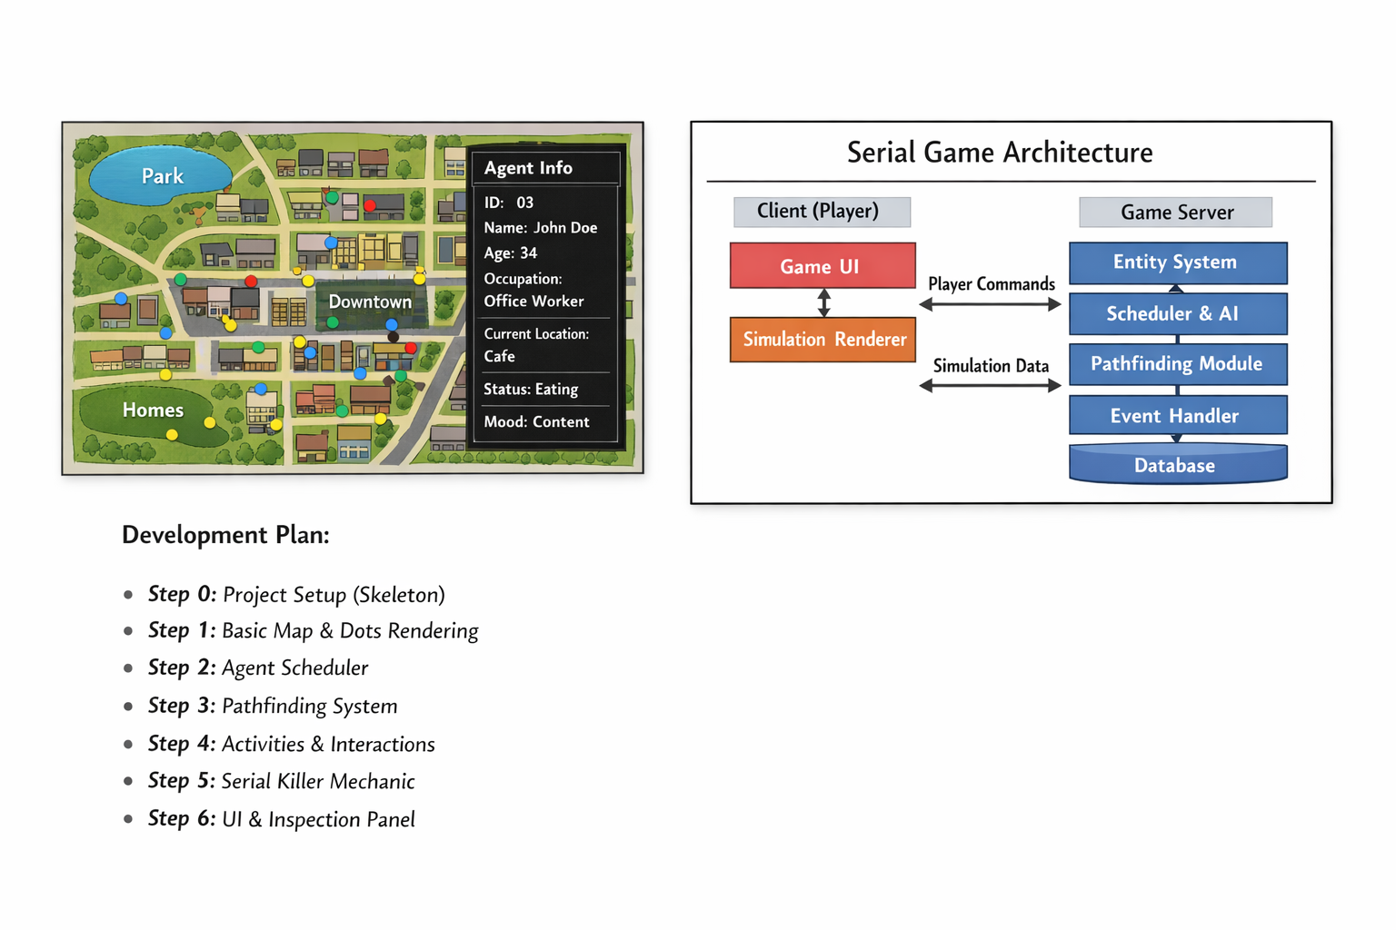
Figure 1. Map-with-dots UI + client/server-ready architecture sketch.

3. Core design decisions (to support scaling + multiplayer later)
Simulation first, rendering second:
Build a headless simulation core that outputs world state and events. Rendering is just a view.
Deterministic, tick-based simulation:
Run the world on fixed timesteps (“ticks”) with a seeded RNG for reproducibility and future server authority.
ECS-ish data layout:
Model entities as IDs with component data and update them via systems (movement, schedule, interactions).

4. World representation (grid-based)
World = a 2D tile grid (e.g., 80×50 tiles). Tiles have types (road, residential, commercial, park, water, etc.). Points-of-interest (POIs) such as home, office, cafe, park occupy tiles. Agents move tile-to-tile.
Movement approach:
- v1: simple tile stepping toward target (fast and easy)
- v2: A* pathfinding (prefer roads, avoid obstacles)
- v3: road graph + congestion modeling (scale / realism)

5. Step-by-step build plan (each step ends runnable)

Step 0 — Project skeleton + “Hello City”
- Vite + TypeScript project
- Canvas renderer stub + HUD (sim time, tick rate, paused state)
- Fixed-timestep simulation loop + seeded RNG utilities
Run check: Acceptance: run dev server; canvas shows HUD; time advances; space toggles pause.

Step 1 — Grid map + dots rendering
- Render a small tile grid with a handful of POIs
- Spawn 10 agents as dots with IDs/names
- Basic pan/zoom (optional in v1, but recommended)
Run check: Acceptance: you can see tiles + POIs; 10 dots spawn near homes.

Step 2 — Time + schedules
- Daily routine: sleep, work, eat, leisure
- Agent state includes status + target POI
Run check: Acceptance: at time boundaries, agents change state and update targets.

Step 3 — Movement system
- Tile-to-tile movement to targets
- Arrival detection + “arrived” state
Run check: Acceptance: agents flow between POIs (e.g., homes → office at 08:00).

Step 4 — Basic interactions + event log
- Proximity-based interactions inside POIs
- Global append-only event stream (time, type, participants, location)
Run check: Acceptance: events appear when agents co-locate; simulation continues.

Step 5 — Inspection UI
- Click an agent to select + highlight
- Side panel shows identity, status, schedule, recent events
Run check: Acceptance: inspection panel updates live for the selected agent.

Step 6 — Serial killer mechanic v1 (hidden role + anomalies)
- One hidden killer agent role
- Simple rules to trigger “missing person” outcomes
- Player-facing signals: last seen time/place, missing reports
Run check: Acceptance: within a few in-game days, at least one agent goes missing and logs update.

6. Multiplayer-ready architecture (without implementing multiplayer yet)
We’ll keep simulation logic in a shared module so we can later run it server-side without rewriting core systems.
Sim Core (shared): Pure logic, no DOM. Inputs: commands + seed + initial state. Outputs: state + event batches.
Client: Renders state and provides UI. Later it receives server snapshots/deltas and interpolates.
Server (future): Authoritative sim core + persistence (event log), broadcasts snapshots/deltas, prevents cheating.

Appendix A — Step 0 quickstart (commands)
mkdir serial
cd serial
npm create vite@latest . -- --template vanilla-ts
npm install
npm run dev

