Harrison Montoya Assignments

Table of Contents

# Assignment 1

Due on Canvas on Monday 9/20 before class at 10:15 am

### Problem 1

Install the datasets package on the console below using install.packages("datasets"). Now load the library.

USArrests

## Murder Assault UrbanPop Rape  
## Alabama 13.2 236 58 21.2  
## Alaska 10.0 263 48 44.5  
## Arizona 8.1 294 80 31.0  
## Arkansas 8.8 190 50 19.5  
## California 9.0 276 91 40.6  
## Colorado 7.9 204 78 38.7  
## Connecticut 3.3 110 77 11.1  
## Delaware 5.9 238 72 15.8  
## Florida 15.4 335 80 31.9  
## Georgia 17.4 211 60 25.8  
## Hawaii 5.3 46 83 20.2  
## Idaho 2.6 120 54 14.2  
## Illinois 10.4 249 83 24.0  
## Indiana 7.2 113 65 21.0  
## Iowa 2.2 56 57 11.3  
## Kansas 6.0 115 66 18.0  
## Kentucky 9.7 109 52 16.3  
## Louisiana 15.4 249 66 22.2  
## Maine 2.1 83 51 7.8  
## Maryland 11.3 300 67 27.8  
## Massachusetts 4.4 149 85 16.3  
## Michigan 12.1 255 74 35.1  
## Minnesota 2.7 72 66 14.9  
## Mississippi 16.1 259 44 17.1  
## Missouri 9.0 178 70 28.2  
## Montana 6.0 109 53 16.4  
## Nebraska 4.3 102 62 16.5  
## Nevada 12.2 252 81 46.0  
## New Hampshire 2.1 57 56 9.5  
## New Jersey 7.4 159 89 18.8  
## New Mexico 11.4 285 70 32.1  
## New York 11.1 254 86 26.1  
## North Carolina 13.0 337 45 16.1  
## North Dakota 0.8 45 44 7.3  
## Ohio 7.3 120 75 21.4  
## Oklahoma 6.6 151 68 20.0  
## Oregon 4.9 159 67 29.3  
## Pennsylvania 6.3 106 72 14.9  
## Rhode Island 3.4 174 87 8.3  
## South Carolina 14.4 279 48 22.5  
## South Dakota 3.8 86 45 12.8  
## Tennessee 13.2 188 59 26.9  
## Texas 12.7 201 80 25.5  
## Utah 3.2 120 80 22.9  
## Vermont 2.2 48 32 11.2  
## Virginia 8.5 156 63 20.7  
## Washington 4.0 145 73 26.2  
## West Virginia 5.7 81 39 9.3  
## Wisconsin 2.6 53 66 10.8  
## Wyoming 6.8 161 60 15.6

Load the USArrests dataset and rename it dat. Note that this dataset comes with R, in the package datasets, so there’s no need to load data from your computer. Why is it useful to rename the dataset?

dat<-USArrests  
dat.USArrests <- dat

*Answer:* It is useful to rename the dataset for two reasons. First, it will help you keep track of your work and not confuse it with other generic-looking names of other datasets. Second, it will allow you to keep an original copy of the file while creating a new file with all of the changes you are currently making on it.

### Problem 2

Use this command to make the state names into a new variable called State.

dat.USArrests$state <- tolower(rownames(USArrests))  
dat.USArrests

## Murder Assault UrbanPop Rape state  
## Alabama 13.2 236 58 21.2 alabama  
## Alaska 10.0 263 48 44.5 alaska  
## Arizona 8.1 294 80 31.0 arizona  
## Arkansas 8.8 190 50 19.5 arkansas  
## California 9.0 276 91 40.6 california  
## Colorado 7.9 204 78 38.7 colorado  
## Connecticut 3.3 110 77 11.1 connecticut  
## Delaware 5.9 238 72 15.8 delaware  
## Florida 15.4 335 80 31.9 florida  
## Georgia 17.4 211 60 25.8 georgia  
## Hawaii 5.3 46 83 20.2 hawaii  
## Idaho 2.6 120 54 14.2 idaho  
## Illinois 10.4 249 83 24.0 illinois  
## Indiana 7.2 113 65 21.0 indiana  
## Iowa 2.2 56 57 11.3 iowa  
## Kansas 6.0 115 66 18.0 kansas  
## Kentucky 9.7 109 52 16.3 kentucky  
## Louisiana 15.4 249 66 22.2 louisiana  
## Maine 2.1 83 51 7.8 maine  
## Maryland 11.3 300 67 27.8 maryland  
## Massachusetts 4.4 149 85 16.3 massachusetts  
## Michigan 12.1 255 74 35.1 michigan  
## Minnesota 2.7 72 66 14.9 minnesota  
## Mississippi 16.1 259 44 17.1 mississippi  
## Missouri 9.0 178 70 28.2 missouri  
## Montana 6.0 109 53 16.4 montana  
## Nebraska 4.3 102 62 16.5 nebraska  
## Nevada 12.2 252 81 46.0 nevada  
## New Hampshire 2.1 57 56 9.5 new hampshire  
## New Jersey 7.4 159 89 18.8 new jersey  
## New Mexico 11.4 285 70 32.1 new mexico  
## New York 11.1 254 86 26.1 new york  
## North Carolina 13.0 337 45 16.1 north carolina  
## North Dakota 0.8 45 44 7.3 north dakota  
## Ohio 7.3 120 75 21.4 ohio  
## Oklahoma 6.6 151 68 20.0 oklahoma  
## Oregon 4.9 159 67 29.3 oregon  
## Pennsylvania 6.3 106 72 14.9 pennsylvania  
## Rhode Island 3.4 174 87 8.3 rhode island  
## South Carolina 14.4 279 48 22.5 south carolina  
## South Dakota 3.8 86 45 12.8 south dakota  
## Tennessee 13.2 188 59 26.9 tennessee  
## Texas 12.7 201 80 25.5 texas  
## Utah 3.2 120 80 22.9 utah  
## Vermont 2.2 48 32 11.2 vermont  
## Virginia 8.5 156 63 20.7 virginia  
## Washington 4.0 145 73 26.2 washington  
## West Virginia 5.7 81 39 9.3 west virginia  
## Wisconsin 2.6 53 66 10.8 wisconsin  
## Wyoming 6.8 161 60 15.6 wyoming

This dataset has the state names as row names, so we just want to make them into a new variable. We also make them all lower case, because that will help us draw a map later - the map function requires the states to be lower case.

List the variables contained in the dataset USArrests.

names(dat.USArrests)

## [1] "Murder" "Assault" "UrbanPop" "Rape" "state"

*Answer:* The variables include Murder, Assault, Rape, Urban Population, and State.

### Problem 3

What type of variable (from the DVB chapter) is Murder?

*Answer:* In the DVB chapter, “Murder” would be considered a qualitative, or categorical, variable.

What R Type of variable is it?

*Answer:* “Murder” is considered a character in R.

### Problem 4

What information is contained in this dataset, in general? What do the numbers mean?

*Answer:* The dataset includes the arrest rates for murder, assault, and rape per 100,000 residents in each of the US’s 50 states. Additionally, the percent of the population living in urban areas is given. Here, then, the numbers mean either the arrest rates for a crime per 100k residents in a state or the percent of residents living in urban spaces in a state.

### Problem 5

Draw a histogram of Murder with proper labels and title.

hist(dat.USArrests$Murder, main="Histogram of Murder Rates", xlab="Murder Rates per State", ylab="Frequency")

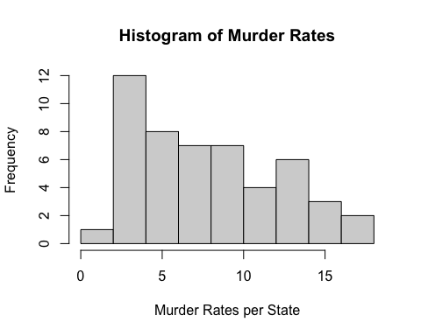

### Problem 6

Please summarize Murder quantitatively. What are its mean and median? What is the difference between mean and median? What is a quartile, and why do you think R gives you the 1st Qu. and 3rd Qu.?

summary(dat.USArrests$Murder)

## Min. 1st Qu. Median Mean 3rd Qu. Max.   
## 0.800 4.075 7.250 7.788 11.250 17.400

*Answer:* The mean of “Murder” is 7.788, while its median is 7.250. Generally, mean signifies the solution of all of the values added together and then divided by the number of values, while median signifies the middle value when all values are lined up in ascending order. A quartile constitutes one of three values that divides a data distribution into fourths. Lastly, R would provide the first and third quartile in order to help the statistician understand where the majority of values lie (in between the first and third quartile) or what values might be considered outliers (before the first and after the third).

### Problem 7

Repeat the same steps you followed for Murder, for the variables Assault and Rape. Now plot all three histograms together. You can do this by using the command par(mfrow=c(3,1)) and then plotting each of the three.

hist(dat.USArrests$Assault, main="Histogram of Assault Rates", xlab="Assault Rates per State", ylab="Frequency")

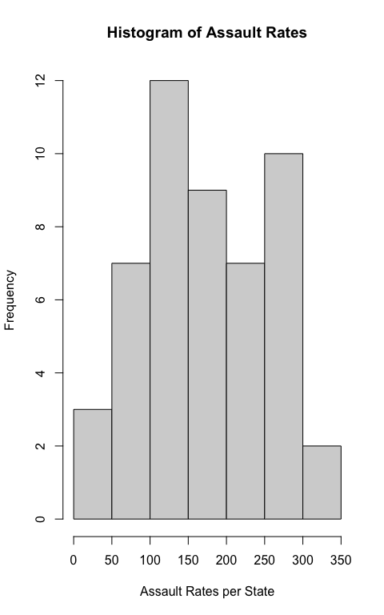

hist(dat.USArrests$Rape, main="Histogram of Rape Rates", xlab="Rape Rates per State", ylab="Frequency")

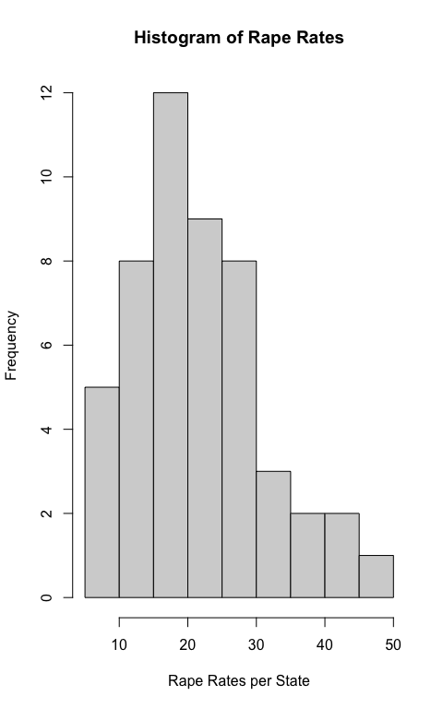

par(mfrow=c(3,1))  
hist(dat.USArrests$Murder, main="Histogram of Murder Rates", xlab="Murder Rates per State", ylab="Frequency")  
hist(dat.USArrests$Assault, main="Histogram of Assault Rates", xlab="Assault Rates per State", ylab="Frequency")  
hist(dat.USArrests$Rape, main="Histogram of Rape Rates", xlab="Rape Rates per State", ylab="Frequency")

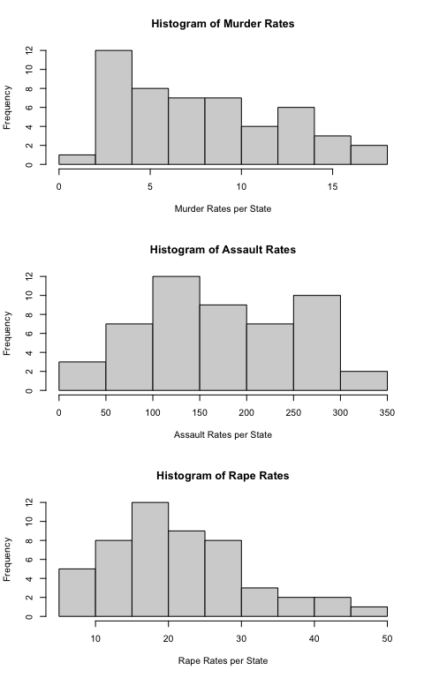

What does the command par do, in your own words (you can look this up by asking R ?par)?

*Answer:* The command par enables the statistician to set graphical parameters for data in either a singular graph or multiple graphs.

What can you learn from plotting the histograms together?

*Answer:* By plotting histograms together, you are able to compare the data between different categories – in this case, comparing the differences in assault and murder rates per state, for example. Additionally, you can gain a better understand of the data overall by looking at it holistically instead of piece-by-piece.

### Problem 8

In the console below (not in text), type install.packages("maps") and press Enter, and then type install.packages("ggplot2") and press Enter. This will install the packages so you can load the libraries.

Run this code:

library('maps')   
library('ggplot2')   
  
ggplot(dat, aes(map_id=state, fill=Murder)) +   
 geom_map(map=map_data("state")) +   
 expand_limits(x=map_data("state")$long, y=map_data("state")$lat)

What does this code do? Explain what each line is doing.

*Answer:* This code is mapping the arrest rates of murder per 100,000 citizens per state. With this, we are able to see the salience and prominence of arrest rates through a colored map of the United States. The first line is using the data groups of “state” and “Murder” to construct aesthetic mapping in a ggplot, filling the map with “Murder” rates. Next, the second line is the direction to map the states, while the third line is expanding the x and y axes, i.e. longitude and latitude, in the graph.