Peer Evaluation for Lab 0 – TTT 5 by 5 And Memory
Your name: (Your lab is the one being evaluated) | Harrison Preusse
Name(s) of peer evaluator(s)
Date: | 01/15/2019

Instructions You should have already completed Lab 0. After you and a peer have evaluated your work, you will submit this evaluation along with screen shots and source code indicated in moodle. You may make corrections to your work as a result of the evaluation.
TTT Problem
Variable scope  • Does the application use any form level variables? What are they? Is it reasonable to use an instance variable for each of these? | Yes, several constants for player symbols and other variables. The most important is SIZE, which can be changed to accommodate any size table. This has to be form-level, as multiple methods use it.
Methods  • Application includes definitions for appropriate set of methods?  • Does each pass parameters and return values appropriately?  • Source code for methods that you wrote is included? | Yes  Yes  Yes
Event handlers  • Application includes definitions for appropriate set of event handlers?  • Algorithm for each event handler is included?  • Source code for each event handler is included? | Yes  Yes  Yes
Does the application function appropriately? Can you interact with the application in a way that causes it to “degrade” and not gracefully? | Yes  No
One thing that you learned from writing the application: I learned how to easily expand an application’s capabilities by using constants instead of hard-coding numbers.

Something that you’d like to continue working on: I would like to continue working with these form-level constants, as I think they will make things much simpler in future applications.

Time you spent completing the application: About an hour.

Screen shots and source code:
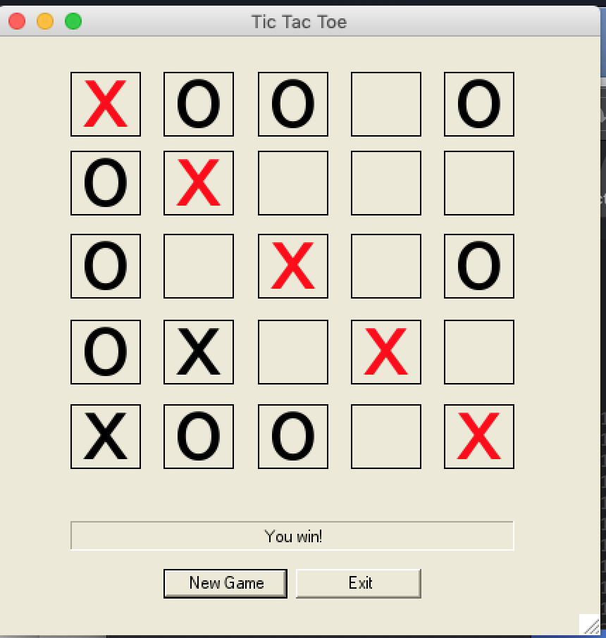
Source Code:
namespace TicTacToe
{
public partial class TTTForm : Form
{
public TTTForm()
{
InitializeComponent();
}
const string USER_SYMBOL = "X";
const string COMPUTER_SYMBOL = "O";
const string EMPTY = "";
const int SIZE = 5;
// constants for the 2 diagonals
const int TOP_LEFT_TO_BOTTOM_RIGHT = 1;
const int TOP_RIGHT_TO_BOTTOM_LEFT = 2;
// constants for IsWinner
const int NONE = -1;
const int ROW = 1;
const int COLUMN = 2;
const int DIAGONAL = 3;
// This method takes a row and column as parameters and
// returns a reference to a label on the form in that position
private Label GetSquare(int row, int column)
{
int labelNumber = row * SIZE + column + 1;
return (Label)(this.Controls["label" + labelNumber.ToString()]);
}
// This method does the "reverse" process of GetSquare
// It takes a label on the form as it's parameter and
// returns the row and column of that square as output parameters
private void GetRowAndColumn(Label l, out int row, out int column)
{
int position = int.Parse(l.Name.Substring(5));
row = (position - 1) / SIZE;
column = (position - 1) % SIZE;
}
// This method takes a row (in the range of 0 - 4) and returns true if
// the row on the form contains 5 Xs or 5 Os.
// Use it as a model for writing IsColumnWinner
private bool IsRowWinner(int row)
{
Label square = GetSquare(row, 0);
string symbol = square.Text;
for (int col = 1; col < SIZE; col++)
{
square = GetSquare(row, col);
if (symbol == EMPTY || square.Text != symbol)
return false;
}
return true;
}
//* TODO: finish all of these that return true
private bool IsAnyRowWinner()
{
for (int row = 0; row < SIZE; row++)
{
if (IsRowWinner(row))
return true;
}
return false;
}
private bool IsColumnWinner(int col)
{
Label square = GetSquare(0, col);
string symbol = square.Text;
for (int row = 1; row < SIZE; row++)
{
square = GetSquare(row, col);
if (symbol == EMPTY || square.Text != symbol)
return false;
}
return true;
}
private bool IsAnyColumnWinner()
{
for (int col = 0; col < SIZE; col++)
{
if (IsColumnWinner(col))
return true;
}
return false;
}
private bool IsDiagonal1Winner()
{
Label square = GetSquare(0, 0);
string symbol = square.Text;
for (int row = 1, col = 1; row < SIZE; row++, col++)
{
square = GetSquare(row, col);
if (symbol == EMPTY || square.Text != symbol)
return false;
}
return true;
}
private bool IsDiagonal2Winner()
{
Label square = GetSquare(0, (SIZE - 1));
string symbol = square.Text;
for (int row = 1, col = SIZE - 2; row < SIZE; row++, col--)
{
square = GetSquare(row, col);
if (symbol == EMPTY || square.Text != symbol)
return false;
}
return true;
}
private bool IsAnyDiagonalWinner()
{
if (IsDiagonal1Winner())
return true;
else if (IsDiagonal2Winner())
return true;
else
return false;
}
private bool IsFull()
{
for (int row = 0; row < SIZE; row++)
{
for (int col = 0; col < SIZE; col++)
{
Label square = GetSquare(row, col);
if (square.Text == EMPTY)
{
return false;
}
}
}
return true;
}
// This method determines if any row, column or diagonal on the board is a winner.
// It returns true or false and the output parameters will contain appropriate values
// when the method returns true. See constant definitions at top of form.
private bool IsWinner(out int whichDimension, out int whichOne)
{
// rows
for (int row = 0; row < SIZE; row++)
{
if (IsRowWinner(row))
{
whichDimension = ROW;
whichOne = row;
return true;
}
}
// columns
for (int column = 0; column < SIZE; column++)
{
if (IsColumnWinner(column))
{
whichDimension = COLUMN;
whichOne = column;
return true;
}
}
// diagonals
if (IsDiagonal1Winner())
{
whichDimension = DIAGONAL;
whichOne = TOP_LEFT_TO_BOTTOM_RIGHT;
return true;
}
if (IsDiagonal2Winner())
{
whichDimension = DIAGONAL;
whichOne = TOP_RIGHT_TO_BOTTOM_LEFT;
return true;
}
whichDimension = NONE;
whichOne = NONE;
return false;
}
// I wrote this method to show you how to call IsWinner
private bool IsTie()
{
int winningDimension, winningValue;
return (IsFull() && !IsWinner(out winningDimension, out winningValue));
}
// This method takes an integer in the range 0 - 4 that represents a column
// as it's parameter and changes the font color of that cell to red.
private void HighlightColumn(int col)
{
for (int row = 0; row < SIZE; row++)
{
Label square = GetSquare(row, col);
square.Enabled = true;
square.ForeColor = Color.Red;
}
}
// This method changes the font color of the top right to bottom left diagonal to red
// I did this diagonal because it's harder than the other one
private void HighlightDiagonal2()
{
for (int row = 0, col = SIZE - 1; row < SIZE; row++, col--)
{
Label square = GetSquare(row, col);
square.Enabled = true;
square.ForeColor = Color.Red;
}
}
// This method will highlight either diagonal, depending on the parameter that you pass
private void HighlightDiagonal(int whichDiagonal)
{
if (whichDiagonal == TOP_LEFT_TO_BOTTOM_RIGHT)
HighlightDiagonal1();
else
HighlightDiagonal2();
}
//* TODO: finish these 2
private void HighlightRow(int row)
{
for (int col = 0; col < SIZE; col++)
{
Label square = GetSquare(row, col);
square.ForeColor = Color.Red;
}
}
private void HighlightDiagonal1()
{
for (int row = 0, col = 0; row < SIZE; row++, col++)
{
Label square = GetSquare(row, col);
square.ForeColor = Color.Red;
}
}
//* TODO: finish this
private void HighlightWinner(string player, int winningDimension, int winningValue)
{
switch (winningDimension)
{
case ROW:
HighlightRow(winningValue);
resultLabel.Text = (player + " wins!");
break;
case COLUMN:
HighlightColumn(winningValue);
resultLabel.Text = (player + " wins!");
break;
case DIAGONAL:
HighlightDiagonal(winningValue);
resultLabel.Text = (player + " wins!");
break;
}
}
//* TODO: finish these 2
private void ResetSquares()
{
for (int row = 0; row < SIZE; row++)
{
for (int col = 0; col < SIZE; col++)
{
Label square = GetSquare(row, col);
square.ForeColor = Color.Black;
square.Text = EMPTY;
}
}
resultLabel.Text = EMPTY;
EnableAllSquares();
}
private void MakeComputerMove()
{
Random generator = new Random();
Label square = null;
do
{
int row = generator.Next(0, SIZE);
int col = generator.Next(0, SIZE);
square = GetSquare(row, col);
} while (square.Text != EMPTY);
square.Text = COMPUTER_SYMBOL;
DisableSquare(square);
}
// Setting the enabled property changes the look and feel of the cell.
// Instead, this code removes the event handler from each square.
// Use it when someone wins or the board is full to prevent clicking a square.
private void DisableAllSquares()
{
for (int row = 0; row < SIZE; row++)
{
for (int col = 0; col < SIZE; col++)
{
Label square = GetSquare(row, col);
DisableSquare(square);
}
}
}
// Inside the click event handler you have a reference to the label that was clicked
// Use this method (and pass that label as a parameter) to disable just that one square
private void DisableSquare(Label square)
{
square.Click -= new System.EventHandler(this.label_Click);
}
// You'll need this method to allow the user to start a new game
private void EnableAllSquares()
{
for (int row = 0; row < SIZE; row++)
{
for (int col = 0; col < SIZE; col++)
{
Label square = GetSquare(row, col);
square.Click += new System.EventHandler(this.label_Click);
}
}
}
//* TODO: finish the event handlers
private void label_Click(object sender, EventArgs e)
{
int winningDimension = NONE;
int winningValue = NONE;
Label clickedLabel = (Label)sender;
clickedLabel.Text = USER_SYMBOL;
DisableSquare(clickedLabel);
if (IsWinner(out winningDimension, out winningValue))
{
DisableAllSquares();
HighlightWinner("The user, ", winningDimension, winningValue);
resultLabel.Text = "You win!";
}
else if (!IsFull())
{
MakeComputerMove();
if (IsWinner(out winningDimension, out winningValue))
{
DisableAllSquares();
HighlightWinner("The computer, ", winningDimension, winningValue);
resultLabel.Text = "I won!";
}
}
else
{
DisableAllSquares();
resultLabel.Text = "It's a tie!";
}
}
private void newGameButton_Click(object sender, EventArgs e)
{
ResetSquares();
}
private void exitButton_Click(object sender, EventArgs e)
{
this.Close();
}
}
}

Concentration Problem
Variable scope  - • Does the application use any form level variables? What are they? Is it reasonable to use an instance variable for each of these? | Yes,firstCardNumber, secondCardNumber, and matches. No, they need to be accessed by multiple methods.
Methods  - • Application includes definitions for appropriate set of methods?  - • Does each pass parameters and return values appropriately?  - • Source code for methods that you wrote is included? | Yes  Yes  Yes
Event handlers  - • Application includes definitions for appropriate set of event handlers?  - • ACE chart is included?  - • Algorithm for each event handler is included?  - • Source code for each event handler is included? | Yes  Yes  Yes  Yes
Does the application function appropriately? Can you interact with the application in a way that causes it to “degrade” and not gracefully? | Yes  No
One thing that you learned from writing the application: I learned how to do a simple swap with an RNG, where you take two variables and swap their values.

Something that you’d like to continue working on: I would like to continue working with random number generators, along with using form-level constants in multiple methods.

Time you spent completing the application: About 2 hours.

Screen shots and source code:
ACE Chart
Action | Control | Event
- Load all 20 card values  - Shuffle cards  - Load card back images on form | Form | Load
- Determine if card clicked is first or second in round  - If first  - Store first card number  - Reveal card to player  - Disable card  - If second:  - Store second card number  - Reveal card to player  - Disable all cards on form  - Start flip timer | Card back picture | Click
- Stop flip timer  - Determine if first and second card match  - If they match:  - Add 1 to match count  - Hide both cards  - Reset saved card numbers  - Determine if 10 matches have been made  - If so, let the user know they won  - If not, enable all visible cards remaining  - If they don’t match  - Load card backs for both selected cards  - Reset saved card numbers  - Enable all visible cards remaining | Timer | Time tick

Source Code:
namespace Memory
{
public partial class boardForm : Form
{
public boardForm()
{
InitializeComponent();
}
#region Instance Variables
const int NOT_PICKED_YET = -1;
int firstCardNumber = NOT_PICKED_YET;
int secondCardNumber = NOT_PICKED_YET;
int matches = 0;
#endregion
#region Methods
// This method finds a picture box on the board based on it's number (1 - 20)
// It takes an integer as it's parameter and returns the picture box controls
// that's name contains that number
private PictureBox GetCard(int i)
{
PictureBox card = (PictureBox)this.Controls["card" + i];
return card;
}
// This method gets the filename for the image displayed in a picture box given it's number
// It takes an integer as it's parameter and returns a string containing the
// filename for the image in the corresponding picture box
private string GetCardFilename(int i)
{
return GetCard(i).Tag.ToString();
}
// This method changes the filename for a given picture box
// It takes an integer and a string that represents a filename as it's parameters
// It doesn't return a value but stores the filename for the image to be displayed
// in the picture box. It doesn't actually display the new image
private void SetCardFilename(int i, string filename)
{
GetCard(i).Tag = filename;
}
// These 2 methods get the value (and suit) of the card in a given picturebox
// Both methods take an integer as the parameter and return a string
private string GetCardValue(int index)
{
return GetCardFilename(index).Substring(4, 1);
}
private string GetCardSuit(int index)
{
return GetCardFilename(index).Substring(5, 1);
}
// TODO: students should write this one
private bool IsMatch(int index1, int index2)
{
string value1 = GetCardValue(index1);
string value2 = GetCardValue(index2);
if (value1 != value2)
return false;
return true;
}
// This method fills each picture box with a filename
private void FillCardFilenames()
{
string[] values = { "a", "2", "j", "q", "k" };
string[] suits = { "c", "d", "h", "s" };
int i = 1;
for (int suit = 0; suit <= 3; suit++)
{
for (int value = 0; value <= 4; value++)
{
SetCardFilename(i, "card" + values[value] + suits[suit] + ".jpg");
i++;
}
}
}
// TODO: students should write this one
private void ShuffleCards()
{
Random generator = new Random();
for (int i = 1; i <= 20; i++)
{
//get card 1 by 1
//get random
//swap
//temp = 1st
//get 2nd
//set 1st to 2nd
//set 2nd to temp
string currentName = GetCardFilename(i);
int randomCardIndex = generator.Next(1, 20);
string randomCardName = GetCardFilename(randomCardIndex);
SetCardFilename(i, randomCardName);
SetCardFilename(randomCardIndex, currentName);
}
}
// This method loads (shows) an image in a picture box. Assumes that filenames
// have been filled in an earlier call to FillCardFilenames
private void LoadCard(int i)
{
PictureBox card = GetCard(i);
card.Image = Image.FromFile(System.Environment.CurrentDirectory + "\\Cards\\" + GetCardFilename(i));
}
private void LoadAllCards()
{
for (int i = 1; i <= 20; i++)
{
LoadCard(i);
}
}
// This method loads the image for the back of a card in a picture box
private void LoadCardBack(int i)
{
PictureBox card = GetCard(i);
card.Image = Image.FromFile(System.Environment.CurrentDirectory + "\\Cards\\black_back.jpg");
}
// TODO: students should write all of these
// shows (loads) the backs of all of the cards
private void LoadAllCardBacks()
{
for (int i = 1; i <= 20; i++)
{
LoadCardBack(i);
}
}
// Hides a picture box
private void HideCard(int i)
{
GetCard(i).Visible = false;
}
private void HideAllCards()
{
for (int i = 1; i <= 20; i++)
{
HideCard(i);
}
}
// shows a picture box
private void ShowCard(int i)
{
LoadCard(i);
}
private void ShowAllCards()
{
for (int i = 1; i <= 20; i++)
{
ShowCard(i);
}
}
// disables a picture box
private void DisableCard(int i)
{
PictureBox card = GetCard(i);
card.Click -= new System.EventHandler(this.card_Click);
}
private void DisableAllCards()
{
for (int i = 1; i <= 20; i++)
{
DisableCard(i);
}
}
private void EnableCard(int i)
{
PictureBox card = GetCard(i);
card.Click += new System.EventHandler(this.card_Click);
}
private void EnableAllCards()
{
for (int i = 1; i <= 20; i++)
{
EnableCard(i);
}
}
private void EnableAllVisibleCards()
{
for (int i = 1; i <= 20; i++)
{
PictureBox card = GetCard(i);
if (card.Visible)
EnableCard(i);
}
}
#endregion
#region EventHandlers
private void boardForm_Load(object sender, EventArgs e)
{
/*
* Fill the picture boxes with filenames
* Shuffle the cards
* Load all of the card backs -
* While you're testing you might want to load all of card faces
* to make sure that the cards are loaded successfully and that
* they're shuffled. If you get all 2s, something is wrong.
*/
FillCardFilenames();
ShuffleCards();
LoadAllCardBacks();
}
private void card_Click(object sender, EventArgs e)
{
PictureBox card = (PictureBox)sender;
int cardNumber = int.Parse(card.Name.Substring(4));
if (firstCardNumber == NOT_PICKED_YET)
{
firstCardNumber = cardNumber;
ShowCard(cardNumber);
DisableCard(cardNumber);
}
else
{
secondCardNumber = cardNumber;
ShowCard(cardNumber);
DisableAllCards();
flipTimer.Start();
}
/*
* if the first card isn't picked yet
* save the first card index
* load the card
* disable the card
* else (the user just picked the second card)
* save the second card index
* load the card
* disable all of the cards
* start the flip timer
* end if
*/
}
private void flipTimer_Tick(object sender, EventArgs e)
{
flipTimer.Stop();
if (IsMatch(firstCardNumber, secondCardNumber))
{
matches++;
HideCard(firstCardNumber);
HideCard(secondCardNumber);
firstCardNumber = NOT_PICKED_YET;
secondCardNumber = NOT_PICKED_YET;
if (matches == 10)
{
MessageBox.Show("You win!");
}
else
{
EnableAllVisibleCards();
}
}
else
{
LoadCardBack(firstCardNumber);
LoadCardBack(secondCardNumber);
firstCardNumber = NOT_PICKED_YET;
secondCardNumber = NOT_PICKED_YET;
EnableAllVisibleCards();
}
/*
* stop the flip timer
* if the first card and second card are a match
* increment the number of matches
* hide the first card
* hide the second card
* reset the first card number
* reset the second card number
* if the number of matches is 10
* show a message box
* else
* enable all of the cards left on the board
* end if
* else
* flip the first card back over
* flip the second card back over
* reset the first card number
* reset the second card number
* enable all of the cards left on the board
* end if
*/
}
#endregion
}
}

Programming style for all programs
Is proper indentation used? Is each event handler indented properly?
Are comments used appropriately?
Do variable names use camel case? (camelCase for example)
Do method names use Title Case (or Pascal Case?)
Is the source code contained in a private repository on github?

General comments and notes from the evaluator:

One thing that you learned from completing the evaluation:

