Dyna Documentation
Table of Contents
- System Requirements
- Release Notes
- Installation
- Uninstallation
- Running Dyna
- Author
- Acknowledgements
- Copyright
- Disclaimer
1. System Requirements
Sun Java Runtime Environment 1.5
Microsoft Windows XP, Microsoft Vista or Linux
Protege 3.2.1

2. Release notes
Release 1.1.1, October 10, 2007
- Fixed bug causing object attributes to not be summed and stored in the object on the left-hand-side.
- Added sqrt function to TBL for calculating square root.
- Improved the scoping and garbage collection. Variables that are out of scope are now automatically removed from the stack.
Release 1.1
- Added export to OWL (OWL DL).
Release 1.0
    - Initial release.

3. Installation
Unzip the dyna.zip file into the <Protege_Dir>/plugins directory

4. Uninstallation
Delete the <Protege_dir>/plugins/ca.uregina.engg.eil.dyna directory

5. How to Use Dyna
Create a new Protege project
a. Run Protege
b. Click the New Project button
c. Select a project type. ex. OWL/RDF Files. Click Next.
d. Select an existing source type. ex. OWL Files. Click Next.
e. Enter a name for the project. Click Next.
f. If you chose “OWL/RDF” as a project type, you will now have to select the type of OWL to use. OWL DL is the default type.
g. Click Finish

Enable the Dyna plugin
a. Click Project--->Configure
b. On the “Tabs Widget” screen, shown in Figure 1, check Dyna.
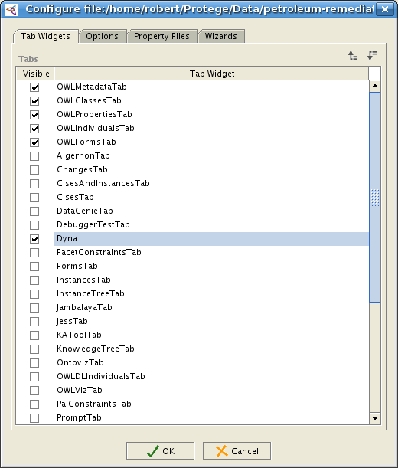
Figure 1. Enabling Dyna plug-in

c. Click OK
d. Dyna can now be accessed by clicking on the tab titled “Dyna”

Static knowledge is created in Protege.
- http://protege.stanford.edu/publications/ontology_development/ontology101-noy-mcguinness.html

Dynamic knowledge is created in Dyna. Figure 2 shows some different areas of the screen in Dyna. For reference, the important areas are labeled and briefly described below.

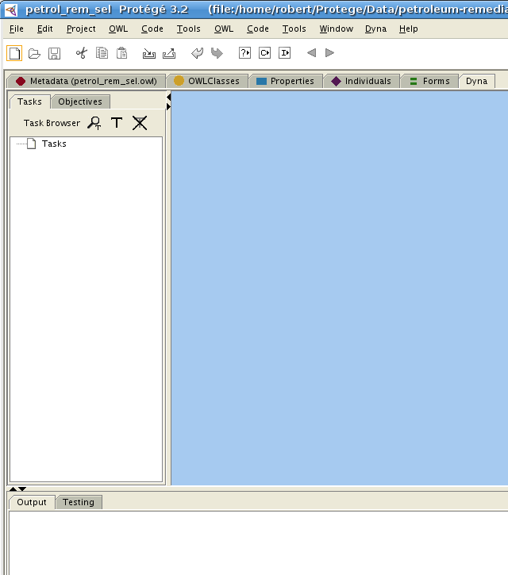

1. Create a new Dyna project
a. Click Dyna--->New Project
2. Create an objective
a. On the “Objective Browser”, click the Add Objective button
A new objective will appear in the Objective Browser
3. Modify the objective
a. Select the objective in the Objective Browser
b. Click the Show Objective button on the Objective Browser
A window will appear showing more information about the objective
c. Rename the objective by typing new text into Name field. A “quirk” of the system, is that the new value of the name will not be registered until the mouse clicks outside of the Name field. After you have finished typing the new name, click once in the Documentation field.
d. Add some documentation to describe the objective.
e. If there are any tasks, they can be added/removed/prioritized. See #6 for more details.
4. Create a task.
a. On the “Task Browser”, click the Add Task button
A new task will appear in the Task Browser
5. Modify the task
a. Select the task in the Task Browser
b. Click the Show Task button on the Task Browser
A window will appear showing more information about the task
2. Create a task: MeasureContaminatedSiteVolume
  - Specify task behaviour and any inputs and output. The behaviour for MeasureContaminatedSiteVolume is shown in Figure 26. The behaviour does not involve any inputs or output.
  - Specify any objects (instances of classes or individuals) that are used in the behaviour. MeasureContaminatedSiteVolume uses the object site, which is an individual of Media.
  - Specify test cases. The testing suite, shown in Figure 27, provides facilities for adding, deleting, and running test cases. Test cases may be run individually or all at once. The test cases shown in Figure 27 are for the task MeasureContaminatedSiteVolume. This step may be done before task behaviour and object specification.
- Specify strategy by linking the task to the objective. The link between the task MeasureContaminatedSiteVolume and the objective DetermineSiteSize is shown in Figure 4.
- Adjust the priority of the task in the objective (if necessary). MeasureContaminatedSiteVolume has a priority of 2, which means that it is to be performed after the task MeasureContaminatedSiteArea.
- Repeat Steps 1-4 until the knowledge engineer is satisfied that the model is complete. While it is difficult to know when the model is complete, a useful heuristic is to assess whether all the tasks have test cases and if they run successfully. If both criteria are satisfied, then it is likely the model is complete.

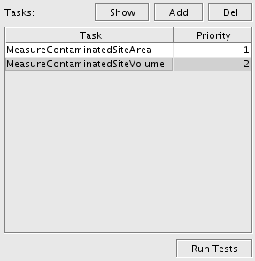
Figure 25. Dyna : DetermineSiteSize Objective

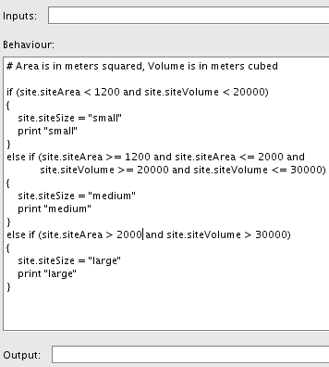
Figure 26. Dyna : Task Behaviour

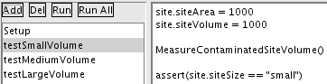
Figure 27. Dyna : Testing Task Behaviour

6. Author
Robert Harrison
email: harrisor@uregina.ca

7. Acknowledgements
I would like to thank the following people for their contributions to this project:
- Daniel Obst - XMLManager class
- Yuxiang Wu - Event handling is based on Wu's Event Service
- Christine Chan - Developer of Inferential Modeling Technique (IMT) and Supervisor
We are also grateful for the generous support of a Research Grant from Natural Sciences and Engineering Research Council (NSERC) of Canada.

8. Copyright
Copyright 2007, Energy Informatics Laboratory, Faculty of Engineering, University of Regina. All rights reserved.

9. Disclaimer
Use Dyna at your own risk.

