

Settling the Great Australian Rivalry – Is Sydney Better than Melbourne?

## Introduction

Since the mid 1800’s Australia’s two major two cities, Sydney and Melbourne, have battled it out over claims to be the best. Early protectionist policies naturally led Melbourne towards its future as a fashion and culture centre, while more liberal policies made Sydney the natural centre for finance and media.

As Australia fought for Federation, it was delayed as each city argued its case for being the capital of the newly formed country. Eventually a compromise was required, that would see a new capital city constructed between Melbourne and Sydney. But even then, there was no simple resolution: the site of the new capital, Canberra, was to be situated geographically closer to Sydney than Melbourne and thus Melbourne demanded to be home to the first federal parliament, while the new capital was built.

Even during World War I, Sydney complained that too much of the war effort was coming from Melbourne and the complaints and rivalry have not stopped since.

To add further division to this rivalry between two cities in a small country, each city adopted their own particular code of football, providing another area in which the cities could claim superiority, but in which these claims could not be tested.

Over the years the rivalry been distilled to two claims: Melbourne claims to be the world’s most liveable city, while Sydney contends that it’s the world’s best city. And while the rationale for holding these positions are justified in the historical strengths of the cities, do these claims still hold up?

Melbourne claims the most liveable title due to its culture and sport, while Sydney claims the best title due to its natural beauty and being an international city.

To settle the rivalry between the citizens of Australia’s two largest cities, the aim of this analysis is to attempt to quantify the features and strengths of each city – does Melbourne have more culture than Sydney; is Sydney more international than Melbourne?

With some cold hard facts its hoped that finally it can be stated categorically whether Sydney is indeed better than Melbourne.

## Data

To better quantify the features and strengths of Sydney and Melbourne, information about the respective cities was needed. Postcode data was available from Matthew Proctor and this data was used as a starting point of the analysis as it provided information on all postcodes and suburbs throughout Australia.

However, to get data representative of the greater cities of Sydney and Melbourne, the postcodes were limited to delivery areas (i.e. physical locations) for metro areas in NSW and Victoria – the states of which Sydney and Melbourne are capitals, respectively. This still provided a wide view of each city and so it was decided to take the four most central local government areas (LGAs) of each city, to be representative of the cities themselves.

In order to extract the information about each postcode using the Foursquare API, meant that a reasonable radius needed to be provided for each postcode. As the postcode sizes varied between cities and LGAs, some basic analysis was undertaken to estimate a suitable radius for each postcode in a given LGA. This resulted in a radius of from 1km for the central LGAs of Sydney and Melbourne and up to 3km for postcodes in the Melbourne – West LGA. Mapping of the radii showed that these simple estimates were suitable.

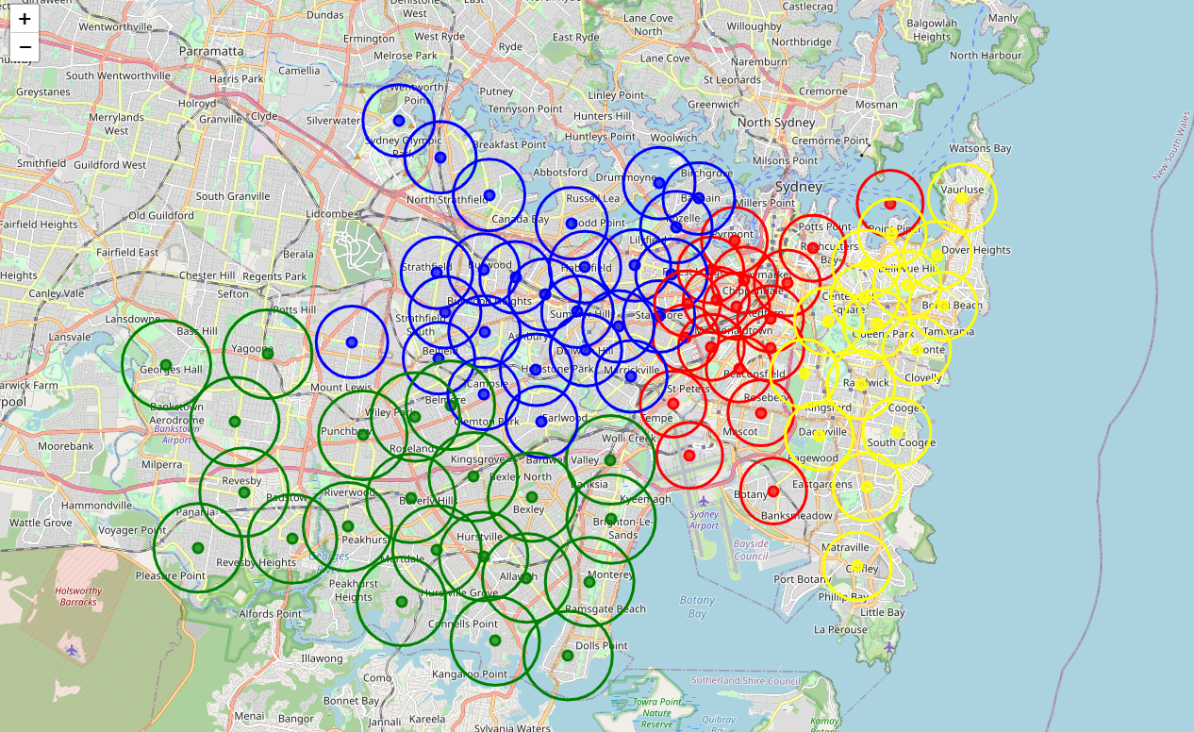

Figure 1: Map showing estimated radii for Sydney postcodes

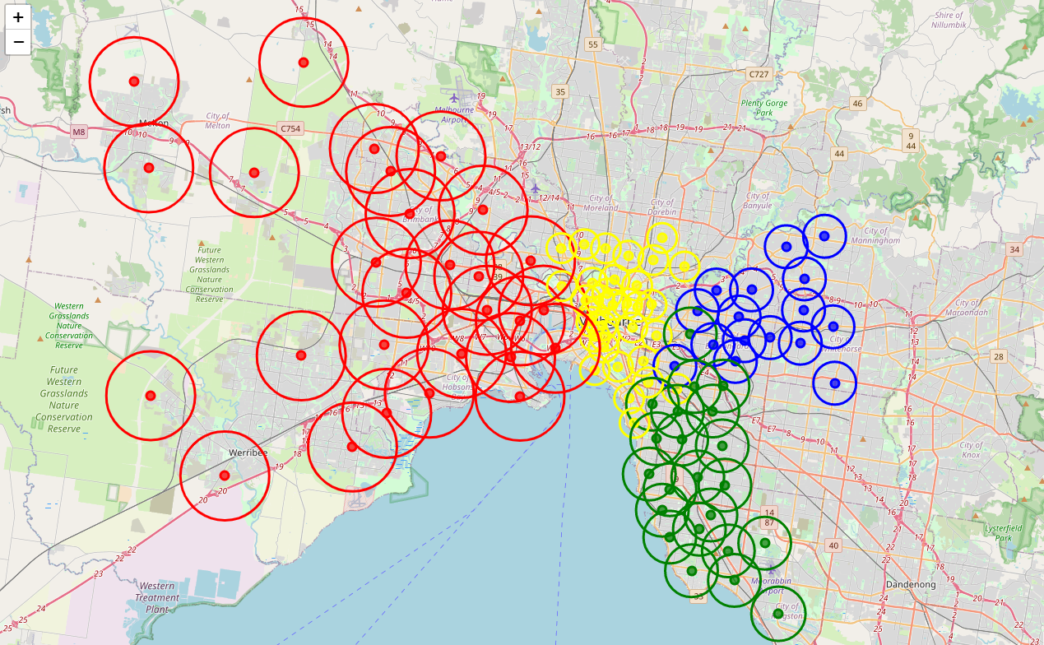

Figure : Map showing estimated radii for Melbourne postcodes

Using the calculated radius, along with the latitudes and longitudes provided in the postcodes data, all information for the given postcodes was extracted from Foursquare. This returned over 11,000 locations from the 182 postcodes. These locations were categorised by Foursquare into one of 403 location categories – such as restaurant, park, gym, etc.

These categories were too fine grained for the analysis, which looks to understand the cities from sporting, culture, nature and international diversity perspectives. To better improve the analysis, the classifications were further grouped into one of 17 groups, including international cuisine, sport, nature and cultural. These groups were manually developed by reviewing the provided categories and were appended to the Foursquare information.

It is this data that will be used to analyse and understand the features and strengths of Sydney and Melbourne, through their individual postcodes.

## References

A history of the Sydney v Melbourne rivalry

[https://www.crikey.com.au/2019/07/25/melbourne-sydney-rivalry-history/](javascript:openWebLink('https://www.crikey.com.au/2019/07/25/melbourne-sydney-rivalry-history/'))

Matthew Proctor

[https://www.matthewproctor.com/](javascript:openWebLink('https://www.matthewproctor.com/'))