If the size of the logical address space is **2*m*,** and a page size is **2*n*** bytes, then the high-order *m* − *n* bits of a logical address designate the page number, and the *n* low-order bits designate the page offset.

**logical address space size** = **2*m* | page size** = **2*n***

or = **2*32*** for 32-bit address

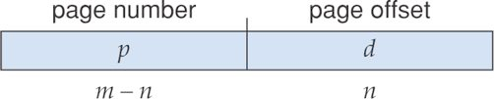

**page number** **(p) = *m – n* | page** **offset** = **(d) = *n***

As a concrete (although minuscule) example, consider the memory in Figure 7.12. Here, in the logical address, *n*= 2 and *m* = 4. Using a page size of 4 bytes and a physical memory of 32 bytes (8 pages), we show how the programmer’s view of memory can be mapped into physical memory.

Figure 7.18: Address translation for a two-level 32-bit paging architecture.

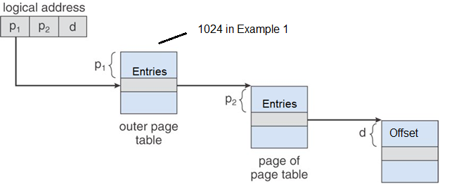

*n*= 2, **2*n* = 2 *2*** = 4 bytes

…

…

*n*= 10, **2*n* = 2 *10*** = 1024 = 1 KB

*n*= 11, **2*n* = 2 *11*** = 2048 = 2 KB

*n*= 12, **2*n* = 2 *12*** = 4096 = 4 KB

*n*= 13, **2*n* = 2 *13*** = 8192 = 8 KB

1. Consider a **32-bit** address for a two-level paging system with a **4 KB** page size. The outer page table has **1024** entries. How many bits are used to represent the second-level page table?

Select one:

a. 10

b. 8

c. 12

d. 9

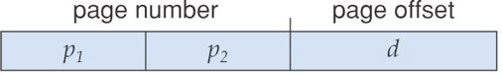

10 10 12 = 32

1024 = **2*10 Answer*** 4096 = **2*12*** = **4KB**

1. Consider a **32-bit** address for a two-level paging system with an **8 KB** page size. The outer page table has **1024** entries. How many bits are used to represent the second-level page table?

Select one:

a. 10

b. 8

c. 12

d. 9



10 9 13 = 32

1024 = **2*10 Answer*** 8192 = **2*13*** = **8KB**

1. Consider a **32-bit** address for a two-level paging system with a **16 KB** page size. The outer page table has **1024** entries. How many bits are used to represent the second-level page table?

Select one:

a. 10

b. 8

c. 12

d. 9



10 8 14 = 32

1024 = **2*10 Answer*** 16384 = **2*14*** = **16KB**

1. Consider a **32-bit** address for a two-level paging system with an **8 KB** page size. The outer page table has **2048** entries. How many bits are used to represent the second-level page table?

Select one:

a. 10

b. 8 (also)

c. 12

d. 9



11 8 13 = 32

2048 = **2*11 Answer*** 8192 = **2*13*** = **8KB**