Conflict-Related Sexual Violence (CRSV) & Reparation Deficits in Nigeria: An Empirical Policy Assessment (1995–2023)
Decoupling Survivor Redress from Inaccessible Judicial Dockets via Administrative Interim Reparative Measures (IRMs)
Author: Sayemo Harris | Date: October 2026
Methodological Framework: Longitudinal Secondary Analysis based on the SVAC 3.3 Dataset (PRIO/Harvard)
1. Executive Summary
This policy report provides a systematic evaluation of institutional exposure patterns, longitudinal severity trajectories, and post-conflict reparation deficits related to Conflict-Related Sexual Violence (CRSV) in Nigeria. Grounded in standardized, longitudinal conflict-actor data from 1995 to 2023, the analysis moves beyond localized case studies to construct an empirical baseline of documented violation frequency and institutional exposure across sovereign security forces and non-state insurgent factions.
Core Analytical Findings
• Aggregated Institutional Exposure (33 Cumulative Actor-Violation Years): Between 1995 and 2023, armed actors in Nigeria accumulated a combined 33 actor-years of active, documented sexual violence. Because state forces and insurgent groups operated concurrently during high-intensity conflict phases, this total reflects additive actor-year observations across concurrent forces, rather than 33 unique calendar years of conflict.
• Direct State Institutional Footprint (14 Actor-Years / 42.4%): Statutory armed forces (incorporating military formations and police commands) account for 14 documented violation actor-years between 2004 and 2019. Because statutory actors bear positive human rights and international humanitarian law obligations, this substantial empirical footprint provides a compelling imperative for the state to fulfill positive duties through administrative redress and structural guarantees of non-recurrence.
• Protracted Insurgent Severity (19 Actor-Years / 57.6%): Non-State Armed Groups, specifically Boko Haram (Jamā'at Ahl as-Sunnah lid-Da'wah wa'l-Jihād - JAS) and the Islamic State West Africa Province (ISWAP), demonstrate sustained violations, maintaining peak systematic severity (prevalence level 3) continuously through 2023.
• High-Risk Targeting of Children (19 Actor-Years): In 19 actor-years, documented violations against children reached massive or systematic proportions (prevalence score ≥ 2), highlighting a protracted vulnerability profile requiring specialized, multi-generational reparative and educational frameworks.
• The Structural Reparations Deficit: Despite clear empirical evidence of systematic harm spanning decades, victim redress is structurally inaccessible within existing legal frameworks. Because redress is theoretically subordinated to individual criminal prosecutions where perpetrators are largely unidentifiable, deceased, or beyond legal reach and because existing counter-terrorism dockets focus exclusively on state security rather than victim restitution, thousands of survivors receive zero urgent medical care, fistula repair, or rehabilitation. A policy deficit remains in dedicated, non-judicial administrative reparations and Interim Reparative Measures (IRMs).
Fig 1. Conflict-Related Sexual Violence (CRSV) & Reparation Deficit Analysis
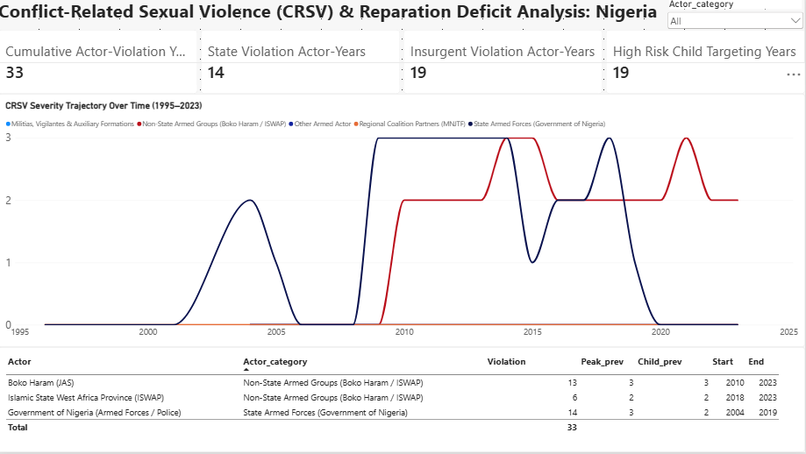
2. Methodology & Analytical Framework
2.1 Scope and Unit of Analysis
• Temporal Coverage: 1995–2023 conflict actor-years within the territorial boundaries of Nigeria.
• Analytical Actor Groupings: 1) State Armed Forces (Government of Nigeria: statutory military formations, joint task forces, and national police units); 2) Non-State Armed Groups (Boko Haram/JAS and ISWAP).
• Unit of Measurement: The primary quantitative metric is the Actor-Year. Where multiple armed actors commit documented violations in the same calendar year, each actor accumulates an autonomous actor-year observation in the dataset.
• Prevalence Scoring Framework: Severity is benchmarked against international SVAC coding standards: Level 0 (None reported); Level 1 (Isolated, <25 victims); Level 2 (Massive/Widespread, 25 to hundreds of victims); Level 3 (Systematic/Strategic weaponization, mass abductions, or institutionalized detention abuse).
2.2 Core Equations & Calculations
Cumulative Actor-Violation Years = ∑ (Actors) [ Years with max_prevalence ≥ 1 ] = 33 Actor-Years
State Documented Exposure Share = (14 State Actor-Years / 33 Cumulative Years) = 42.4%
Insurgent Exposure Share (JAS / ISWAP) = (19 Insurgent Actor-Years / 33 Cumulative Years) = 57.6%
High-Risk Child Targeting Exposure = ∑ (Actors) [ Years with child_prevalence ≥ 2 ] = 19 Actor-Years

3. Comparative Longitudinal Findings
Actor Name | Analytical Category | Documented Violation Years | Peak Severity (0–3) | Peak Child Prevalence (0–3) | Documented Active Horizon
Boko Haram (JAS) | Non-State Armed Groups | 13 | 3 (Systematic) | 3 (Systematic) | 2010 – 2023
Islamic State West Africa Province (ISWAP) | Non-State Armed Groups | 6 | 2 (Massive) | 2 (Massive) | 2018 – 2023
Government of Nigeria (Armed Forces / Police) | State Armed Forces | 14 | 3 (Systematic) | 2 (Massive) | 2004 – 2019
Cross-Conflict Aggregation | Combined Profile | 33 | 3 | 3 | 1995 – 2023

Analytical Trajectory & Institutional Exposure
State Force Violations (2004–2019): Documentation covers early internal security operations through counter-insurgency surges around 2014–2016, with recorded incidents in formal operations, screening sites, and displacement settings. Because the state holds sovereign legal obligations under international human rights treaties, these 14 documented actor-years supply an empirical basis for state-funded administrative reparative measures independent of individual criminal trial convictions.
Insurgent Dynamics (Post-2015): The bifurcation of Boko Haram into JAS and ISWAP around 2016 decentralized the operational pattern of violence. JAS retained high child-targeting prevalence via abductions and forced marriages, while ISWAP institutionalized social control across rural operational theaters. Because individual insurgent combatants and commanders are largely unreachable, unidentified, or processed through non-judicial defection tracks, individual criminal prosecution offers no viable pathway for victim compensation. Consequently, the state maintains a positive surrogate obligation to facilitate non-judicial, administrative redress.
4. Key Limitations & Strategic Recommendations
4.1 Addressing the Survivor-Centric Evidence Gap
While conflict-actor datasets provide an essential empirical baseline of documented perpetrator reporting patterns, they remain inherently perpetrator- and incident-centric. They track the frequency, timing, and severity of violations committed by armed factions, but they do not record survivor agency, post-violation medical needs, or localized priorities for redress. Macro-level accountability metrics must be paired with survivor-centered evidence to develop functional transitional justice programs.
4.2 Policy Recommendations
• 1. Establish a Standardized, Survivor-Led Reparations Registry: Design a secure, trauma-informed intake mechanism in partnership with local survivor networks and civil society organizations. Intake protocols must disaggregate survivor-demanded forms of redress across key categories: material & economic redress (direct compensation, restitution of land/cattle), clinical & psychosocial care (reconstructive surgery, specialized fistula treatment, clinical trauma support), support for children born of war (expedited legal identity documentation, schooling grants), and symbolic reparations (formal state apologies, memorialization).
• 2. Operationalize Administrative Interim Reparative Measures (IRMs): Decouple humanitarian assistance and victim compensation from judicial court dockets. Given the direct exposure share of statutory forces (14 actor-years), the Federal Government and Northeast State Governments should establish an administrative reparations fund to deliver urgent material relief without waiting for perpetrator trials or peace settlements.
• 3. Incorporate Survivor Redress into Regional Security Frameworks: Integrate structured victim consultation and compensation mechanisms into ongoing Disarmament, Demobilization, and Reintegration (DDR) and transitional justice programs in Northeast Nigeria to ensure assistance aligns directly with survivor priorities.
Appendix A: Data Provenance, Acquisition Pipeline & Licensing
A.1 Primary Data Source
The quantitative metrics used in this assessment originate from the Sexual Violence in Armed Conflict (SVAC) database, maintained collaboratively by the Peace Research Institute Oslo (PRIO), the University of Gothenburg, and the Harvard Kennedy School.
• Core Dataset: SVAC Actor-Year Dataset (Version 3.3).
• Citation Standard: Cohen, Dara Kay, and Ragnhild Nordås. Sexual Violence in Armed Conflict (SVAC) Dataset. Peace Research Institute Oslo (PRIO) & Harvard Kennedy School.
• Primary Documentation Streams: The dataset triangulates findings from three authoritative monitoring sources: 1) United Nations Secretary-General Annual Reports on CRSV and CAAC; 2) United States Department of State Country Reports on Human Rights Practices; 3) Authoritative human rights reporting from Amnesty International and Human Rights Watch.
A.2 Acquisition & Transformation Pipeline
1. Extraction: The full global SVAC repository was accessed through PRIO’s open data repository and filtered to extract conflict actors operating within Nigeria from 1995 to 2023.
2. Standardization: Entities were standardized into state statutory forces and non-state insurgent factions (JAS and ISWAP).
3. Metric Calculation: Prevalence scores across all three source streams were evaluated using max-aggregation logic to construct standardized integer variables (max_prevalence and child_prevalence, scaled 0–3). DAX measures were built in Microsoft Power BI Desktop by Sayemo Harris to compute institutional exposure totals and longitudinal trajectories.
A.3 Open Data Licensing & Attribution Terms
Data Terms of Use & Licensing: The underlying SVAC dataset is provided by PRIO / Harvard Kennedy School for open research and policy analysis under standard academic attribution terms.
Analytical Output License: This derived compilation, analytical model, and report are released under the Creative Commons Attribution 4.0 International (CC BY 4.0) License.
Permitted Use: Open to sharing, copying, adapting, and redistributing in any medium or format for research, reporting, advocacy, and policy development.
Attribution Requirement: Any secondary publication, policy brief, dashboard, or report using these metrics must acknowledge the original data collectors (Cohen & Nordås / PRIO), with citation of this analytical compilation and model adaptation attributed to: Harris, Sayemo. Conflict-Related Sexual Violence (CRSV) & Reparation Deficits in Nigeria: An Empirical Policy Assessment (1995–2023). Analytical Dashboard & Policy Brief, 2026.

