CYCLISTIC BIKE-SHARE CASE STUDY: EXECUTIVE REPORT
Maximizing Annual Memberships Through Data-Driven Behavioral Insights

Author: Sayemo Harris
Role: Data Analyst
Organization: Cyclistic Bike-Share
Track: Google Data Analytics Professional Certificate — Capstone Case Study 1
Date: October 2026

1. Executive Summary
Cyclistic operates a successful bike-share fleet in Chicago, offering flexible pricing plans that include single-ride passes, full-day passes, and annual memberships. While casual riders using single-day or single-ride passes contribute substantial volume, financial analysis has demonstrated that annual members are considerably more profitable over their customer lifetime. Lily Moreno, Director of Marketing, has identified the conversion of casual riders into annual members as the primary growth engine for Cyclistic.
This report examines 12 months of historical transactional ride data totaling 5.40 million trips. Using Python (Pandas) for data cleansing and Power BI for visual analytics, this analysis isolates the operational differences between annual members and casual riders across seasonality, weekly cadences, intraday hourly rhythms, and trip durations.
The findings confirm that members ride out of utilitarian necessity (weekday commuting at 8:00 AM and 5:00 PM, averaging ~12.27 minutes), while casual riders utilize the service for discretionary recreation (surging on weekends and warm afternoons, averaging ~19.46 minutes). To convert casual riders, marketing strategy must pivot away from standard commuter advertising and toward weekend-focused, leisure-friendly membership incentives.

2. Phase 1: Ask

2.1 Business Task Statement
Design data-driven marketing strategies aimed at converting casual riders into annual members to maximize long-term profitability and revenue sustainability for Cyclistic.

2.2 Key Stakeholders
- Lily Moreno: Director of Marketing; responsible for campaign strategy, brand development, and digital marketing channel execution.
- Cyclistic Executive Team: Primary decision-makers; responsible for approving commercial marketing budgets, pricing structures, and overall strategic direction.
- Cyclistic Marketing Analytics Team: Collaborative data team analyzing user behavior and tracking key performance indicators across campaigns.

2.3 Core Analytical Questions
- How do annual members and casual riders use Cyclistic bikes differently?
- Why would casual riders buy a Cyclistic annual membership?
- How can Cyclistic use digital media to influence casual riders to become members?

3. Phase 2: Prepare

3.1 Data Source Overview
- Data Source: 12 months of historical Cyclistic trip data spanning 2025 (stored in 01_RAW_DATA), made available by Motivate International Inc. under an open data license.
- File Structure: Monthly tabular CSV files capturing trip-level attributes: unique ride IDs, rideable types (classic, electric), start and end timestamps, start and end station names, station IDs, geographic coordinates, and customer classification (member or casual).

3.2 Data Evaluation via the ROCCC Framework
- Reliable (High): Sourced directly from automated bike docking station system logs and digital transaction records.
- Original (High): First-party transactional platform data collected directly by Motivate International Inc.
- Comprehensive (High): Contains over 5.4 million distinct trip records capturing all four seasons across the entire Chicago metropolitan footprint.
- Current (High): Encompasses the most recent 12-month operational period.
- Cited (High): Governed and released under an official, recognized open-source data license agreement.

3.3 Data Privacy & Ethics
In compliance with data privacy standards, all personal identifiable information (PII)—including rider names, credit card numbers, and home addresses—is excluded from the dataset. Individual rides cannot be connected to specific individuals, preserving user confidentiality while allowing aggregate behavioral analysis.

4. Phase 3: Process

4.1 Processing Environment
Data cleaning, manipulation, and feature engineering were executed using Python (Pandas) within a Jupyter Notebook environment (stored in 03_NOTEBOOK).

4.2 Data Cleaning & Transformation Pipeline
- Consolidation: Imported all 12 monthly raw CSV files and concatenated them into a single consolidated Pandas DataFrame (5,400,000+ rows).
- Datetime Formatting: Converted started_at and ended_at fields from raw object strings into native datetime objects (pd.to_datetime).
- Trip Duration Calculation: Engineered the trip length metric:
$$\text{ride\_length\_minutes} = \frac{\text{ended\_at} - \text{started\_at}}{60}$$
- Data Integrity Filtering:
  - Removed anomalous negative durations caused by system maintenance reboots.
  - Filtered out false starts and docking errors where trips lasted less than 60 seconds.
- Feature Engineering: Extracted temporal dimensions to support cyclical analysis:
  - month (January through December)
  - day_of_week (Monday through Sunday)
  - hour_of_day (0 through 23)
- Export for BI Modeling: Aggregated summary tables were exported as structured CSV files into 02_PROCESSED_DATA for report visualization.

5. Phase 4: Analyze

5.1 Baseline Behavioral Contrast

Analytical Dimension | Annual Members | Casual Riders | Behavioral Meaning
Total Annual Volume | Dominant majority across all 12 months | Substantial volume, highly seasonal | Members form the stable revenue baseline.
Average Trip Duration | 12.27 minutes | 19.46 minutes | Casual trips last ~58% longer; members prioritize direct transit.
Weekly Concentration | Monday – Friday (~500K+ daily rides) | Saturday – Sunday (surge to peak levels) | Commuter reliance vs. weekend leisure exploration.
Intraday Peaks | Dual peaks at 8:00 AM and 5:00 PM | Single gradual wave peaking 2:00 PM – 6:00 PM | Rush-hour transit schedules vs. daylight recreation.
Seasonality Profile | Steady utility usage across all seasons | Sharp summer spike (June–August); winter drop | High weather dependency among non-members.

5.2 Key Analytical Findings
- The Commute vs. Recreation Dichotomy: Annual members rely on Cyclistic for structured, utilitarian transit. The member volume curves trace typical 9-to-5 workday commutes with sharp spikes at 8:00 AM and 5:00 PM. Casual riders, conversely, show minimal morning rush-hour use, building their volume smoothly across warm afternoons and peaking over the weekend.
- Trip Duration Disparity: Casual riders spend nearly 60% more time per ride (19.46 minutes) than members (12.27 minutes). This indicates leisurely riding, sightseeing along waterfront trails, and social outings, rather than point-to-point transit.
- Severe Weather Sensitivity: Casual ridership falls below 100K during cold winter months (November to February) before surging to over 300K monthly trips between June and August. Member ridership remains substantially more resilient during the off-season.

6. Phase 5: Share

6.1 Executive Dashboard Overview
An executive reporting dashboard was designed to communicate the behavioral split between rider segments to Lily Moreno and the executive committee.

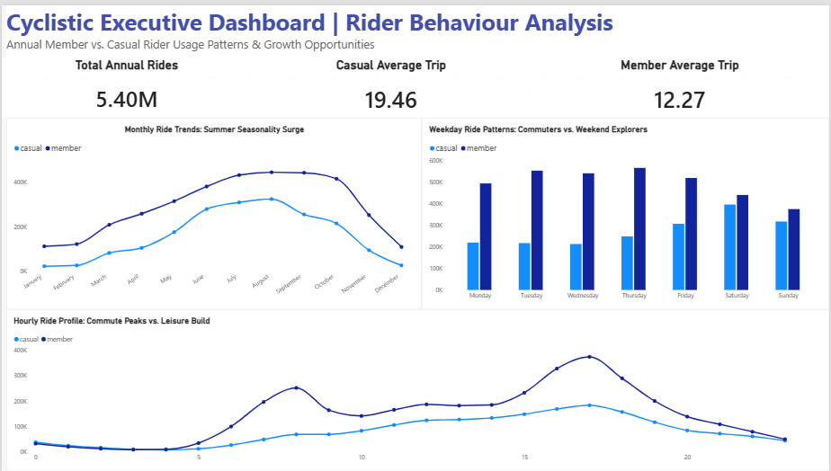

6.2 Visual Component Breakdown

Visual Component | Chart Type | Key Data Observation | Business Meaning
KPI Header | Cards | 5.40M rides; Casual avg: 19.46 min; Member avg: 12.27 min | Casual trips last ~58% longer; members prioritize utility transit.
Monthly Seasonality | Line Chart | Peak surge June–August; winter volumes drop below 100K | High weather sensitivity; conversion campaigns belong in spring/summer.
Weekly Cadence | Clustered Column | Members dominate Mon–Fri (~500K+); Casuals surge on Sat–Sun | Workday commuter base vs. weekend recreational lifestyle riders.
Hourly Profile | Line Chart | Member spikes at 8 AM & 5 PM; Casual single afternoon curve | Commute rush hours vs. daylight leisure riding patterns.

6.3 Addressing the Stakeholder Presentation Questions
- Were you able to answer how members and casual riders use Cyclistic bikes differently?
Yes. Members use the platform for point-to-point daily commuting, while casual riders use it for open-ended, warm-weather weekend recreation.
- What story does the data tell?
The data illustrates that casual riders represent a passionate, high-duration customer segment that values the service for leisure. They cannot be converted by advertising transit efficiency; they must be engaged based on lifestyle flexibility and recreational perks.

7. Phase 6: Act

7.1 Strategic Answers to the Guiding Questions
- What is your final conclusion based on your analysis?
Converting casual riders into annual members requires campaigns tailored to recreational value, summer exploration, and weekend utility, rather than generic workday commuter messaging.
- How could Cyclistic apply these insights?
Reallocate marketing budgets away from low-yield winter windows and weekday morning rush hours. Concentrate digital ad spend between April and August, at high-volume leisure stations, and across weekend afternoons.
- What next steps should stakeholders take?
Approve the campaign concepts, develop targeted digital out-of-home (DOOH) assets for recreational docks, launch a 90-day pilot testing promotional conversion incentives during the spring ramp-up, and track customer acquisition cost (CAC) and retention through the summer.
- What additional data would expand on these findings?
Integrating individual user IDs (with privacy compliance) to conduct cohort retention analysis, tracking revenue and margin data per trip, and layering local weather datasets (temperature and precipitation) for predictive demand forecasting.

7.2 Top Three Marketing Recommendations for Lily Moreno

Recommendation 1: Launch Seasonal Conversion Campaigns During the Spring Surge (April–May Window)
- Evidence: Member ridership remains steady throughout the year, whereas casual volume drops below 100K during winter and surges to peak levels between May and August.
- Strategic Action: Concentrate digital media spend in April and May to intercept casual riders as they reactivate their riding habits for the warm season. Offer an early-bird "Spring into Summer" annual membership discount, avoiding costly ad spend during dormant winter months.

Recommendation 2: Implement a "Weekend Explorer to Member" Conversion Rebate Program
- Evidence: Casual riders concentrate heavily on Saturdays and Sundays and stay out for an average of 19.46 minutes (compared to members at 12.27 minutes), showing a willingness to invest time and money in weekend recreation.
- Strategic Action: Introduce an in-app bridge incentive: allow 100% of single-ride or day-pass fees spent on a weekend to be applied as a direct credit toward an annual membership upgrade if redeemed within 48 hours. This lowers upfront price resistance for riders who already value the service.

Recommendation 3: Target Digital Out-of-Home (DOOH) and Geofenced Promos at Recreational Docks
- Evidence: Casual rider activity builds through afternoon leisure hours (2:00 PM–6:00 PM) rather than morning rush hours, with volume concentrating near parks, lakefront paths, and waterfront docks.
- Strategic Action: Deploy digital screen advertising and geofenced mobile push notifications near high-traffic recreational docking corridors during weekend afternoons. Messaging should emphasize leisure perks: waived unlock fees, longer ride limits before overage charges, and priority weekend bike availability.

8. Conclusion & Deliverables Summary
- Final Deliverable: Cyclistic_Case_Study_Executive_Report.docx
- Analytical Pipeline: Python cleaning scripts archived in 03_NOTEBOOK
- Processed Datasets: Summary tables archived in 02_PROCESSED_DATA
- Visual Artifacts: Executive Dashboard modeled and available for Power BI presentation

