PLAZA PRO
DEVELOPER BUILD GUIDE
Real Estate Sales CRM
Building It from Zero — Architecture, Foundations
and a Step-by-Step Engineering Workflow
Laravel · Vue 3 · MySQL · Docker · Ubuntu
Document | Developer Build Guide & Engineering Workflow
For | PLAZA PRO — Real Estate Sales CRM
Stack | Laravel (API) · Vue 3 (SPA) · MySQL · Docker
Environment | Ubuntu + containers
Version | 1.0
Date | June 2026
Status | Working engineering reference

Table of Contents

1. How to Use This Guide
This is the practical guide for building the PLAZA PRO Real Estate Sales CRM from zero. It is written to be easy to follow and detailed enough to act on directly: set up the environment, lay down strong foundations, then build the product feature by feature. Follow it top to bottom for a brand-new project, or jump to a section when you need a specific pattern.
The guide is opinionated on purpose. A consistent structure is what keeps a growing codebase clean, makes it easy to extend with new modules later, and lets AI-assisted development stay accurate — because the AI has clear conventions to follow rather than guessing. Wherever a choice matters, this guide makes it for you and explains why in a sentence.

1.1 What You Will Build
A web application with three parts working together: a Vue 3 single-page app for the interface, a Laravel REST API for the logic, and MySQL for the data — all running in Docker containers on your Ubuntu machine. The result is responsive (works well on phones), themeable (gold-and-white by day, gold-and-black at night), and extensible (new features slot in without disturbing the old ones).
The five commitments this guide bakes in
1. Foundations first — nothing is built on sand. Phase 0 establishes the patterns every later feature reuses.
2. Extensible by design — feature modules are isolated, so a new one is added without touching the others.
3. Traceable always — the no-delete, cancel-and-duplicate and audit-log rules are part of the base model, not an afterthought.
4. Responsive & themed — mobile-first layouts and a gold/white + gold/black design-token system from day one.
5. Quality as you go — every feature ships as a tested vertical slice, so the app always works.

2. Architecture at a Glance
Before any code, hold the shape of the system in your head. It is a clean separation between a frontend that shows things, a backend that decides things, and a database that remembers things — with a few shared foundations that every feature relies on.
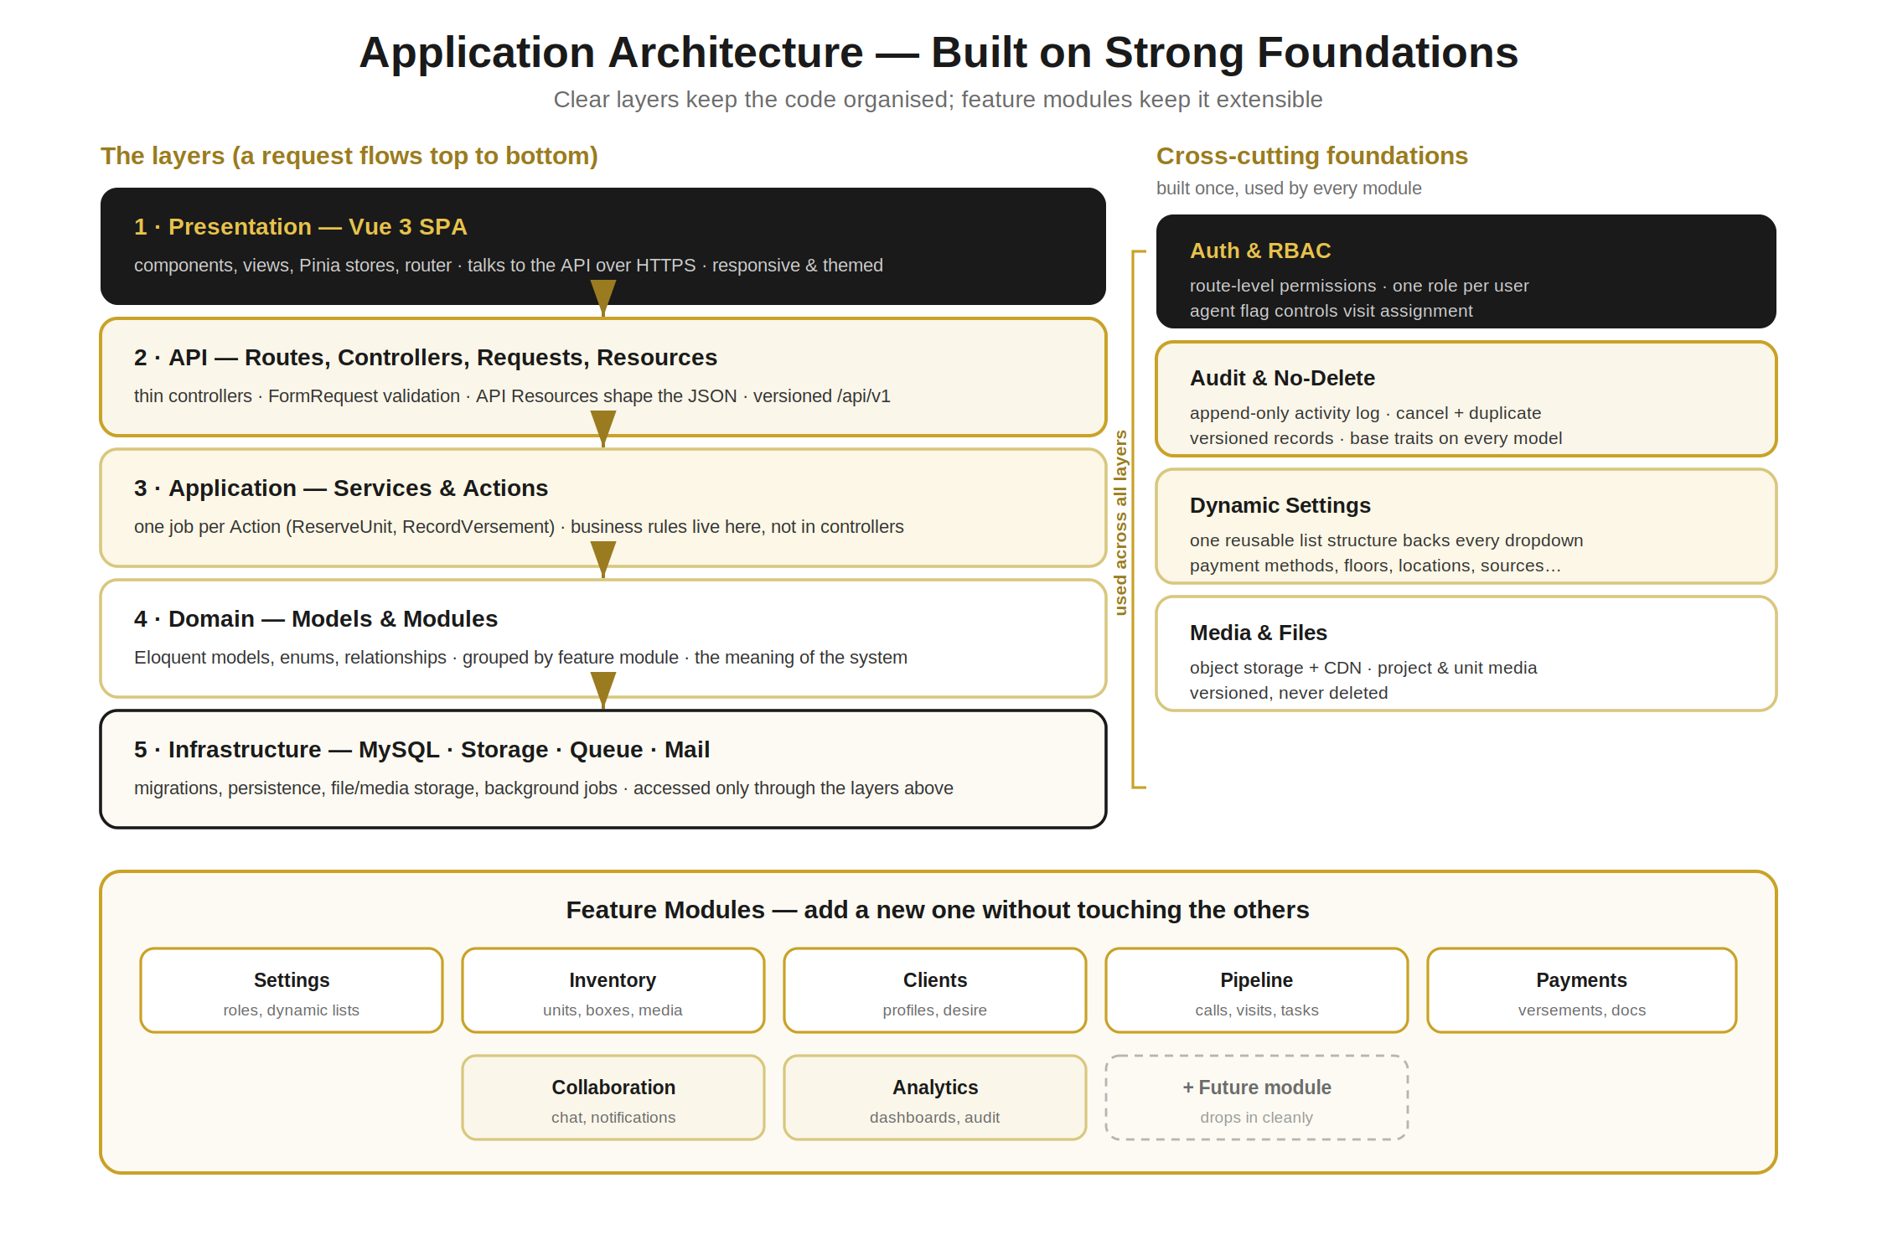
Figure 2.1 — The layered, modular architecture this guide builds toward.

2.1 The Layers
A request travels down through clear layers, each with a single responsibility. Keeping these boundaries is the most important habit in the whole codebase.
- Presentation (Vue) — components, views, stores and routing. It never contains business rules; it asks the API.
- API (Laravel routes, controllers, requests, resources) — the front door. Controllers stay thin; validation lives in FormRequests; responses are shaped by API Resources.
- Application (services & actions) — the business logic. Each Action does one job (for example, ReserveUnit or RecordVersement), so a rule exists in exactly one place.
- Domain (models & modules) — Eloquent models, enums and relationships, grouped by feature module. This is the meaning of the system.
- Infrastructure (MySQL, storage, queue, mail) — persistence and external services, reached only through the layers above.

2.2 The Shared Foundations
Four cross-cutting foundations are built once in Phase 0 and used by every module. Getting these right early is what makes the rest of the project fast and safe.
Foundation | What it gives every feature
Auth & RBAC | Login, and route-level permissions; one role per user, with an agent flag that controls who can be assigned visits
Audit & No-Delete | An append-only activity log, plus the cancel-and-duplicate correction and record versioning, applied through base model traits
Dynamic Settings | One reusable list structure that powers every dropdown (payment methods, floors, locations, sources, and so on)
Media & Files | Project- and unit-level photos, video, PDF and PPTX in object storage with a CDN, versioned and never deleted
Table 2.1 — The four shared foundations established in Phase 0.

3. The Containerized Development Environment
You will develop on Ubuntu using Docker, so every service runs in its own container and the whole environment starts with one command. This means your machine stays clean, every developer (and every AI session) works against an identical setup, and production later mirrors development closely.
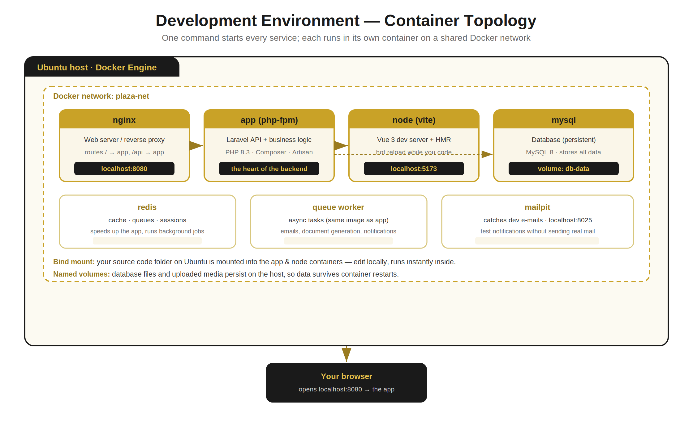
Figure 3.1 — The container topology you will run locally.

3.1 Install the Tools on Ubuntu
You need just three things on the host: Docker Engine, the Docker Compose plugin, and Git. Everything else (PHP, Node, MySQL) lives inside containers, so you never install them on the host directly.
Ubuntu — one-time setup
# Update and install prerequisites
sudo apt update && sudo apt upgrade -y
sudo apt install -y ca-certificates curl gnupg git

# Install Docker Engine + Compose plugin (official convenience script)
curl -fsSL https://get.docker.com -o get-docker.sh
sudo sh get-docker.sh

# Run docker without sudo (log out/in afterwards)
sudo usermod -aG docker $USER

# Verify
docker --version
docker compose version

3.2 The Project Layout on Disk
Keep the backend and frontend side by side in one repository, with the Docker files at the root. This "mono-repo" keeps everything versioned together and easy to start.
Repository root
plaza-pro/
├── docker/ # Dockerfiles & service configs
│ ├── php/Dockerfile
│ └── nginx/default.conf
├── backend/ # Laravel API (see Section 4)
├── frontend/ # Vue 3 SPA (see Section 5)
├── docker-compose.yml # the whole dev stack
├── .env # shared dev settings
└── README.md

3.3 The Compose File
This single file defines every container, how they connect, and what persists. It is the backbone of your environment; read it once and you understand the whole local setup.
docker-compose.yml
# docker-compose.yml
services:
nginx:
image: nginx:alpine
ports: ["8080:80"]
volumes:
- ./backend:/var/www/html
- ./docker/nginx/default.conf:/etc/nginx/conf.d/default.conf
depends_on: [app]
networks: [plaza-net]

app: # Laravel + PHP-FPM
build: ./docker/php
volumes: ["./backend:/var/www/html"]
depends_on: [mysql, redis]
networks: [plaza-net]

node: # Vue dev server (Vite)
image: node:20-alpine
working_dir: /app
command: sh -c "npm install && npm run dev -- --host"
ports: ["5173:5173"]
volumes: ["./frontend:/app"]
networks: [plaza-net]

mysql:
image: mysql:8
environment:
MYSQL_DATABASE: plaza
MYSQL_ROOT_PASSWORD: secret
ports: ["3306:3306"]
volumes: ["db-data:/var/lib/mysql"]
networks: [plaza-net]

redis:
image: redis:alpine
networks: [plaza-net]

mailpit: # catches dev e-mails
image: axllent/mailpit
ports: ["8025:8025"]
networks: [plaza-net]

volumes:
db-data:
networks:
plaza-net:

3.4 Daily Commands
A handful of commands cover almost everything you do day to day. Run Artisan and Composer inside the app container so they use the container’s PHP, not the host’s.
Everyday workflow
docker compose up -d # start the whole stack (detached)
docker compose down # stop everything
docker compose logs -f app # follow the Laravel logs

# Run commands inside the app container
docker compose exec app php artisan migrate
docker compose exec app php artisan make:model Unit -m
docker compose exec app composer require <package>

# Frontend (inside the node container)
docker compose exec node npm run build
Tip
Add these as short aliases (for example, "dart" for "docker compose exec app php artisan") so the long commands never slow you down.

4. Backend Foundation — Laravel
The backend is a pure REST API: it speaks JSON, holds all the business rules, and owns the database. Its structure is organised by feature module so the project can grow without becoming tangled.

4.1 Folder Structure
Start from a standard Laravel install, then introduce a Modules folder. Each module owns its own models, actions, controllers, requests and resources. This is what makes the system extensible — a new module is a new folder, not a change scattered across the app.
Modular backend layout
backend/app/
├── Modules/
│ ├── Settings/ # roles, departments, users, dynamic lists
│ ├── Inventory/ # locations, units, boxes, media
│ ├── Clients/ # clients, desire
│ ├── Pipeline/ # calls, visits, tasks, next-action
│ ├── Payments/ # versements, schedules, documents
│ ├── Collaboration/ # chat, notifications
│ └── Analytics/ # dashboards, audit views
│ ├── Models/
│ ├── Actions/ # one job each (business logic)
│ ├── Http/
│ │ ├── Controllers/ # thin — call actions
│ │ ├── Requests/ # validation
│ │ └── Resources/ # JSON shaping
│ └── routes.php
├── Core/ # base model, traits, audit, RBAC
└── Providers/

4.2 The Base Model — Traceability Built In
Every model in the system extends one base model that carries the foundations: automatic activity logging, the cancellable (no-delete) behaviour, and versioning. Because it is inherited, traceability is automatic everywhere and impossible to forget.
BaseModel.php — the no-delete guarantee
// app/Core/Models/BaseModel.php
abstract class BaseModel extends Model
{
use LogsActivity; // writes who/what/when to the audit log
use Cancellable; // "delete" => status = cancelled (+reason)
use HasVersions; // edits create a new version, keep the old

// Hard delete is disabled at the framework level:
public function delete() {
throw new \RuntimeException("Records are cancelled, never deleted.");
}
}
The Cancellable trait gives every record a status (active or cancelled) and a cancellation reason; the LogsActivity trait records each change with before-and-after values; HasVersions keeps superseded versions instead of overwriting. Together they deliver exactly the no-hide, no-remove, fully-traceable behaviour the product requires.

4.3 The Activity Log
A single append-only table records every meaningful action. It is written automatically by the base model and is never updated or deleted. An administrator can search it by user, date, entity or action.
Column | Holds
user_id | Who performed the action (and their role at the time)
action | create · update · cancel · restore · duplicate · view · login · export
subject_type / subject_id | Which record was affected
changes | Before and after values for an edit (JSON)
ip_address / user_agent | Where the action came from
created_at | Server timestamp (immutable)
Table 4.1 — The activity_log table.

4.4 RBAC — Permissions on Every Route
Access is controlled at the route level. Each user has exactly one role; each role grants a set of permissions; middleware checks the permission before the controller runs. An "is agent" flag on the role decides who appears in the visit-assignment list, exactly as the product specifies.
Route-level permission
// A route is protected by a permission, not just "logged in"
Route::middleware(['auth:sanctum', 'can:units.reserve'])
->post('/units/{unit}/reserve', [UnitController::class, 'reserve']);

4.5 The Request Lifecycle
Every write follows the same ten steps. Learn this once and every feature you build (or ask AI to build) looks the same — which is what keeps the codebase coherent.
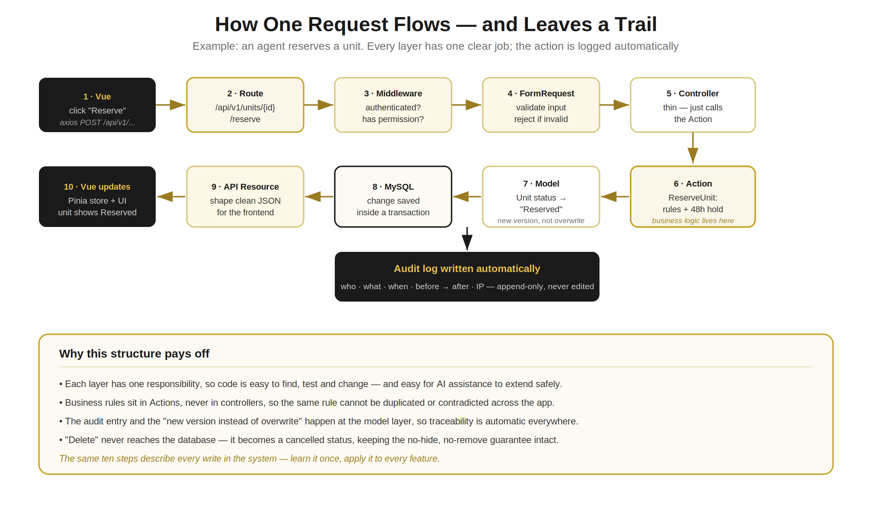
Figure 4.1 — The lifecycle of a single write, with the audit entry created automatically.

4.6 Naming Conventions
Consistency in names removes a thousand small decisions. Use these throughout:
- Models — singular PascalCase (Unit, ClientProject, Versement).
- Actions — a verb phrase describing the job (ReserveUnit, GenerateVersementDocument, MatchDesireToInventory).
- Controllers — resource name + Controller, thin, delegating to actions.
- Database tables — plural snake_case (units, client_projects, versements); foreign keys as singular_id (location_id).
- API routes — versioned and plural (/api/v1/units, /api/v1/clients).

5. Frontend Foundation — Vue 3
The frontend is a Vue 3 single-page app built with Vite. It is responsive first, themed from the start, and organised by feature so it mirrors the backend modules. It holds no business rules — it presents data and calls the API.

5.1 The Stack
Tool | Role
Vue 3 (Composition API) | The UI framework; <script setup> for concise components
Vite | Lightning-fast dev server and build tool
Vue Router | Client-side routing between pages
Pinia | State management (stores per feature)
Axios | Talks to the Laravel API
Tailwind CSS | Utility styling, wired to the gold/black design tokens
Table 5.1 — The frontend stack.

5.2 Folder Structure
Group by feature, not by file type, so everything about (say) inventory lives together and matches the backend module of the same name.
Feature-based frontend layout
frontend/src/
├── assets/styles/ # tokens.css (themes), tailwind entry
├── components/base/ # buttons, inputs, cards (themed, reused)
├── composables/ # useApi, useTheme, useAuth
├── layouts/ # AppShell (sidebar, top bar, mobile nav)
├── features/
│ ├── inventory/ # views, components, store, api calls
│ ├── clients/
│ ├── pipeline/
│ ├── payments/
│ └── ... # one folder per module
├── router/index.js
└── main.js

5.3 Theming — Gold & White / Gold & Black
Colour is never hard-coded in a component. Instead, the whole palette is defined once as CSS variables (design tokens). A single toggle switches the theme by swapping the values, and every component re-themes instantly. The gold accent stays identical in both modes, so the brand feels consistent day and night.
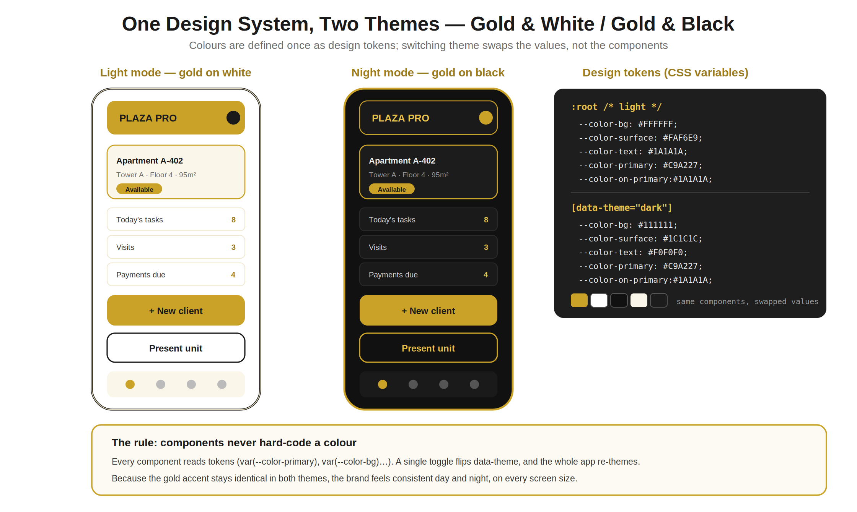
Figure 5.1 — One design system, two themes, driven by CSS variables.
tokens.css
/* assets/styles/tokens.css */
:root { /* light: gold on white */
--color-bg: #FFFFFF;
--color-surface: #FAF6E9;
--color-text: #1A1A1A;
--color-primary: #C9A227; /* gold */
--color-on-primary: #1A1A1A;
--radius: 12px;
}
[data-theme="dark"] { /* night: gold on black */
--color-bg: #111111;
--color-surface: #1C1C1C;
--color-text: #F0F0F0;
--color-primary: #C9A227; /* same gold */
--color-on-primary: #1A1A1A;
}
Tailwind is pointed at these variables, so utility classes follow the theme automatically:
Wiring Tailwind + toggling
// tailwind.config.js (excerpt)
theme: { extend: { colors: {
bg: "var(--color-bg)",
surface: "var(--color-surface)",
primary: "var(--color-primary)",
ink: "var(--color-text)",
}}}

// Switching theme is one line (persist the choice):
document.documentElement.dataset.theme = isNight ? "dark" : "light";

5.4 Mobile-First & Responsive
Design every screen for the phone first, then enhance for larger screens. Field agents work on mobile, so this is not optional polish — it is the primary experience.
- Start with a single-column layout; add columns at larger breakpoints with Tailwind’s sm: / md: / lg: prefixes.
- Use a bottom navigation bar on mobile and a sidebar on desktop, both from the same AppShell layout.
- Make tap targets generous, and ensure the present-a-unit and log-a-call flows work in a few taps.
- Test at phone width continuously — the stacking plan, media viewer and forms must all reflow cleanly.

5.5 The API Layer
All network calls go through one small wrapper, so authentication, error handling and the base URL are defined in a single place rather than scattered across components.
useApi.js
// composables/useApi.js
const api = axios.create({ baseURL: "/api/v1" });
api.interceptors.request.use(cfg => {
cfg.headers.Authorization = `Bearer ${useAuth().token}`;
return cfg;
});
// Components call api.get("/units"), never raw fetch().

6. Database Foundation — MySQL
MySQL stores everything, and its design follows the same traceability rules as the rest of the system. Schema changes are made only through migrations, so the database structure is versioned alongside the code.

6.1 Conventions
- Migrations only — never change the schema by hand; every change is a migration file, reviewable and repeatable.
- Plural snake_case tables, singular foreign keys — units, client_projects; location_id, client_id.
- Timestamps everywhere — created_at and updated_at on every table; the audit log adds the full history.
- Status over deletion — tables carry a status column (active / cancelled) and a cancellation_reason; rows are never removed.
- Indexes on foreign keys and on the columns you filter by (status, dates), so lists stay fast as data grows.

6.2 The No-Delete Pattern in the Schema
The immutability rule shows up directly in table design. A correction cancels the original and inserts a corrected row that links back to it, so both remain in history.
A migration that encodes traceability
// Example migration: versements (instalments)
Schema::create('versements', function (Blueprint $t) {
$t->id();
$t->foreignId('client_project_id')->constrained();
$t->decimal('amount', 12, 2);
$t->date('paid_on');
$t->string('status')->default('active'); // active | cancelled
$t->string('cancellation_reason')->nullable();
$t->foreignId('supersedes_id')->nullable() // links a fix
->constrained('versements');
$t->timestamps();
$t->index(['client_project_id', 'status']);
});

6.3 Core Tables
The main entities and how they relate are captured in the data model from the Scope of Work. At a high level: locations hold units and boxes; clients have projects; projects carry interactions and payments; and shared tables (users, roles, dynamic settings, media, activity log) support everything.
Re-use the ERD you already have
The conceptual entity-relationship diagram in the Scope of Work is the reference for these tables and relationships. Build the migrations to match it, table by table, as each module is implemented.

7. Coding Standards & Git Workflow
Shared standards are what let several people — and AI assistance — work on the same codebase without it drifting. Automate them so they are enforced, not just hoped for.

7.1 Automated Style
- PHP — follow PSR-12; run Laravel Pint to format automatically before every commit.
- JavaScript / Vue — ESLint for correctness and Prettier for formatting, on save and in CI.
- One source of truth — these tools are configured in the repo, so every machine and session formats identically.

7.2 Git Branching
Keep main always working. Build each feature on its own short-lived branch and merge through a reviewed pull request.
Branching & commit style
main # always deployable
└── feature/inventory-stacking-plan
└── feature/client-desire-matching
└── fix/versement-rounding

# Commit messages: short, present tense, scoped
feat(inventory): add reservation hold with 48h auto-expiry
fix(payments): correct partial cancellation total

7.3 Definition of Done
A feature is "done" only when all of these are true. Treat the list as a gate before merging.
- Works end to end — UI, API and database, on phone and desktop, in both themes.
- Respects the foundations — permissions checked, actions used for logic, nothing deletes, activity logged.
- Tested — at least one feature test for the happy path and the key rule (for example, the 48-hour expiry).
- Formatted and reviewed — Pint/ESLint clean, and approved in a pull request.

8. Building Efficiently with AI Assistance
You will use an AI assistant to write much of the code. Used well, it dramatically speeds up delivery; used carelessly, it produces inconsistent code that erodes the foundations. These habits keep it firmly an accelerator.

8.1 Give It the Rules
- Feed it this guide — point the assistant at these conventions (structure, base model, naming, lifecycle) at the start of a session, so it generates code that fits.
- Work one vertical slice at a time — ask for a single feature end to end (migration, model, action, controller, request, resource, Vue view), not a whole layer at once.
- Show an example — once one module follows the pattern, ask the assistant to mirror it for the next. Consistency compounds.

8.2 Stay in Control
- Review every change — read what it produced before accepting; confirm it uses an Action for logic, checks a permission, and never deletes.
- Run it — let the tests and the app, not the chat, be the proof that something works.
- Keep slices small — small, tested increments are easy to verify and easy to roll back; large dumps of code are neither.
The golden rule
The AI follows your structure; your structure does not follow the AI. When generated code and these conventions disagree, the conventions win — adjust the code, then continue.

9. The Build Sequence
Build in the order below. Each phase delivers something demoable, and every feature within a phase is built as a full vertical slice — a thin path from screen to database that actually works — rather than building entire layers in isolation.
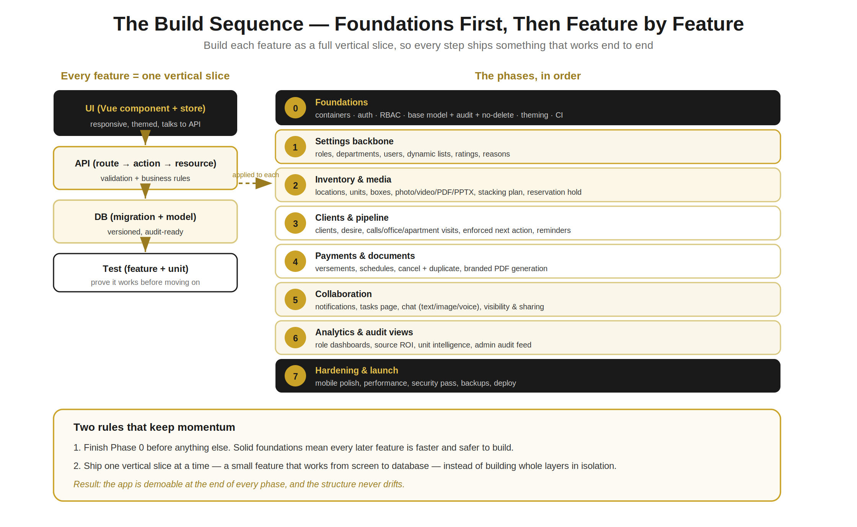
Figure 9.1 — The phased build sequence and the vertical-slice approach applied to every feature.

9.1 Phase 0 — Foundations (do this first)
Resist the urge to build features until this is done. It is the platform everything else stands on.
- The container stack running and the Laravel + Vue projects talking to each other.
- Authentication and RBAC, with one role per user and the agent flag.
- The base model with logging, cancellable and versioning; the activity_log table; the no-delete guarantee.
- The theming system (gold/white + gold/black tokens) and the responsive AppShell.
- The continuous-integration pipeline running tests and style checks on every push.

9.2 Phases 1–7 — Feature by Feature
Phase | Focus | What ships
1 | Settings backbone | Roles, departments, users, ratings, reasons, and the dynamic-list structure every dropdown uses
2 | Inventory & media | Locations, units and boxes; photo/video/PDF/PPTX media; the visual stacking plan and reservation hold
3 | Clients & pipeline | Clients and Desire; call / office-visit / apartment-visit chain; enforced next action with auto-reminders
4 | Payments & documents | Versements and schedules; cancel-and-duplicate corrections; branded document generation
5 | Collaboration | Notifications, the tasks page, and chat with text, images and voice notes; visibility and sharing
6 | Analytics & audit | Role dashboards, source ROI, unit-level intelligence, and the admin audit feed
7 | Hardening & launch | Mobile polish, performance, a security pass, backups, and deployment
Table 9.1 — Phases 1 through 7, building on the Phase 0 foundation.
How to know a phase is finished
You can open the app, use the new feature on a phone and on desktop, in both themes, with permissions enforced and every action traceable — and the tests for it pass. Then move to the next phase.

10. Testing, Quality & Going Live

10.1 Testing
Aim for confidence, not perfection. A focused set of tests on the rules that matter is worth more than chasing a coverage number.
- Backend — Pest or PHPUnit feature tests hitting the API: the happy path plus each key rule (next-action match, 48-hour expiry, no-delete, archive-only-without-payments).
- Frontend — Vitest for components and composables; a few end-to-end checks for the critical flows (capture a client, reserve a unit, record a payment).
- Continuous integration — run the whole suite and the style checks on every push, so main is always green.

10.2 Going Live
Production uses the same container approach, tightened for security and performance. Keep configuration in environment variables, never in code.
- Build optimised images — compiled Vue assets served as static files; PHP with caching (config, routes, views) enabled.
- Use real services — a managed or hardened MySQL with automated backups, object storage with a CDN for media, and HTTPS everywhere.
- Run migrations on deploy — automatically and safely, with a backup taken first.
- Monitor — log errors centrally and watch the queue, so issues surface before users report them.

10.3 Foundation Checklist
Before declaring the foundations complete, confirm every item:
- Containers start with one command; frontend and backend communicate.
- Login works; routes are permission-protected; the agent flag drives visit assignment.
- Nothing can be hard-deleted; corrections cancel-and-duplicate; the activity log records every action.
- Dynamic settings power dropdowns; media attaches at project and unit level.
- Both themes work; layouts are responsive on phone and desktop.
- Tests and style checks run automatically on every push.
The bottom line
Get Phase 0 right and the rest of this build is steady, predictable work: pick the next feature, build it as a tested vertical slice that respects the foundations, ship it, repeat.
That is how a small team — with AI assistance — builds a genuinely world-class, extensible, beautifully themed CRM from zero, without the structure ever drifting.

