LTVF Cloud Dashboard
Ideation & Architecture Discussion

Date: 13 July 2026
Status: DRAFT — For Discussion Only
Audience: Architecture Review / Business Stakeholders
1. The Idea — What Are We Trying to Do?
Right now, the LTVF report lives entirely inside SAP GUI. To view it, a user needs SAP GUI installed, a valid SAP login, and usually VPN access. That creates friction — especially for finance managers, business analysts, or external stakeholders who only need to read the report, not operate SAP.
The idea is simple: take the same LTVF data and surface it through a modern web browser — no SAP GUI, no VPN dependency, no special software. The data stays in SAP. We just put a better window in front of it.
In one sentence: A cloud-hosted dashboard that reads LTVF data from SAP and displays it in a browser — accessible to anyone with the URL and credentials.

What the current SAP screen looks like vs what we're building
 | SAP GUI (Today) | Cloud Dashboard (Proposed)
Access | SAP Logon + VPN | Any browser, any device
Who can see it | SAP-licensed users only | Any authorised business user
Layout | Fixed ALV grid | Interactive table + KPI cards
Export | Manual SAP list export | One-click download
Sharing | Screenshot or export file | Share a URL

2. High-Level Architecture
Three layers — each doing one job:
[ Browser ] ←→ [ Cloud API ] ←→ [ SAP S/4HANA ]
React UI FastAPI (Python) OData / Gateway

- Browser (React): renders the report table, KPI numbers, and charts. Talks only to our API — never directly to SAP.
- Cloud API (FastAPI): the middleman. Fetches data from SAP, formats it, hands it to the browser. Holds SAP credentials securely.
- SAP: the system of record. Nothing changes here. We read data through the existing SAP Gateway OData interface.
Key point: SAP is untouched. We are building a read-only view on top of existing data. There is no risk of data modification and no SAP development required (assuming an OData service exists).

3. Frontend — Why React?
What the frontend does
- Displays the LTVF hierarchy as an interactive table — matching the SAP layout but better.
- Shows KPI summary cards at the top: Net MRP, Global Amount, Delta.
- Colour-codes positive/negative deltas (green / red) — same as SAP traffic lights.
- Refresh button to pull latest data from SAP on demand.

Why React — and not something else?
This came up early. Below is honest reasoning, not marketing:
Option | Why we looked at it | Why we moved on
React | Largest ecosystem, best AG Grid support, huge talent pool | — Selected —
Next.js | React-based, great for SEO and server-side rendering | SSR not needed for an internal dashboard. Adds complexity we don't need yet.
Angular | Enterprise-grade, Google-backed, strong TypeScript | Heavy framework for a read-only report. Steeper learning curve, larger bundle.
Vue 3 | Lightweight, gentle learning curve, good for small apps | AG Grid enterprise integration is less mature than React. Smaller hiring pool.
Svelte / SvelteKit | Very fast, minimal boilerplate, growing community | Immature ecosystem for data-heavy grid components. Higher risk for enterprise.
Plain HTML + JS | No framework overhead, fastest to ship a prototype | Becomes unmaintainable quickly as features grow. No component reuse.

The real reason: The LTVF report is a deeply hierarchical data grid. AG Grid — which has the best React integration — handles tree data, large row counts, sorting, and filtering out of the box. That alone makes React the practical choice for this specific use case.

What the screen looks like (rough layout)
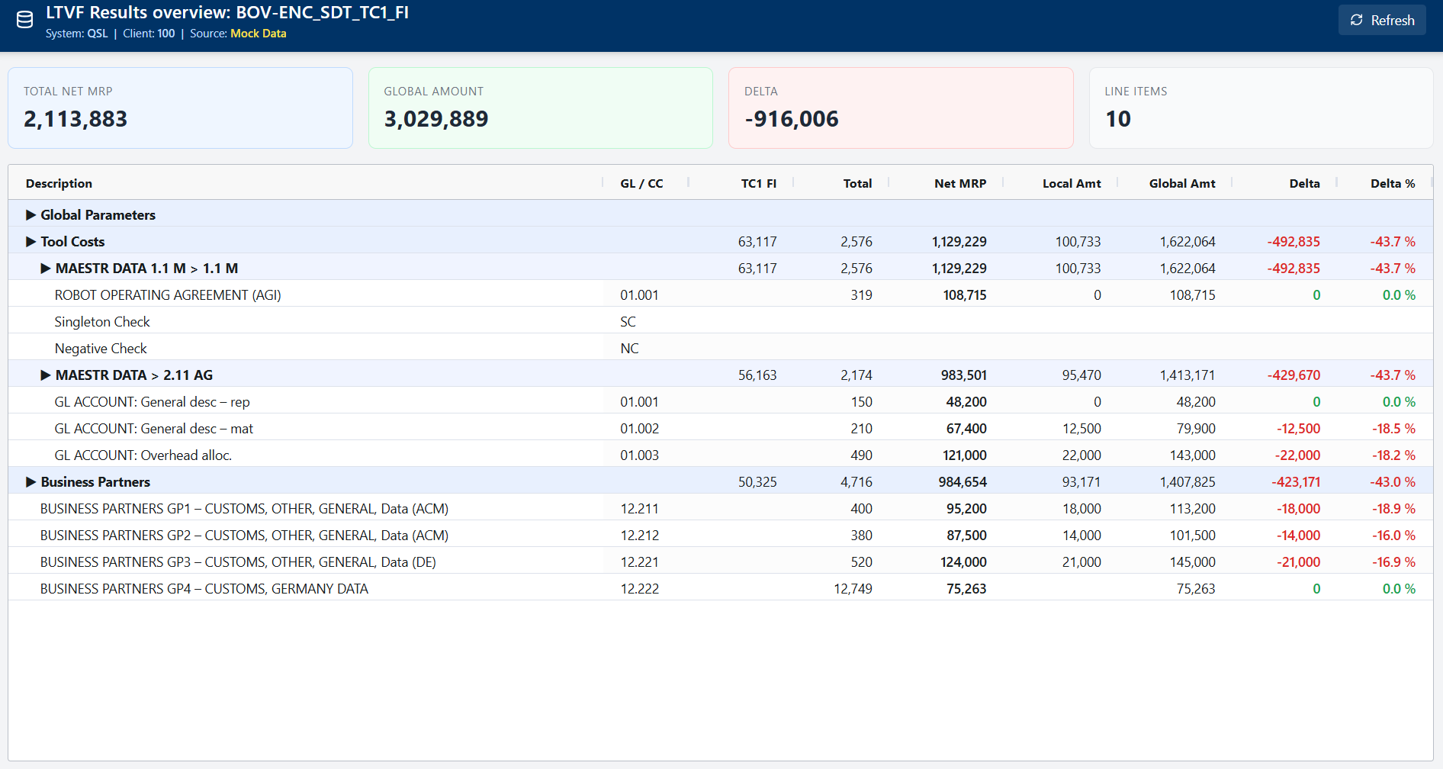

4. Backend — FastAPI (Python)
What the backend does
- Acts as the secure bridge between the browser and SAP.
- Holds SAP credentials — the browser never sees them.
- Calls the SAP OData service, normalises the JSON response, returns it to the frontend.
- Provides a mock mode — returns sample data when SAP is not yet connected.

Why FastAPI over other backend options?
Option | Considered? | Verdict
FastAPI (Python) | Yes | Selected. Fast to build, auto-generates API docs, clean SAP OData integration via requests library.
Node.js / Express | Yes | Viable. But Python has more mature SAP integration libraries and the team is more comfortable with it.
Java Spring Boot | Yes | Technically strong but heavy. Overkill for a read-only reporting API. Slower iteration.
SAP BTP / CAP | Yes | Native SAP cloud platform. Keeps everything in SAP ecosystem but locks us in and adds cost.
Serverless (Lambda/Functions) | Briefly | Could work for low-traffic. Cold start latency is a concern for a dashboard that needs to feel responsive.

SAP Connection approach
- Protocol: SAP OData via HTTPS — standard, supported, no custom SAP development needed.
- Auth: HTTP Basic Auth with a dedicated read-only service account (not a personal login).
- Mock toggle: USE_MOCK=true/false — one environment variable switches between live SAP and sample data.
Still to confirm with BASIS team: We need the OData service URL, HTTPS port, and a service account before we can go live. The architecture is ready — it's a config change, not a code change.

5. Challenges — What Are We Worried About?
Being honest here. These are the real things that could cause friction and they are worth discussing before we go further.
5.1 SAP Connectivity
- Risk: SAP Gateway OData may not be enabled, or the LTVF program data may not be exposed as an OData service.
- Impact: If no OData service exists, BASIS would need to create one — adding time and SAP transport effort.
- Mitigation: We are already running in mock mode. The frontend is fully built. The SAP connection is the last mile.

5.2 Data Accuracy & Trust
- Risk: Business users may not trust a web dashboard to show the same numbers as SAP GUI.
- Impact: Adoption could be slow if users keep double-checking against SAP.
- Mitigation: Add a 'Last refreshed' timestamp and a direct link back to the SAP report for validation during rollout.

5.3 User Adoption
- Risk: Users are accustomed to the SAP ALV layout. A web UI — even a better one — requires a change in habit.
- Impact: Training overhead; resistance from power users who know SAP shortcuts.
- Mitigation: Keep the column names, row structure, and colour coding as close to SAP as possible. Run a parallel period.

5.4 Authentication & Access Control
- Risk: The current build has no user login on the web app itself.
- Impact: Anyone with the URL can see the financial data — not acceptable for production.
- Mitigation: Must add authentication before go-live. Options: Azure AD SSO, Google OAuth, or a simple API key for internal use. This is a Phase 4 item.

5.5 SAP Performance
- Risk: The OData call to SAP could be slow if the LTVF dataset is large or the Gateway is under load.
- Impact: The dashboard may feel slow to load — poor first impression.
- Mitigation: Add a loading spinner (already in place). Consider caching the response for 5–10 minutes if data does not need to be real-time.

5.6 Network / Firewall
- Risk: The cloud-hosted backend may not be able to reach the SAP system on-premise due to firewall rules.
- Impact: Entire integration blocked until network path is opened.
- Mitigation: Raise with IT/BASIS early. If cloud-to-SAP is blocked, the backend can be deployed inside the corporate network instead.

5.7 Keeping Up With SAP Changes
- Risk: If the LTVF program or OData service changes (e.g. due to an SAP upgrade or a CNV re-configuration), the dashboard could break.
- Impact: Silent failures — wrong or missing data.
- Mitigation: Add a health check endpoint and monitoring alert. Any OData schema change should trigger a dashboard review.

Discussion question for this review: Which of these challenges is the biggest blocker from the business / customer side? Prioritising the mitigation order will shape the next phase of work.

6. Open Questions for This Discussion
- 1. Should the dashboard be accessible externally (internet) or internal network only?
- 2. Who are the primary users — finance team, management, external auditors?
- 3. Do we need user-level access control (some users see some cost centres, others see all)?
- 4. Is real-time data a hard requirement, or is a 10-minute cache acceptable?
- 5. Will the report need to support multiple SAP clients / systems (QSL and PRD)?
- 6. Is there a preference for cloud provider — Azure, AWS, GCP, or on-premise?
- 7. What does success look like for Phase 1 go-live — number of users, data scope?

7. What Is Already Built
To give this discussion something concrete — here is where we are today:
Component | Status | Detail
React frontend | Done | Running at localhost:3000. Full LTVF table, KPI cards, header.
FastAPI backend | Done | Running at localhost:8000. Mock LTVF data. /api/ltvf endpoint live.
SAP OData client | Ready | Code written. Waiting for SAP Gateway URL and service account from BASIS.
Docker containers | Done | docker-compose.yml ready. One command to run both services.
Authentication | Not started | Needed before production. Azure AD SSO recommended.
Cloud deployment | Not started | Pending cloud platform decision.

LTVF Cloud Dashboard — Ideation Draft | 13 July 2026 | For Discussion Only

