

project

SUBMITTED TO

Submitted By

Mohammad Abubakar Iftikhar Muhammad Abdullah

F2019266396 F2019266065

Section V6

Text Editor

OBJECT ORIENTED PROGRAMMING(OOP)

Sir Rana Waqas

**GROUP MEMBERS**

Name Roll Number Section

Mohammad Abubakar Iftikhar F2019266396 V6

Muhammad Abdullah F2019266065 V6

**RESPONSIBILITIES**

Member Responsibility

Abubakar Menu bar, File menu, Edit menu, Text Editor

Abdullah Format menu, Help menu.

# **PROJECT FEATURE**

1. Text area
2. Menu
   1. File menu
      1. New file
      2. Load file
      3. Save file
      4. Save as file
      5. Page Setup
      6. Print
      7. Exit
   2. Edit menu
      1. Redo
      2. Undo
      3. Cut
      4. Copy
      5. Paste
      6. Delete
      7. Find
      8. Find next
      9. Replace
      10. Go to
      11. Select all
      12. Time and Date
   3. Format menu
      1. Word Wrap
      2. Font
      3. Back ground Color
   4. Help
      1. About

**TEXT AREA**

Contains text area to write on.

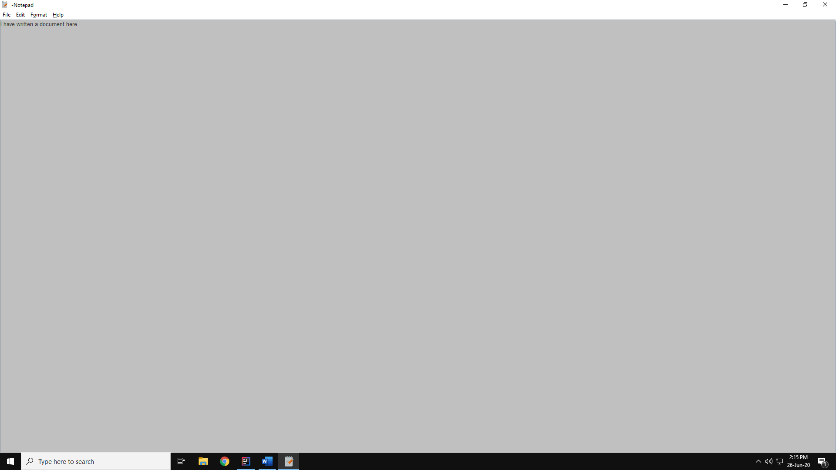

**MENU**

Contains dropdown buttons of File, Edit, Format, Help

**FILE MENU**

Contains buttons as shown.

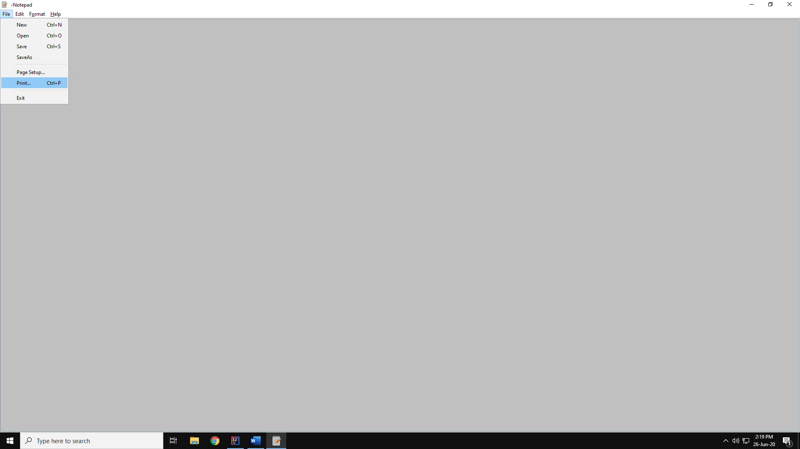

**NEW**

Displays new file and discards all and get an empty unsaved file.

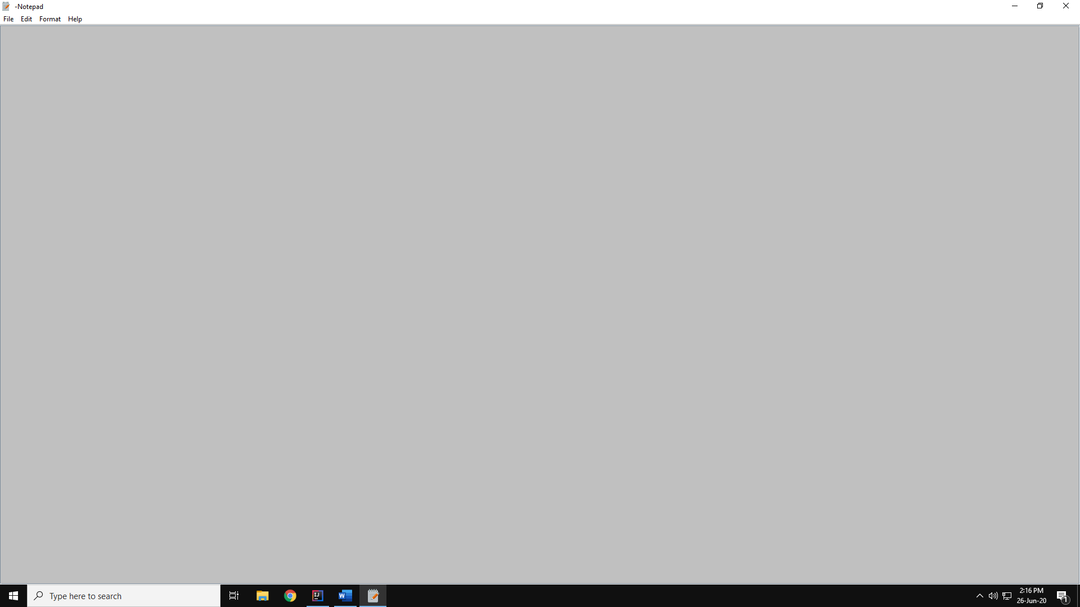

**OPEN**

Opens a text file stored in secondary memory.

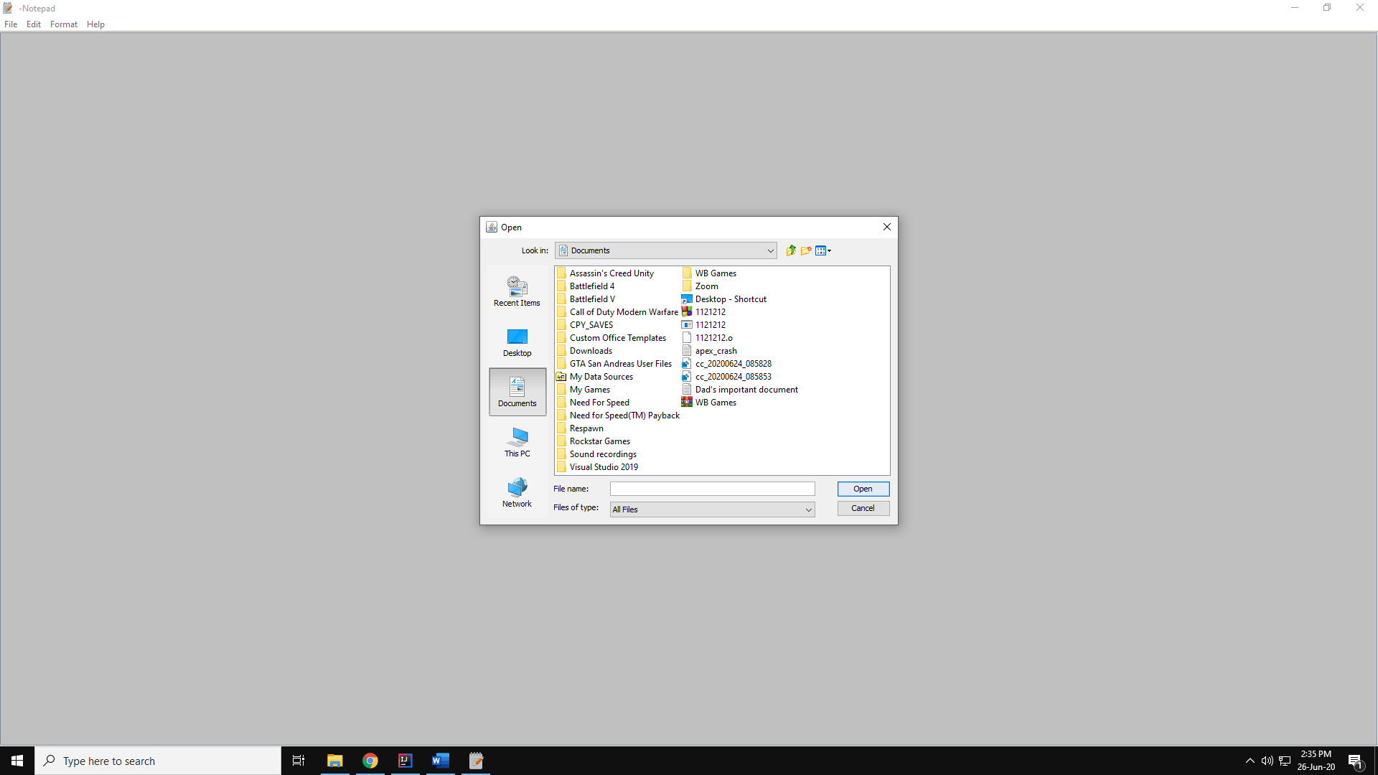

**SAVE FILE**

Saves file if save destination is selected, otherwise acts as a Save as button

**SAVE AS FILE**

Saves to a new location provided by used



**PAGE SETUP**

Used to setup text page like set the page type

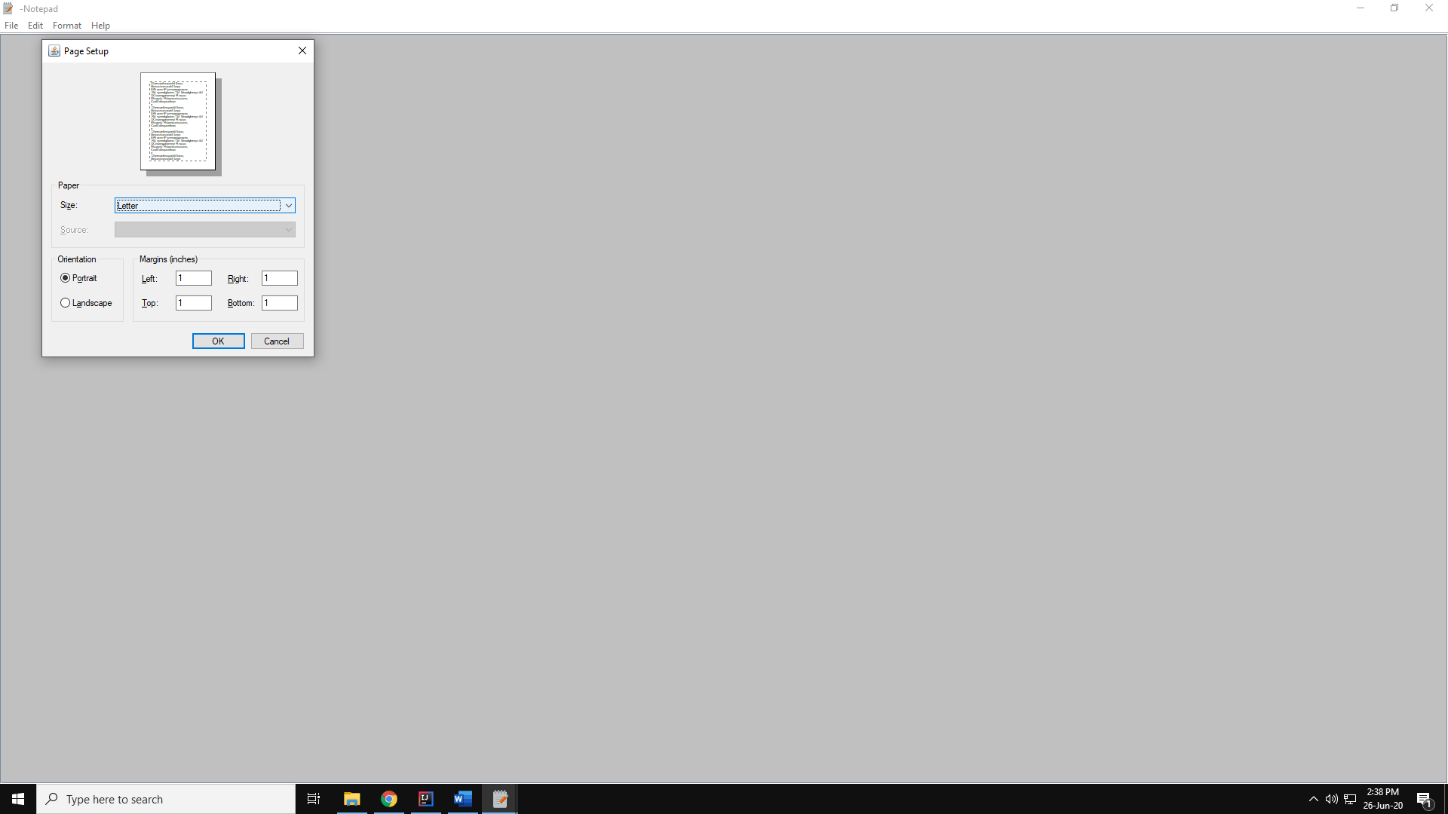

**PRINT**

Print and provide print settings like set the page type.

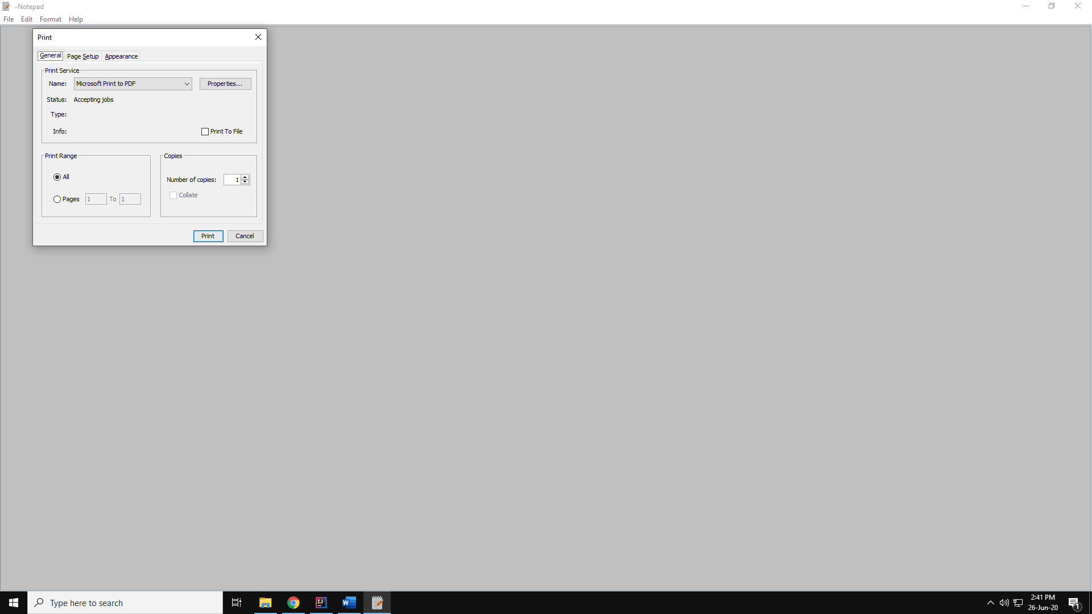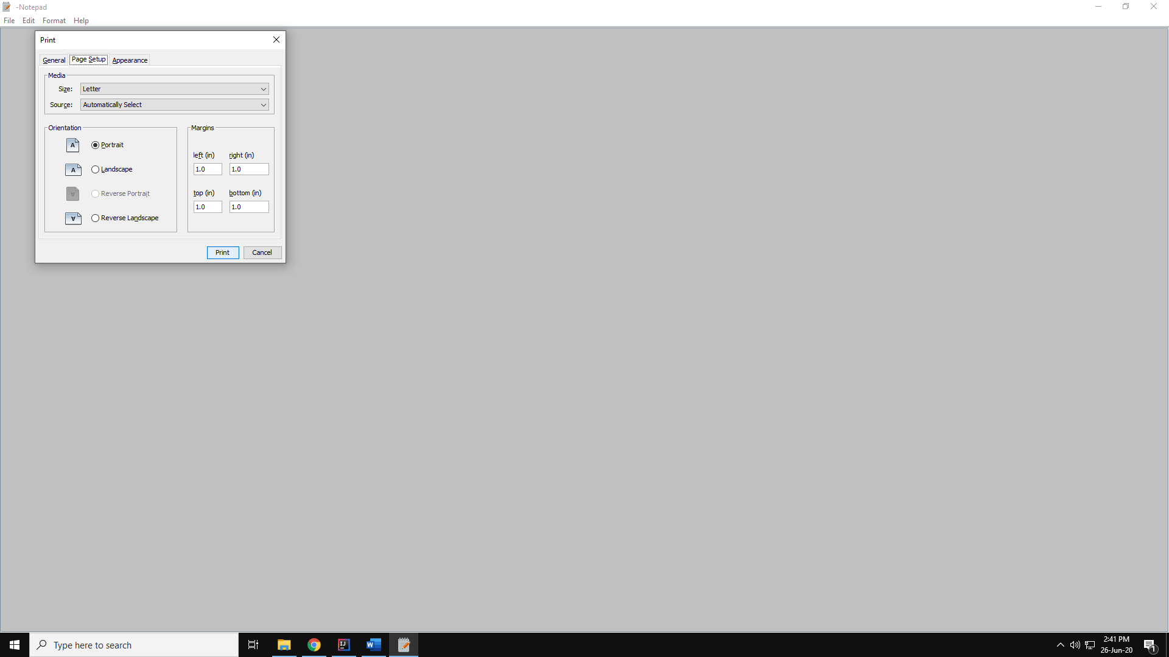

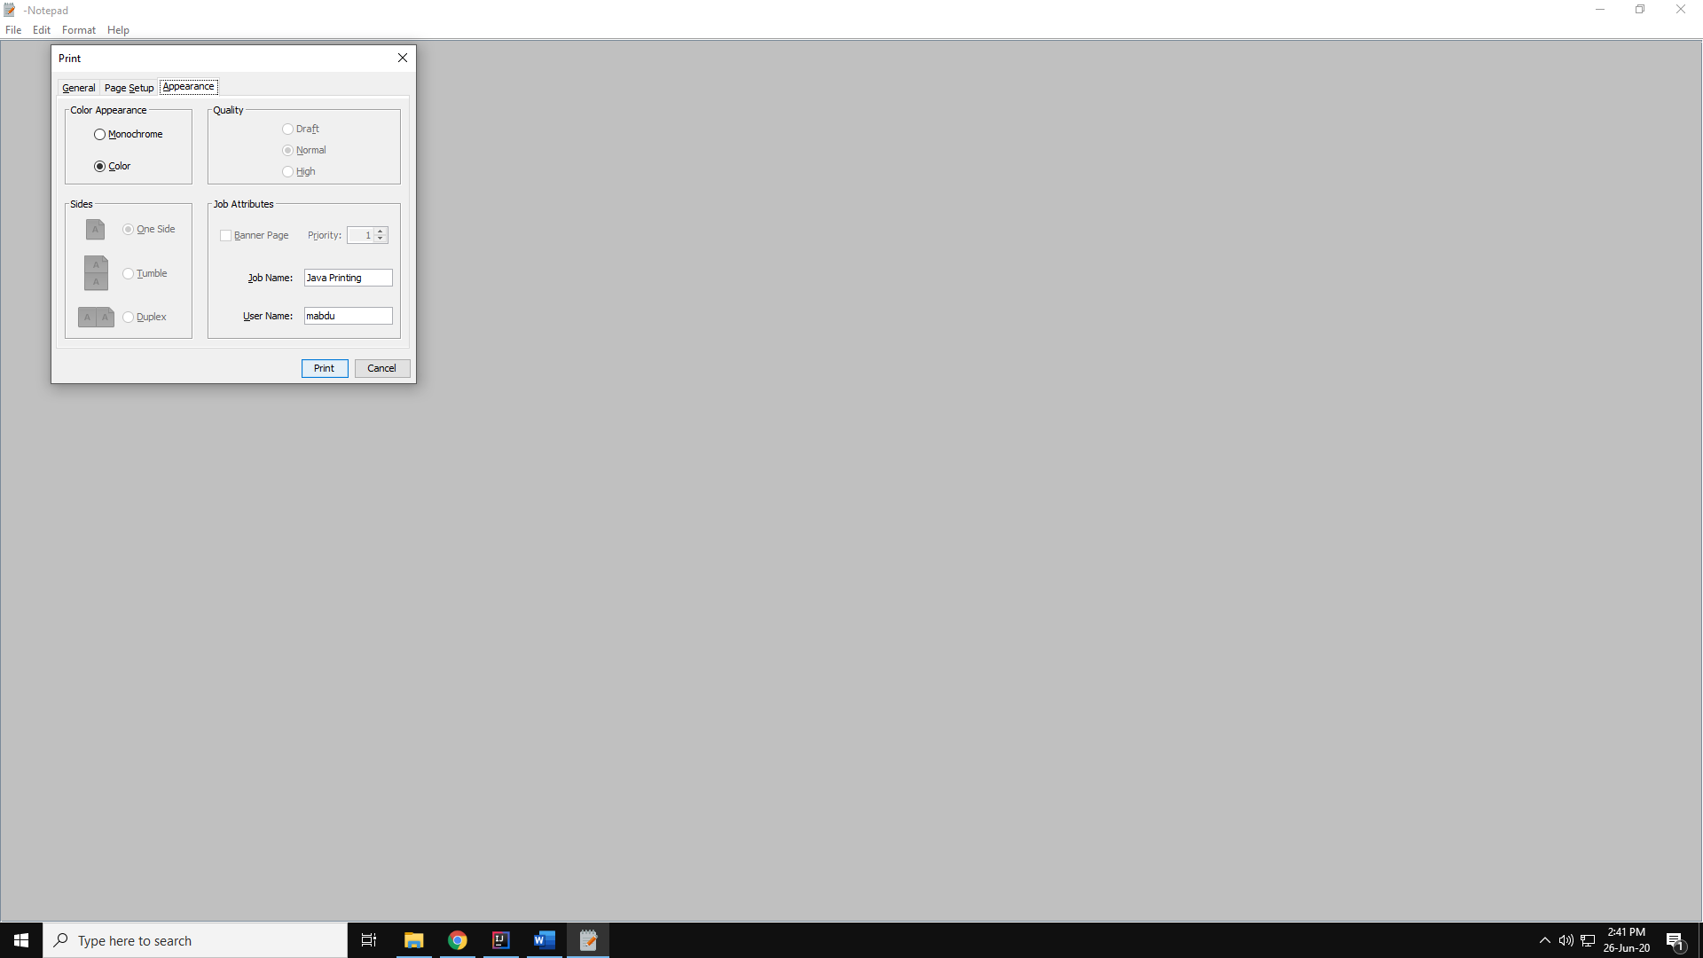

**EXIT**

Exit the program and if progress not saved then ask to save first.

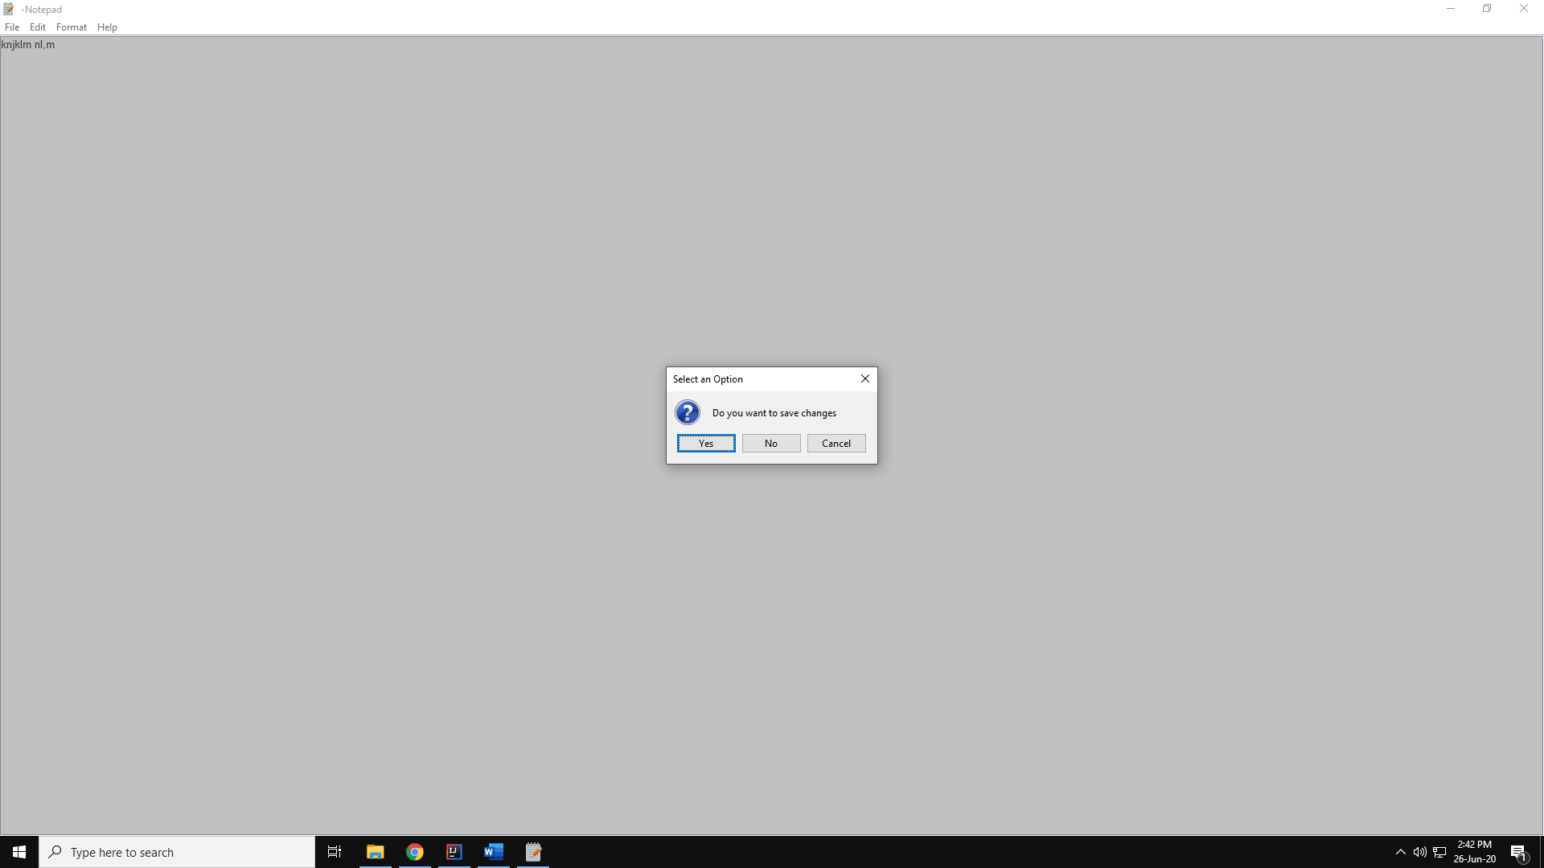

**EDIT MENU**

Has items as shown

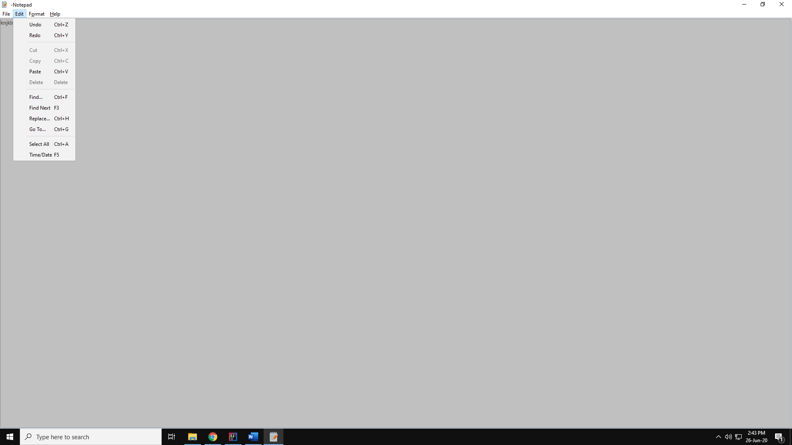

**REDO**

Undo change in text by one letter

**UNDO**

Redo change in text by one letter

**CUT**

Move the selected text to clipboard

**COPY**

Make copy of the selected text to clipboard

**PASTE**

Copy text from clipboard to current cursor location.

**DELETE**

Remove selected text

**FIND**

Find what the user has written from the document.

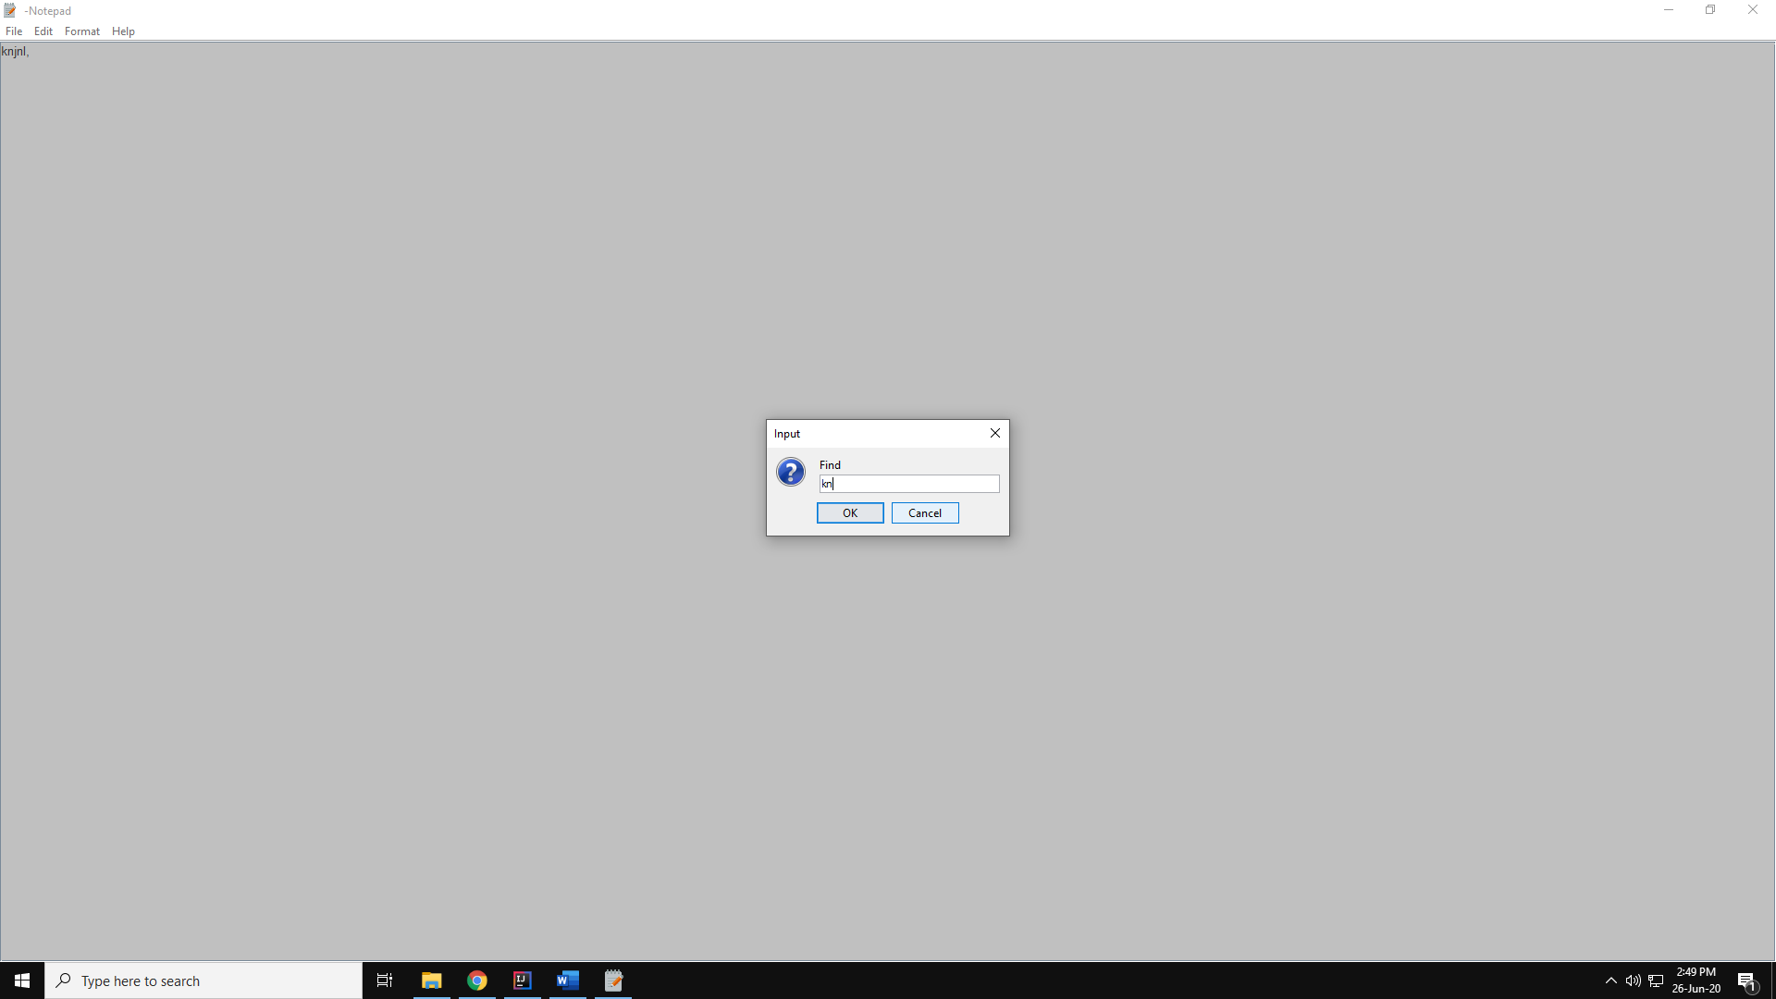

**FIND NEXT**

Find the next word after the find button has found a word.

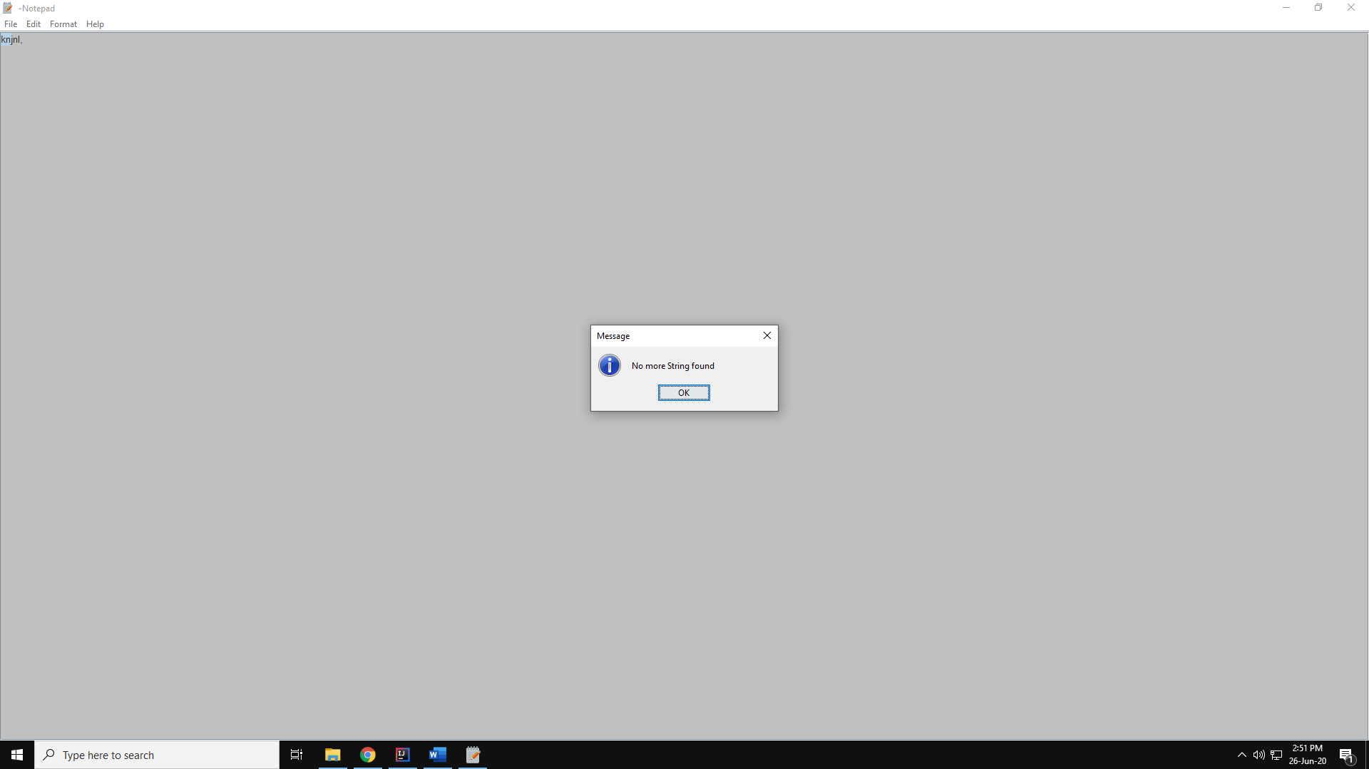

**REPLACE**

Replace text, user enter text that is to be replaced and that is to be replaced by. 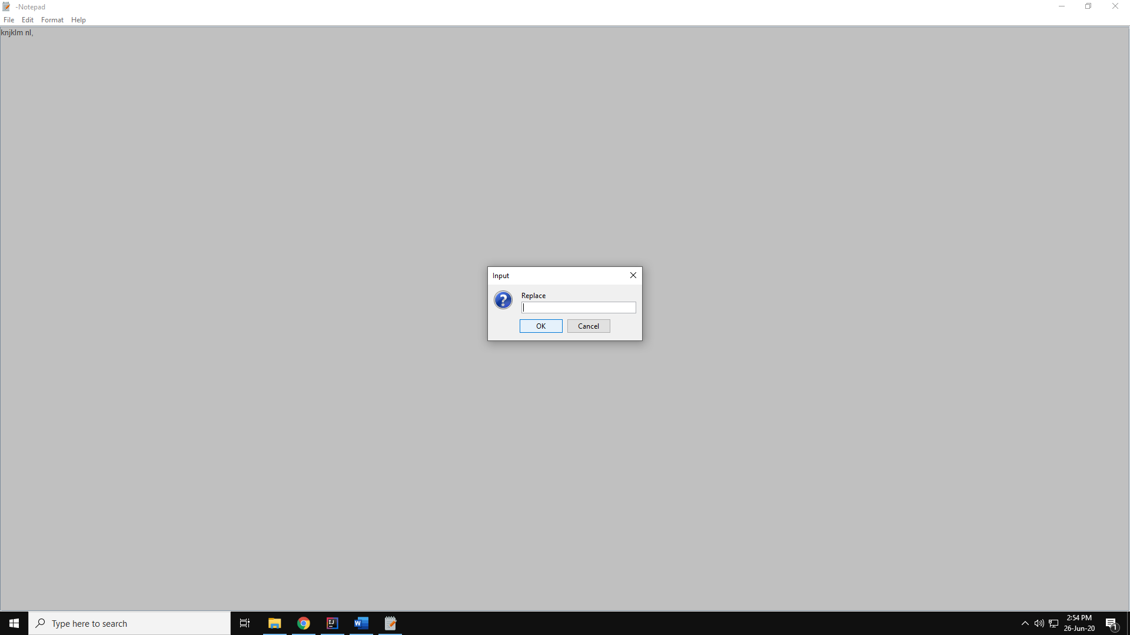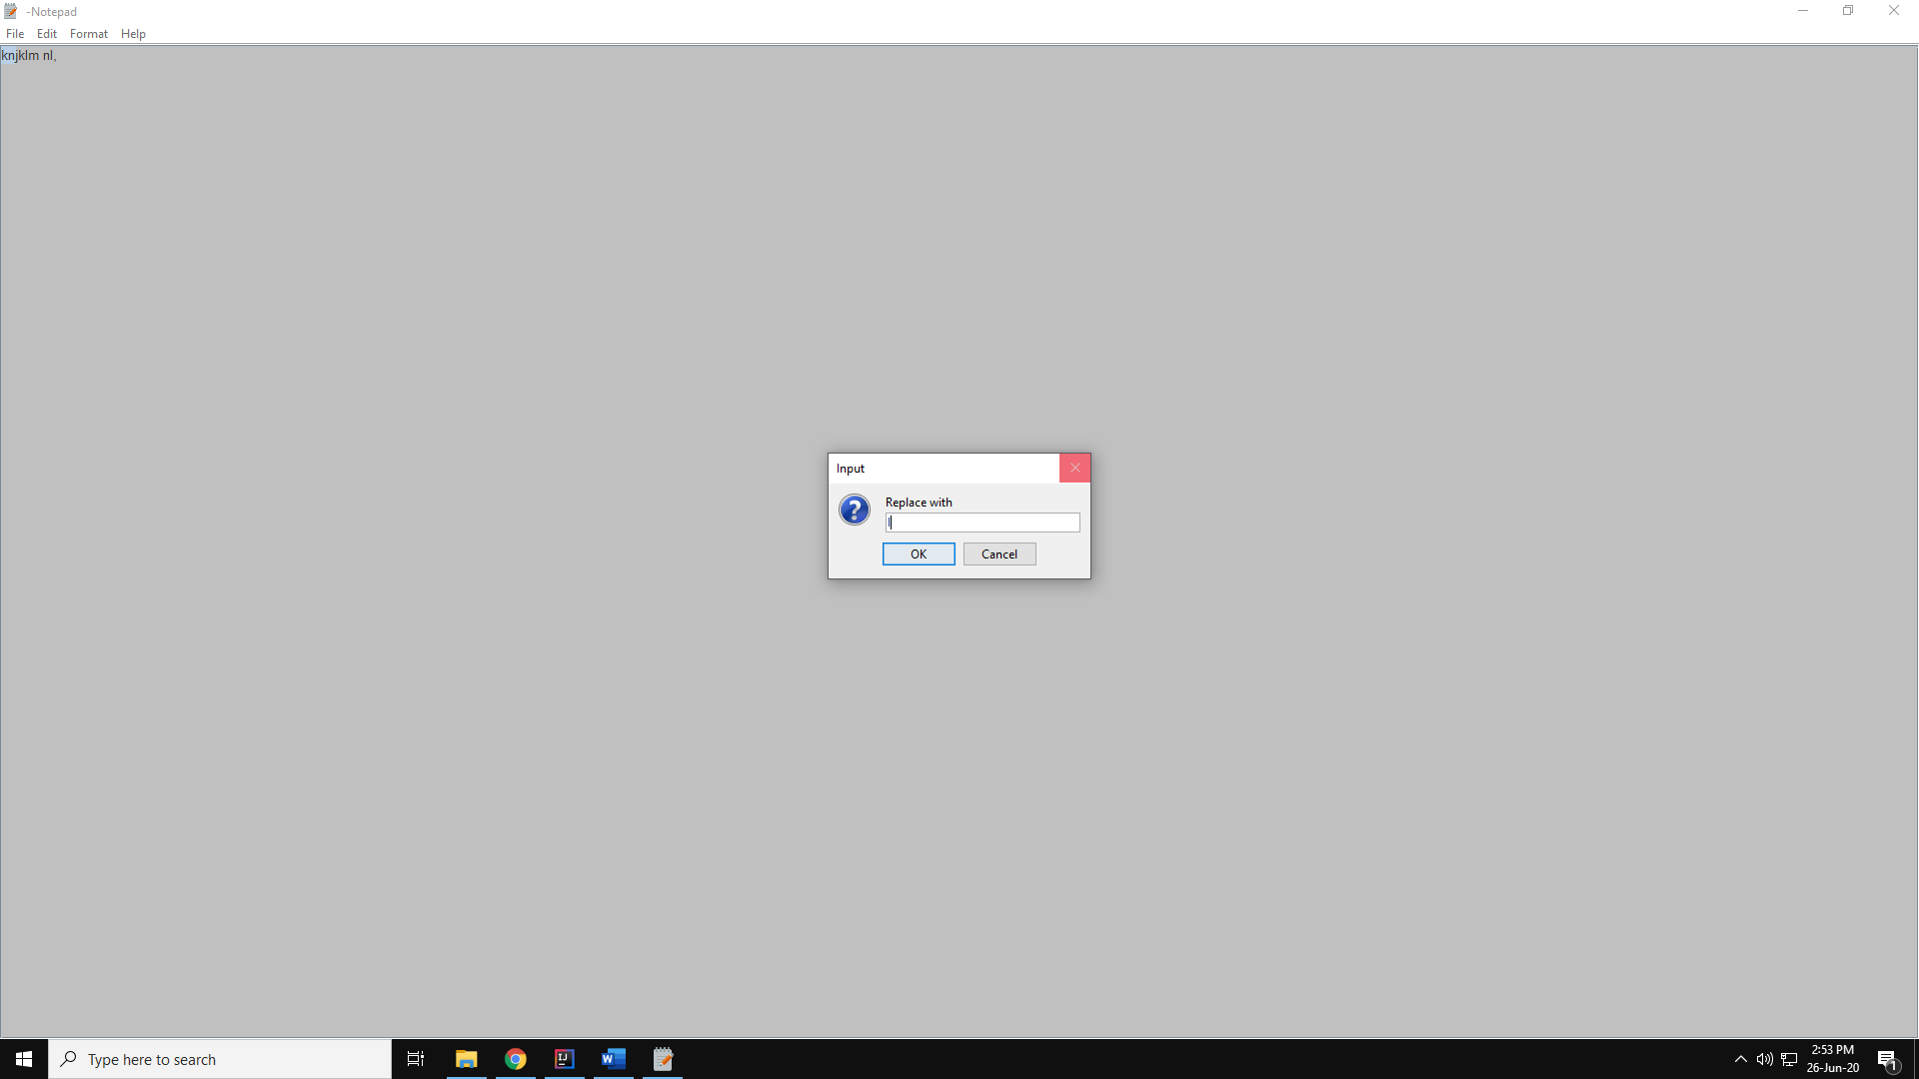



**GO TO**

Cursor goes to text in the document used entered.

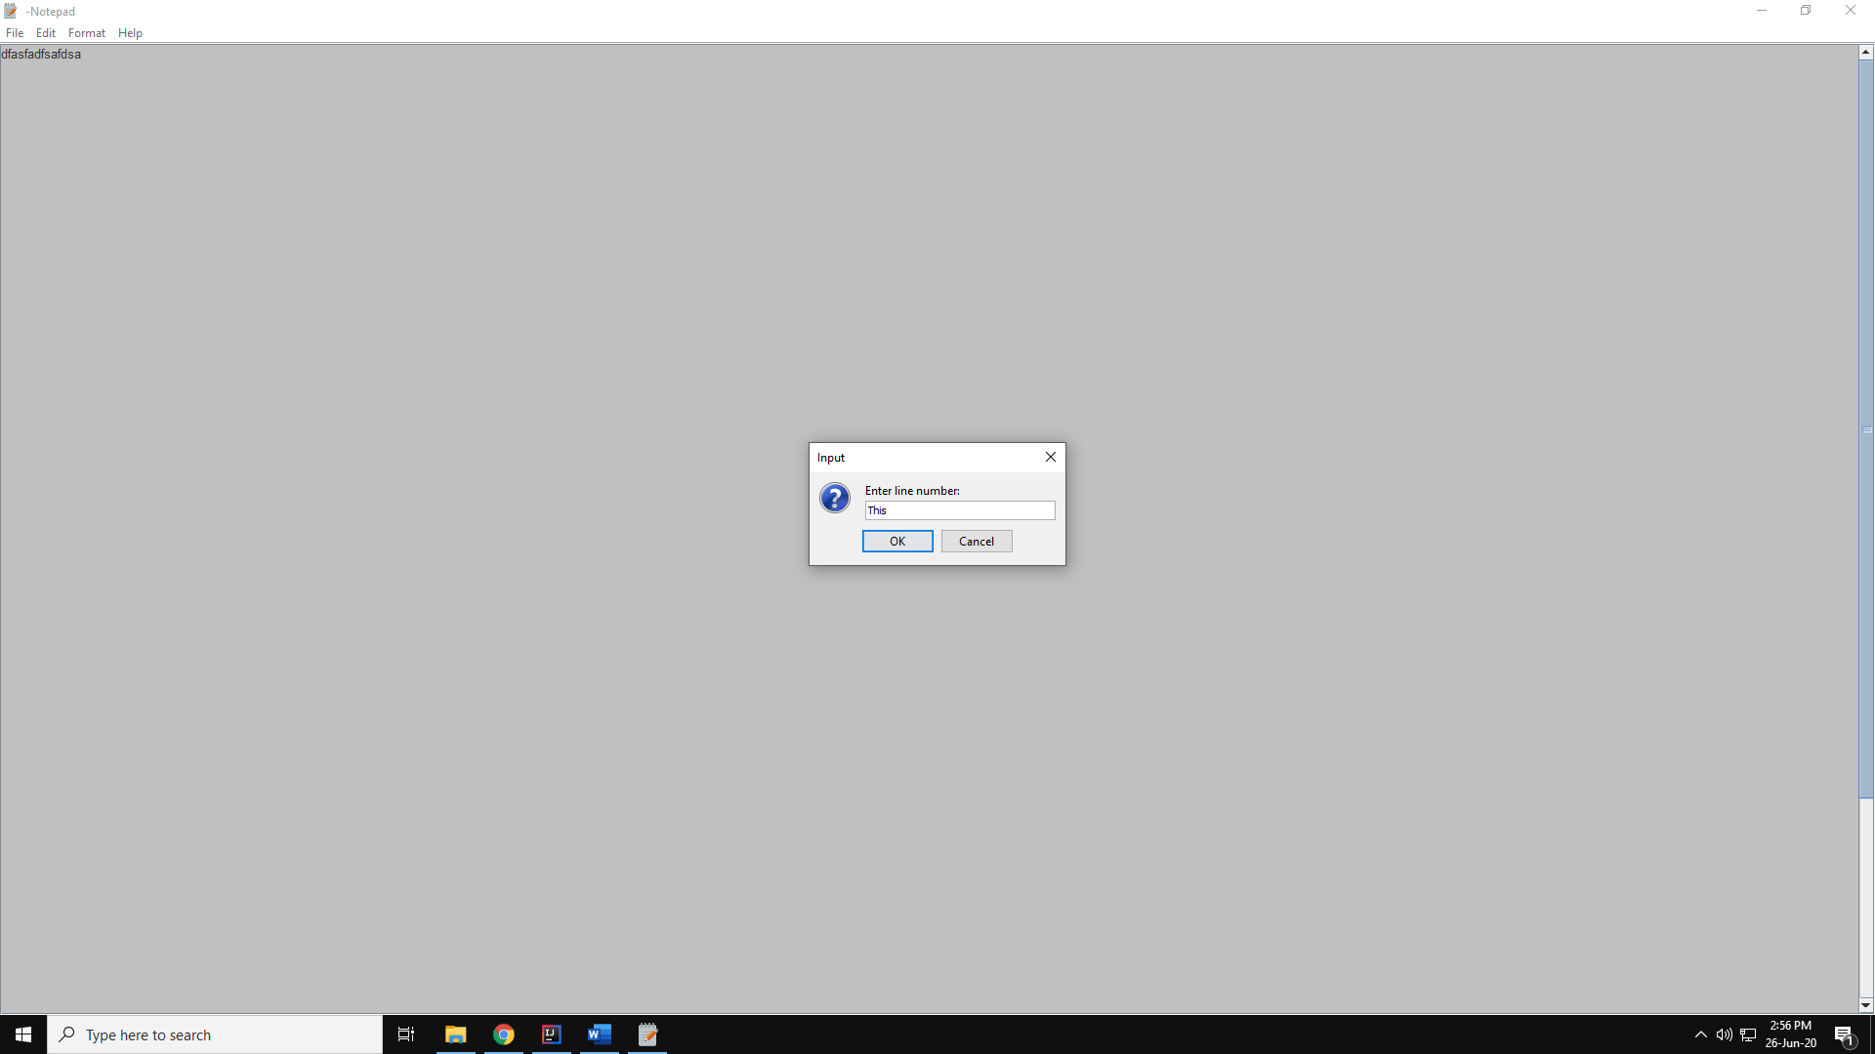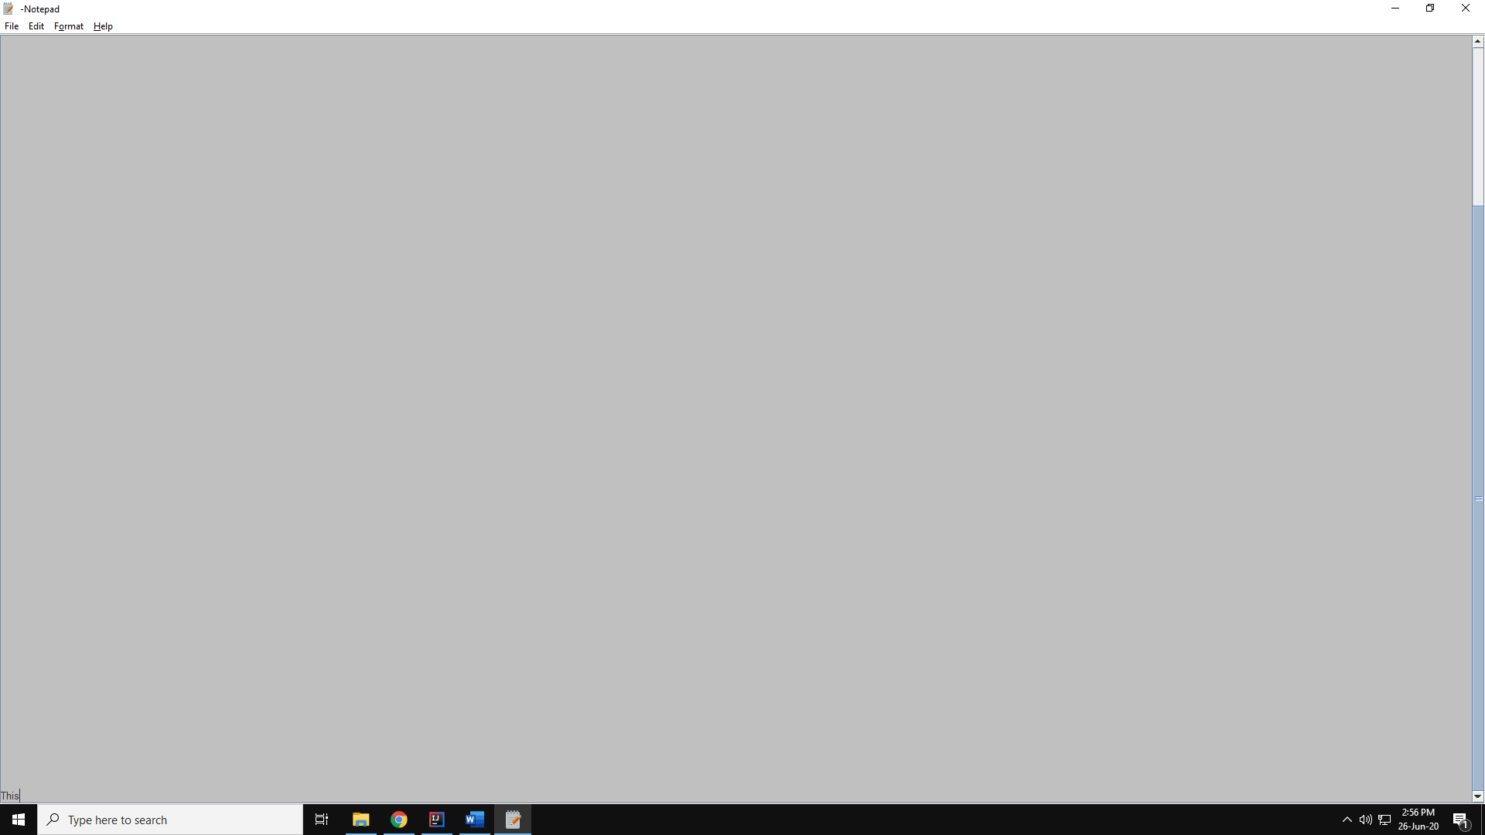

**SELECT ALL**

Selects all text in the document

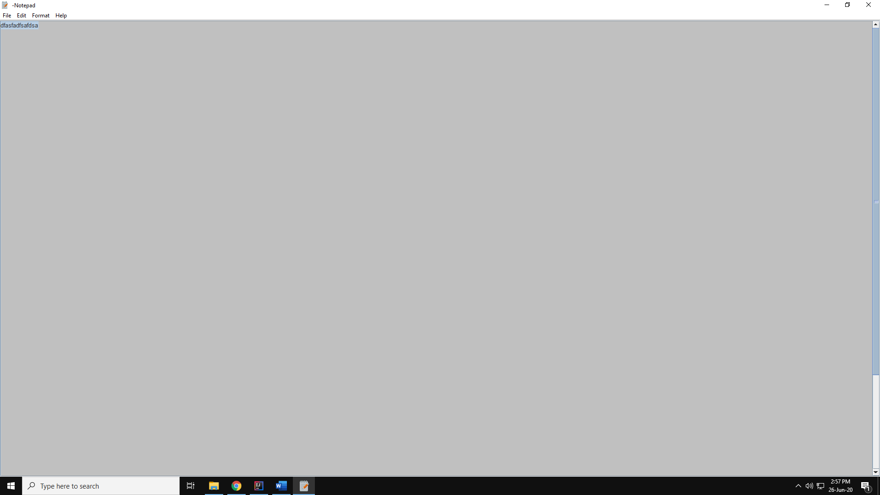

**TIME AND DATE**

Displays time and date

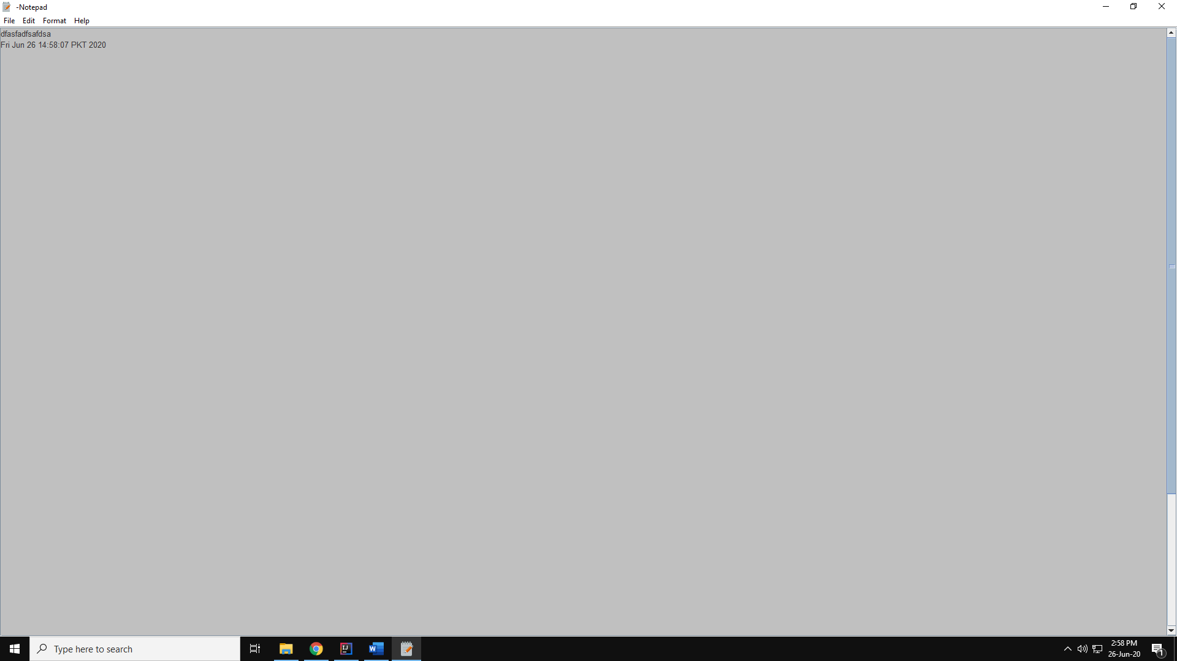

**FORMAT MENU**

Displays all items as shown

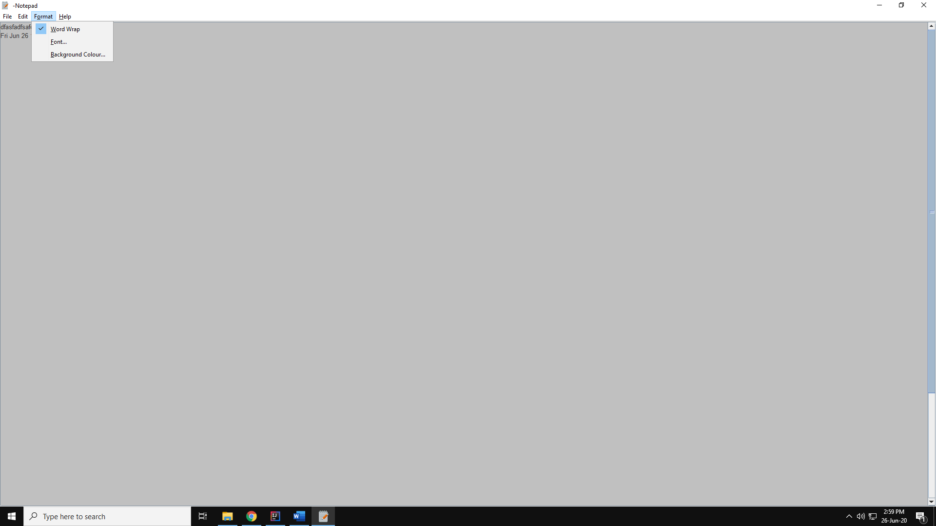

**WORD WRAP**

Applies/removes word wrap

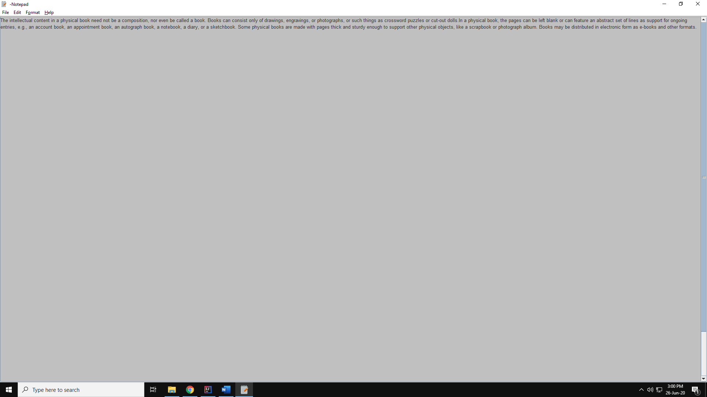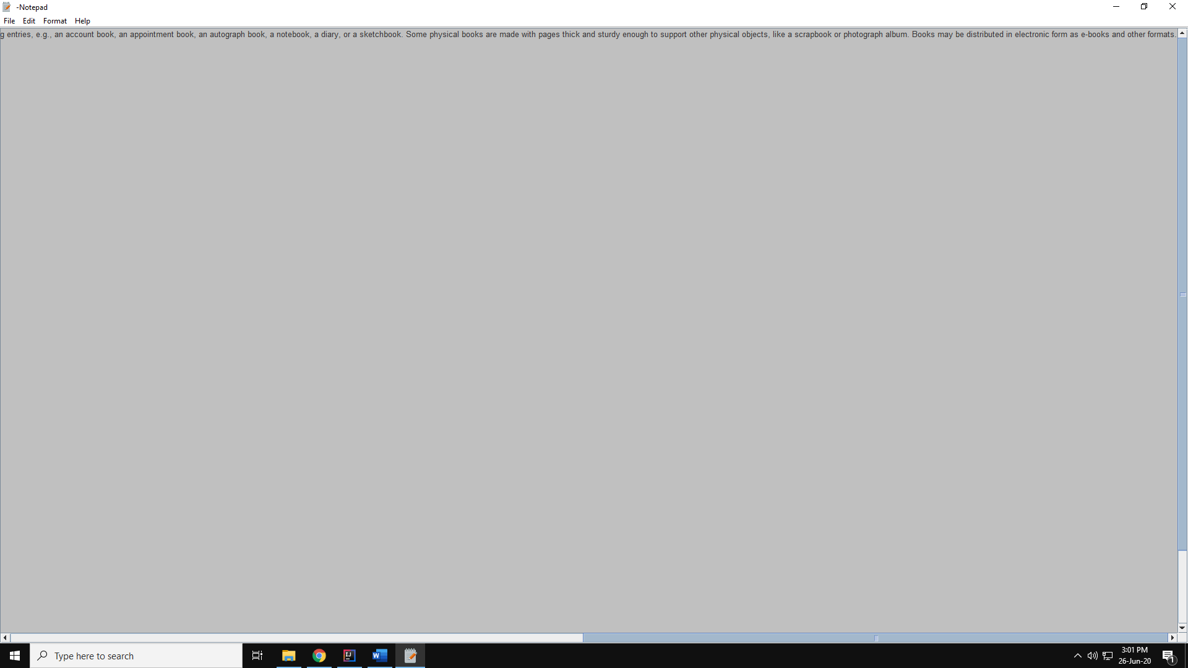

**FONT**

Gives font options

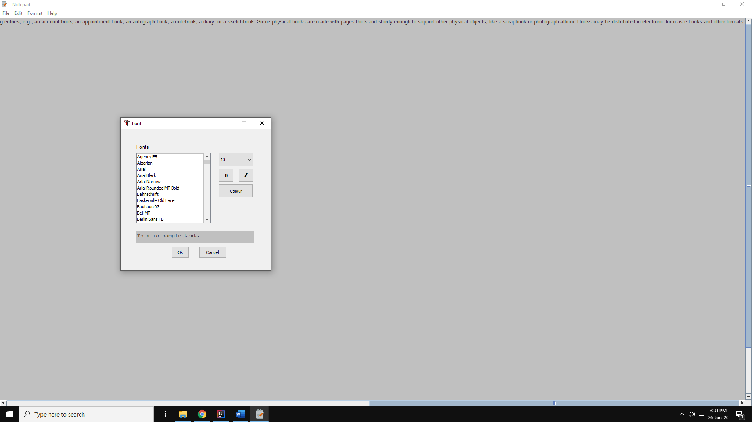 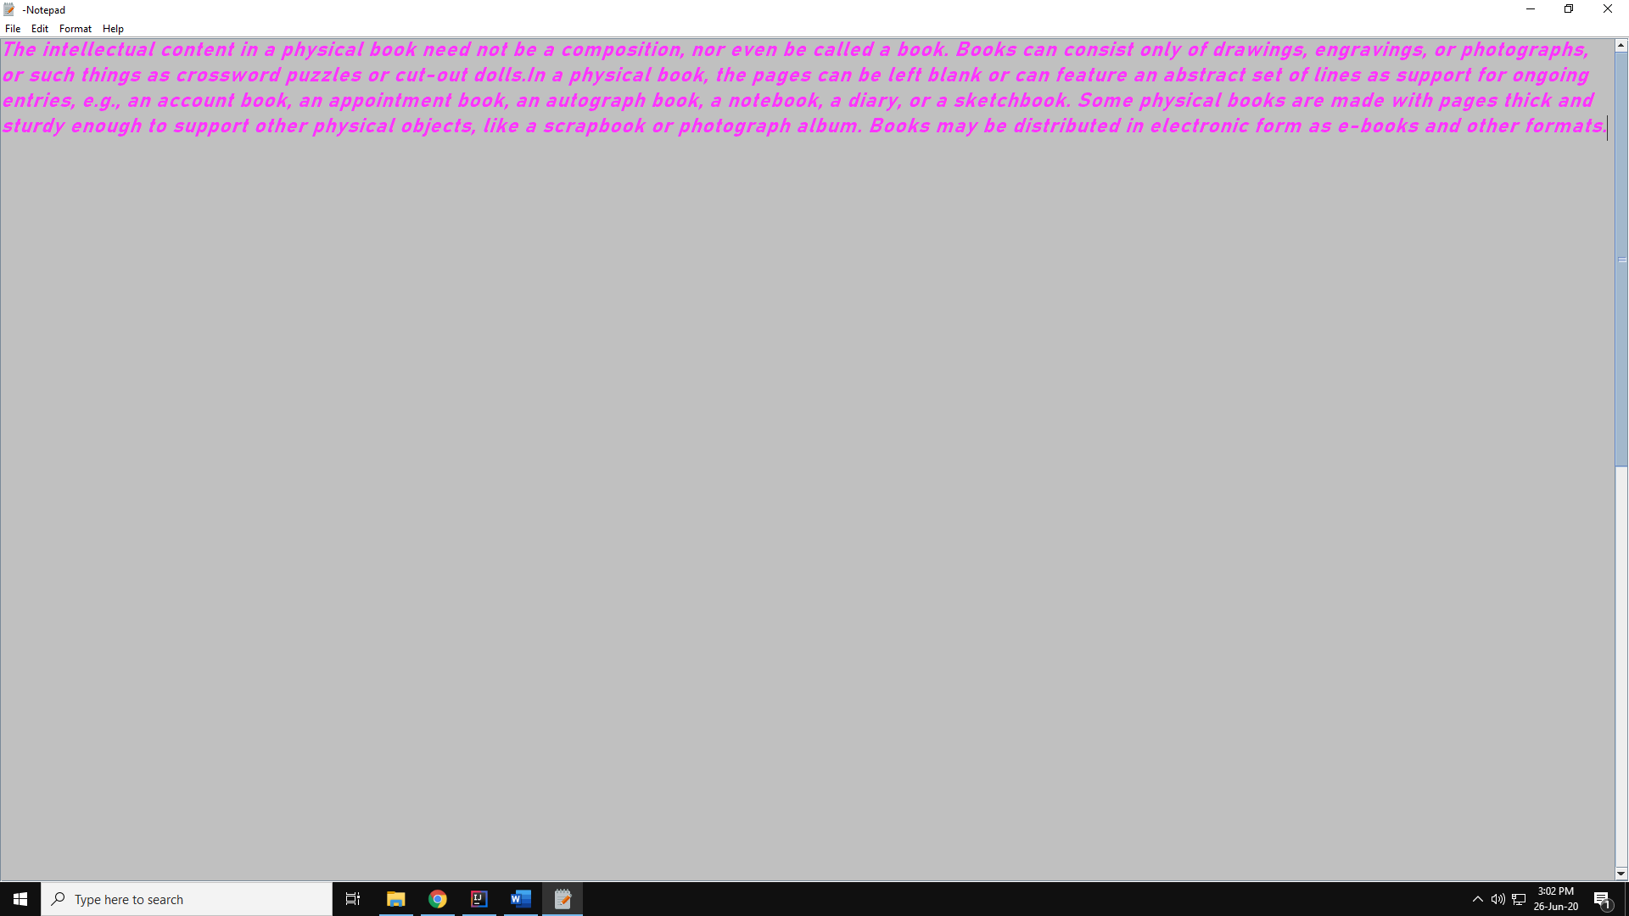

**BACK GROUND COLOR**

Sets background Color

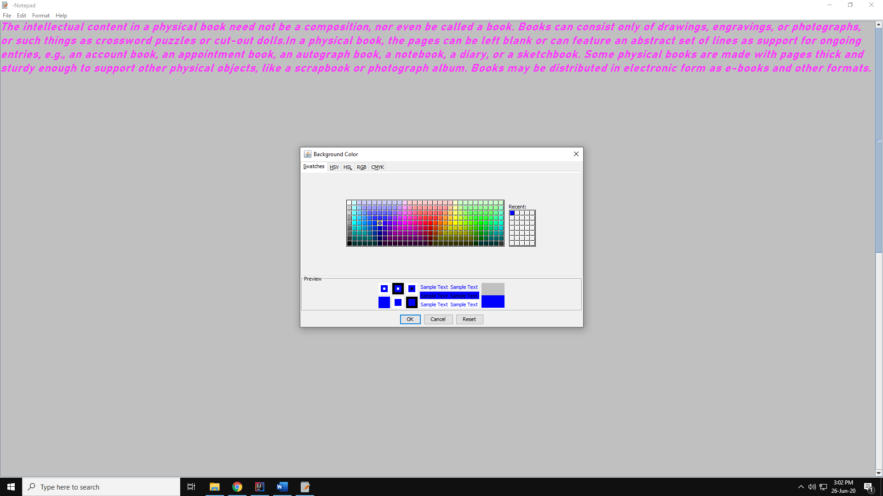 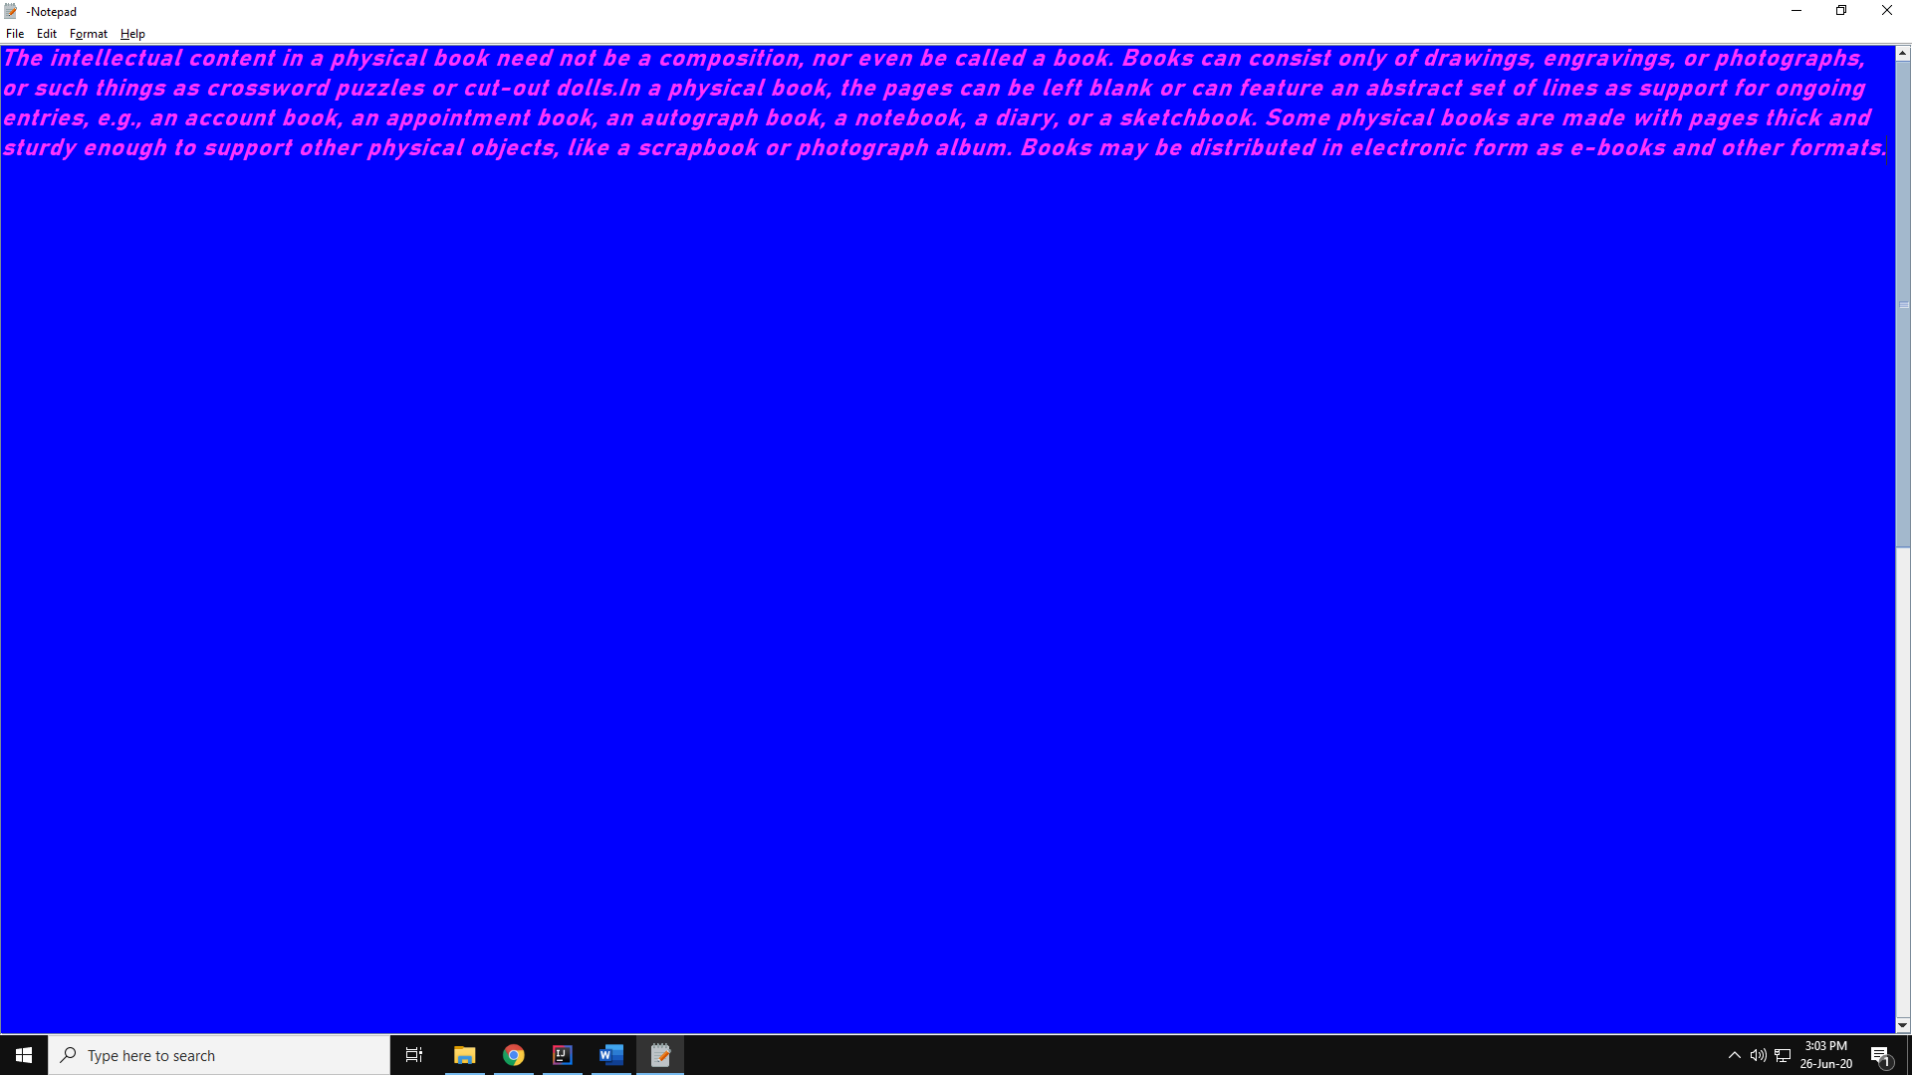

**HELP**

Displays all items shown



**ABOUT**

Gives information about program.

