Gmail capable agent project notes 260414.docx
Location of Claude known MCP tools available in the 51_project_simple_aggentic_automation project. https://claude.ai/customize/connectors
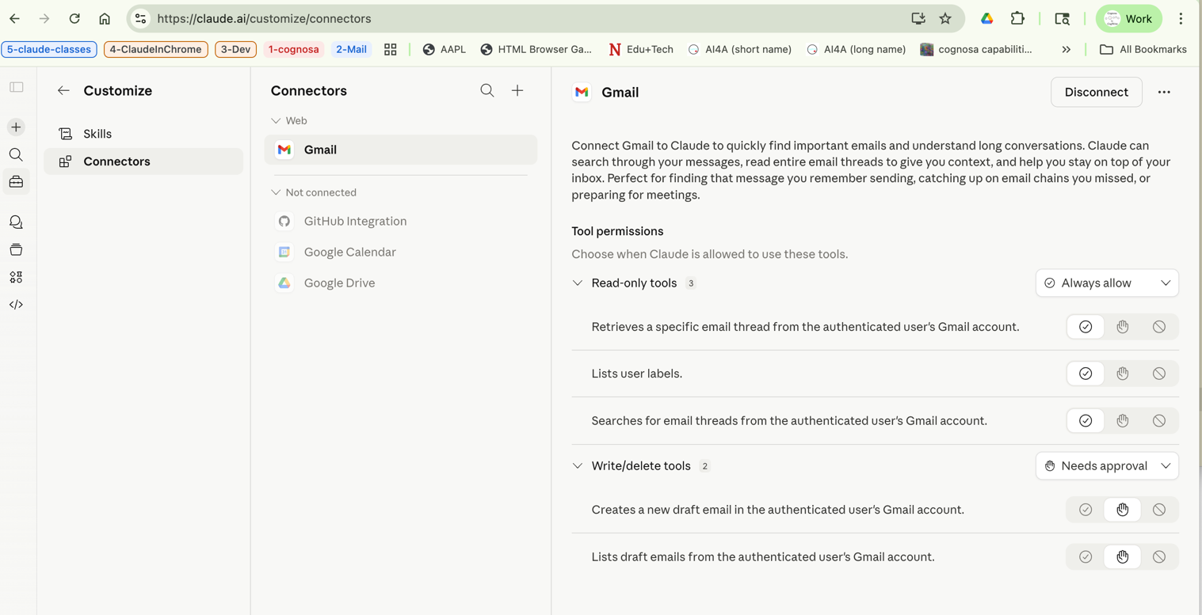

Now let me pull a sample of recent threads to see what kind of email volume and content we're working with:

Called Gmail (ctrl+o to expand)

⏺ Gmail is working great. I can see a good mix of email in just the last 7 days:

- Business/Financial: DocuSign tax documents, QuickBooks invoice from your CPA
- Tech/AI: Claude Sonnet deprecation notice, Reddit r/ClaudeCode post
- Government/Research: NSF SAP Portal migration notice
- Learning: Outlier Linguistics Mandarin deep dive sessions
- Marketing/Spam: Docusign upsell, cart abandonment

This is plenty to work with for the topic monitor. Now let me set up the tasks and start building:

⏺ Now, here's an important design decision for this task. Unlike the data analyzer where the Python script did all the
work, the Gmail monitor needs Claude as the active agent because:

1. The Gmail MCP tools are only accessible through Claude -- a standalone Python script can't call them
2. The topic categorization benefits from LLM judgment (not just keyword matching)
3. Urgency detection is a judgment call, not a rule

So the architecture for this task is different: Claude itself is the agent, using MCP tools to read email, making
categorization decisions, then calling a Python script only for the Excel output formatting.

This is a genuinely more "agentic" pattern than Task 1. Want me to proceed with building it this way?
The Anthropic MCP proxy is having a temporary outage (502 Bad Gateway). This is on Anthropic's server side, not your
setup. Let me try again:

Called Gmail (ctrl+o to expand)

⏺ Still down. Anthropic's MCP proxy (mcp-proxy.anthropic.com) is returning a 502 error. This is a server-side issue --
nothing we can do but wait.

The good news is everything is built and ready to go:
- scripts/email_to_excel.py -- Excel output generator
- .claude/skills/check-email/SKILL.md -- skill definition

We have two choices:

1. Wait and retry -- try again in a few minutes when the proxy comes back up
2. Test with the earlier data -- I already successfully pulled 10 threads from your Gmail earlier in this session. I
can use that data to do a dry run through the categorization and Excel generation, then do the full run when the
proxy is back.

What would you prefer? ( we go with 2) then …

recap: We're building an agentic automation demo platform. We just finished the Gmail topic monitor (Task 3) using
real email data and are waiting for you to review the Excel output. Next step is writing the MCP and scheduling
learning guides. (disable recaps in /config)

❯ the excel file looks good. is the 14d in the file name the duration in days of the data?

✻ Brewed for 2m 10s
No -- 14d is the slug I passed manually via --slug gmail_14d when I ran the script. I chose that label because we searched for newer_than:14d (14 days), but it's just a freeform string I typed, not something the script calculated automatically.

Good observation though -- it should reflect the actual query period. When we wire this up properly (either through the skill or as a scheduled job), we should auto-generate the slug from the actual date range used, like apr08_apr15 or 7d. That's the same kind of improvement we noted for the data analyzer -- making output filenames self-documenting so you don't have to open files to know what's inside.

❯ excellent then. lets write the guides. will i also be able to observe the specific instructions for making the xlsx -- i guess that is what is in the skill.md ?

⏺ The instructions for making the Excel file are split across two files:

- .claude/skills/check-email/SKILL.md -- tells Claude the overall process: search Gmail, categorize emails, assess urgency, save a JSON file, then call the Python script to generate Excel
- scripts/email_to_excel.py -- the actual Excel formatting code: creates the Summary sheet, All Emails sheet, per-topic sheets, urgency highlighting in red, column widths, headers, etc.

The skill file doesn't describe the Excel formatting details -- it just says "run the script." The script has all the styling logic (colors, fonts, borders, sheet layout). So you'll want to look at both files.

Let me write the learning guides now.

Both guides are written:

- docs/guides/05-mcp-integrations.md -- How MCP works, Gmail setup, the available tools, search query syntax, pagination, and the key architectural insight: why the Gmail monitor uses Claude-as-agent instead of a standalone script. Includes the comparison table showing the fundamental difference from Task 1.
- docs/guides/04-scheduling.md -- Scheduled triggers (cron-based remote agents), how to create/manage them with /schedule, cron syntax reference, designing for autonomous execution, and how scheduling relates to skills and hooks.

Phase 3 status: The Gmail monitor is built and tested (with cached data due to the MCP outage). When the proxy is
back up, we can do a full live run with more emails and also set up an actual scheduled trigger.

What you should review:
1. The two new guides in docs/guides/
2. The skill definition at .claude/skills/check-email/SKILL.md -- this shows how the process is orchestrated
3. The Excel generator at scripts/email_to_excel.py -- this has the formatting logic
4. The Excel output file in output/email_monitor_20260415_044200/

Ready to continue when you are -- next up would be either setting up an actual scheduled trigger (once Gmail MCP is back), or moving to Task 2 (SQL Query Runner) or Task 5 (the multi-step workflow with approval gates).

recap: We're building an education-first demo platform showcasing Claude Code capabilities through office automations. We completed Task 1 (data analyzer) and Task 3 (Gmail monitor). Next step is your choice: set up a scheduled trigger, build the SQL query runner, or tackle the multi-step workflow. (disable recaps in /config)

⏺ RemoteTrigger(create)
⎿ HTTP 200 (1 lines)

⏺ The trigger is created and live. Here's what you've got:
Daily Gmail Topic Monitor
- Trigger ID: trig_01R8hBYJjCeTfTTy7t7Y1417
- Schedule: Daily at 3pm UTC (8am Pacific)
- Next run: Today at 8:00 AM Pacific (April 15, 2026)
- Model: Claude Sonnet 4.6
- Status: Enabled

What it will do each morning:
1. Search Gmail for the last 24 hours of email
2. Categorize each email into your 5 topics
3. Flag urgent items
4. Save JSON + generate a formatted Excel report

You can manage it here: https://claude.ai/code/scheduled/trig_01R8hBYJjCeTfTTy7t7Y1417

Want to do a test run right now to see it work?

