**Topics: Descriptive Statistics and Probability**

1. Look at the data given below. Plot the data, find the outliers and find out $μ, σ, σ^{2}$

|  |  |
| --- | --- |
| **Name of company** | **Measure X** |
| Allied Signal | 24.23% |
| Bankers Trust | 25.53% |
| General Mills | 25.41% |
| ITT Industries | 24.14% |
| J.P.Morgan & Co. | 29.62% |
| Lehman Brothers | 28.25% |
| Marriott | 25.81% |
| MCI | 24.39% |
| Merrill Lynch | 40.26% |
| Microsoft | 32.95% |
| Morgan Stanley | 91.36% |
| Sun Microsystems | 25.99% |
| Travelers | 39.42% |
| US Airways | 26.71% |
| Warner-Lambert | 35.00% |

Ans:

-**Mean** for the given data is **37.271333**

**- Standard Deviation** for the given data is **16.945401**

**- Variance**  for the given data is **287.146612**

**-Outlier** in the given data is at **MeasuresX-91.36%**  and **name of the company**  is **Morgan Stanley** concluded with the help of  **Box plot.**

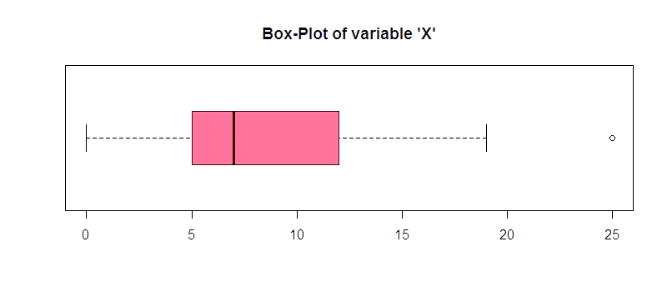

Answer the following three questions based on the box-plot above.

1. What is inter-quartile range of this dataset? (please approximate the numbers) In one line, explain what this value implies.
2. What can we say about the skewness of this dataset?
3. If it was found that the data point with the value 25 is actually 2.5, how would the new box-plot be affected?

Ans:

1. IQR = Q3 – Q1 = 12 – 5 = 7 (Approximately) . It means 50% of it is between 5 to 12.
2. The is positively/ Right skewed. Tail is extended towards the right side. That means the MEAN is greater than the MEDIAN (mean>median)
3. The median value will remain same, but the inter quartile range will change. Moreover, there will not be any outlier.



Answer the following three questions based on the histogram above.

1. Where would the mode of this dataset lie?
2. Comment on the skewness of the dataset.
3. Suppose that the above histogram and the box-plot in question 2 are plotted for the same dataset. Explain how these graphs complement each other in providing information about any dataset.

Ans:

1. The mode of the dataset lies between 5 and 10 and approximately in between 4 to 8.
2. The is positively/ Right skewed. Tail is extended towards the right side. That means the MEAN is greater than the MEDIAN (Mean>Median>Mode)
3. They both are right-skewed and both have outliers the median can be easily visualized in box plot where as in histogram mode is more visible.

1. AT&T was running commercials in 1990 aimed at luring back customers who had switched to one of the other long-distance phone service providers. One such commercial shows a businessman trying to reach Phoenix and mistakenly getting Fiji, where a half-naked native on a beach responds incomprehensibly in Polynesian. When asked about this advertisement, AT&T admitted that the portrayed incident did not actually take place but added that this was an enactment of something that “could happen.” Suppose that one in 200 long-distance telephone calls is misdirected. What is the probability that at least one in five attempted telephone calls reaches the wrong number? (Assume independence of attempts.)

Ans:

If 1 in 200 long-distance telephone calls are getting misdirected.

Probability of call misdirecting = 1/200

Probability of call not Misdirecting = 1-1/200 = 199/200

The probability for at least one in five attempted telephone calls reaches the wrong number.   
Number of Calls = 5

n = 5

p = 1/200

q = 199/200

P(x) = at least one in five attempted telephone calls reaches the wrong number

P(x) = ⁿCₓ pˣ qⁿ⁻ˣ

P(x) = (nCx) (p^x) (q^n-x)

# nCr = n! / r! * (n - r)!

P (1) = (5C1) (1/200) ^1 (199

The probability that at least one in five attempted telephone calls reaches the wrong number is 0.0245037.

1. Returns on a certain business venture, to the nearest $1,000, are known to follow the following probability distribution

|  |  |
| --- | --- |
| x | P(x) |
| -2,000 | 0.1 |
| -1,000 | 0.1 |
| 0 | 0.2 |
| 1000 | 0.2 |
| 2000 | 0.3 |
| 3000 | 0.1 |

1. What is the most likely monetary outcome of the business venture?
2. Is the venture likely to be successful? Explain
3. What is the long-term average earning of business ventures of this kind? Explain
4. What is the good measure of the risk involved in a venture of this kind? Compute this measure

Ans:

Expected Value – Sum of X* P(X)

Expected Value Square = X

|  |  |
| --- | --- |
| E(X)=Sum X *P(X) | E(X^2)=X^2*P(X) |
| -200 | 4,00,000 |
| -100 | 1,00,000 |
| 0 | 0 |
| 200 | 2,00,000 |
| 600 | 12,00,000 |
| 300 | 90,000 |
| Total  800 | 28,00,000 |

(i)The most likely monetary outcome of the business venture is 2000$ and as for 2000$ the probability is 0.3 which is maximum as compared to others.

(ii)Yes the venture likely to be successful because the probability that the venture will make more than 0 profit.

p(x>0) + p(x>1000) + p(x>2000) + p(x=3000).

= 0.2+0.2+0.3+0.1

= 0.8

This states that there is good 80% chances for this venture to be making a profit.

(iii)The long-term average is Expected value.

E(X) = Sum (X * P(X)) = 800$

Which means on an average the returns will be + 800$.

(iv)The good measure of the risk involved in a venture of this kind depends on the Variability in the distribution.

Higher Variance means more chances of risk.

Var (X) = E(X^2) –(E(X)) ^2

= 2800000 – 800^2

= 2160000