Target: DVWA (Damn Vulnerable Web Application)
Environment: Localhost
Tester: Hari Haran P

Summary:
This penetration test was conducted against the DVWA web application to assess and demonstrate common web vulnerabilities and their impacts.

Some of the web application vulnerabilities which DVWA contains;
- Brute Force: HTTP Form Brute Force login page; used to test password brute force tools and show the insecurity of weak passwords.

- Command Execution: Executes commands on the underlying operating system.

- Cross Site Request Forgery (CSRF): Enables an ‘attacker’ to change the applications admin password.

- File Inclusion: Allows an ‘attacker’ to include remote/local files into the web application.

- SQL Injection: Enables an ‘attacker’ to inject SQL statements into an HTTP form input box. DVWA includes Blind and Error based SQL injection.

- Insecure File Upload: Allows an ‘attacker’ to upload malicious files on to the web server.

- Cross Site Scripting (XSS): An ‘attacker’ can inject their own scripts into the web application/database. DVWA includes Reflected and Stored XSS

- Brute force:
Here we can see that, when we intercept the session in burp suite here we can do brute force by using the number of possible words list

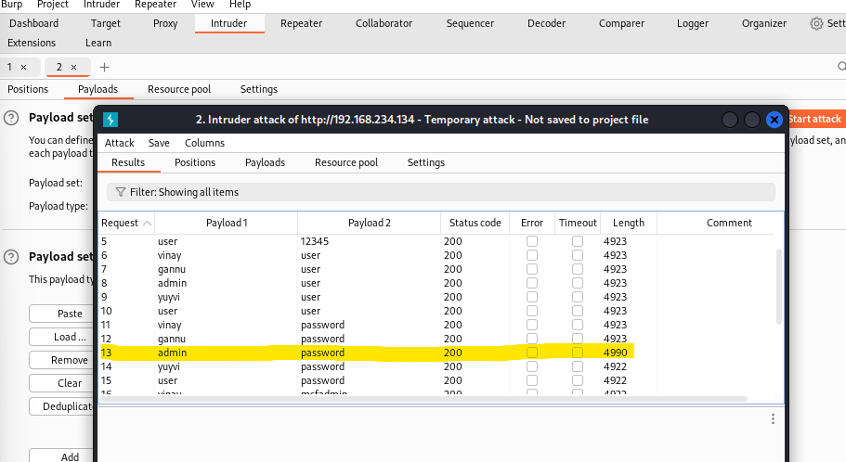

Here we got the username -admin and password -password after login we will Get access

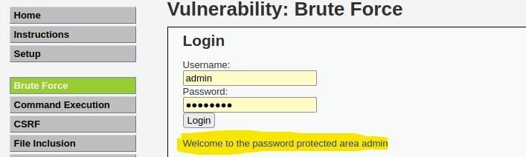
MITIGATIONS:
  - Utilize or require strong passwords
  - Allow a limited number of login attempts
  - Set time delays between attempts
  - Limit failed login attempts

- Command Execution:
In submit box we can access the directories
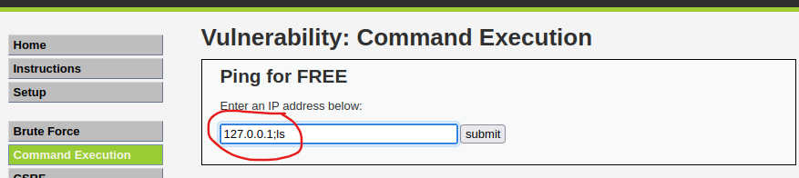
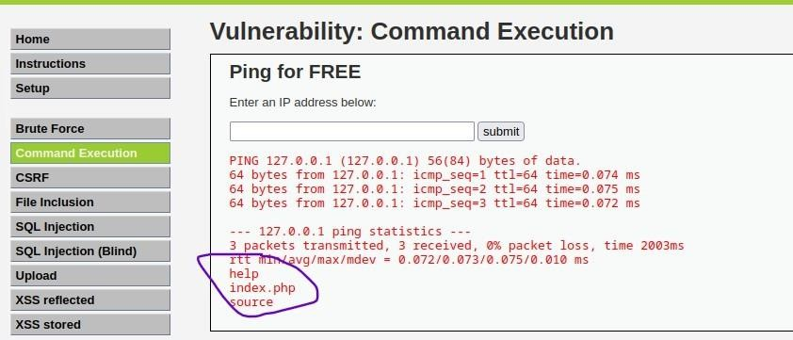

- Cross site request forgery

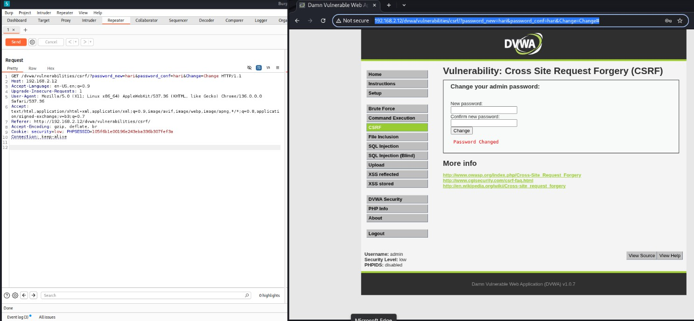

http://192.168.2.12/dvwa/vulnerabilities/csrf/? password_new=hari&password_conf=hari&Change=Change
After pasting the url in browser then the password will be changed

MITIGATIONS:
  - Anti-CSRF Tokens
  - SameSite Cookies
  - Use of CAPTCHA
  - Require Reauthentication for Sensitive Operations
  - Content Security Policy

- File inclusion:
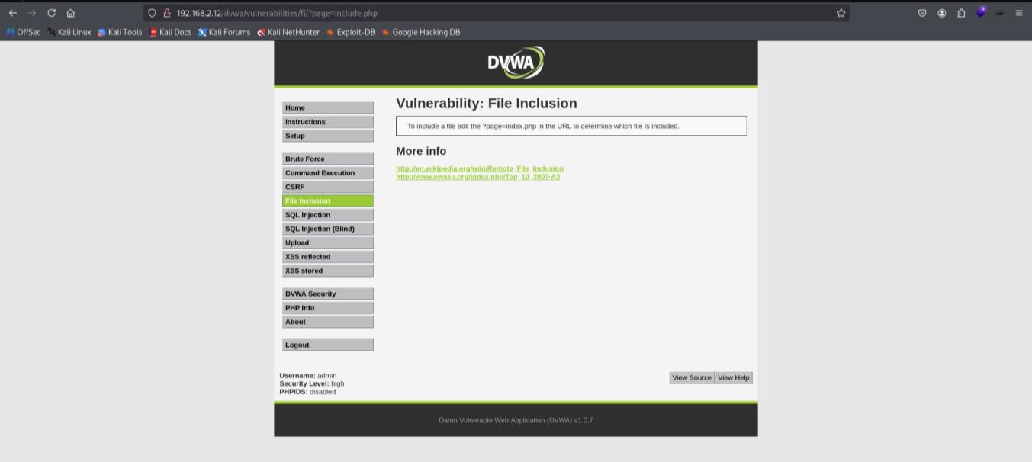
Now change the url as “/etc/passwd”
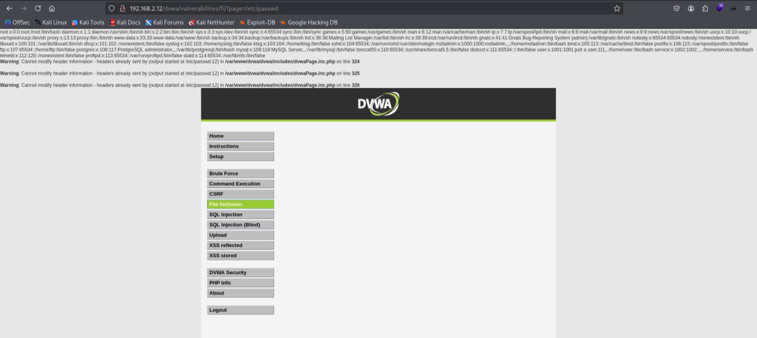
Mitigation:
  - Validate and sanitize all user inputs
  - Use allow-lists for file names or paths
  - Avoid using user input directly in file paths
  - Use absolute paths instead of relative or dynamic ones
  - Restrict file permissions on the server

- ​SQL injection:
In this vulnerability we can see that if we run any SQL query then it will going to show us the critical information about system
Now after running the following query ' or 1=2 union select user, password from users# we will get the list of password hash to which we can easily de- hash to know the password

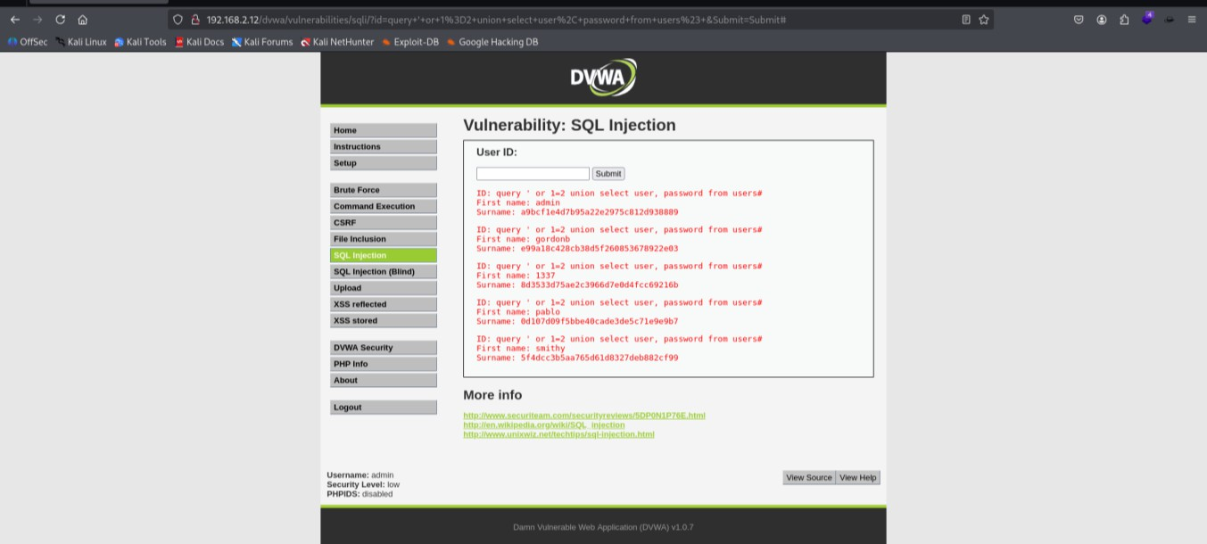

Mitigations:
  - Use prepared statements
  - Use ORMs (Object-Relational Mappers)
  - Validate and sanitize all user inputs
  - Use allow-lists for input validation
  - Limit database user privileges
  - Regularly update and patch your database and libraries
  - Implement error handling to avoid exposing SQL errors

6. Reflected XSS
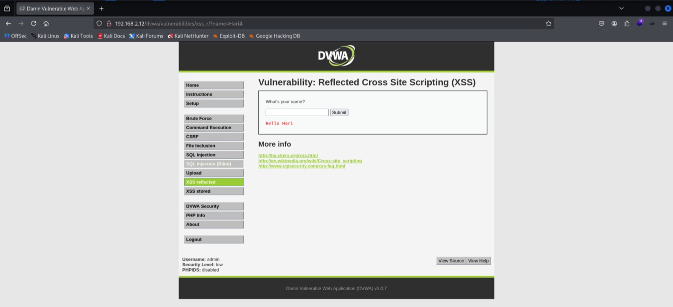
When we type anything normal word it will give like this

But when we write script it will show error
<script>alert(“Hi hari”)</script>

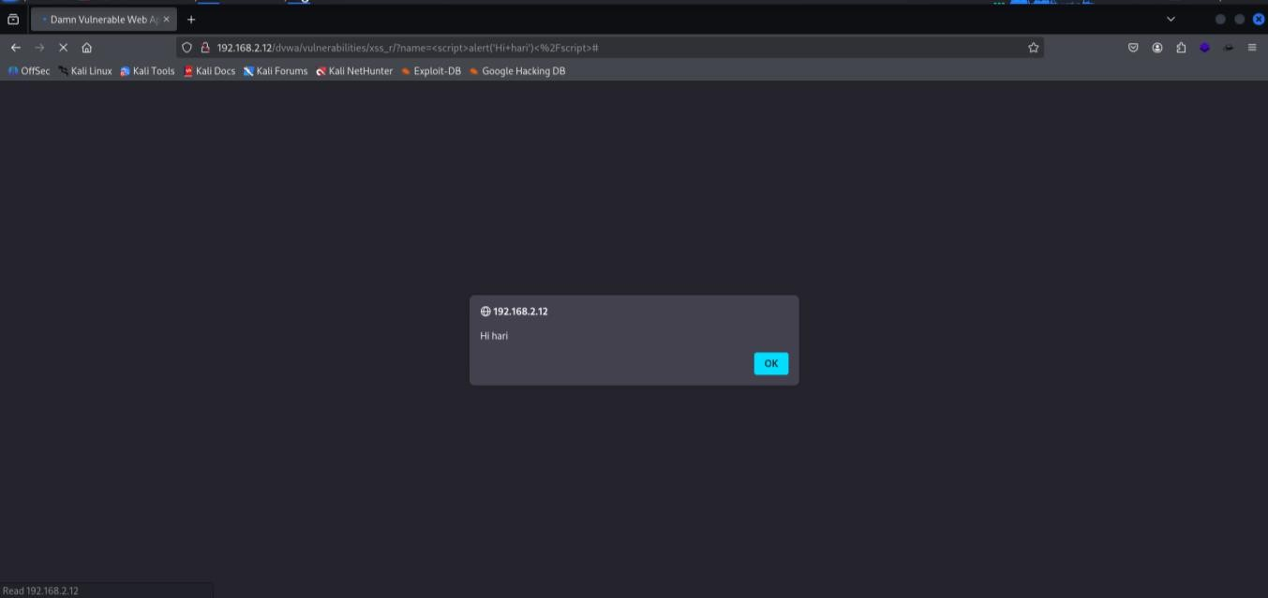
Then after running this script we will get the session id that can be used for session hijakcing
<script>alert(document.cookie)</script>
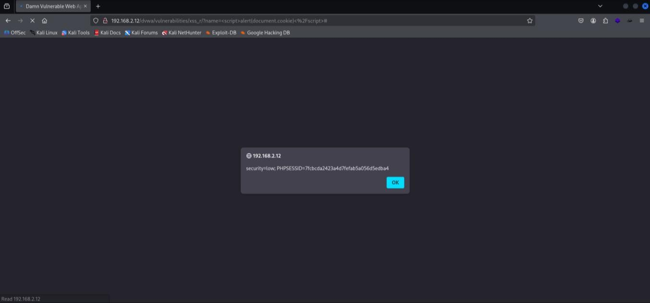

IMPACT:

Session Hijacking
Attackers can steal session cookies and impersonate the victim, gaining unauthorized access to their account.

Credential Theft
Malicious scripts can trick users into entering their usernames and passwords into fake forms, capturing their login credentials.

Phishing Attacks
The attacker can craft deceptive pages or pop-ups that appear to be legitimate, tricking users into revealing sensitive information.

Redirection to Malicious Sites
Users can be silently redirected to malicious websites that may install malware or further exploit their system.

Browser Exploitation
The injected script can exploit vulnerabilities in the user's browser or plugins to gain deeper control or execute harmful actions.

- Stored XSS:
Here where we give normal input it shows out- put like this
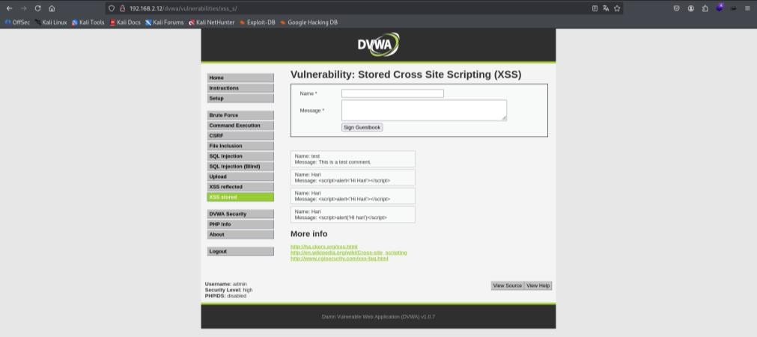

But when we run script in input are our message store permanently in server it will pop up every time
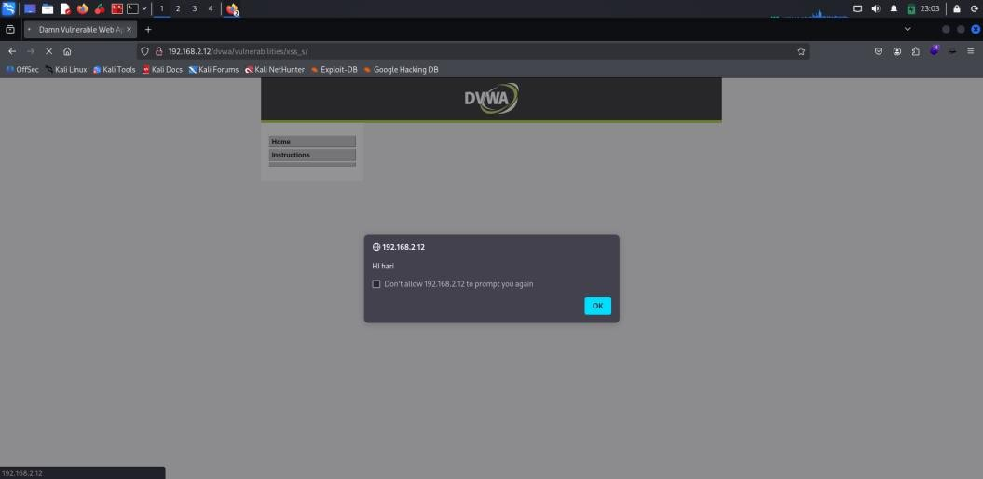

MITIGATION
- Input Validation: Sanitize and whitelist user inputs.
- Output Encoding: Encode dynamic content (HTML, JavaScript, etc.) before rendering.
- Content Security Policy (CSP): Implement a strong CSP to restrict script sources.
- Use Frameworks with Built-in Protection: Leverage frameworks that automatically escape user inputs.
- Server-Side Validation: Always validate and sanitize inputs on the server side, not just on the client.

- File Upload:
In file upload section where we can upload revershell.php file
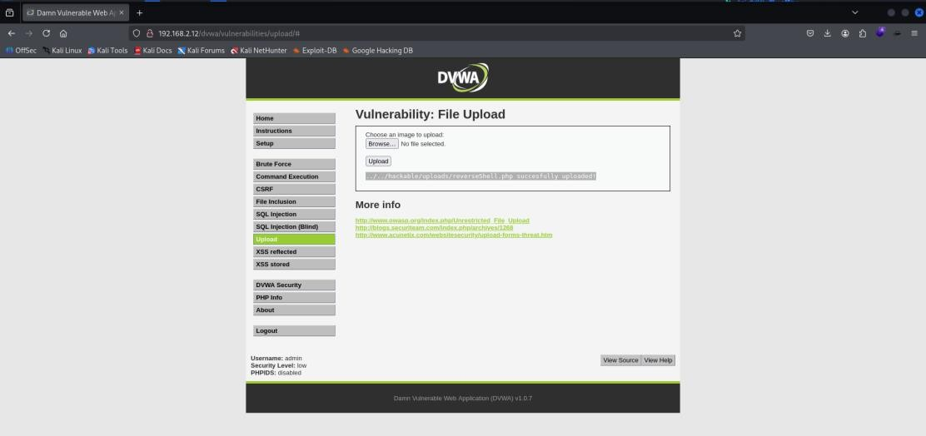

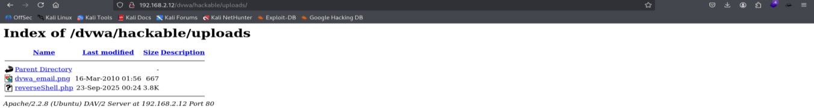
Using that path we can see that file upload directory we can run malicious file to get access

MITIGATION
- Allow only certain file extensions
- Set maximum file size and name length
- Allow only authorized users
- Make sure the fetched file from the web is an expected one
- Keep your website updated

