Supplementary Information Elkelani 2024 Timecourses

This is the supplementary information for the submission to ECCE 2024 in Paris:
"Timecourses showing mind wandering and heuristic strategies interact
complexly to affect SART performance rapidly"
Omar Elkelani, Sara I. Ribeiro-Ali, Carina E.I. Westling, Harry J. Witchel
Addresses: Department of Clinical Neuroscience, Brighton and Sussex Medical School, UK
and Bournemouth University, Bournemouth, UK

Methods

<h2>This experiment is a Sustained Attention Task</h2> <p> It is called SART (version 05)</p> <p>These instructions (<b>including ethical and consent forms</b>) will appear on multiple screens and will take around <b>7 minutes</b> to read.</p><p>Please read them carefully because your most accurate responses are important for our research team to understand why people make errors when their attention falters at work. </p>
<h3>Requirements to perform this experiment</h3> <p>For this experiment you will need a reliable internet connection and to be in a <b>quiet</b> room with minimal distractions, otherwise it may influence the results of the experiment.</p> <p>Even a ticking clock may influence the results of the experiment!</p> <p>If you need to move to another room that is quieter or has a more reliable internet connection (wifi), now is the best time to do so.</p>
<h1>Summary of ethics and informed consent for research participants</h1><p>We estimate that this experiment will take around <b>20 minutes</b> to complete.</p><p>This study involves you responding to images and then rating the task's <b>difficulty</b> level, whether you were <b>mind wandering</b>, as well as your levels of <b>effort</b> and <b>caution</b>.</p> <p>We do not anticipate this will result in either pain or embarrassment.</p>
<h2>Ethical Protections</h2> <p>The process is completely voluntary and <i>you may withdraw at any point, by closing your browser window.</i></p> <p><b>Withdrawal will lead us to erase all previous data of participation.</b></p><p>This study is hosted by <b>Brighton and Sussex Medical School</b> (United Kingdom) and has been approved via the university ethics assessment.</p> <p>All data will be confidential and publications will keep your participation anonymous.</p> <p>If you have a complaint, in the first instance you can contact the experimental team via email on h.witchel@bsms.ac.uk</b>
<h1>Informed Consent</h1><p>If you consent to being involved in this experiment please press the letter <b>&lt;Y&gt;</b> key for yes.</p> <p>Otherwise, please close your browser window</p>
<h3>Please select your age group</h3> <p><center>Please select one answer by clicking on a button</center></p>
<h3>Please select your biological sex from the options below</h3> <p><center>Please select one answer by clicking on a button</center></p>
<h2>Initial Personality Questions</h2> <p>First we would like you to answer four personality questions.</p><p>There are no right or wrong answers to these questions, but please answer as accurately as possible.</p> <p>On the next 4 screens, click on one of the buttons to answer the questions.</p>
<p> How much do you agree or disagree with the following statement: </p> <h3> I am a person who ... </h3> <h2 style="color:red"> <center>does a thorough job.</centre></h2>
<p> How much do you agree or disagree with the following statement: </p> <h3> I am a person who ... </h3> <h2 style="color:red"> <center>is lazy.</centre></h2>
<p> How much do you agree or disagree with the following statement: </p> <h3> I am a person who ... </h3> <h2 style="color:red"> <center>…is relaxed, handles stress well.</centre></h2>
<p> How much do you agree or disagree with the following statement: </p> <h3> I am a person who ... </h3> <h2 style="color:red"> <center>…gets nervous easily.</centre></h2>
<h2>Next Stage: Tasks</h2> <p>This test measures your ability to pay attention.</p> <p>You will be asked to do a simple task that demands you pay attention, and after each step you will need to answer some quick questions about the task.</p>
<h4>Reaction Time Test</h4> <p>We will begin these experiments by testing your reaction time. When you see a large number appear on the screen (for example: "8"), you should press as quickly as you can.</p> <p>For this experiment you will press the <b>&lt;right arrow&gt;</b> key to respond to stimuli, as shown in the image below.</p>
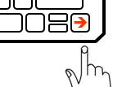
<h1>Get Ready</h1> <p>Press the <b>&lt;right arrow&gt;</b> key as soon as you see a number on the screen.</p> <p>A brief fixation cross will appear just before the number appears.</p>
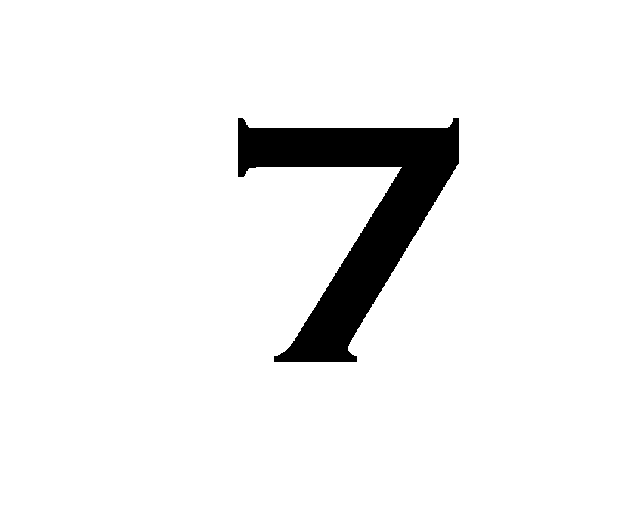
<p>Next you will repeat the reaction time test you just did four more times.</p>
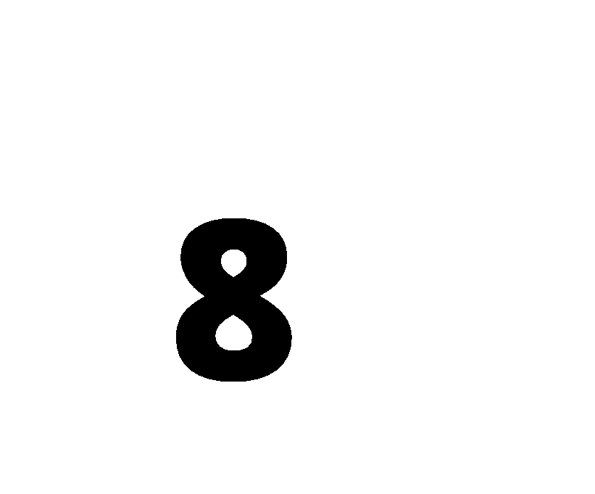


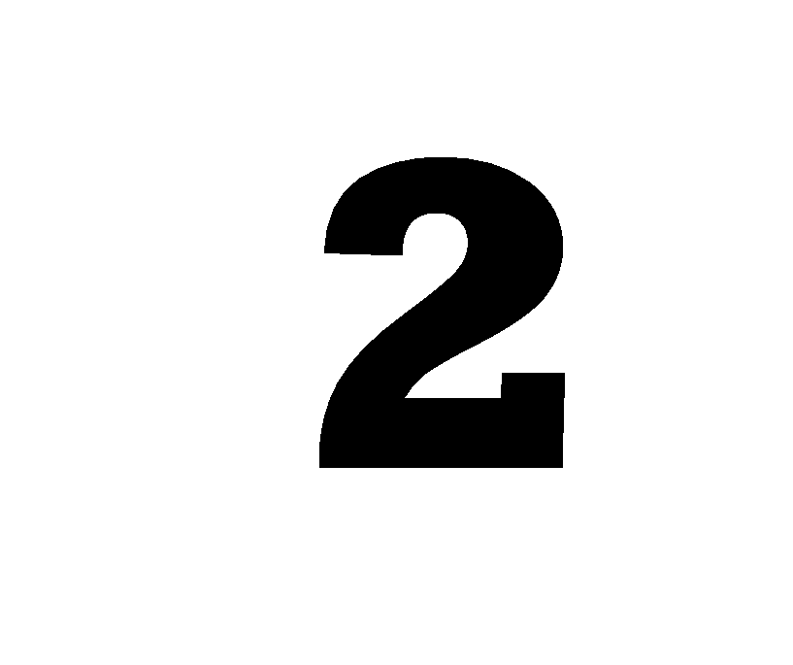
<h2>Change Tasks to Sustained Attention</h2> <p>That was the end of the reaction time task. For the rest of the experiment, you <b> MUST NOT</b> press any button when you see the number "3", so you will need to choose whether or not to respond to the number that appears.</p>
<h1>Instructions</h1> <p>For this experiment, you will see different numbers from 1 to 9 presented at various rates.</p> <p>Your task is to press the <b>&lt;right arrow&gt;</b> key when you see any number other than <b>3</b>. If the number is <b>3</b> then <b>DO NOT PRESS</b> any key. Instead you should wait, and then the screen will advance automatically.</p>
<h3>Instructions Continue</h3> <p>The aim is to press the <b>&lt;right arrow&gt;</b> key as quickly AND as accurately as possible when numbers <b>1,2,4,5,6,7,8,9</b> are presented.</p>
<h2>Thought Probes</h2> <p>Every once in a while, the task will temporarily stop and you will be presented with a screen asking you to indicate whether you were <b>ON TASK</b> or <b>MIND WANDERING</b> just before the thought probe appeared.</p>
<h2>ON TASK:</h2><p>Being <b>ON TASK</b> means that, just before the screen appeared, you were focused on completing the task and were not thinking about anything unrelated to the task. If you are focused on the screen and have no other thoughts, then you are also <b>ON TASK</b>. Some examples of <b>ON TASK</b> thoughts include thoughts about your performance on the task, thoughts about the pacing of the numbers, or thoughts about your response.</p>
<h3>MIND WANDERING:</h3><p><b>MIND WANDERING</b> means that, just before the screen appeared, you were thinking about something completely unrelated to the task.</p><p>Some examples of <b>MIND WANDERING</b> include thoughts about other places, people or events, such as wondering what you might eat for dinner.</p>
<h4>The thought probe screen is seen <b>below</b></h4> <p>When you see a thought probe screen, please answer by pressing either the <b>&lt;up arrow&gt;</b> key OR the <b>&lt;down arrow&gt;</b> key.
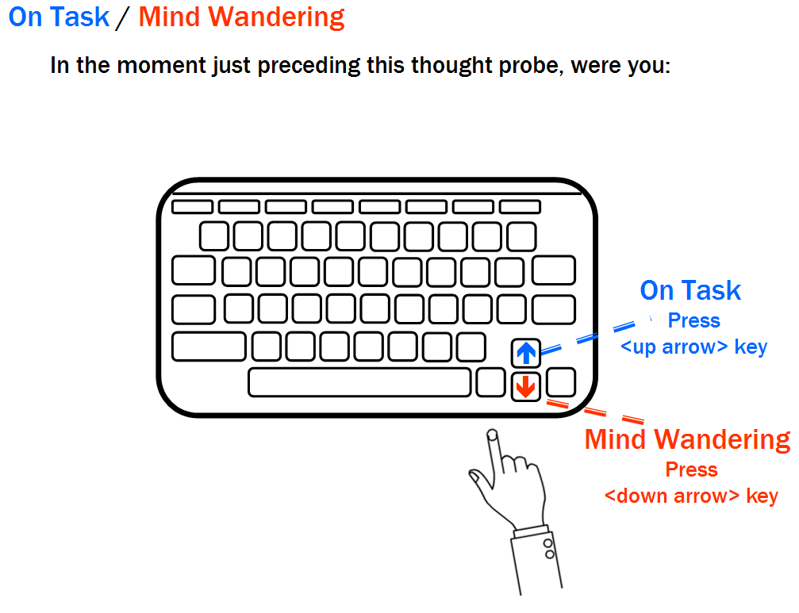
<h2>There are two forms of mind wandering:</h2><ol><li><b>INTENTIONAL</b> mind wandering</li><li><b>UNINTENTIONAL</b> mind wandering</li></ol>
<h3>INTENTIONAL MIND WANDERING:</h3><p>When you <b>INTENTIONALLY</b> mind wander, it is as if you <b>CHOSE</b> to think about things that are unrelated to the task, almost as if you gave your mind permission to wander, and that you could have stayed on task if you wanted to.</p>
<h3>UNINTENTIONAL MIND WANDERING:</h3> <p>You might <b>UNINTENTIONALLY</b> mind wander to task-unrelated thoughts, <b>DESPITE YOUR BEST INTENTIONS TO FOCUS</b> on the task.</p> <p>That is, in your current state of mind, you would have found it impossible to control your mind wandering and keep your thoughts continuously on the task.</p>
<h4>Selecting which type of mind wandering</h4> <p>If you are mind wandering, you will be asked whether this is <b>INTENTIONAL</b> or <b>UNINTENTIONAL</b></p> <p>This screen is shown <b>below</b></p>
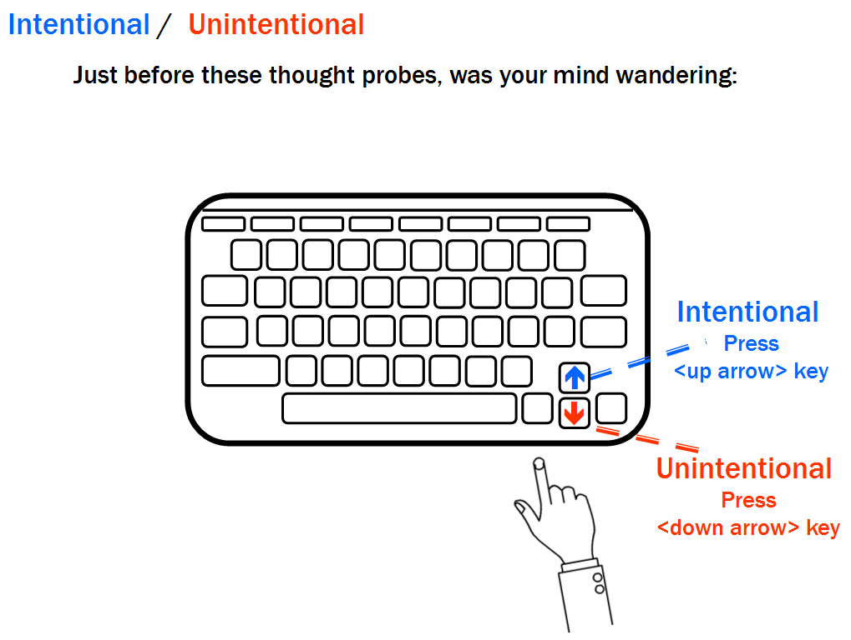
<h3>This experiment aims to observe the way different minds respond to tasks.</h3> <p>Please be as <b>honest</b> as possible when responding to the questions about your mind wandering. We make <b>no judgments</b> about people who are on-task versus mind wandering in this task. We recognise that these tasks are repetitive and require persistence. Most people will mind wander at some point despite their best efforts not to.</p>
<h4>Rating how difficult you found the task</h4> <p>You will also be asked to rate how difficult you are finding the task, on a scale of 1-9.</p><ul><li>If you press 1 means you found the task very <b>easy</b>.</li><li>If you press 9 means you found the task very <b>difficult</b>.</li></ul><p>An example of this is seen <b>below</b>:</p>
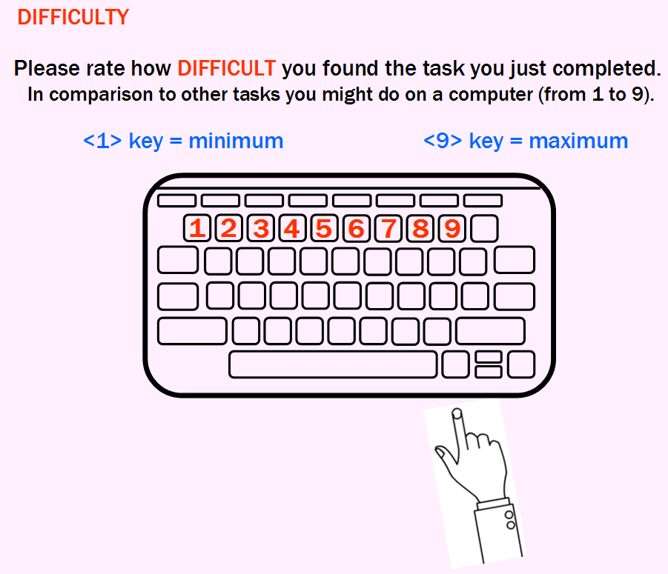
<h4>Rating how much effort you made</h4> <p>You will then be asked to rate how much <b>EFFORT</b> you put into the previous task, on a scale of 1-9. Your rating should be in comparison to the other tasks you might do on a computer.</p> <ul><li>If you press 1 that means you made only minimal effort to complete the task as accurately as possible.</li><li>If you press 9 that means you made a lot of effort to complete the task as accurately as possible.</li></ul>
<h2>Rating Your Effort</h2><p>An example of what the screen for rating your effort looks like is shown <b>below</b>:</p>
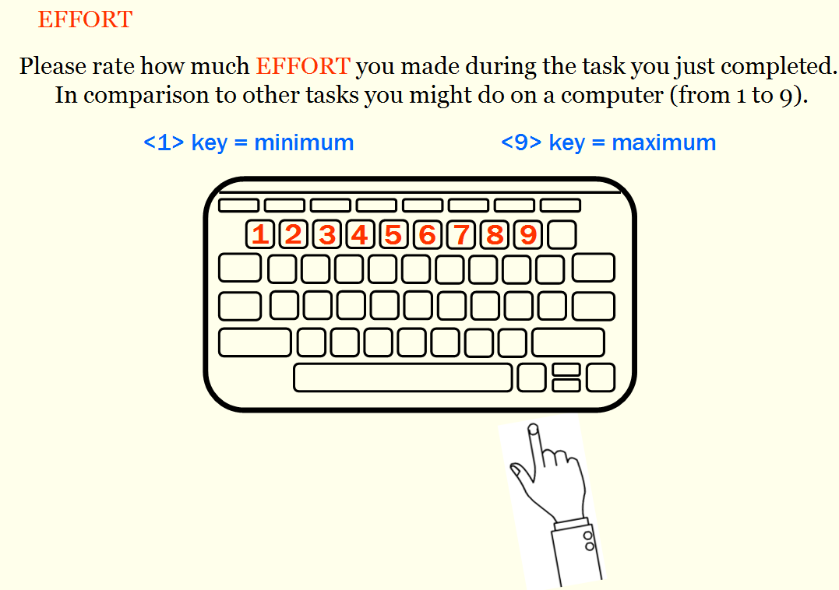
<h4>Rating how cautious you were while doing the task</h4> <p>You will then be asked to rate how <b>CAUTIOUS</b> you were during the previous task, on a scale of 1-9.</p> <ul><li>If you press 1, that means you were not at all cautious, giving no care to how accurate your answers were.</li><li>If you press 9, that means you were extremely cautious about being as accurate as possible.</li></ul>
<h3>Rating Your Caution</h3> <p>An example of the caution rating screen is shown <b>below</b>:</p>
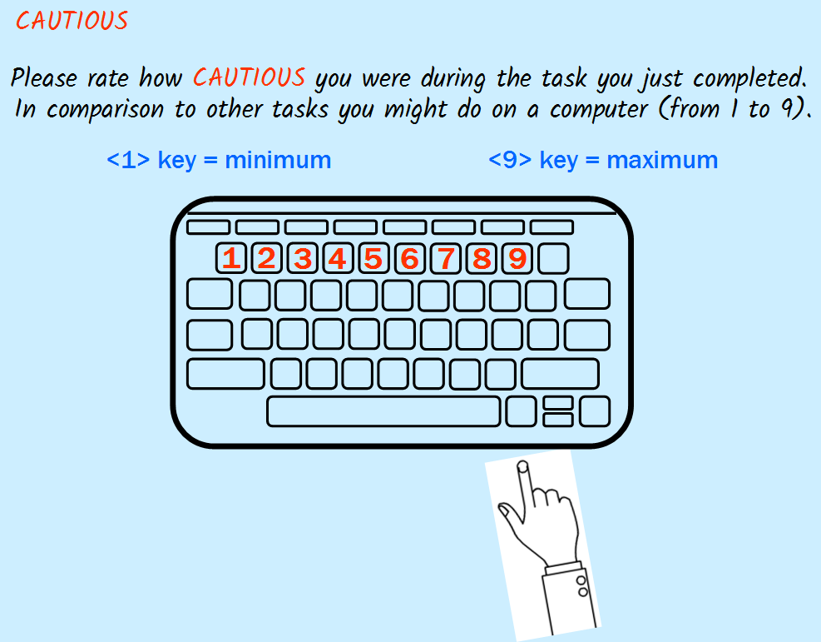
<h2>Practise Task</h2> <h4> After this screen, you will see a <b>number</b> appear on the screen.</h4> <p>If the number is <b>1,2,4,5,6,7,8,9</b> then press the <b>&lt;right arrow&gt;</b> key on your keyboard. If the number is <b>3</b> then <b>DO NOT press</b> anything and wait for the next screen.</p><p><i>If for any reason you do not see an image, or cannot press the &lt;right arrow&gt;, please press the early exit button.</i></p>
<h2>End of Practice</h2> <p>Next you will begin the actual experiment. There will be no feedback between stimuli. The stimuli will occur one after another, sometimes followed by a thought probe.</p> <p>Remember: Do <b>NOT</b> press when you see a 3, but press the <b>&lt;right arrow&gt;</b> key when you see any other number. The goal is to be as fast <b>AND</b> as accurate as possible.</p>

