Supplement_06_Power_calculation_for_sample_size

We assume that
nA / nB = 1
σ = 25
mean diff = 15
1 - β = 0.99 (strong)
α = 0.05

Calculate Sample Size Needed to Compare 2 Means: 2-Sample, 2-Sided Equality

This calculator is useful for tests concerning whether the means of two groups are different. Suppose the two groups are 'A' and 'B', and we collect a sample from both groups -- i.e. we have two samples. We perform a two-sample test to determine whether the mean in group A, μAμA, is different from the mean in group B, μBμB. The hypotheses are
H0: μA − μB =0
H1: μA − μB ≠0
.
where the ratio between the sample sizes of the two groups is
κ=nA / nB

Formulas
This calculator uses the following formulas to compute sample size and power, respectively:
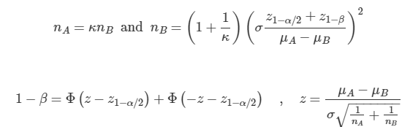
where
- κ=nA/nB is the matching ratio
- σ is standard deviation
- Φ is the standard Normal distribution function
- Φ−1 is the standard Normal quantile function
- α is Type I error
- β is Type II error, meaning 1−β is power

R Code
R code to implement these functions:
1  2  3  4  5  6  7  8  9  10 | muA=5  muB=10  kappa=1  sd=10  alpha=0.05  beta=0.20  (nB=(1+1/kappa)*(sd*(qnorm(1-alpha/2)+qnorm(1-beta))/(muA-muB))^2)  ceiling(nB) # 63  z=(muA-muB)/(sd*sqrt((1+1/kappa)/nB))  (Power=pnorm(z-qnorm(1-alpha/2))+pnorm(-z-qnorm(1-alpha/2)))

References
Chow S, Shao J, Wang H. 2008. Sample Size Calculations in Clinical Research. 2nd Ed. Chapman & Hall/CRC Biostatistics Series. page 58.

Power Size for Detecting Font Differences

Assuming a standard deviation of 25

