**Harry Huang Bio 312 11/30/20  
Evolutionary History of Transcript Variant XP_032221022.1**

# Introduction

The RRN3 gene family has been functionally conserved amongst species and is involved in the facilitating the efficient transcription of DNA by RNA polymerase I. In *Nematostella vectensis,* NCBI identifies XP_032221022.1 as the only known transcript variant of the gene LOC116603617 and provides the description “RNA polymerase I-specific transcription initiation factor RRN3-like”, indicating that the protein product is similar to that of the initiation factor RRN3 in yeast. The human RRN3 homolog is involved with rDNA transcription and misregulation of the system in humans leads to cancer (Fernández-Tornero 2018). That goes to suggest research into RRN3 could possibly yield advances in cancer treatment or prevention. Yet the evolutionary history of RRN3 and homologs across different species is still poorly understood. While much is known about paralogous RRN3 genes in yeast and humans, the evolution of RRN3 with respect to Nematostella and cnidaria at large is less studied.

The putative function of the protein product, based on similar paralogous genes, is to serve as a transcription factor for RNA polymerase I and enable the efficient transcription of DNA by RNA polymerase I. Within yeast, RRN3 is unique because as the other two required transcription factors are comprised of multiple proteins, this protein product is a whole transcription factor and functions as a single subunit. In humans, TIF-IA shares the same functional similarity with RRN3 in yeast in that it’s activity is regulated by cellular growth rate. RRN3 associates directly with RNA polymerase I and RRN3 is not associated with RNA polymerase I in extracts from growth arrested cells, suggesting a link between RRN3 association and RNA transcription. The functional equivalence of the homologs is further supported in that when the human cDNA for the homolog is expressed in yeast, it is capable of rescuing a lethal deletion of RRN3. This suggests that the human cDNA homolog protein product (TIF-IA) has similar or equivalent function to RRN3 in yeast (Moorefield, Greene, and Reeder 2000).

Although the mechanisms of gene LOC116603617 in cnidaria are not known, it’s suspected paralog in the closest studied organism, humans, has been well documented. In humans, the paralog of RRN3 is known as hRRN3 and it’s protein product is TIF-IA. Literature tends to interchangeably use the gene name “hRRN3” and it’s protein product name “TIF-IA”, but the names will be used separately here for consistency. TIF-IA’s function in humans is through association with initiation competent RNA polymerase I and linking RNA polymerase I to SL1. The majority of human RNA pol I complexes are transcriptionally inactive, but the complexes that are active have TIF-IA in them. TIF-IA interacts with two proteins on transcription factor SL1 and blocking interaction with these proteins prevents recruitment of transcriptionally active RNA pol I to SL1 (Miller et al. 2001). During times of stress, rRNA synthesis is down-regulated by targeting TIF-IA to inactivate RNA polymerase-I. c-Jun N-terminal kinase (JNK) phosphorylates and effectively inactivates TIF-IA a single residue (Mayer, Bierhoff, and Grummt 2005).

Changes to essential genes that lead to lethal result or infertility are often heavily selected against during evolution, resulting in heavy gene conservation, and the RRN3 gene family are essential genes. In bacteria, such phenomena is observed as “essential genes”, genes in which changes would be lethal or lead to infertility, are more evolutionarily conserved than “non-essential genes”(Jordan et al. 2002). Since all life is based on the central dogma of DNA 🡪 RNA 🡪 protein, machinery in regards to the processing of any of these items (RRN3 included) should be relatively well conserved (at least in function) through all life as deleterious changes to these processes are most likely lethal. Following that, this gene is functionally conserved between two different species in two different kingdoms (Moorefield, Greene, and Reeder 2000). As evident by the gene homologs in both yeast and humans, as well as supported by a search of RRN3 on OrthoDB, there are many homologs of this gene that expands well outside of Cnidaria. In fact, there are actually 1307 genes in 1138 species, with 487 of them belonging to species within Metazoa and even others belonging in protista (Kriventseva et al. 2018).

Although the RRN3 gene and it’s evolutionary history with closer regards to cnidaria have not been studied, it’s homologous genes in yeast and humans have extensive documentation that allows us to infer the punitive function of the gene family and even speculate on RRN3’s evolution with regards to cnidaria. Yeast and human RRN3 homologs are functionally conserved. When considering the logic of functional conservation of genes involved in the central dogma (Isenbarger et al. 2008), the homologs in yeast and humans, and observing the large number of suspected homologs found by OrthoDB, there is extensive support that the RRN3 gene family evolved into existence well before the divergence of cnidaria from it’s common ancestor. If LOC116603617 is indeed part of the RRN3 family, it is unlikely that it evolved independently in Cnidaria or even Bilateria. The purpose of this paper is to determine if LOC116603617 evolved independently in Cnidaria.

# Methods

Gene identification and alignment were performed using Blast Tools, seqkit, muscle, and t_coffee. The identity of the query protein was provided by Dr. Joshua Rest as XP_032221022.1. Dr. Joshua Rest retrieved proteomes from Uniprot for five species: Nematostella vectensis, Pocillopora damicornis, Strongylocentrotus purpuratus, Homo sapiens, and Drosophila melanogaster. Dr. Rest filtered the proteomes for a single isoform per gene, providing the longest isoforms for *Nematostella vectensis* and using an undisclosed method to filter for the other four species. These filtered proteomes were used to make a blast database with the makeblastdb program (Altschul et al. 1990). Using the ncbi-acc-download (Blin and Hole 2020) program, the fasta file for protein transcript XP_032221022.1 was retrieved from NCBI. The protein was then blasted against the database using the program blastp (Altschul et al. 1990) with option -outfmt "6 sseqid pident length mismatch gapopen evalue bitscore pident stitle" to output high-scoring pairs with details in the format specified by the option. The high-scoring pairs were filtered for putative homologs to XP_032221022.1 by requiring the e-value to be less than 1*10-14 using awk. The proteomes for the filtered, low e-value homologs were obtained using seqkit (Shen et al. 2016) and the proteomes. The definition lines of the seqkit output were then manually adjusted to have the species name first in format “Genus_species_protein-identifier_...” and the query gene, XP_032221022.1, was renamed to “Nematostella_vectensis_RRN3” for ease of analysis. A global multiple sequence alignment was performed on the renamed seqkit output using muscle (Edgar 2004) and statistics on the alignment were derived using t_coffee (Notredame, Higgins, and Heringa 2000). The difficulty of comparing nucleotides with gaps was avoided by having highly gapped positions, positions containing greater than 50% gapped residues, removed through t_coffee using option -action +rm_gap 50.

Phylogenetic analysis required the use of IQ-Tree, newick tools, and gotree. Using IQ-Tree (Nguyen et al. 2015) and the gap-removed aligned homologs output from t_coffee -action +rm_gap 50, a phylogenetic tree was constructed. The arbitrarily rooted tree and unrooted tree were viewed with nw_display (Junier and Zdobnov 2010) and gotree (Lemoine and Wang 2017) draw png. Literature surrounding XP_032221022.1 did not identify an outgroup for rooting and midpoint rooting was performed by gotree reroot midpoint.

Reconciliation of the gene tree and species tree required the use of …. To obtain bootstrap support, a full bootstrap (Hoang et al. 2018) was run on the gap-removed aligned sequences provided by t_coffee using IQ-Tree -b 100 (Nguyen et al. 2015). The output bootstrap supported tree was then midpoint rooted using gotree reroot midpoint. The midpoint rooted, bootstrap supported, tree was viewed with nw_display. A species tree was provided by Dr. Joshua Rest. The names of the species tree and the midpoint rooted, bootstrap supported, tree were put into a text file on the first and second lines, respectively. The midpoint rooted, bootstrap supported, tree was reconciled with the gene tree using Notung (Chen, Durand, and Farach-Colton 2000), the aforementioned text file, and the –reconcile command. The Notung output was a reconciled tree. To view the tree, a RecPhyloXML (Duchemin et al. 2018) object was generated. Reconciliation based re-rooting of the tree was subsequently performed using Notung and the   
--root option.

Notung was used to rearrange the gene tree by re-arranging branches with low bootstrap support values using a threshold of 80 because a full bootstrap was used and full bootstrap scores above 80 are considered good support for a node. A RecPhyloXML object was created to visualize the rearranged tree. To test if the rearranged tree fell within the phylogenetic confidence set, the rearranged tree and midpoint rooted tree were compared in a topology test using IQ-Tree and non-default options -z -au -zb -m -te. The -z option defined the files with the trees of interest, the -au option specified the desired test as “approximately unbiased”, and the -zb 10000 option specified 10000 bootstrap replicates. The optimal model was identified as VT+G4 in the iqtree file for the homologs and applied with the -m option. The optimal tree was defined as the full bootstrap treefile and applied with the -te option. Since the rearranged tree produced a p-value less than 0.05, the preferred tree used moving forward was the tree rerooted via minimization of duplications and deletions in Notung.   
   
 Domain prediction was performed with Interproscan5 web service (Jones et al. 2014). The domains returned from Interproscan were then filtered for domains defined by the Pfam database (Bateman et al. 2004). The filtered domains were then plotted onto the rearranged phylogeny through Evolview (Zhang et al. 2012).

# Results

Filtering BLAST output for e-values less than 1 e-14 produced 14 genes including the query gene itself, yielding 13 putative homologs (figure 1). The average percent identity in the alignment was 21.27%

|  |  |  |  |
| --- | --- | --- | --- |
| Phylum | Species | Number of genes | Gene names |
| Cnidaria | *Nematostella vectensis* | 3 | Nematostella_XP_032221022.1  Nematostella_XP_032225881.1  Nematostella_XP_032221138.1 |
| *Pocillopora damicornis* | 4 | A0A3M6TY46|A0A3M6TY46_9CNID  A0A3M6TPZ0|A0A3M6TPZ0_9CNID  A0A3M6V5X9|A0A3M6V5X9_9CNID  A0A3M6TV88|A0A3M6TV88_9CNID |
| Chordata | *Homo sapiens* | 1 | Q9NYV6|RRN3_HUMAN |
| Arthropoda | *Drosophila melanogaster* | 1 | Q9V9M6|Q9V9M6_DROME |
| Echinodermata | *Strongylocentrotus purpuratus* | 4 | W4XX55|W4XX55_STRPU  W4XMK7|W4XMK7_STRPU  W4Y3R2|W4Y3R2_STRPU  W4Z7T7|W4Z7T7_STRPU |

Figure 1. Putative homologs derived from filtering BLAST output for e-values less than 1 e-14. Fourteen genes were filtered out, including the query gene itself, leaving 13 putative homologs.

The midpoint rooted tree suggests stronger evolutionary relatedness of homologs within Cnidaria. Rooting the tree by midpoint using Notung provided a possible phylogeny with shortest evolutionary distance from other Nematostella genes and slightly further distance to pocillopora genes . Rooting via minimization of duplications and deletions in Notung yielded the exact same tree as the midpoint rooted tree (figure 2). However, full bootstrap analysis revealed that only 3 nodes had good bootstrap support. The duplication proximal to *Nematostella vectensis*  RRN3, the duplication for Nematostella_vectensis XP 032225881.1 and XP 032239229.1, and the duplication for *Strongylocentrotus purpuratus* W4Y3R2 and W4XMK7 have good bootstrap support values of 90, 92, and 100, respectively. The rest of the nodes have very low bootstrap support, with most of the rest in the single digits (figure 3).

Figure 2. Midpoint rooted phylogeny for putative homologs of query protein XP_032221022.1. Query protein is renamed as Nematostella_vectensis_RRN3 and other proteins are renamed to species descriptive names for posterity. The phylogeny displayed 10 duplications (1.5 event score each), 15 losses (1 event score each), and a total event score of 30. Red nodes labeled “D” are duplications to extant genes. Grey lineages and species names represent loss events respective to the species labeled.

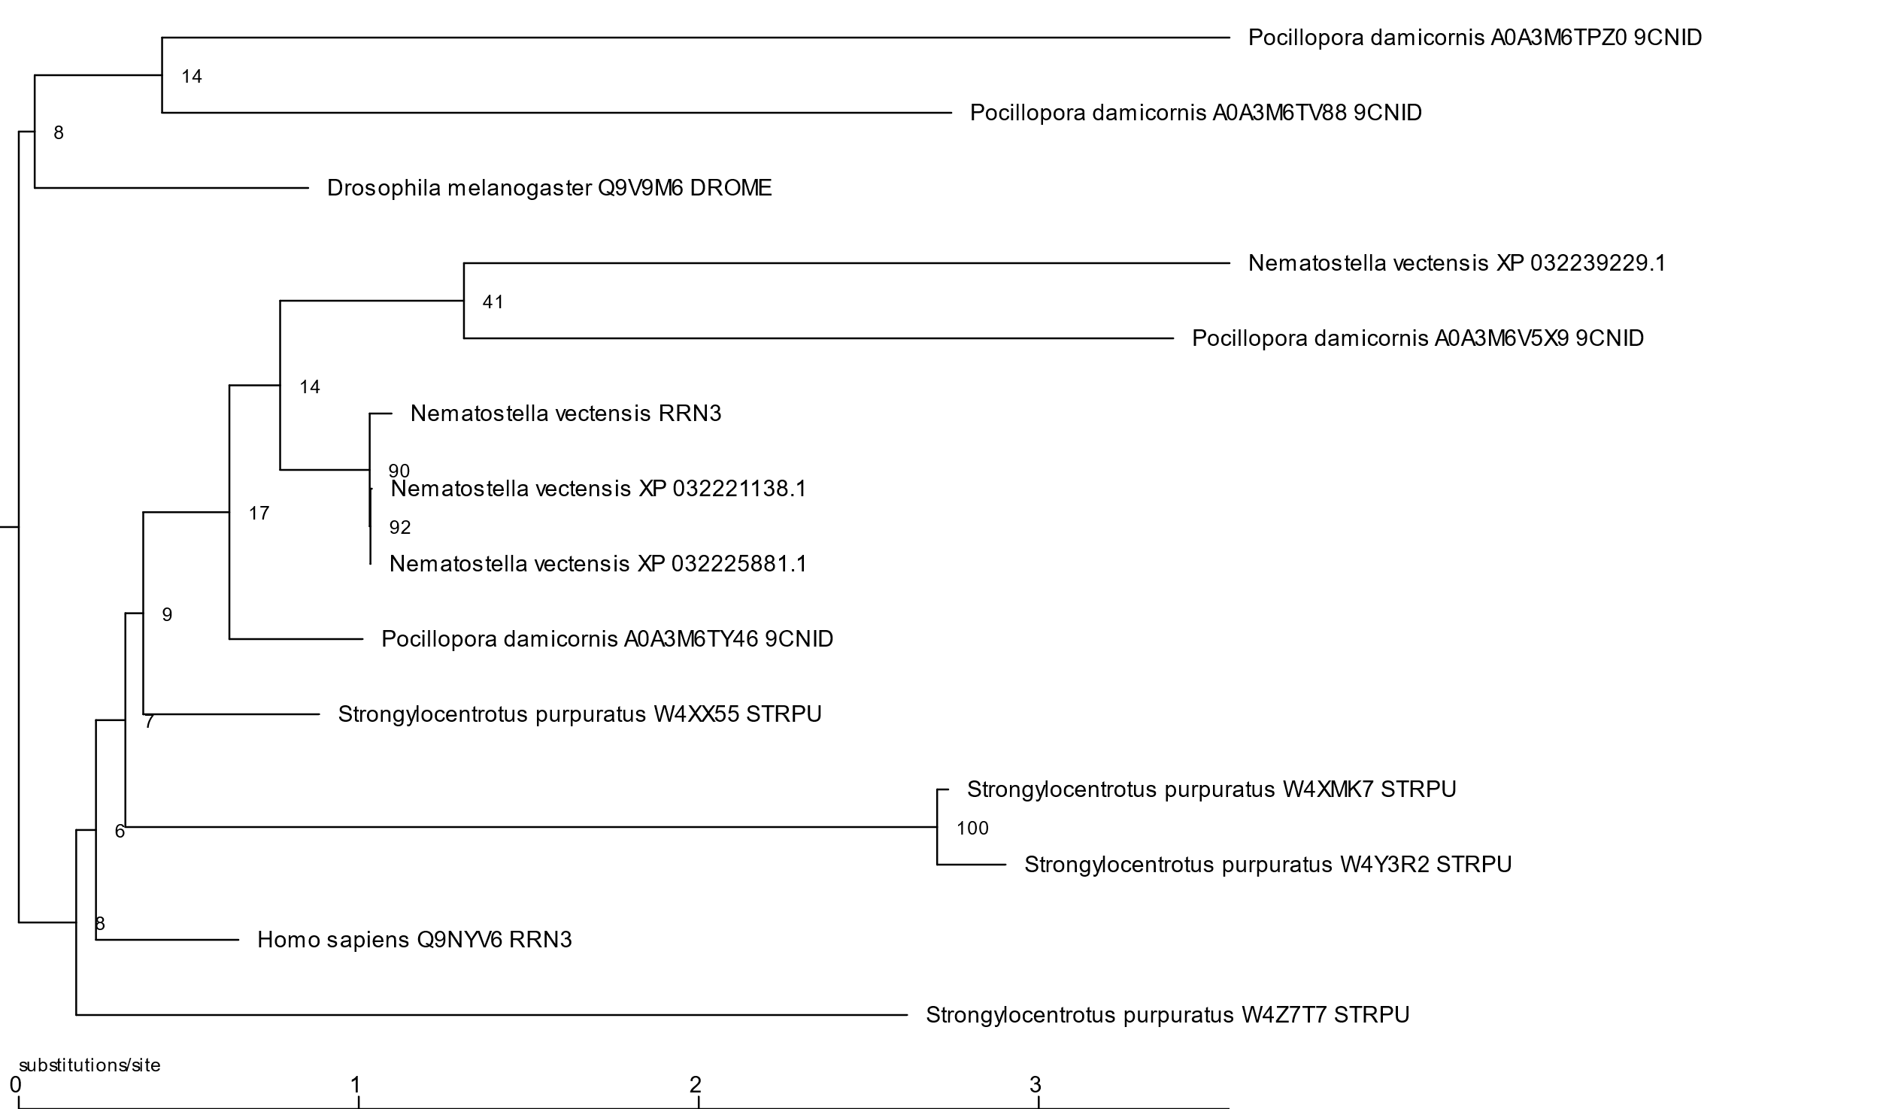

Figure 3. Midpoint rooted tree with bootstrap scores on nodes. Full bootstrap analysis was used to score nodes and a bootstrap value greater than 80 is considered good support for a node.

Reconciling the midpoint rooted gene tree and the species tree yielded lots of deletions towards the beginning, entering Cnidaria, and for *Homo sapiens* and *Drosophila melanogaster*. A cluster of the duplications are at the beginning, with another two duplications entering Cnidaria. The rest of duplications happen at the species level. Every species experiences at least one deletion at the species level (figure 4).

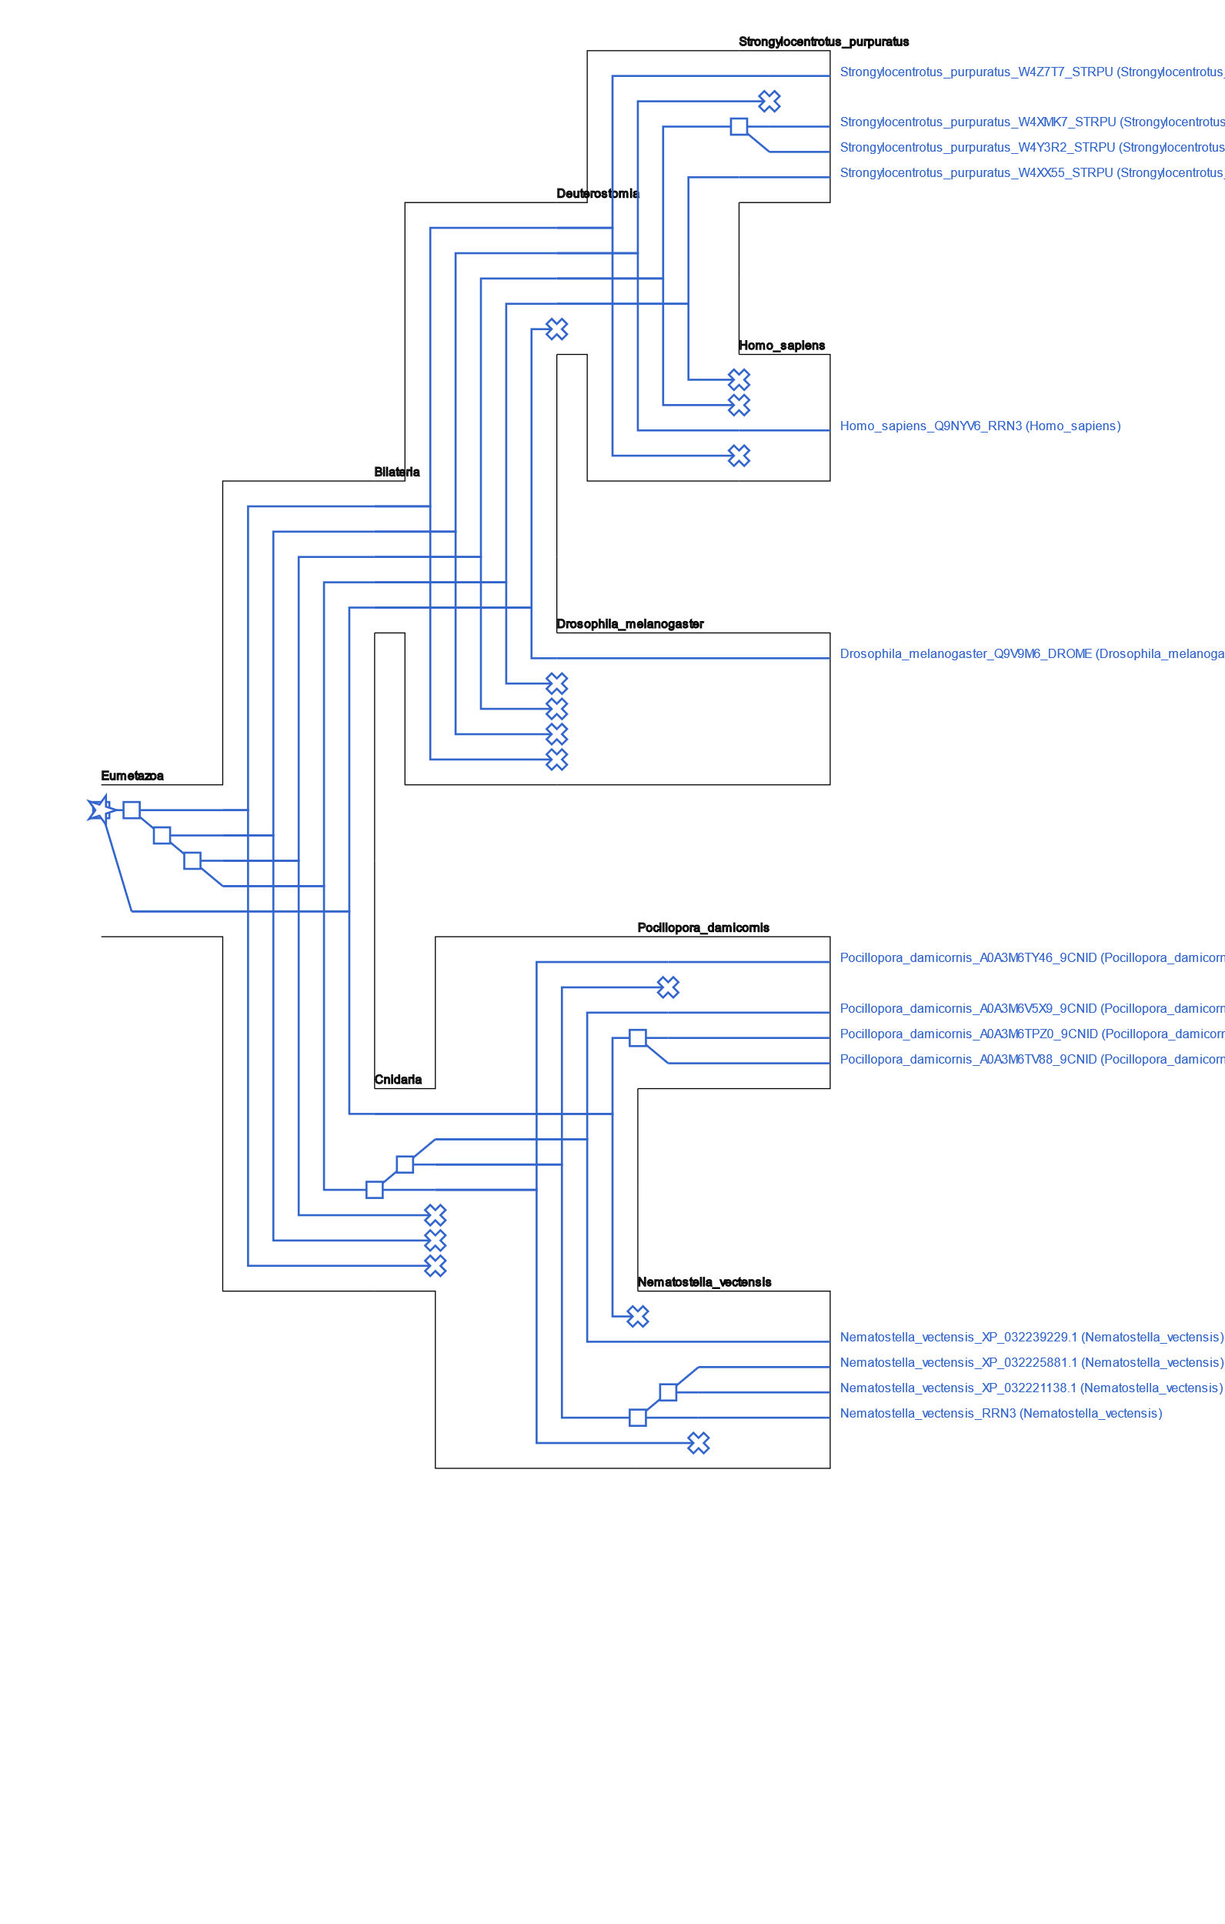  
Figure 4. Reconciled midpoint rooted gene tree and species tree. Boxes represent duplications and “x” represent deletions. The star represents the common ancestor for all species in the tree.

Rearranging poorly support branches produced a tree with fewer duplications and no loss events. The rearranged tree shows strong groupings by species and is more parsimonious than the midpoint rooted gene tree (Figure 5). Topology test for the optimal tree from IQ-TREE gave it a log likelihood of -11023.475 and gave the rearranged tree a log likelihood of -11033.911. The AU topology p-value for the optimal tree from IQ-TREE was 0.914 and the p-value for the rearranged tree was 0.086 (figure 6). Since the p-value for the rearranged tree is greater than 0.05, the rearrangement changes suggested by the reconciliation are not inconsistent with the phylogenetic signal. The rearranged tree is supported by both reconciliation and has no significant difference in support from the phylogenetic analysis.

Figure 5. Gene tree rooted to minimize duplications and losses by rearranging poorly supported branches. Node bootstrap values are in green and presented bottom left to it’s respective node. Duplications are represented as red notes with the label “D”. The bootstrap value meshed with the red duplication on the bottom reads “92.0” and refers to the node for *Nematostella vectensis*  XP genes. The bootstrap score of 90 refers to the node for *Nematostella vectensis*  RRN3. The bootstrap score of 100 refers to the rightmost duplication on the top cluster of three duplications. The gene of interest, XP_032221022.1, is represented as “Nematostella_vectensis_RRN3”.

|  |  |  |
| --- | --- | --- |
| Tree ID | Log likelihood | AU p-value |
| 1 | -11023.475 | 0.914 |
| 2 | -11033.911 | 0.086 |

Figure 6. Log likelihoods and AU p-values for topology test. Tree 1 is the optimal tree from IQ-TREE. Tree 2 is the tree produced by rearranging poorly supported nodes based on bootstrap scores.

Predicting protein domains from the Pfam database through Interproscan5 revealed the prevalence of the PF05327 Pfam protein domain in the gene tree. PF05327 is the only protein domain identified in the gene of interest, *Nematostella vectensis* RRN3. However, the protein domain in the gene of interest is relatively truncated compared to in other genes, even other Nematostella genes. PF05327 is predicted in *Homo sapiens* Q9NYV6 RRN3 from amino acid 55 – 585, giving a length of 531 amino acids. PF05327 is predicted in both *Nematostella vectensis* XP 032225881.1 and 0.2221138.1 from amino acid 52 – 558, giving a length of 506 amino acids. Since the total gene lengths are 601 amino acids, the distance In the gene of interest, PF05327 goes from 11-84, giving a length of 74 amino acids.

Figure 7. Predicted Pfam domains characterized by Interproscan and plotted using Evolview. Predicted domains are color-coded by legend on the left. Gene of interest has been labeled The gene of interest, XP_032221022.1, is represented as “Nematostella_vectensis_RRN3”.

# Discussion

LOC116603617/XP_032221022.1[1] is likely evolved from ancestral genes prior to the split to Cnidaria and did not likely evolve specifically inside Cnidaria. In all likely phylogenies produced within this analysis, XP_032221022.1 has homologs derived from duplications of an ancestral gene from a most recent common ancestor that exists outside the domain of Cnidaria (figures 2, 5). This suggests XP_032221022.1 is not the result of lateral gene transfer, gene fusion/fission, or De Novo gene origination, but is rather descendant from a protein coding gene in the most recent common ancestor of all analyzed species.

The rearranged gene tree has both phylogenetic and reconciliation support and represents the most likely accurate phylogeny produced by this analysis (figure 5). The rearranged gene tree also strongly resembles the species tree (figure 4). Since lineage-specific expansion of a gene family reduces species tree accuracy (Shi 2016), the agreement between the gene tree and the species tree suggests low lineage-specific expansion of the RRN3 gene family and supports that the gene family is evolutionarily conserved throughout. The relatively few number of events leading up to XP_032221022.1, with only 2 duplication events between it and the most recent common ancestor of all species in the tree, suggests conserved evolution (figure 5). However, the accuracy of the rearranged phylogeny is shaky as it’s AU p-value is almost significant (p=0.086) and the phylogeny is close to being inconsistent with the phylogenetic signal (figure 6). Therefore, the rearranged tree’s support for conserved evolution of XP_032221022.1 is weak because the phylogenetic accuracy of the tree is dubious.

Analysis of Pfam domains and gene lengths in the reconciled gene tree suggest drastic change of XP_032221022.1 within Cnidaria. PF05327 is the family of genes homologous to yeast RRN3 protein. With *Homo sapiens* RRN3 being a known functional homolog of yeast RRN3 and the closest studied gene included in our analysis, *Homo sapiens* Q9NYV6 RRN3 serves as a point of reference for analysis of how the gene has evolved in *Nematostella vectensis*. The length of predicted domain of PF05327 in *Nematostella vectensis* XP 032221138.1 and 032225881.1 are similar to that in *Homo sapiens* homolog, with a 25 amino acid difference in total length. However, the predicted domain of PF05327 in the gene of interest, XP_032221022.1, is 74 amino acids and is much shorter (figure 7). Visual inspection of all three *Nematostella vectensis* genes aligned suggest at least one massive deletion in the middle of the predicted domain in XP_032221022.1 because the ends of the short predicted domain in XP_032221022.1 almost exactly match the ends of the domain in the other two *Nematostella vectensis* genes. Since the predicted domain of RRN3 in XP_032221022.1 is so much shorter than the predicted domain of RRN3 in *Homo sapiens* Q9NYV6 RRN3, the known functional of RRN3, it is reasonable to cast doubt that XP_032221022.1 is a ortholog nor has it been evolutionarily conserved.

In conclusion, XP_032221022.1 is evolved from a common ancestral gene outside of cnidaria and while it’s most likely phylogeny would suggest the opposite, domain analysis gives stronger support that the gene is not evolutionarily conserved. The major challenge of this analysis is the lack of literature surrounding the function of XP_032221022.1 or any of the other suspected RRN3 homologs within *Nematostella vectensis*. Genes essential to the perpetuation of the central dogma are typically well conserved (Isenbarger et al. 2008) and through this logic, we expect *Homo sapiens* RRN3 to well conserved because it is a known RRN3 homolog and therefore involved in the central dogma. However, XP_032221022.1 does not seem well conserved because it is drastically shorter than *Homo sapiens* RRN3 and therefore it’s orthology to RRN3 is unlikely (figure 7). Additional research into the function of XP_032221022.1 in vitro are recommended to perpetuate the evolutionary understanding of this gene and to discover whether the gene is truly an ortholog. A future research direction could be to include yeast proteomes into a similar analysis because yeast RRN3 is well documented.

GitHub

GitHub repository for this analysis can be found at:   
<https://github.com/Bio312/finalproject-thundernyan>

# Works Cited

Altschul, S. F., W. Gish, W. Miller, E. W. Myers, and D. J. Lipman. 1990. 'Basic local alignment search tool', *J Mol Biol*, 215: 403-10.

Bateman, A., L. Coin, R. Durbin, R. D. Finn, V. Hollich, S. Griffiths-Jones, A. Khanna, M. Marshall, S. Moxon, E. L. Sonnhammer, D. J. Studholme, C. Yeats, and S. R. Eddy. 2004. 'The Pfam protein families database', *Nucleic Acids Res*, 32: D138-41.

Blin, Kai, and Darian Hole. 2020. 'NCBI accession download script'. <https://github.com/kblin/ncbi-acc-download>.

Chen, K., D. Durand, and M. Farach-Colton. 2000. 'NOTUNG: a program for dating gene duplications and optimizing gene family trees', *J Comput Biol*, 7: 429-47.

Duchemin, Wandrille, Guillaume Gence, Anne-Muriel Arigon Chifolleau, Lars Arvestad, Mukul S. Bansal, Vincent Berry, Bastien Boussau, François Chevenet, Nicolas Comte, Adrián A. Davín, Christophe Dessimoz, David Dylus, Damir Hasic, Diego Mallo, Rémi Planel, David Posada, Celine Scornavacca, Gergely Szöllosi, Louxin Zhang, Éric Tannier, and Vincent Daubin. 2018. 'RecPhyloXML: a format for reconciled gene trees', *Bioinformatics (Oxford, England)*, 34: 3646-52.

Edgar, R. C. 2004. 'MUSCLE: multiple sequence alignment with high accuracy and high throughput', *Nucleic Acids Res*, 32: 1792-7.

Fernández-Tornero, Carlos. 2018. 'RNA polymerase I activation and hibernation: unique mechanisms for unique genes', *Transcription*, 9: 248-54.

Hoang, D. T., O. Chernomor, A. von Haeseler, B. Q. Minh, and L. S. Vinh. 2018. 'UFBoot2: Improving the Ultrafast Bootstrap Approximation', *Mol Biol Evol*, 35: 518-22.

Isenbarger, Thomas A., Christopher E. Carr, Sarah Stewart Johnson, Michael Finney, George M. Church, Walter Gilbert, Maria T. Zuber, and Gary Ruvkun. 2008. 'The Most Conserved Genome Segments for Life Detection on Earth and Other Planets', *Origins of Life and Evolution of Biospheres*, 38: 517-33.

Jones, P., D. Binns, H. Y. Chang, M. Fraser, W. Li, C. McAnulla, H. McWilliam, J. Maslen, A. Mitchell, G. Nuka, S. Pesseat, A. F. Quinn, A. Sangrador-Vegas, M. Scheremetjew, S. Y. Yong, R. Lopez, and S. Hunter. 2014. 'InterProScan 5: genome-scale protein function classification', *Bioinformatics*, 30: 1236-40.

Jordan, I. King, Igor B. Rogozin, Yuri I. Wolf, and Eugene V. Koonin. 2002. 'Essential genes are more evolutionarily conserved than are nonessential genes in bacteria'.

Junier, T., and E. M. Zdobnov. 2010. 'The Newick utilities: high-throughput phylogenetic tree processing in the UNIX shell', *Bioinformatics*, 26: 1669-70.

Kriventseva, Evgenia V, Dmitry Kuznetsov, Fredrik Tegenfeldt, Mosè Manni, Renata Dias, Felipe A Simão, and Evgeny M Zdobnov. 2018. 'OrthoDB v10: sampling the diversity of animal, plant, fungal, protist, bacterial and viral genomes for evolutionary and functional annotations of orthologs', *Nucleic Acids Research*, 47: D807-D11.

Lemoine, Frederic, and Albert Wang. 2017. 'Gotree'. <https://github.com/evolbioinfo/gotree>.

Mayer, Christine, Holger Bierhoff, and Ingrid Grummt. 2005. 'The nucleolus as a stress sensor: JNK2 inactivates the transcription factor TIF-IA and down-regulates rRNA synthesis'.

Miller, Gail, Kostya I. Panov, J. Karsten Friedrich, Laura Trinkle-Mulcahy, Angus I. Lamond, and Joost C. Zomerdijk. 2001. 'hRRN3 is essential in the SL1-mediated recruitment of RNA Polymerase I to rRNA gene promoters'.

Moorefield, Beth, Elizabeth A. Greene, and Ronald H. Reeder. 2000. 'RNA polymerase I transcription factor Rrn3 is functionally conserved between yeast and human'.

Nguyen, L. T., H. A. Schmidt, A. von Haeseler, and B. Q. Minh. 2015. 'IQ-TREE: a fast and effective stochastic algorithm for estimating maximum-likelihood phylogenies', *Mol Biol Evol*, 32: 268-74.

Notredame, C., D. G. Higgins, and J. Heringa. 2000. 'T-Coffee: A novel method for fast and accurate multiple sequence alignment', *J Mol Biol*, 302: 205-17.

Shen, Wei, Shuai Le, Yan Li, and Fuquan Hu. 2016. 'SeqKit: A Cross-Platform and Ultrafast Toolkit for FASTA/Q File Manipulation', *PloS one*, 11: e0163962-e62.

Shi, Tao. 2016. 'Impact of gene family evolutionary histories on phylogenetic species tree inference by gene tree parsimony', *Molecular Phylogenetics and Evolution*, 96: 9-16.

Zhang, H., S. Gao, M. J. Lercher, S. Hu, and W. H. Chen. 2012. 'EvolView, an online tool for visualizing, annotating and managing phylogenetic trees', *Nucleic Acids Res*, 40: W569-72.

1. For purposes of continuity, gene LOC116603617 will be referred to interchangeably by the name of its only protein transcript XP_032221022.1.