**Making Instant Film at Home ( Polaroid 55 )**

By [julsdylan](https://www.instructables.com/member/julsdylan/) in [Craft](https://www.instructables.com/craft/)[Photography](https://www.instructables.com/craft/photography/projects/)

51,299

187

18

Featured

**Introduction: Making Instant Film at Home ( Polaroid 55 )**

[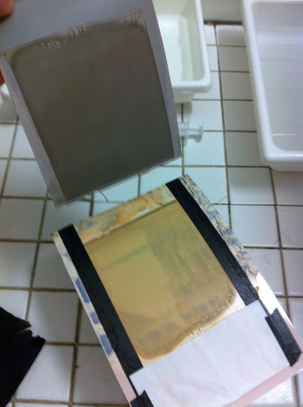](https://cdn.instructables.com/FYT/OHE3/HNKGH1M5/FYTOHE3HNKGH1M5.LARGE.jpg?auto=webp&frame=1&width=1024&height=1024&fit=bounds)

[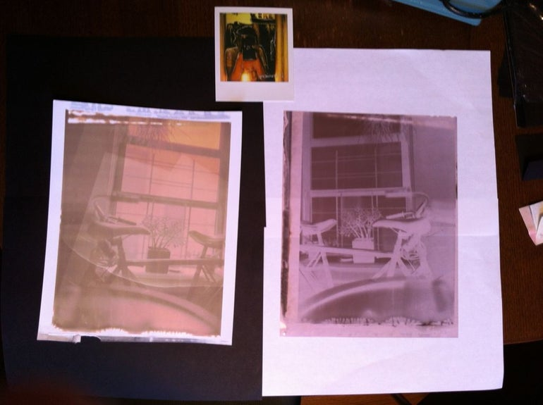](https://cdn.instructables.com/FL9/U6RG/HNKGH1ST/FL9U6RGHNKGH1ST.LARGE.jpg?auto=webp&frame=1&width=1024&height=1024&fit=bounds)

After following the New55 project closely i decided to give it a try on making instant film positive & negative at home.  
  
Need  
Ilford 4X5 film FP4  
ilford RC paper  
kodak HC 110  
ilford rapid fixer  
ammonia  
methylcellulose   
freezer paper   
heat sealer  
black paper  
electric tape

**Teacher Notes**

Teachers! Did you use this instructable in your classroom?  
Add a Teacher Note to share how you incorporated it into your lesson.

**Step 1: Reagent & Pods**

[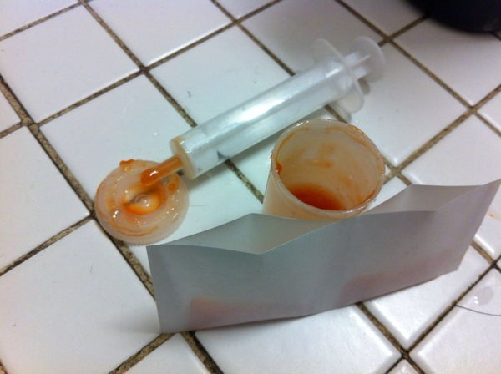](https://cdn.instructables.com/FZO/FY4U/HNKGH1LS/FZOFY4UHNKGH1LS.LARGE.jpg?auto=webp&frame=1&width=1024&height=1024&fit=bounds)

[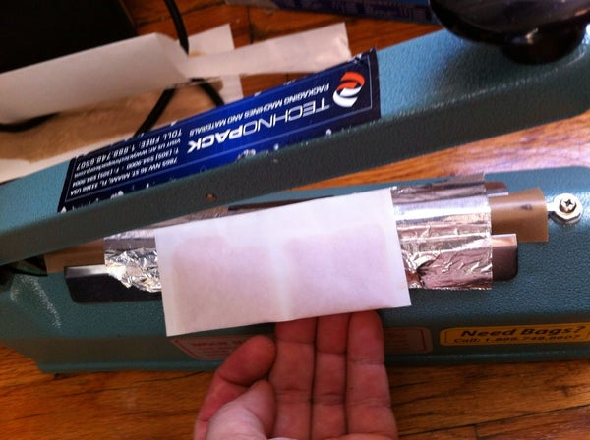](https://cdn.instructables.com/FQJ/93E8/HNKGH1LU/FQJ93E8HNKGH1LU.LARGE.jpg?auto=webp&frame=1&width=1024&height=1024&fit=bounds)

instant film at home  
  
be careful wear gloves and glasses !  
  
  
R 3.4   
  
hc110 5ml,   
  
ammonia 12ml,   
  
rapid fixer 3ml,   
  
water14ml (use a syringe) methylcellulose to make a gelly reagent but not thick ! its easier to mix if the solution is cold, its the tricky part !  
  
for a 4X5 2ml of reagent is way enough, i used a heat sealer and some freezer / butcher paper to make the pod fold with the plastic coating to the inside

**Step 2: Take a Picture Using a Regular 4X5 Back**

[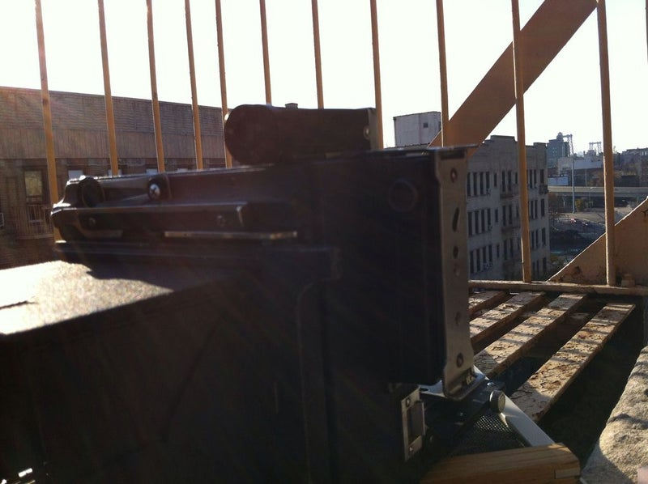](https://cdn.instructables.com/F00/EA6Y/HNKGH1MG/F00EA6YHNKGH1MG.LARGE.jpg?auto=webp&frame=1&width=1024&height=1024&fit=bounds)

[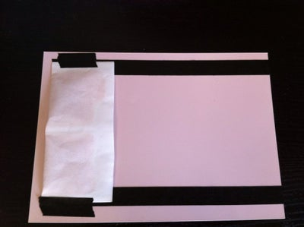](https://cdn.instructables.com/FBN/29ZF/HNKGH1LV/FBN29ZFHNKGH1LV.LARGE.jpg?auto=webp&frame=1&width=1024&height=1024&fit=bounds)

[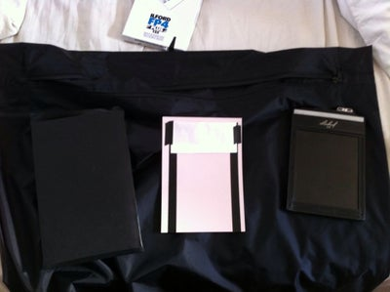](https://cdn.instructables.com/FF4/6ZLD/HNKGH1LW/FF46ZLDHNKGH1LW.LARGE.jpg?auto=webp&frame=1&width=1024&height=1024&fit=bounds)

6 More Images

film exposed ( i'm using an some ilford FP4 ), then assembled the film, the paper ( i used ilford RC fixed as a receiver ) and the pod in the dark, in a black paper sleeve taped to be light proof . process  through rollers and wait 8min !

**Step 3: Peel It**

[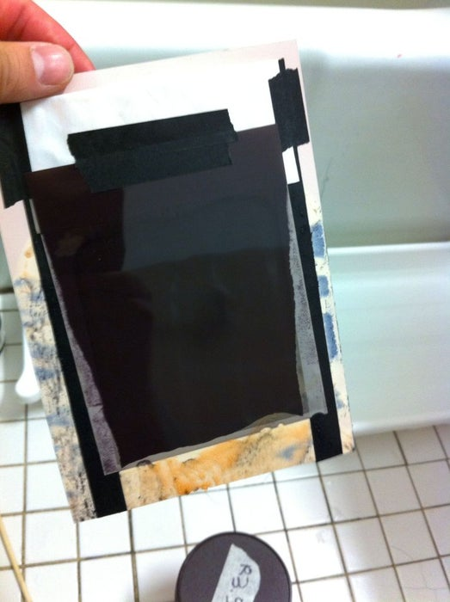](https://cdn.instructables.com/FPK/BZQK/HNKGH1M4/FPKBZQKHNKGH1M4.LARGE.jpg?auto=webp&frame=1&width=1024&height=1024&fit=bounds)

[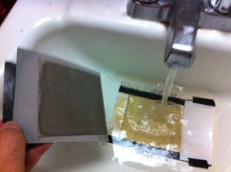](https://cdn.instructables.com/F79/O9AO/HNKGH1M7/F79O9AOHNKGH1M7.LARGE.jpg?auto=webp&frame=1&width=1024&height=1024&fit=bounds)

[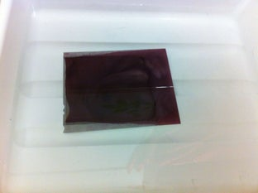](https://cdn.instructables.com/FCC/XDWN/HNKGH1M8/FCCXDWNHNKGH1M8.LARGE.jpg?auto=webp&frame=1&width=1024&height=1024&fit=bounds)

[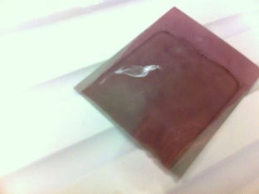](https://cdn.instructables.com/FAP/IP57/HNKGH1M9/FAPIP57HNKGH1M9.LARGE.jpg?auto=webp&frame=1&width=1024&height=1024&fit=bounds)

3 More Images

open and peel the film , clean the receiver with clear water , and negative with some ilford rapid fixer .  
  
done