Project title: Authorship Mimicry Using Generative AI: Investigating Their Potential
Synopsis: The rapid development of generative artificial intelligence (AI) has significantly lowered the barrier for cybercriminals to create convincing texts that mimic the writing style of trusted individuals. With affordable, easy-to-use natural language generation tools like ChatGPT and the vast availability of personal text data online, the mass production of deceptive messages through identity impersonation has become increasingly straightforward. As a result, the potential for cybercrime has expanded considerably. To the best of our knowledge, no studies have specifically investigated the ability of generative AI to learn and mimic individuals’ writing styles (cf. de Boer et al. 2023). Perhaps the most closely related task is the detection of AI-generated texts vs. human-written texts; many studies report high classification accuracy in distinguishing them (Desaire et al. 2023; Islam et al. 2023; Liao et al. 2023; Zaitsu et al. 2024), even though humans struggle to do so (Casal and Kessler 2023; Gao et al. 2023). This study aims to evaluate the ability of generative AI models to learn and replicate the writing styles of different individuals, using various large language models (LLMs) for analysis. If time permits, we will explore the most effective approaches for training AI models to achieve optimal authorship imitation, including fine-tuning, prompt engineering, and expanding the training dataset.
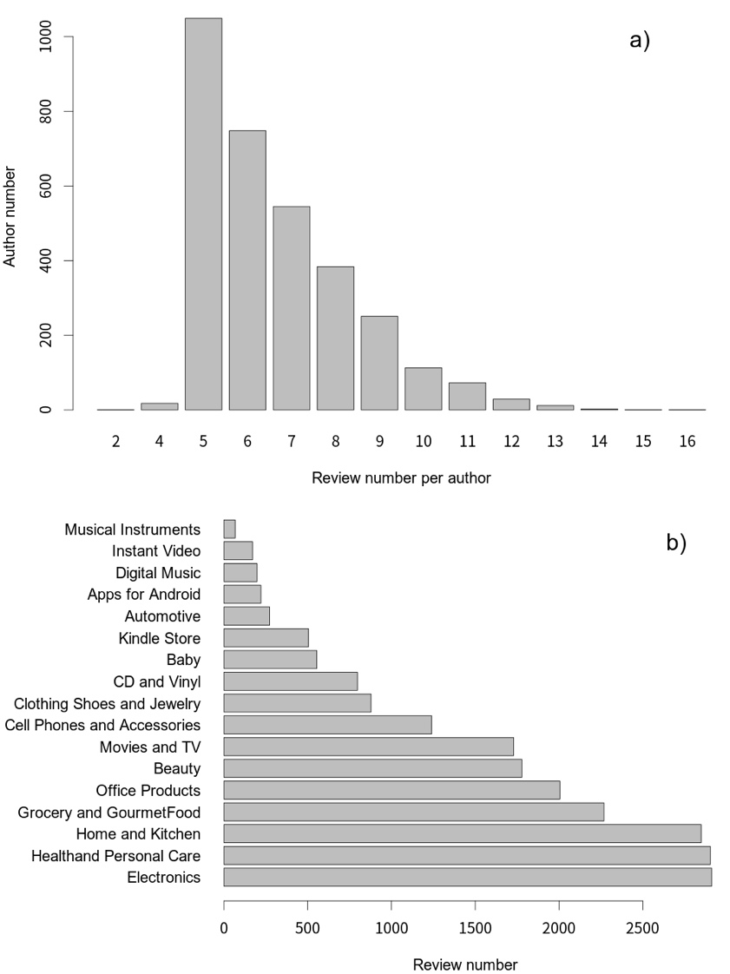
Figure 1: a) Number of reviews contributed by authors, and (b) the 17 review topics along with their respective review counts.
For this purpose, the Amazon Authorship Verification Corpus (AAVC) (Halvani et al. 2017) served as the foundation for selecting the authors and their texts used in the current study. The AAVC corpus comprises reviews of Amazon products, which are classified into 17 product categories, contributed by 3,227 reviewers (or authors), totalling 21,347 reviews. See Figure 1. The reviewers contributed varying numbers of reviews to this corpus. All reviews are standardised to 4 kB, which is approximately 700-800 words in length.
Tasks:
- Familiarise yourself with the corpus and identify which generative AI models to use for the study (1 week).
- Prepare the necessary code for API processes to generate texts (1 week).
- Analyse human-written and machine-generated texts (3 weeks).
- Optimise models for authorship imitation (3 weeks).
- Prepare the report and present outcomes (1 week).
References
Casal, J. E. and Kessler, M. (2023) Can linguists distinguish between ChatGPT/AI and human writing?: A study of research ethics and academic publishing. Research Methods in Applied Linguistics 2(3): 100068. https://doi.org/10.1016/j.rmal.2023.100068
de Boer, M., van der Houwen, F. and Blackwell, S. (2023) Disguise and imitation of language style in WhatsApp messages. Language and Law/Linguagem e Direito 10(1): 1-18. https://doi.org/10.21747/21833745/lanlaw/10_1/a1
Desaire, H., Chua, A. E., Isom, M., Jarosova, R. and Hua, D. (2023) Distinguishing academic science writing from humans or ChatGPT with over 99% accuracy using off-the-shelf machine learning tools. Cell Reports Physical Science 4(6): 101426. https://doi.org/10.1016/j.xcrp.2023.101426
Gao, C. A., Howard, F. M., Markov, N. S., Dyer, E. C., Ramesh, S., Luo, Y. and Pearson, A. T. (2023) Comparing scientific abstracts generated by ChatGPT to real abstracts with detectors and blinded human reviewers. NPJ Digital Medicine 6(1): 75. https://doi.org/10.1038/s41746-023-00819-6
Halvani, O., Winter, C. and Graner, L. (2017) Authorship verification based on compression-models. ArXiv:1706.00516 https://doi.org/10.48550/arXiv.1706.00516
Islam, N., Sutradhar, D., Noor, H., Raya, J. T., Maisha, M. T. and Farid, D. M. (2023) Distinguishing human generated text from ChatGPT generated text using machine learning. arXiv preprint arXiv:2306.01761 https://doi.org/10.48550/arXiv.2306.01761
Liao, W., Liu, Z., Dai, H., Xu, S., Wu, Z., Zhang, Y., … Liu, T. (2023) Differentiate ChatGPT-generated and human-written medical texts. arXiv preprint arXiv:2304.11567 https://doi.org/10.48550/arXiv.2304.11567
Zaitsu, W., Jin, M., Ishihara, S., Tsuge, S. and Inaba, M. (2024) Can we spot fake public comments generated by ChatGPT(-3.5, -4)?: Japanese stylometric analysis expose emulation created by one-shot learning. PLoS One 19(3): e0299031. https://dx.doi.org/10.1371/journal.pone.0299031

