Account Basics
Task:
- Create an IAM user for personal user.
- Setup MFA for the root user, turn off all root user API keys.
- Setup billing alerts for anything over a few dollars.
- Configure Azure CLI for your user API credentials.

We first create a new tenant within Azure Active Directory, we call this tenant Cotiss (a tenant represents an organization). From here we create a new IAM user called “Admin” with the original password (Hupa5797) .

We then setup a MFA for the root user. This helps to protect all instances that the account profile has access to. We do this within the Conditional Access | Policies settings within the Azure Active Directory. We set it up so the user must be in New Zealand aswell as using the Mobile authenticator.

To ensure we don’t exceed the project budget we setup cost alerts within the “Cost Managment + Billing | Cost Management” section. We set a limit of $8 .

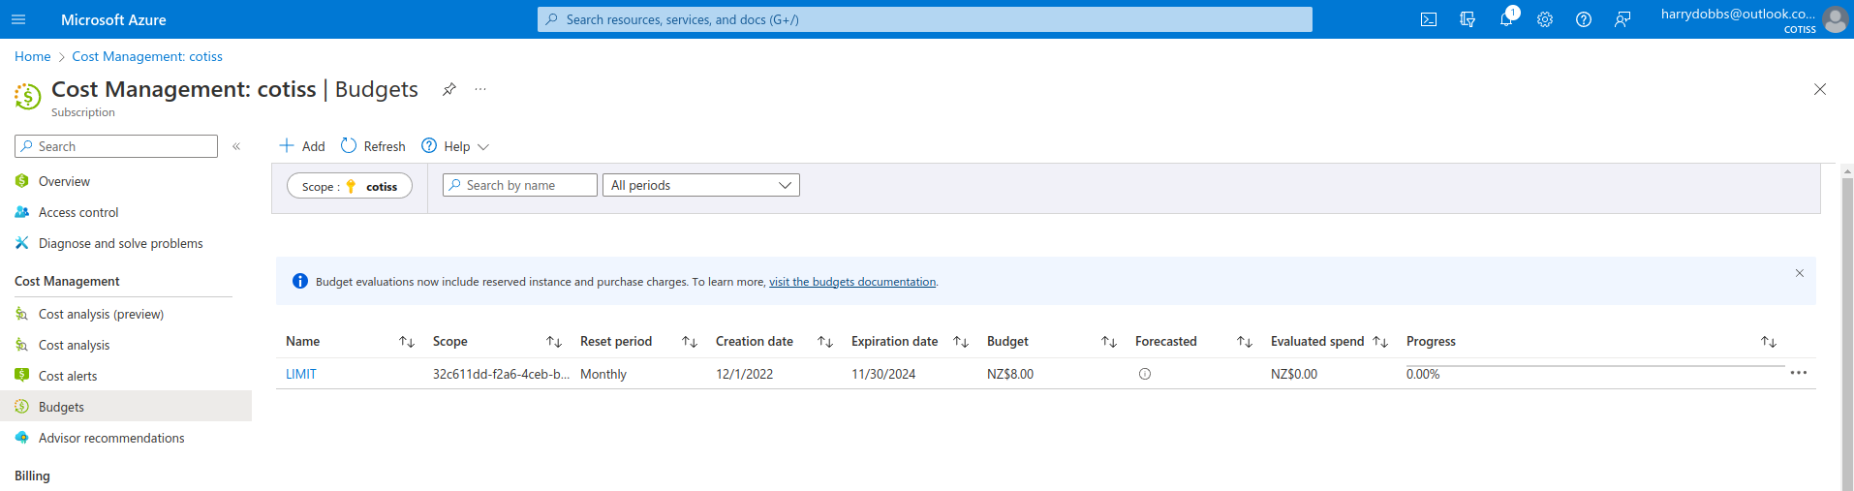

Webhosting Basics
Task:
- Deploy a Virtual Machine (VM) and host a simple static “Honest-Feedback Coming Soon” web page.
- Take a snapshot of your VM, delete the VM, and deploy a new one from the snapshot (i.e enable disaster recovery)

First we make a storage account which will hold all the data for the website. We then setup the webserver virtual machine and allow access via SSH and HTTP. We SSH into the machine and update it, install apache2 and then modify the /var/www/html/index.html page to display “Honest-Feedback Coming Soon...” .

