HeartGuard Chapter 3 Design Diagrams
HEARTGUARD: Preventive Insights for Heart Failure Readmission Forecasting using Machine Learning
The following figures are prepared for Chapter 3: Analysis and Design. Each diagram uses a white background and a formal academic visual style suitable for insertion into the final BE Computer Engineering project report.
Place after Section 3.6: System Architecture Design
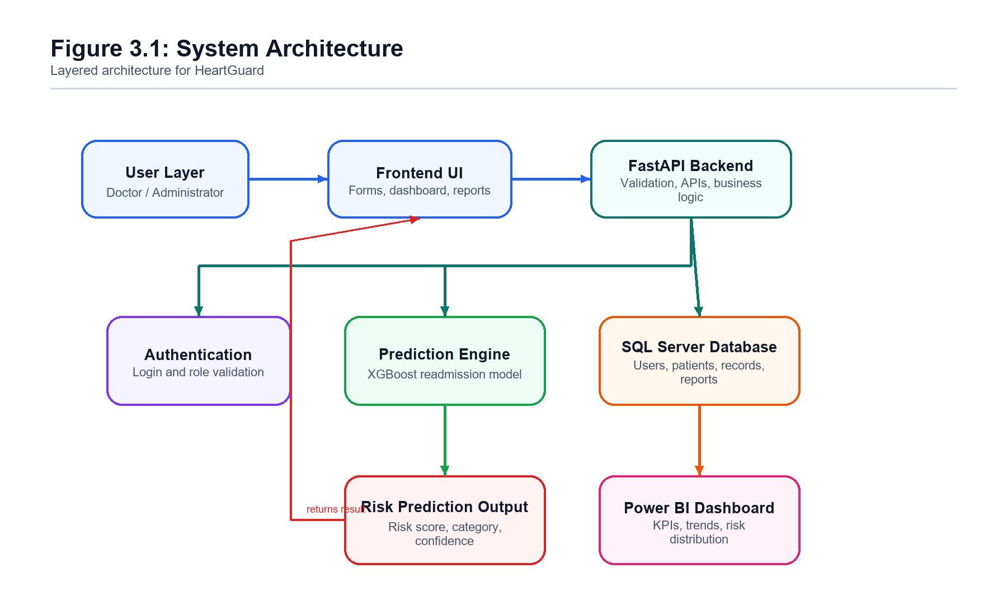
Figure 3.1: System Architecture of HeartGuard

Place after Section 3.7: Use Case Analysis
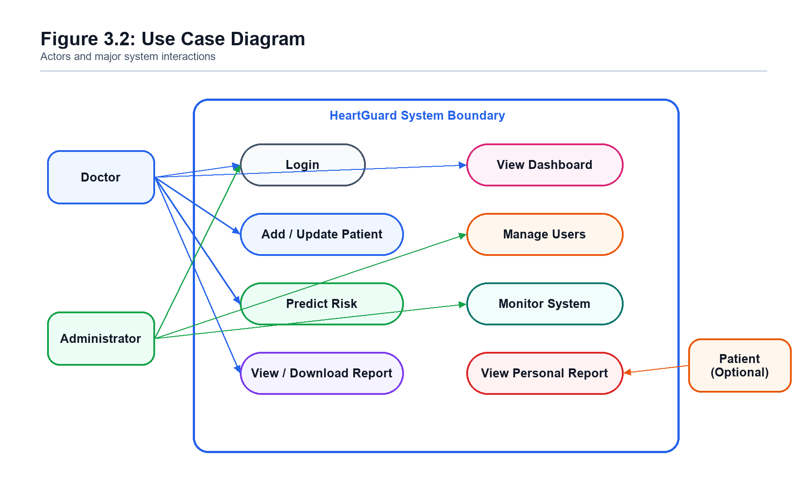
Figure 3.2: Use Case Diagram of HeartGuard

Place after Section 3.8: Data Flow Analysis
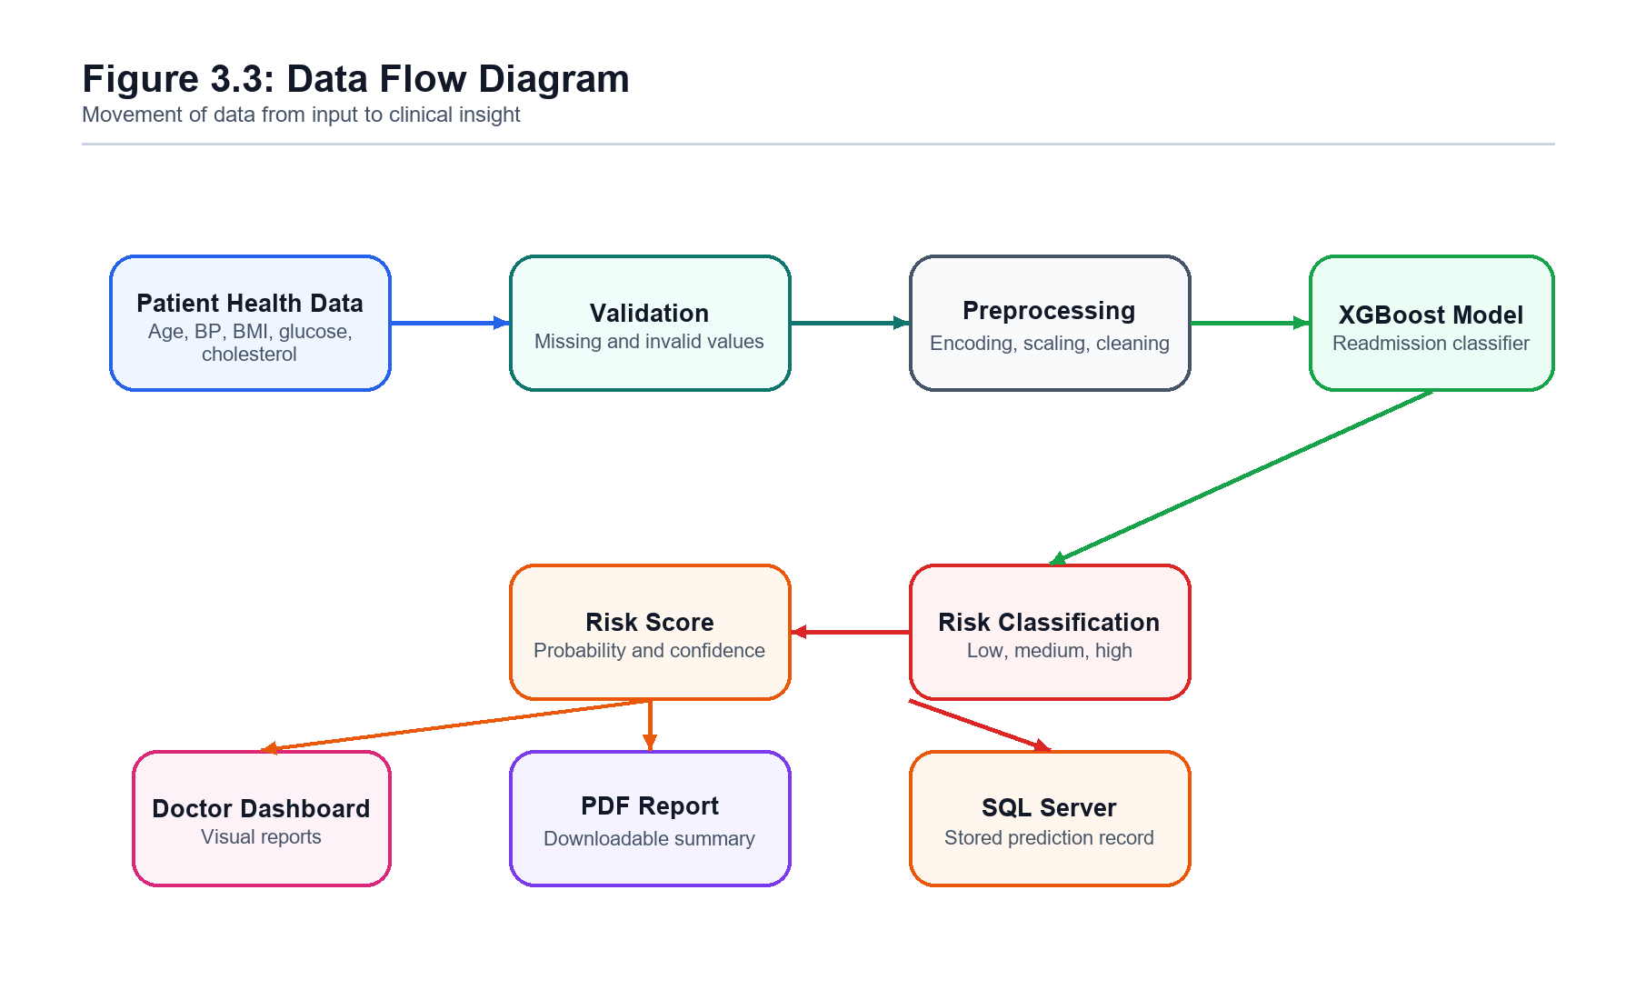
Figure 3.3: Data Flow Diagram of HeartGuard

Place after Section 3.9: Database Design
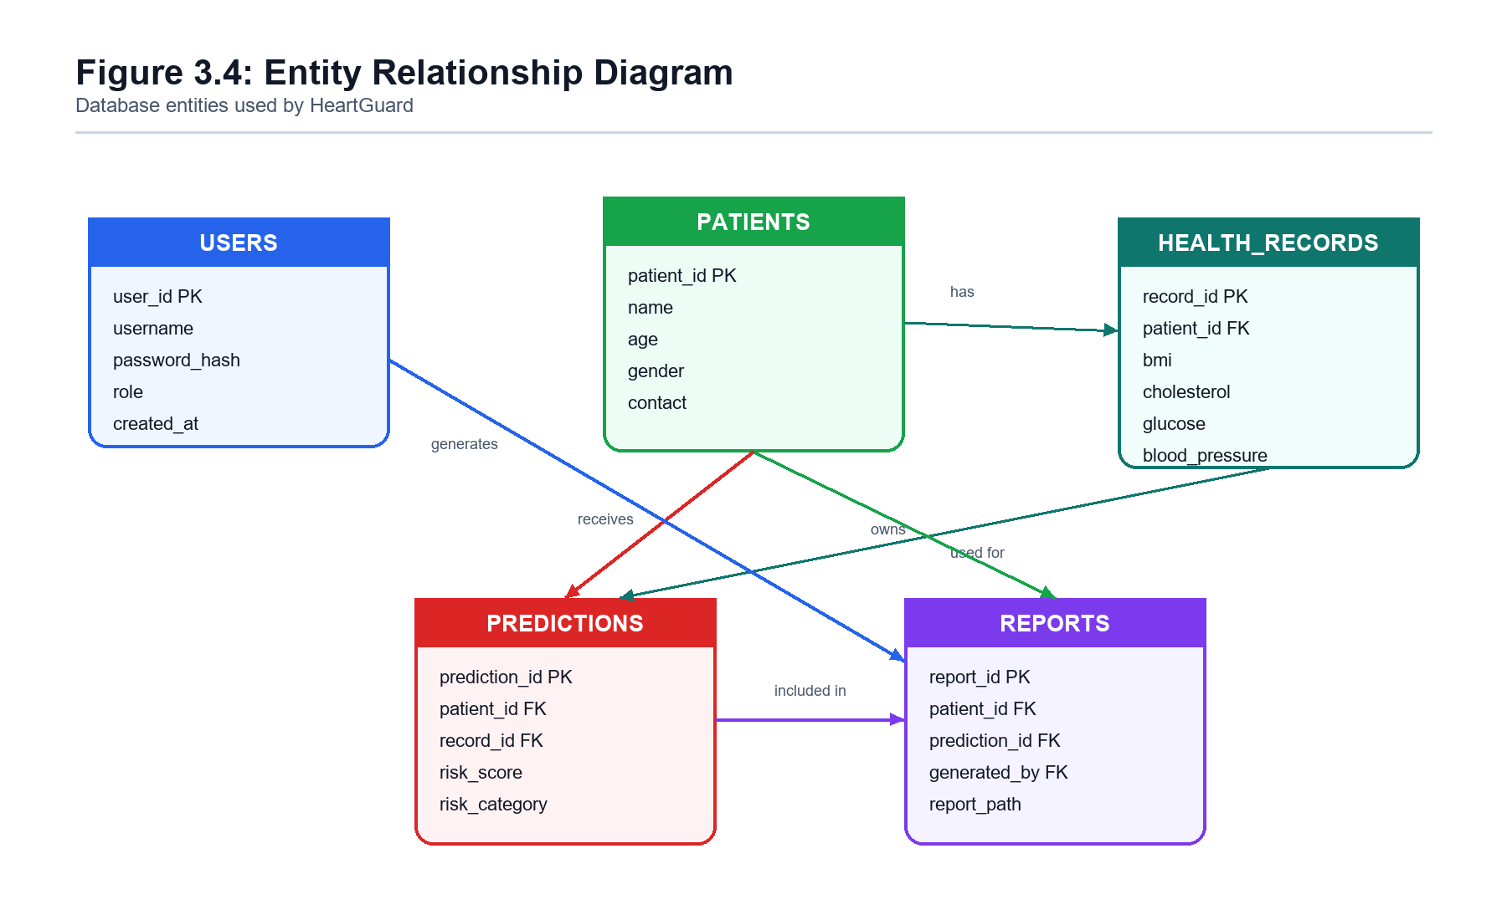
Figure 3.4: Entity Relationship Diagram of HeartGuard Database

Place after Section 3.10 or 3.11: Prediction Workflow
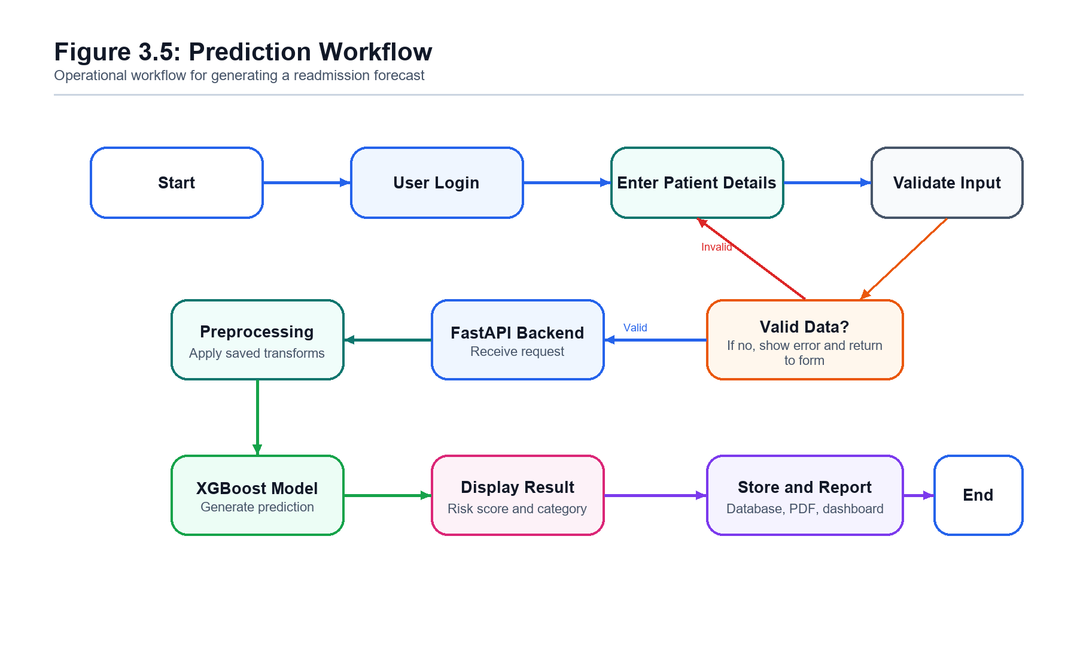
Figure 3.5: HeartGuard Prediction Workflow

