



Student Image

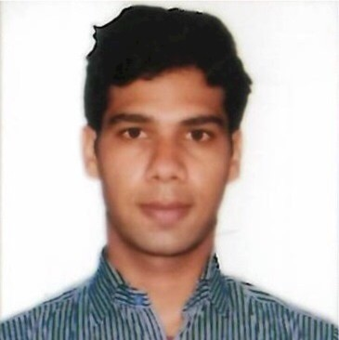

Candidate Code - CC03



Technical Proficiency

JavaScript, Java, Bootstrap, Apache Kafka, React.js, Node.js, Redux, Express.js, Python3, HTML + CSS, MongoDB, Docker, C++ Language, C Programming, Kubernetes, SQL

Subjects / Electives

Discrete Structures in Computer Science, Image Processing, Data Structures and Algorithms, C Programming, Information Retrieval, Design and Analysis of Algorithms, Database Systems, Compiler Construction, Computer Architecture, Computer Networks, Object Oriented Programming, Operating Systems, Theory of computation, Linear Algebra, Artificial Intelligence, Logic In Computer Science, Probability and Statistics

|  |  |
| --- | --- |
| SUMMER INTERNSHIP / WORK EXPERIENCE |  |
| Technical Undergraduate Intern, Cisco Systems India Pvt. Ltd. Jun 2022 - Present Working on apache flink and stateful data stream processing  Full Stack Web Development Intern, Prodapt Solutions Pvt Ltd Jun 2021 - Jul 2021 Implemented user authentication microservice using MERN stack. | |



Designed various data structures required for implementing different stages and modules of compiler which includes Lexer, Parser, Abstract Syntax Tree, Semantic analyzer.

ProShop (E-commerce Website) - React.js and Express.js Jul 2021 - Aug 2021 Self-Learnt and implemented an ecommerce website using MERN stack.

Feb 2022 - Apr 2022

Compiler Project - C programming

Implemented a C like compiler for a toy language as a part of compiler construction course

PROJECTS



Jul 2021 - Present

Grub Co-Ordinator - Andhra Samithi

POSITION OF RESPONSIBILITY

|  |  |
| --- | --- |
| EXTRA CURRICULAR ACTIVITIES |  |
| **Marketing Head for Cultural fest at College Level**  **Won Inter-School Basketball Competition** | |

|  |  |  |  |
| --- | --- | --- | --- |
| CERTIFICATIONS |  | | |
| CERTIFICATION | | CERTIFYING AUTHORITY | DESCRIPTION |
| Python Data Structures | | Coursera |  |
| Getting Started with Python | | Coursera |  |