DR. B. R. AMBEDKAR NATIONAL INSTITUTE OFTECHNOLOGY,JALANDHAR

Department of Computer Science and Engineering

B.Tech Semester – 5th

Session: July-Dec 2023

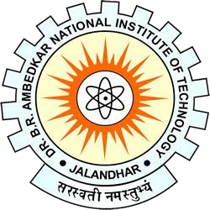

Web Technology Lab

CSPC-355

**Submittedto: Submittedby:**

**Mr. Avishek Sinha Jitendra Lohani(21103068)**

**CSE(A3)**