Embedded Operating System HW04 <A111193>
Screenshot of your source code
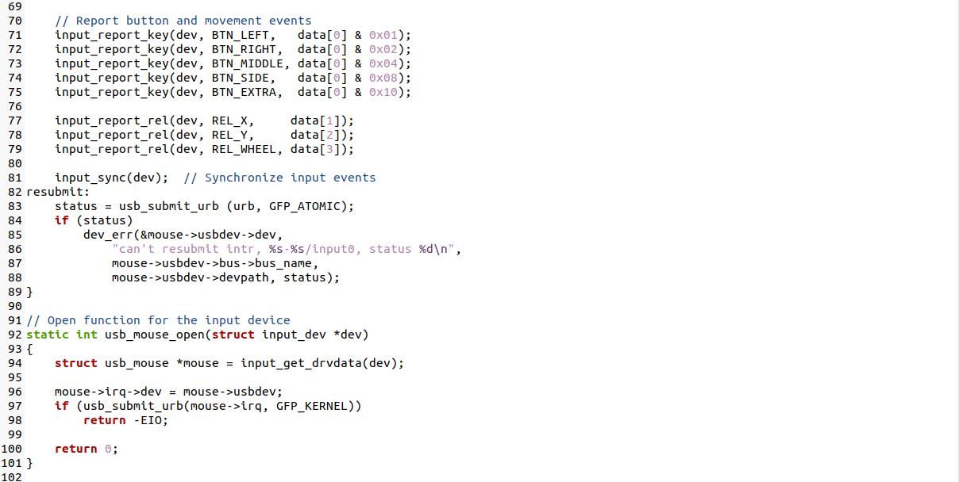
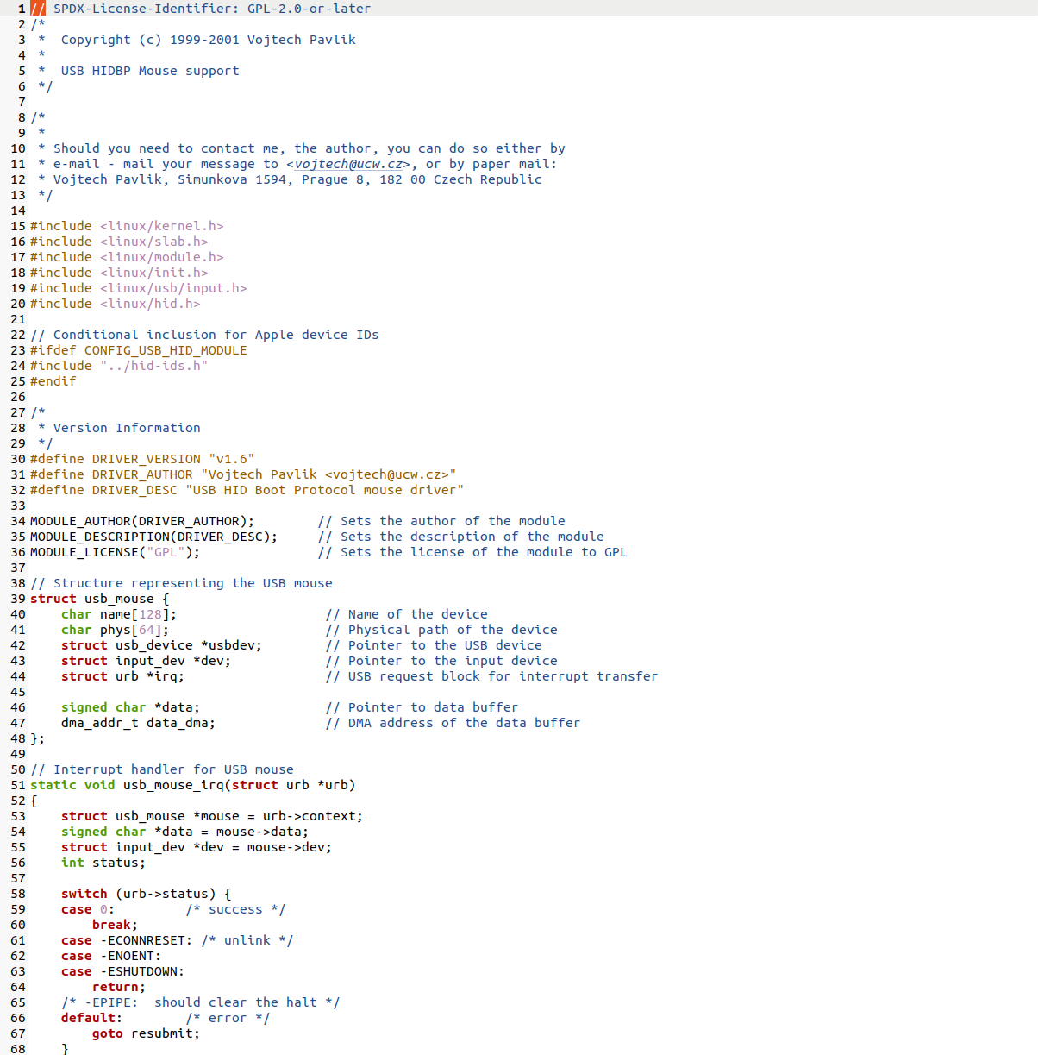
- The original USB HID driver with all your comments.

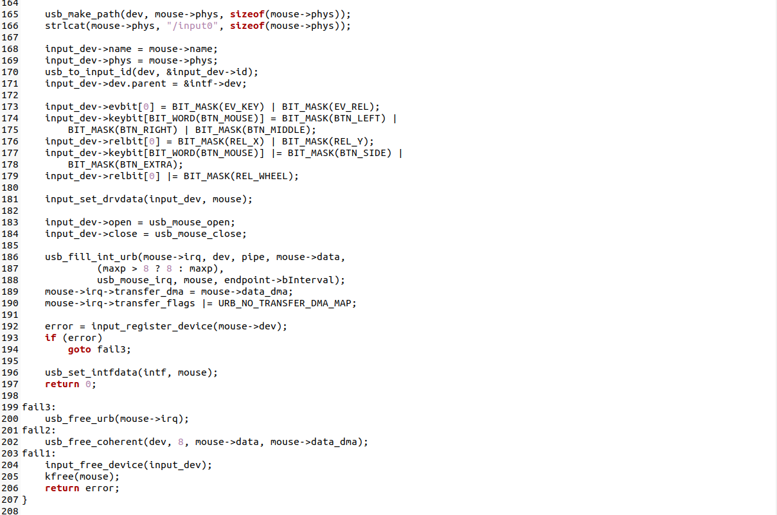
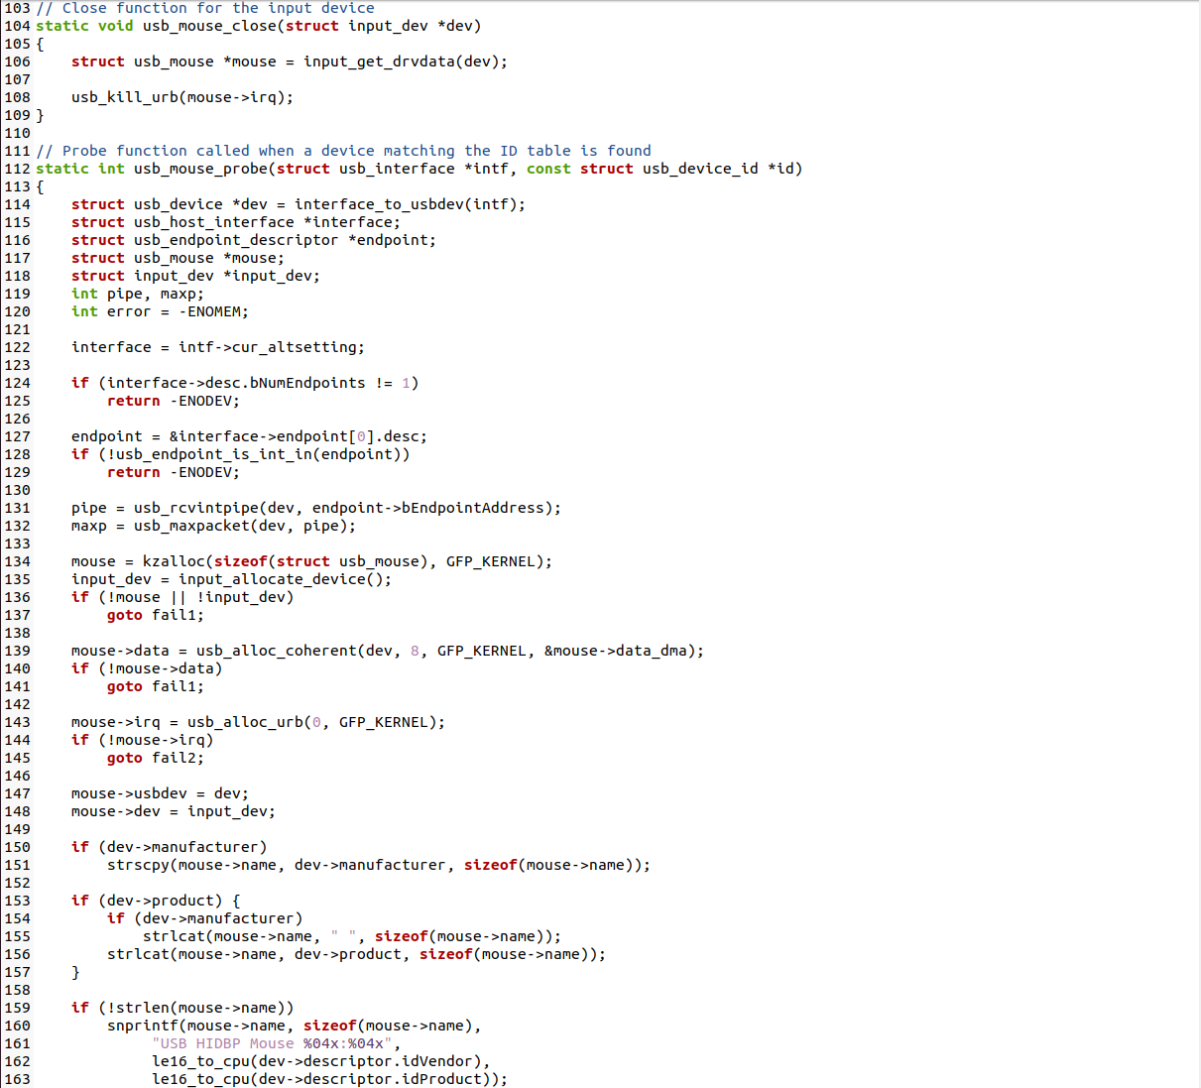
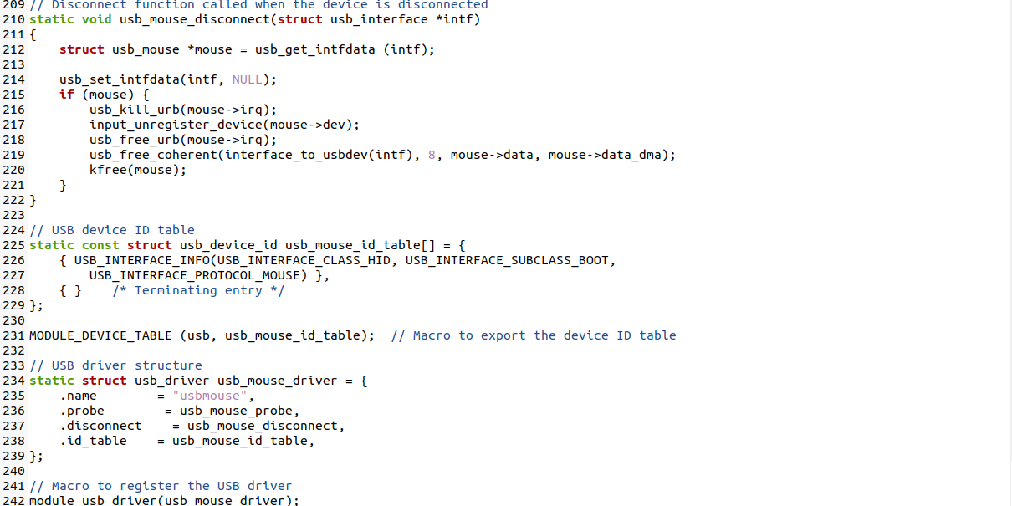
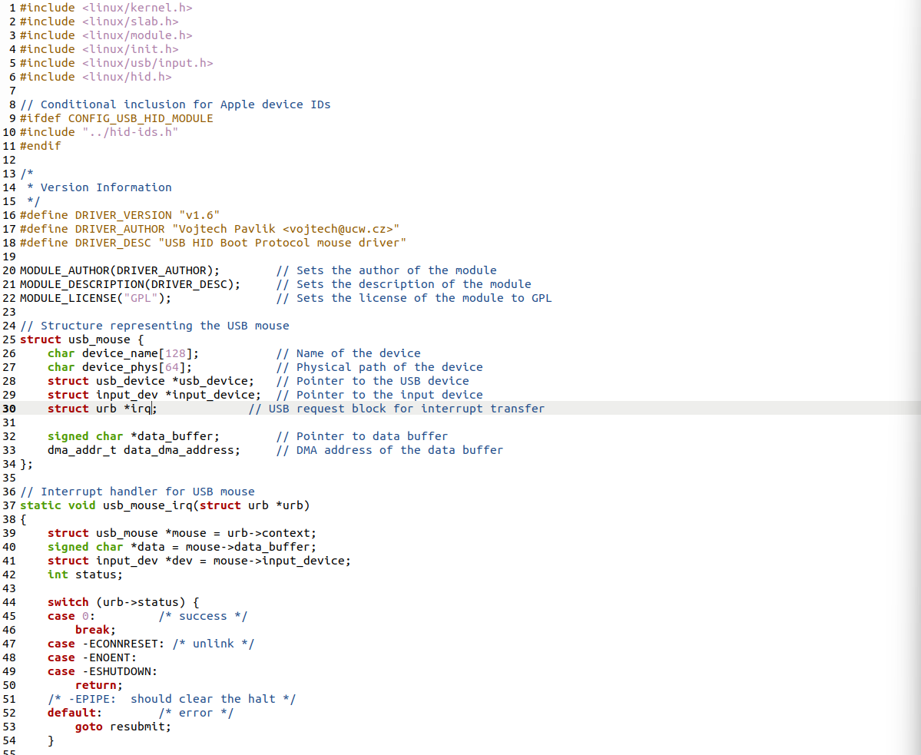
- Your USB HID driver wrote with comments

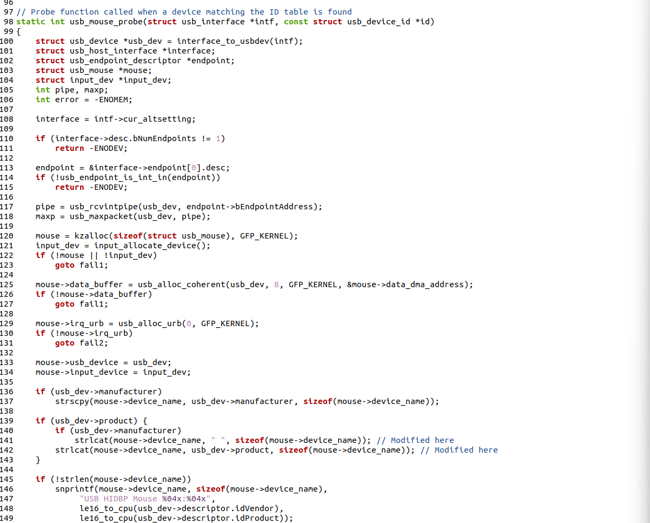
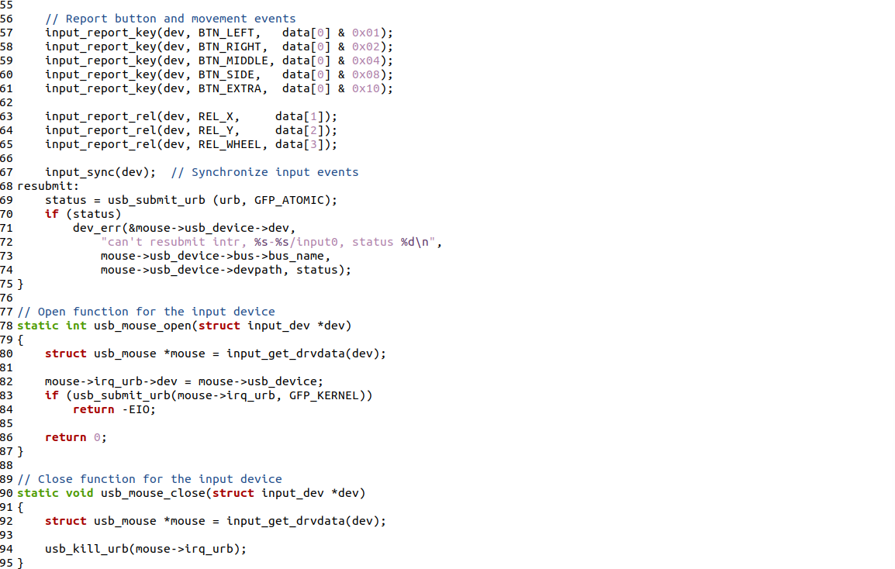

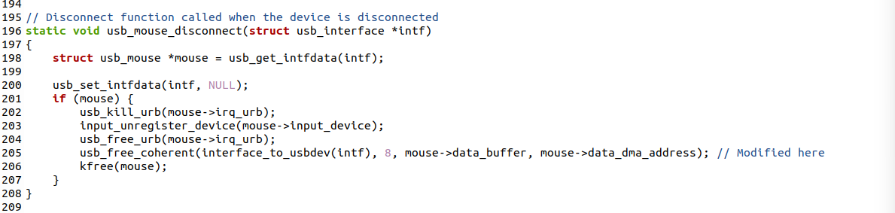
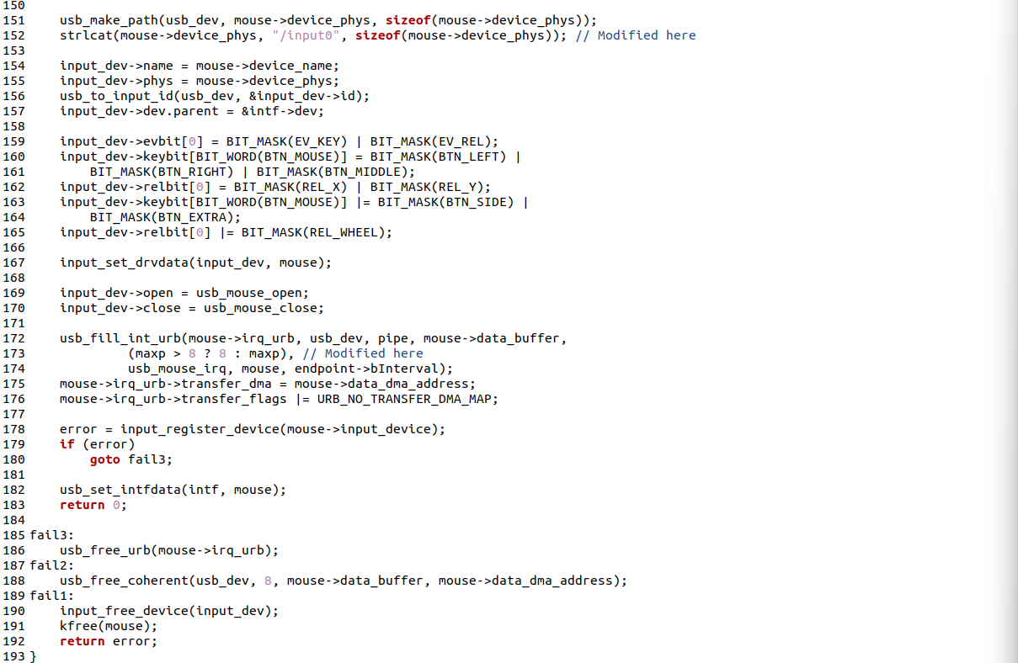
Screenshot of USB & mouse information
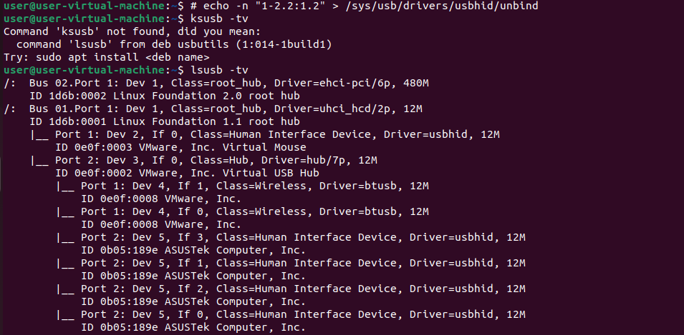
- Your second mouse information before unbind original driver (lsusb -tv)
- Your second mouse usbid (dmesg)
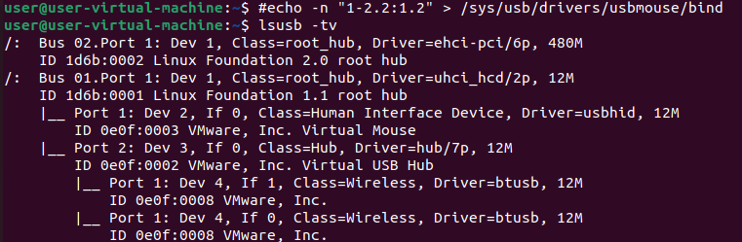
- Your second mouse information after bind on your own driver (lsusb -tv)

Screenshot of left click log messages
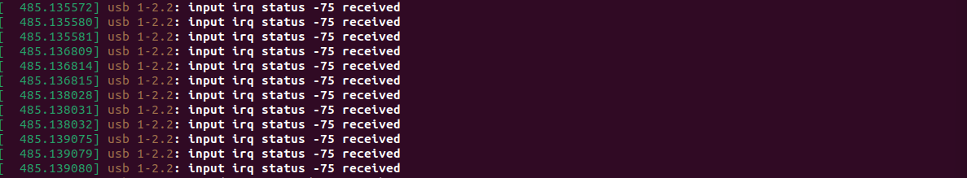
- Left click your mouse 10 times, show your left click printk result (dmesg)

