Q1: 1,2,3,4,7

Q2:

E[X] = (0.8×0.01) + (0.2×−0.1)

= 0.008 – 0.02

= -0.012

= -1.2%

No invest

If fixed, assume p is he probability of the market going up

(p×0.01) + (1-p)×(−0.1) >= 0

0.01p – 0.1 + 0.1p >= 0

0.11p >= 0.1

P >= 0.909

P >= 90.9%

minimal probability of prices going up in order for you to invest rationally is 90.9%

Real life situation: The model doesn’t take risk and variance into consideration. In real life, investors might have ways to avoid or control the risk, makes it still investment worthy even the expected return is negative.

Q3:





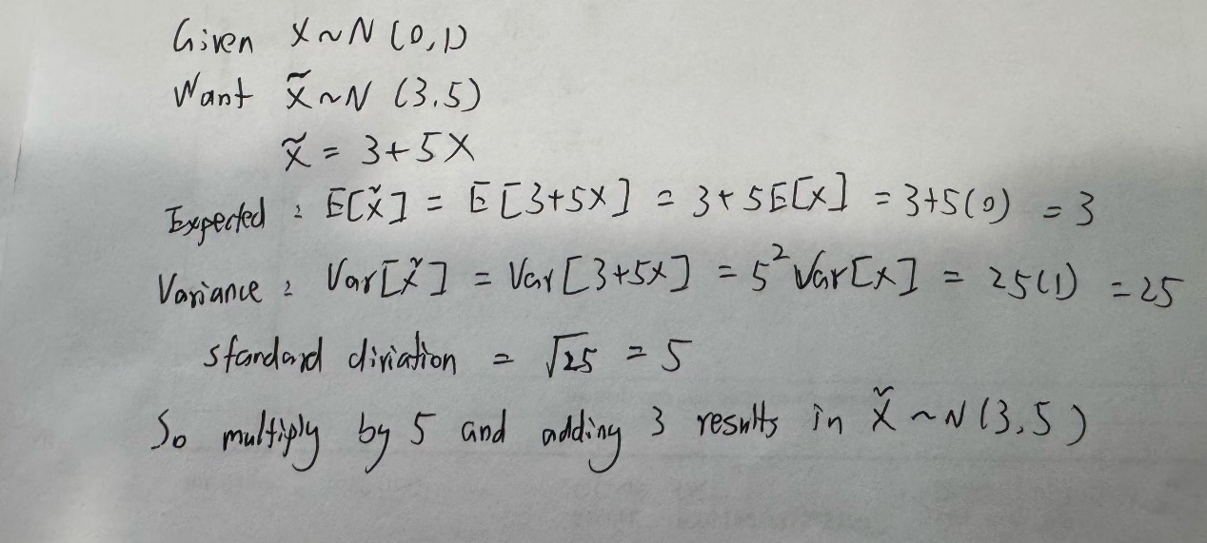

Q4:



Q6：

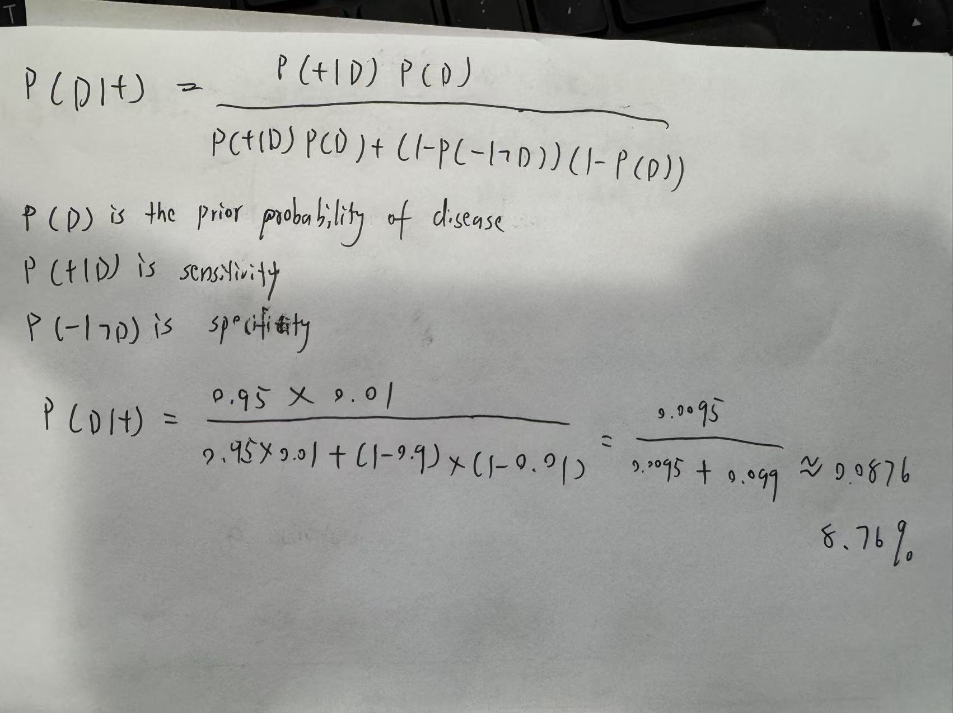

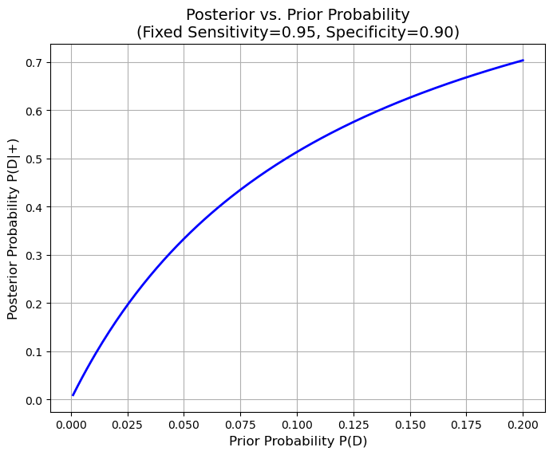

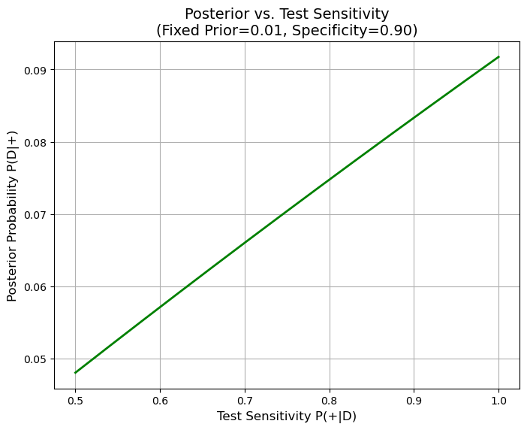

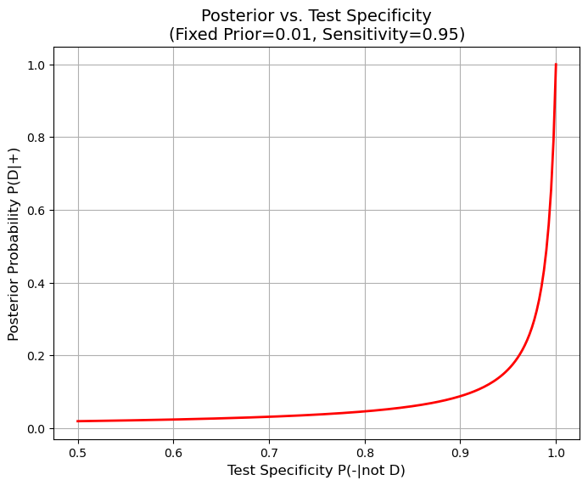

**Variation in Prior Probability:** When the disease prevalence increases, even modestly, the posterior probability rises nonlinearly. This means that in populations where the disease is more common, the same test result would be far more indicative of a true positive.

**Variation in Sensitivity:** With the prior fixed at a low level, improvements in sensitivity lead to an increase in the posterior probability. However, because the disease is rare, the gains from increasing sensitivity have a limited effect compared to changes in specificity.

**Variation in Specificity:** Improvements in specificity have a pronounced effect on the posterior probability. Since false positives dominate when the disease is rare, even a slight enhancement in specificity can significantly boost the reliability of a positive test result.