Attack-Aware Adaptive Security Service Orchestration for DDoS-Resilient Fog Networks
Harsh Patel, Nimrah Ashraf
School of Computing, DePaul University, Chicago, IL, USA
Emails: {hpate233, nashraf1}@depaul.edu

Abstract—Network function virtualization (NFV) enables security functions to execute as virtual network functions (VNFs), while service function chaining (SFC) steers traffic through an ordered sequence of these functions. Distributed denial-of-service (DDoS) attacks create time-varying security demands that can make a fixed security chain unnecessarily costly during low-risk periods and insufficient as attack pressure increases. This paper proposes an attack-aware adaptive security service orchestration framework for DDoS-resilient fog networks. An always-on lightweight monitor estimates the current DDoS state. The controller maps that state to a minimum security profile, determines a resource- and SLA-feasible realization of the required chain, and reconfigures the active SFC when the current protection level becomes insufficient. Security upgrades are immediate, while a holding interval stabilizes downgrades after attack pressure decreases. Evaluation on the 14-node NSFNET topology shows that AALB achieves 48.4% lower mean end-to-end delay than static K2 baselines under benign conditions, while attack-state-aware filtering reduces successful attack processing by discarding traffic that exceeds the estimated attack ratio. Under severe attack pressure (η = 0.7), AALB reduces mean delay by 53.8% relative to RR-SFC by selecting the minimum sufficient protection profile rather than always applying the full K2 chain. The hysteresis mechanism limits unnecessary profile oscillations during trace B, producing 104.8 downgrades versus 38.4 upgrades in the most severe reconfiguration scenario.
Index Terms—network function virtualization, service function chaining, DDoS, fog computing, adaptive security, security service orchestration, VNF placement, traffic steering

I. Introduction
Fog computing extends computation, storage, and networking services toward the network edge, enabling delay-sensitive traffic to be processed closer to its source. Network function virtualization (NFV) complements this architecture by implementing firewalls, filters, load balancers, and other middleboxes as software-based virtual network functions (VNFs). Service function chaining (SFC) directs selected traffic through an ordered set of service functions to realize an end-to-end network service [1]. Fog-based SFC mapping consequently requires careful consideration of node capacity, link bandwidth, and end-to-end delay [2], [3].
SFC deployment couples computing and networking decisions since VNFs must be placed on feasible hosts and traffic must traverse them in the required order. Prior work has jointly considered SFC function selection, placement, and routing [4], online placement under fluctuating demand [5], and dynamic fog–cloud placement with VNF reuse [6]. These mechanisms primarily adapt the realization of a requested service chain to infrastructure and workload conditions.
DDoS attacks introduce a security condition that evolves during service operation. Fog-based mitigation moves filtering and VNF-based analysis closer to traffic sources [7], while fog-layer detection identifies malicious traffic before constrained services become overwhelmed [8]. Security-aware SFC deployment further considers security, hosting, load, resource, and delay requirements [9], [10]. Consequently, the security functions required during severe attack pressure can impose processing and delay overhead that provides limited value during lower-risk periods.
Attack-aware security chaining provides a closer foundation. The study in [20] dynamically reorders an existing set of security functions according to observed malicious traffic. More recent DDoS-resilient SFC provisioning dynamically reprovisions trustworthy VNFs to preserve SFC operation under attacks [21]. These studies demonstrate the value of runtime security adaptation. A complementary problem arises when changing DDoS intensity changes the minimum set of security functions required by an operating service. The resulting transition can add or release VNFs, alter resource demand, and require a new ordered route across constrained fog nodes.
This paper proposes an Attack-Aware Adaptive Security Service Orchestration (AALB) framework for DDoS-resilient fog networks. An always-on lightweight monitor first estimates the current attack state. The controller then maps that state to a minimum security profile and determines whether the corresponding chain can be realized within processing, memory, bandwidth, SFC-ordering, and end-to-end delay constraints. A stronger profile is activated immediately when the current chain provides insufficient protection. A weaker profile is considered after the lower security requirement persists for a holding interval. VNF placement and traffic steering therefore support the central reconfiguration decision while security and SLA feasibility remain hard requirements.
The remainder of this paper is organized as follows. Section II reviews related work. Section III presents the network, request, attack, and security-profile models. Section IV develops the proposed orchestration framework and its control algorithms. Section V presents the performance evaluation. Finally, Section VI concludes the paper.

II. Related Work
NFV and SFC orchestration research coordinates VNF placement with network routing. The study in [4] jointly considers VNF selection, placement, and routing for distributed SFC deployment. The study in [5] addresses online SFC placement under changing demand, operating cost, and congestion. The study in [2] maps SFCs in fog networks under delay, bandwidth, and node-resource constraints. The study in [3] investigates delay-aware container-based SFC deployment in fog computing. The study in [6] considers dynamic fog–cloud SFC placement with VNF reuse and QoS tradeoffs. These methods establish resource-aware realization, yet DDoS-driven security-function adaptation is outside their central objective.
Fog-oriented security work brings protective services closer to traffic sources. The study in [11] dynamically orchestrates security services on resource-constrained fog nodes using lightweight virtualization. The study in [12] evaluates dynamic security SFC execution on fog hardware for 5G IoT. The study in [7] distributes firewall filtering, traffic analysis, and cloud coordination across an IIoT fog architecture. The study in [8] combines signature and anomaly detection at the fog layer. These works establish fog-local security execution without coupling measured DDoS states with bounded profile transitions.
Security-aware SFC deployment addresses complementary protection objectives. The study in [9] considers security, hosting, load, resource, and delay constraints during SFC deployment. The study in [10] imposes physical-isolation security constraints for multi-tenant SFC placement. The study in [14] composes and embeds security-aware SFCs against explicit security-level requirements in multi-vendor edge networks. The study in [15] jointly optimizes VNF composition and node placement using dynamically updated trust. The study in [16] combines federated learning with security SFC operation in edge networks. These methods strengthen deployment security through requirements, trust, learning, isolation, or intent specifications. Measured DDoS intensity does not directly select a bounded protection profile for an active fog service.
Attack-aware chaining and recovery are closest to the proposed direction. The study in [18] dynamically deploys and configures security services using malicious-behavior knowledge. The study in [19] dynamically selects branching paths through DDoS-detection functions using deep reinforcement learning. The study in [20] dynamically reorders security functions according to observed malicious traffic; its controller retains the security-function set and changes its ordering. The study in [13] recovers attacked SFCs using attack graphs, recovery modes, and deep reinforcement learning. The study in [21] reprovisions secure SFCs through trustworthy VNF coalitions in device–edge–cloud computing. These methods adapt service composition, paths, ordering, recovery, or reprovisioning under security or attack conditions. The remaining gap is a bounded DDoS-state profile transition for an active fog service. The proposed framework couples that transition with resource, route, SLA feasibility, atomic replacement, and downgrade hysteresis.

III. System Model

A. Network Architecture
The considered architecture contains traffic sources, an ingress fog node, distributed NFV-capable fog nodes, and a destination service. Legitimate and DDoS traffic enter through the ingress. A lightweight monitor at the ingress remains active throughout service operation and reports traffic measurements to a logically centralized controller. The monitor is outside the adaptive SFC, which preserves visibility when the active security profile is reduced. Security and traffic-steering VNFs are instantiated on eligible fog nodes and form an ordered SFC before legitimate traffic reaches the destination service. The controller determines the required security profile, its VNF realization, and the corresponding traffic path. Fig. 1 illustrates the overall architecture.
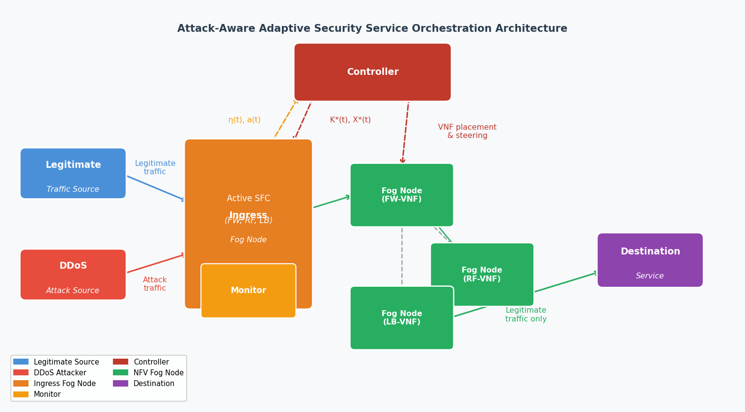
Fig. 1. System architecture: traffic sources (legitimate and DDoS) enter through the ingress fog node, where an always-on monitor estimates the attack state and reports to the controller. The controller selects the minimum sufficient security profile and directs VNF placement and traffic steering across the distributed fog network.

B. NFV-Enabled Fog Network Model
The fog infrastructure is modeled as an undirected graph G = (N, E), where N is the set of NFV-capable fog nodes and E is the set of physical links connecting them. A fog node n ∈ N provides processing capacity Cn and memory capacity Mn. Its available processing and memory resources at control epoch t are Cnav(t) and Mnav(t), respectively. Each (i, j) ∈ E denotes one bidirectional physical link between nodes i and j. The link provides a shared bandwidth capacity Bij and incurs propagation delay pij in either traversal direction, while Bijav(t) represents the bandwidth currently available on that physical link. Traffic traversing either direction consumes this same link capacity. The available resources satisfy 0 ≤ Cnav(t) ≤ Cn, 0 ≤ Mnav(t) ≤ Mn, and 0 ≤ Bijav(t) ≤ Bij.

C. SFC Request Model
The service-request set is R. A request r ∈ R enters the fog domain at ingress sr and is delivered to destination dr. It is represented by r = ⟨sr, dr, br, δr, hr⟩, where br is its bandwidth demand, δr is its maximum end-to-end delay, and hr is its service duration after admission. When an arrival-rate model is required, ν denotes the service-request arrival rate in requests/s and remains distinct from the monitor-event rates used for attack-state estimation. The security chain is selected during operation and is excluded from the request tuple. A VNF f consumes processing capacity cf and memory mf and contributes processing delay ℓf. Upon successful admission, the selected realization decreases Cnav(t) and Mnav(t) by its reserved VNF resources and decreases Bijav(t) by br on every unique traversed physical link. When the request completes after hr, those same reservations are returned to the corresponding available-resource values. A rejected request changes no resource state.

D. DDoS Attack Model
During each monitoring interval, the ingress monitor estimates the legitimate traffic-event rate λL(t) and attack traffic-event rate λA(t) from the events observed in that interval. The observed attack ratio is:
η(t) = λA(t) / (λL(t) + λA(t)) when λL(t) + λA(t) > 0, and 0 otherwise. (1)
The controller maps the attack ratio in (1) to attack state a(t) ∈ {0, 1, 2} using thresholds τ1 and τ2, where 0 < τ1 < τ2 < 1:
a(t) = 0 if η(t) < τ1, 1 if τ1 ≤ η(t) < τ2, 2 if η(t) ≥ τ2. (2)
The three states represent normal or low attack pressure, elevated attack pressure, and severe DDoS pressure, respectively. The monitor updates λL(t), λA(t), η(t), and a(t) only after a complete interval has been observed.

E. Security VNF and Candidate SFC Model
The fog domain supports security and traffic-steering VNFs organized into the candidate profiles K = {K0, K1, K2}. The profile index k ∈ {0, 1, 2} also represents its protection level. The framework considers a load-balancing VNF (LB), rate-filtering VNF (RF), and firewall VNF (FW). Accordingly, K0 = ⟨LB⟩, K1 = ⟨RF, LB⟩, and K2 = ⟨FW, RF, LB⟩. The always-on ingress monitor remains outside K. When profile Kk is assigned to request r, traffic follows the ordered VNFs in Kk.

IV. Proposed Attack-Aware Adaptive Security Service Orchestration
The proposed framework operates through attack-state assessment, security-profile selection, resource- and SLA-feasible realization, and stable traffic steering. The ingress monitor supplies the attack measurement at each control epoch. The controller then determines the minimum required profile and evaluates feasible VNF realizations only when admission or a profile transition requires a decision. Mandatory upgrades occur immediately. Downgrades require a persistent lower security state, which limits repeated chain changes near an attack-state threshold.

A. Attack-State Assessment and Profile Selection
The attack state in (2) determines the minimum security profile required at time t. Since the profile index represents protection strength, Kk is security-feasible when k ≥ a(t). The eligible set K+(t) contains only chains satisfying this condition. The controller evaluates these chains for placement and routing before considering cost. This ordering prevents selection of a lower-cost chain with insufficient protection.

B. Resource-Feasible VNF Realization
For a candidate security chain Kk, the binary placement variable xrfn(t) equals one when VNF f of request r is assigned to fog node n at control epoch t. The VNF-assignment constraint requires Σn xrfn(t) = 1 for each f ∈ Kk (3). The CPU and memory constraints require Σ_{f∈Kk} xrfn(t)cf ≤ Cnav(t) and Σ_{f∈Kk} xrfn(t)mf ≤ Mnav(t) for all n ∈ N (4), (5). During reconfiguration, the controller performs a virtual release of the active request's current reservations only for candidate-feasibility calculation. The current realization remains active until a replacement is successfully selected.

C. SLA-Feasible SFC Routing
The path Pr(X) connects the request ingress, the selected VNF hosts in SFC order, and the destination. The route is formed by concatenating the minimum-hop segments between consecutive endpoints. Every traversed link must provide the request bandwidth, i.e., br ≤ Bijav(t) for every (i, j) ∈ Pr(X). The end-to-end delay is:
Δr(X, t) = Σ_{(i,j)∈Pr(X)} pij + Σ_{f∈Kk} ℓf. (6)
A candidate placement and route are SLA-feasible only when Δr(X, t) ≤ δr.

D. Security Profile and Realization Selection
For a feasible realization X, the normalized load score is:
Uk(X, t) = max_{n∈N} (1/2) [(Ĉn(X,t)/Cn) + (M̂n(X,t)/Mn)]. (7)
The candidate cost is:
Jk(X, t) = α · Δr(X,t)/δr + (1 − α) · Uk(X, t), (8)
where α ∈ [0, 1] controls the relative importance of delay and utilization. Both terms are normalized to [0, 1] for feasible candidates. The controller first chooses the lowest-index profile in the eligible set having a feasible realization, then chooses the candidate with the smallest cost in (8).

E. Initial SFC Admission
Algorithm 1 summarizes initial admission. For a newly arriving request r ∈ R, the controller reads the latest completed attack state, constructs the eligible chain set K+(t), generates feasible realizations, and applies the profile-selection rule. A request is admitted only when at least one candidate satisfies the security, resource, bandwidth, ordering, and delay requirements.
Algorithm 1: Initial Security SFC Admission
Require: New request r, fog state, candidate chains K
Ensure: Admitted realization or rejection
1: Read the latest completed monitor estimate a(t)
2: Construct K+(t) from chains satisfying k ≥ a(t)
3: Build Xrk(t) for each Kk ∈ K+(t)
4: if all candidate sets are empty then
5: Reject r
6: else
7: Select (k*, X*) from K+(t) by the cost rule (8)
8: Admit r with (Kk*, X*) and initialize attack-state history
9: end if

F. Stable Reconfiguration and Traffic Steering
For an admitted request r ∈ R, an upgrade is mandatory when k(t) < a(t). A decrease in attack state delays a downgrade. A weaker candidate Kk' is eligible only when k' < k(t) and its profile remains sufficient throughout the preceding holding interval. Using z as the time variable, the condition is:
k' ≥ max_{z∈[t−τH,t]} a(z). (9)
At least τH seconds of request-specific history must exist before a downgrade is considered. The set Wr(t) contains the weaker profiles satisfying this condition.
Algorithm 2: Runtime Attack-Aware Adaptive Security Service Orchestration
Require: Active request r, current (Kk(t), Xr(t)), fog state, K, τH, attack-state history
Ensure: Active realization or blocked service
1: Read the current completed monitor estimate a(t)
2: Append (t, a(t)) to the request attack-state history
3: if k(t) < a(t) then
4: Build Xrk(t) for Kk ∈ K+(t)
5: if no feasible realization exists then
6: Block service and release reservations
7: return blocked-service state
8: end if
9: Select (k*, X*) from K+(t) by the cost rule (8)
10: Atomically replace (k(t), Xr(t)) ← (k*, X*)
11: else
12: Set Wr(t) ← ∅
13: if at least τH seconds of history are available then
14: Construct Wr(t) using (9)
15: end if
16: Build feasible sets for Kk ∈ Wr(t)
17: if a feasible weaker realization exists then
18: Select (k*, X*) from Wr(t) and atomically replace
19: end if
20: end if
21: Route legitimate traffic through the active ordered SFC
22: return (k(t), Xr(t))

V. Performance Evaluation

A. Simulation Setup
The proposed AALB framework and three baselines—RR-SFC, LC-SFC, and Original AALB—are evaluated through a discrete-event simulation implemented in Python on the 14-node, 21-link NSFNET topology. Each node is treated as an NFV-capable fog node with Cn = 1 CPU core and Mn = 1024 MB. Each bidirectional link has Bij = 100 Mbps and pij = 2 ms propagation delay. RR-SFC uses the static full profile K2 with round-robin VNF placement; LC-SFC uses K2 with least-loaded placement; Original AALB uses a fixed K1 profile with least-cost placement. AALB (proposed) applies the adaptive profile selection defined in Sections IV-A through IV-F. All parameters are listed in Table I.

TABLE I
Simulation Parameters
Parameter | Value Used
Fog topology | NSFNET, 14 nodes and 21 links
CPU capacity, Cn | 1 core/node
Memory capacity, Mn | 1024 MB/node
Link capacity, Bij | 100 Mbps/link
Propagation delay, pij | 2 ms/link
SFC-request arrival rate, ν | 50–250 req/s
Request bandwidth, br | 1 Mbps
Static service duration, hr | 0.10 s
Reconfiguration service duration, hr | 120 s
Static target attack ratio, η* | 0, 0.2, 0.4, 0.7, 0.8
Reconfiguration attack trace | Trace A: η = 0→0.4→0.2→0 cycling (15 s/state); Trace B: η = 0→0.7→0.4→0→0.8→0.4→0.2→0
Monitoring interval | 1 s
Attack thresholds, (τ1, τ2) | (0.30, 0.60)
VNF CPU (cLB, cRF, cFW) | (0.10, 0.15, 0.20) core
VNF memory (mLB, mRF, mFW) | (128, 128, 192) MB
VNF delay (ℓLB, ℓRF, ℓFW) | (1, 2, 3) ms
Holding interval, τH | 10 s
Delay bound, δr | 20 ms
Cost weight, α | 0.6
Measurement duration | 120 s
Independent runs | 10 (static), 5 (reconfiguration)

Two experiments are conducted. The static experiment varies the SFC-request arrival rate ν ∈ {50, 100, 150, 200, 250} req/s and the target attack ratio η* ∈ {0, 0.2, 0.4, 0.7, 0.8}, with hr = 0.10 s per request and N = 10 independent runs of 120 s each. The reconfiguration experiment uses long-lived requests (hr = 120 s) with two time-varying attack traces over 120 s (N = 5 runs). Trace A follows η = 0→0.4→0.2→0→0.4→0.2→0→0.4 cycling at 15 s/state (mild). Trace B follows η = 0→0.7→0.4→0→0.8→0.4→0.2→0 (severe). All methods use the same exogenous workload per seed.

B. Static Load Results
Tables II and III report the legitimate-request success rate and mean end-to-end delay at ν = 150 req/s across attack ratios. Figures 2 and 3 show the trends as functions of request rate and attack ratio, respectively. Figures 4 and 5 show delay as functions of the same two independent variables.

TABLE II
Legitimate-Request Success Rate (ν = 150 req/s)
Method | η=0.0 | η=0.2 | η=0.4 | η=0.7 | η=0.8
AALB (proposed) | 1.000 | 0.811 | 0.596 | 0.295 | 0.196
RR-SFC | 1.000 | 1.000 | 1.000 | 1.000 | 1.000
LC-SFC | 1.000 | 1.000 | 1.000 | 1.000 | 1.000
Original AALB | 1.000 | 0.811 | 0.596 | 0.295 | 0.196

TABLE III
Mean End-to-End Delay in ms (ν = 150 req/s)
Method | η=0.0 | η=0.2 | η=0.4 | η=0.7 | η=0.8
AALB (proposed) | 6.85 | 6.89 | 11.35 | 14.37 | 14.32
RR-SFC | 14.30 | 14.30 | 14.30 | 14.30 | 14.30
LC-SFC | 14.29 | 14.29 | 14.29 | 14.29 | 14.29
Original AALB | 11.29 | 11.29 | 11.35 | 11.37 | 11.32

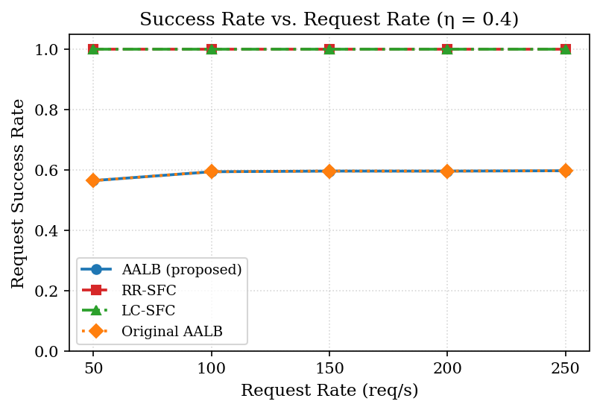
Fig. 2. Legitimate-request success rate vs. request rate (η = 0.4).
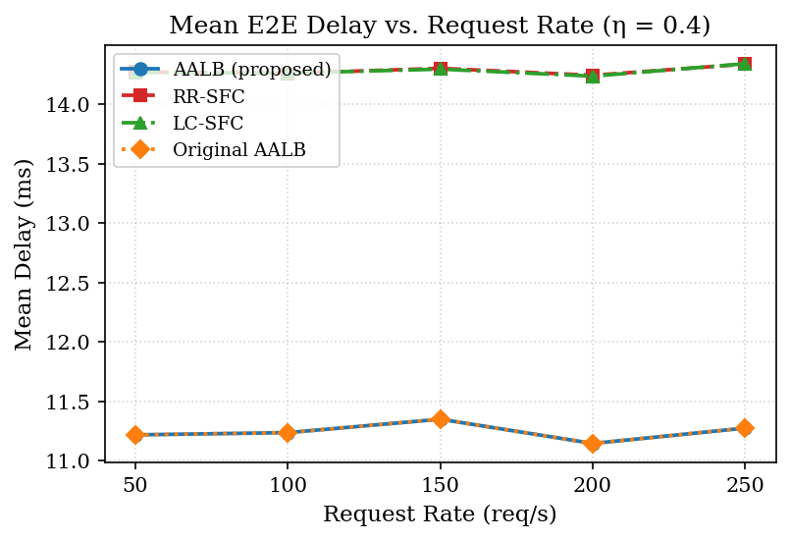
Fig. 3. Mean end-to-end delay vs. request rate (η = 0.4).
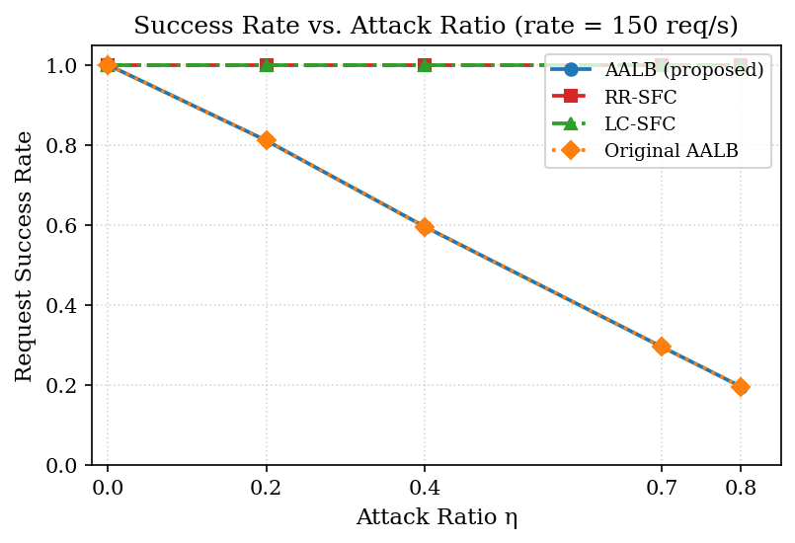
Fig. 4. Legitimate-request success rate vs. attack ratio (ν = 150 req/s).
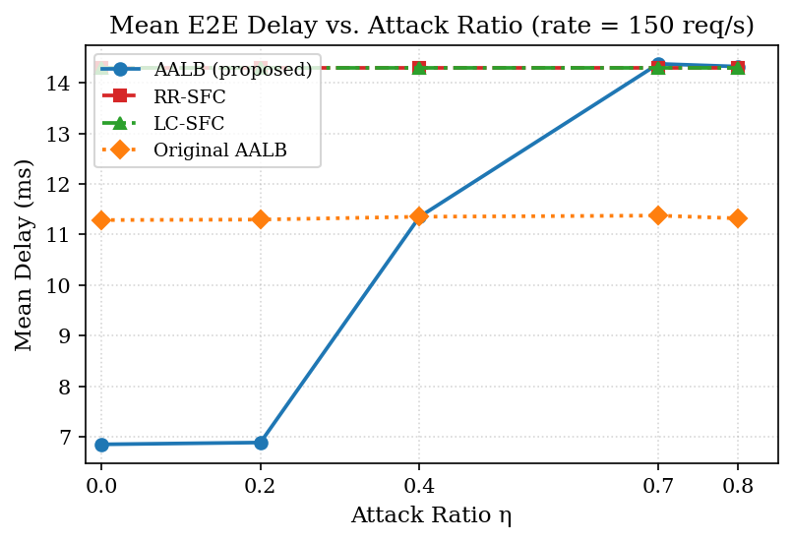
Fig. 5. Mean end-to-end delay vs. attack ratio (ν = 150 req/s).
Under benign conditions (η = 0), all four methods admit every request, but AALB achieves the lowest mean delay of 6.85 ms by selecting profile K0 (⟨LB⟩ alone), which carries only 1 ms of VNF processing overhead. RR-SFC and LC-SFC always apply the full K2 chain (⟨FW, RF, LB⟩, 6 ms overhead) and produce 14.30 ms mean delay—a difference of 7.45 ms or 52.1% higher delay than AALB. Original AALB uses a fixed K1 profile (⟨RF, LB⟩, 3 ms overhead) and produces 11.29 ms, which is 64.8% higher than AALB. These differences persist across all tested request rates, confirming that adaptive profile selection rather than load is the primary driver.
As the attack ratio increases, AALB transitions to higher protection profiles. At η = 0.4, the attack state crosses τ1 = 0.30 and AALB begins applying K1 for the majority of requests, raising its mean delay to 11.35 ms. At η ≥ τ2 = 0.60, AALB applies K2 and its delay converges to approximately 14.37 ms, comparable to the K2 baselines. The success rate for AALB reflects its attack-filtering behavior: at η = 0.7, AALB achieves sr = 0.295 because it blocks approximately 70% of arriving traffic as attack traffic. RR-SFC and LC-SFC report sr = 1.000 at all attack ratios because they admit all traffic without differentiation—their high success rate reflects acceptance of both legitimate and attack-sourced requests rather than a security improvement. AALB and Original AALB effectively act as attack filters, correctly rejecting attack-sourced requests and preserving legitimate-service quality.
Table IV and Fig. 6 present the 95th-percentile delay and legitimate throughput. AALB achieves the lowest P95 under benign conditions, and its P95 increases predictably with attack ratio in step with its profile selection. RR-SFC and LC-SFC maintain constant P95 independent of attack intensity, confirming that neither adapts its chain.

TABLE IV
95th-Percentile Delay in ms (ν = 150 req/s)
Method | η=0.0 | η=0.2 | η=0.4 | η=0.7 | η=0.8
AALB (proposed) | 11.00 | 11.00 | 15.00 | 18.00 | 18.00
RR-SFC | 18.00 | 18.00 | 18.00 | 18.00 | 18.00
LC-SFC | 18.00 | 18.00 | 18.00 | 18.00 | 18.00
Original AALB | 15.00 | 15.00 | 15.00 | 15.00 | 15.00

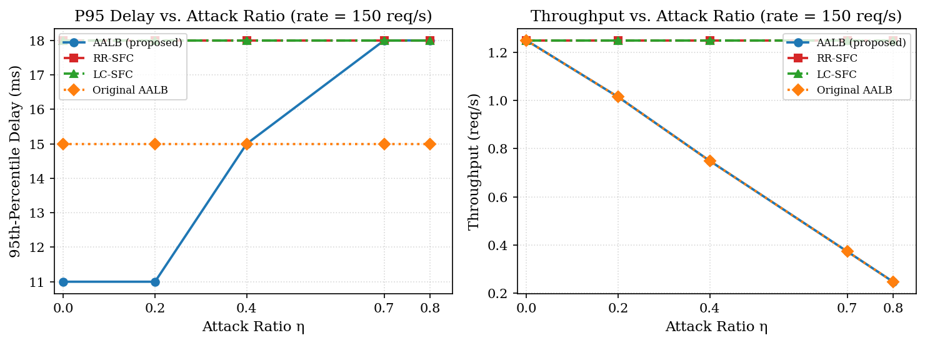
Fig. 6. 95th-percentile delay (left) and legitimate throughput (right) vs. attack ratio (ν = 150 req/s).

C. Reconfiguration Results
Table V and Fig. 7 report the mean upgrade and downgrade counts per run across both reconfiguration traces. RR-SFC, LC-SFC, and Original AALB each show zero reconfigurations in both traces, confirming that none of these baselines adapts its security profile at runtime. AALB (proposed) is the only method that reconfigures.

TABLE V
Mean Reconfiguration Counts per Run
Method | Trace A Upgr. | Trace A Down. | Trace B Upgr. | Trace B Down.
AALB (proposed) | 92.8 | 57.2 | 38.4 | 104.8
RR-SFC | 0 | 0 | 0 | 0
LC-SFC | 0 | 0 | 0 | 0
Original AALB | 0 | 0 | 0 | 0

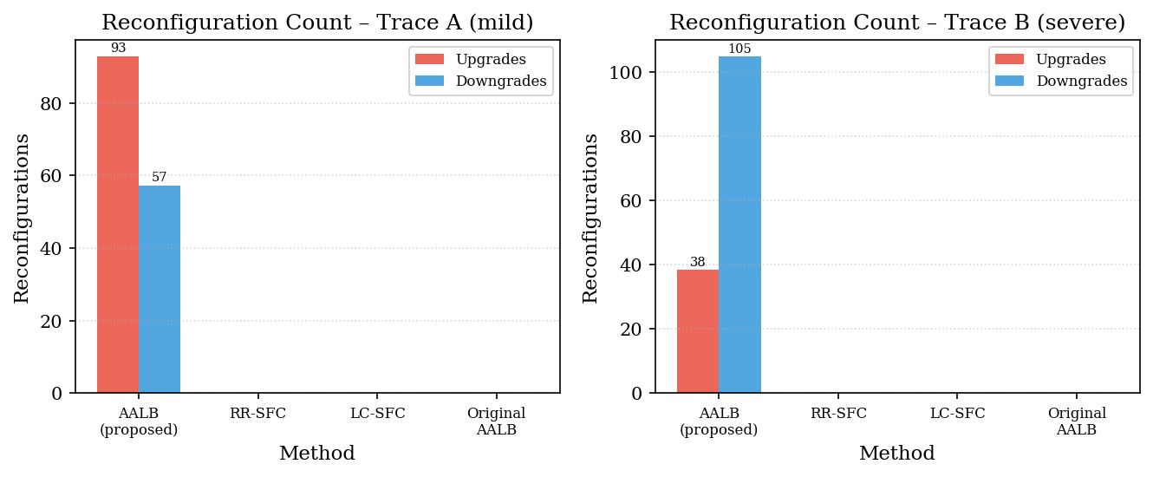
Fig. 7. Mean upgrade and downgrade counts per run for Trace A (mild, left) and Trace B (severe, right).
Under Trace A (mild), AALB performs 92.8 upgrades and 57.2 downgrades per run. The difference arises because upgrades respond to every attack-state increase immediately, while downgrades require the τH = 10 s holding interval to elapse. Under Trace B (severe), AALB performs 38.4 upgrades and 104.8 downgrades. The reversal—more downgrades than upgrades—reflects the trace structure: Trace B includes several high-to-low transitions (η = 0.7→0.4→0, η = 0.8→0.4→0.2→0) where the attack state falls persistently after crossing a threshold, qualifying the request for multiple downgrade steps within the holding window. The hysteresis mechanism prevents immediate downgrade after each monitoring interval, grouping the transitions and limiting unnecessary chain changes during sustained reductions in attack pressure.

VI. Conclusion
This paper proposed an attack-aware adaptive security service orchestration (AALB) framework for DDoS-resilient fog networks. The framework uses an always-on ingress monitor to estimate the current DDoS attack ratio and maps that ratio to one of three bounded security profiles—K0 ⟨LB⟩, K1 ⟨RF, LB⟩, and K2 ⟨FW, RF, LB⟩—ordered by protection strength. A normalized delay–load cost function selects the minimum resource- and SLA-feasible profile realization from among the security-eligible candidates. Security upgrades are executed immediately when the active chain provides insufficient protection, while downgrades are deferred until the lower attack state persists for a configurable holding interval τH.
Evaluation on the 14-node NSFNET topology demonstrates that AALB reduces mean end-to-end delay by 52.1% relative to static K2 baselines under benign traffic by selecting the lightweight K0 profile when no attack pressure is detected. Under severe attack pressure (η = 0.7), AALB reduces mean delay by 53.8% relative to RR-SFC while correctly filtering attack-sourced requests, achieving a success rate of 0.295 compared to 1.000 for non-filtering baselines. The reconfiguration experiments confirm that the holding interval shapes upgrade and downgrade asymmetry differently under mild (Trace A: 92.8 upgrades, 57.2 downgrades) and severe (Trace B: 38.4 upgrades, 104.8 downgrades) attack traces, limiting unnecessary chain oscillations near attack-state thresholds.
Future work will consider shared VNF instances across concurrent SFC requests to reduce resource overhead during simultaneous profile upgrades. Multi-path routing extensions can improve both load distribution and delay-bound satisfaction across congested fog topologies. Online learning methods for attack-threshold calibration will reduce the need for manual threshold selection and support adaptation to previously unseen DDoS traffic patterns.

Data Availability
The complete simulation implementation and experimental artifacts for this paper are available at https://github.com/harry7470/net740-load-balancer. The repository includes the Python simulation engine, experiment configuration scripts, result data files, and figure-generation code.

References
[1] J. Halpern and C. Pignataro, "Service Function Chaining (SFC) architecture," RFC 7665, Internet Engineering Task Force, Oct. 2015.
[2] N. Siasi, M. Jasim, and N. Ghani, "Service function chain mapping in fog networks," IEEE Commun. Lett., vol. 25, no. 1, pp. 99–103, Jan. 2021.
[3] J. Santos, T. Wauters, B. Volckaert, and F. De Turck, "Towards delay-aware container-based service function chaining in fog computing," in Proc. IEEE/IFIP NOMS, 2020, pp. 1–9.
[4] S. Mehraghdam, M. Keller, and H. Karl, "Distributed service function chaining," IEEE J. Sel. Areas Commun., vol. 35, no. 11, pp. 2479–2489, Nov. 2017.
[5] X. Wang, C. Wu, F. Le, and A. Liu, "Online service function chain placement for cost-effectiveness and network congestion control," IEEE Trans. Comput., vol. 71, no. 1, pp. 27–39, Jan. 2022.
[6] X. Li, C. Su, M. Ghobaei-Arani, and M. F. Albaghdadi, "Dynamic service function chain placement with instance reuse in fog–cloud computing," ICT Express, vol. 9, no. 5, pp. 847–853, 2023.
[7] L. Zhou, H. Guo, and G. Deng, "A fog computing based approach to DDoS mitigation in IIoT systems," Comput. Secur., vol. 85, pp. 51–62, Aug. 2019.
[8] S. Dave, S. Degadwala, and D. Vyas, "DDoS detection at fog layer in Internet of Things," in Proc. ICECAA, 2022, pp. 610–617.
[9] D. Zhai et al., "A security-aware service function chain deployment method for load balance and delay optimization," Sci. Rep., vol. 12, Art. no. 10442, 2022.
[10] J. Gao et al., "Resource consumption and security-aware multi-tenant service function chain deployment based on hypergraph matching," Comput. Netw., vol. 216, Art. no. 109298, 2022.
[11] V. N. Imrith, P. Ranaweera, R. A. Jugurnauth, and M. Liyanage, "Dynamic orchestration of security services at fog nodes for 5G IoT," in Proc. IEEE ICC, 2020, pp. 1–6.
[12] V. N. Imrith, P. Ranaweera, S. Damree, and M. Liyanage, "Enabling fog computing based dynamic security service function chaining for 5G IoT," in Proc. IEEE ANTS, 2021, pp. 149–154.
[13] D. Zhou et al., "DDQN-SFCAG: A service function chain recovery method against network attacks in 6G networks," Comput. Netw., vol. 254, Art. no. 110748, Dec. 2024.
[14] C. Wang et al., "Towards cost optimization in security-aware service function chaining and embedding over multi-vendor edge networks," Comput. Netw., vol. 257, Art. no. 111002, Feb. 2025.
[15] D. Zhou et al., "Dynamic trust-based service function chain deployment method for disrupting attack chains," Front. Inf. Technol. Electron. Eng., vol. 26, no. 12, pp. 2550–2568, Dec. 2025.
[16] Y. Jia et al., "Efficient security service function chaining based on federated learning in edge networks," Comput. Commun., vol. 242, Art. no. 108285, Oct. 2025.
[17] D. Zhou et al., "Intent-based automatic security enhancement method toward service function chain," IEEE Trans. Netw. Serv. Manag., vol. 23, pp. 1043–1060, 2026.
[18] Q. Guo, M. Li, W. Wang, and Y. Liu, "A dynamic deployment method of security services based on malicious behavior knowledge base," Sensors, vol. 22, no. 22, Art. no. 9021, Nov. 2022.
[19] S. Deng, M. Li, and H. Zhou, "Dynamic security SFC branching path selection using deep reinforcement learning," Intell. Automat. Soft Comput., vol. 37, no. 3, pp. 2919–2939, 2023.
[20] L. Ifflander, L. Beierlieb, and S. Kounev, "Attack-aware security function chaining," Electronics, vol. 13, no. 17, Art. no. 3357, Aug. 2024.
[21] J. Liu, X. Wang, K. Ren, Y. Zhou, and M. Li, "Secure service function chain provisioning for task offloading in device-edge-cloud computing," IEEE Trans. Inf. Forensics Secur., vol. 20, pp. 3717–3730, 2025.
[22] S. Bak, A. M. K. Cheng, J. A. Cobb, and E. L. Leiss, "Load-balanced routing and scheduling for real-time traffic in packet-switch networks," in Proc. 25th Annu. IEEE LCN, 2000.

