

(s) Harry Ormandy

Harry.ormandy@students.plymouth.ac.uk

Abstract

[Draw your reader in with an engaging abstract. It is typically a short summary of the document.   
When you’re ready to add your content, just click here and start typing.]

Digitalwaves – the digital footprint assistant

COMP3000 Computing Project

Contents

Project definition and Planning 1

Context Review and subject knowledge 1

Existing product research 1

Maltego 1

Shodan 2

Google dorks 3

MIME 4

Summary of existing products: 5

User Stories 5

Project methodology and implementation 5

Critical evaluation and conclusions 5

# Project definition and Planning

# Context Review and subject knowledge

## Existing product research

### Maltego

Maltego is an OpenSource Intelligence tool that allows for mapping and linking of information to aid in investigations. It is available through download of the application.

|  |  |
| --- | --- |
| Pros | Cons |
| Graph-based GUI for information linking | Technically focussed |
| Easy to link APIs to | Difficult to decide what APIs are needed |
| Automatic searching for data when a transformer is selected | Can be a paid service – APIs may need paid keys |
| Technical information is easily found | Limited functionality on community edition |
|  | Inefficient for searching for personal data |

Whilst maltego is an efficient tool for technical OSINT and mapping out data, it is not designed for the specific purpose of tracking digital footprints through social media, websites and companies. This can be achieved, however it can prove difficult. Through a test search using my name using the base features available in the community edition, all that could be found using a prompt of the name “Harry Ormandy” was a GitHub account. There were also many false entries. It is not user friendly for a non-technically minded person, as transformers must be used to search for information.

### Shodan

Shodan is an online OSINT tool that focuses on IoT and any internet connected devices. It is available through their website.

|  |  |
| --- | --- |
| Pros | Cons |
| IoT searches for devices | Limited social media and internet carving features |
| Provides ports, IP addresses and more for devices | Can be a paid service |
| Geolocation data | Complex for new users |
| Integration using API | Possible inconsistent data |

Whilst shodan is a powerful tool, it is not appealing to an inexperienced user. Searching for personal information that could be stored revealed internet connected devices with a similar name. This is not what an application focusing on a digital footprint would focus on, however it could have useful features such as discovering devices owned by a user.

### Google dorks

exploitDB is an online tool that allows users to search through premade google advanced search filters to find information like usernames and passwords leaked online. It is available through their website.

|  |  |
| --- | --- |
| Pros | Cons |
| Free | Ethical issues due to sensitivity |
| Useful web data discovery | Old data can be misleading |
| Versatile | Complex for new users |
| Can be integrated into other tools | More focused on exploits than personal data security |

Using the google hacking database could uncover leaked usernames and passwords, this could be complicated to implement, as specific queries would have to be selected in accordance with the information the user provides. This application is difficult for an inexperienced user to utilise, as it focuses very much on the technical side of OSINT, with emphasis on finding vulnerable servers, leaked passwords and sensitive information on the open web. Its features could be beneficial to integrate in other tools, but it does not have enough features to be an effective standalone OSINT tool for digital footprint removal.

### MIME

Mime is an online application that specifically focuses on the automated removal of user data from companies that store it.

|  |  |
| --- | --- |
| Pros | Cons |
| Automated search and removal of data | Limited control over 3rd party websites |
| Legal compliance | Inconsistent data removal |
| Alerts | Public records not taken into account |
| User friendly | Requires access to reading the users emails |

Whilst MIME can be an effective and established digital footprint removal tool, a number of issues arise with its use. Due to the automation of the service, it has inconsistent success rates and limited control over 3rd parties that may not comply with automated requests. The main issue with this level of automation in a service is that when creating the user account, it requires access to ‘read the email’ of a user. This is a breach of the users privacy, and would make a large number of users uncomfortable if they read the conditions of sharing their information with the service. It has many good features, however its downsides do not make it a viable choice.

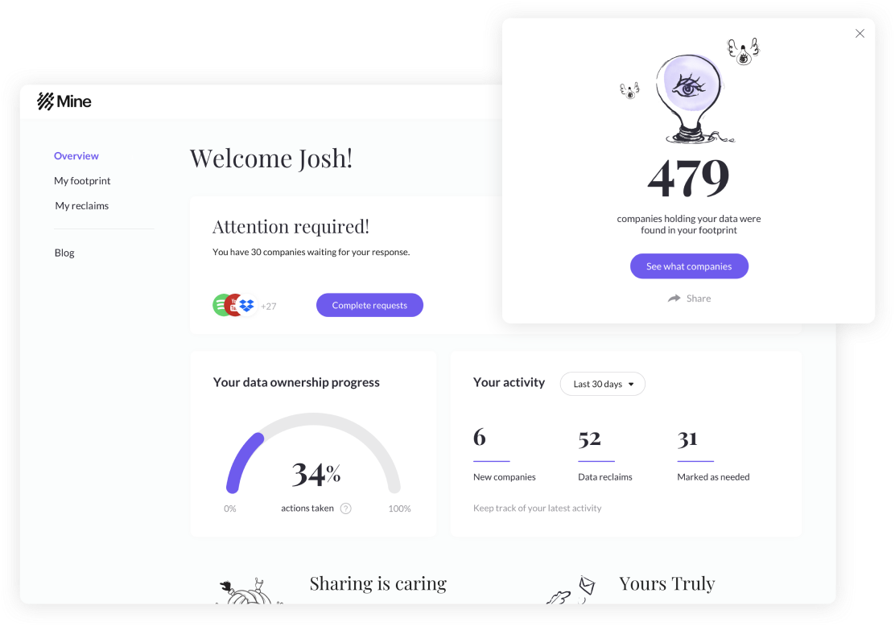

### Summary of existing products:

Whilst each pre-existing tool offers extensive features that would be helpful to a user, the majority focus on the technical side of OSINT, offering complex UIs and information on IP addresses, DNS servers or IoT enabled devices. These features do not align with the product vision, and hence its need in the current market landscape. The application that offers the most similarity is ‘MIME’, however its automation of processes requires for access to information that users may not be comfortable providing. Its automation also does not provide users with an insight on how this information can affect them online, and hence it would need to be used constantly, as it does not encourage the user to improve.

## User Stories

From the pre-existing product research conducted, a list of user requirements can be created that demonstrate what a user would want from the application.

“As a user I want an application that…”:

* Allows me to view my personal information that is online
* Helps me understand why my digital footprint is important
* Provides information on how to reduce my digital footprint
* Is easy to use, understand and navigate
* Provides me with a progression score so I can gauge how I am doing
* Will inform me of how it will use the information I provide it for searching
* Allows only the user to search information about themselves

# Project methodology and implementation

# Critical evaluation and conclusions

Dissertation plan:

How is mine different – whats my USP

Requirements that come from this – fill in trello

Any additional requirements and why I want them – add to Trello, why these features are necessary

Breakdown requirements into MoSCoW board – individual tasks

Adjust and complete sprint plan – excel spreadsheet, add second semester

**If have time:**

UML planning – sections of the app and how they interact

Low-fidelity prototypes – starting