# Introduction to Programming – Week 1

1. Level 1 - Task 1 – Create an image of a house and sun:

* I began by opening BlueJ and opening the shapes project which we downloaded.
* I made a new instance of each of the classes involved in the picture I wanted to created – this was the canvas, a square, a triangle and a circle.
* I was able to alter the properties of each object substantially, choosing appropriate colours and positioning for each object – in order to create the image presented on Figure 1.

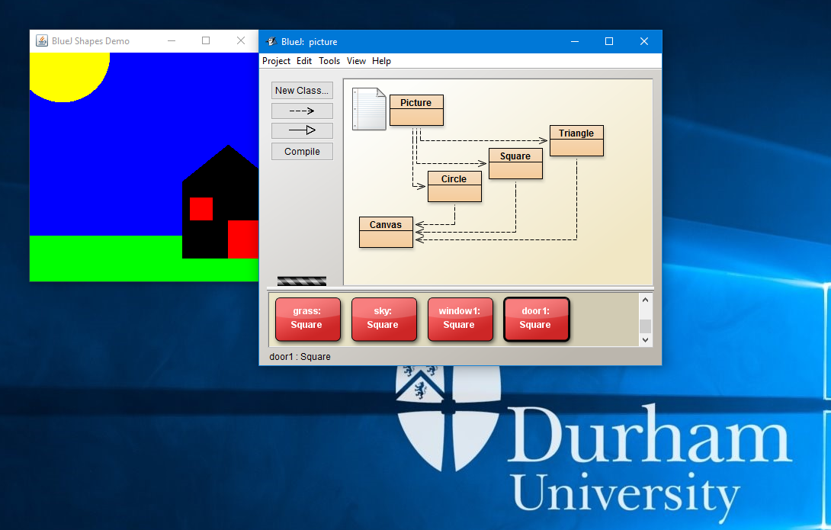

Figure – Sun and house

2. Level 1 – Task 2 – Drawing my initials using the turtle

* In order to do this, I first had to create a new instance of both a turtle world and a turtle.
* Using the instance of the turtle I was able to pen down and move forwards which meant the turtle effectively drew in the turtle world.
* In order to produce my initials, I had to turn the turtle at different stages and move forward when appropriate, at the point when the H was completed and I moved onto the R I had to ‘pen up’ and move forwards so the turtle was in a position to draw the R.
* The distances that I moved forwards and degrees I turned were done in order to fit in with the symmetry of the initials drawn.
* Figure 2 displays the initials produced.

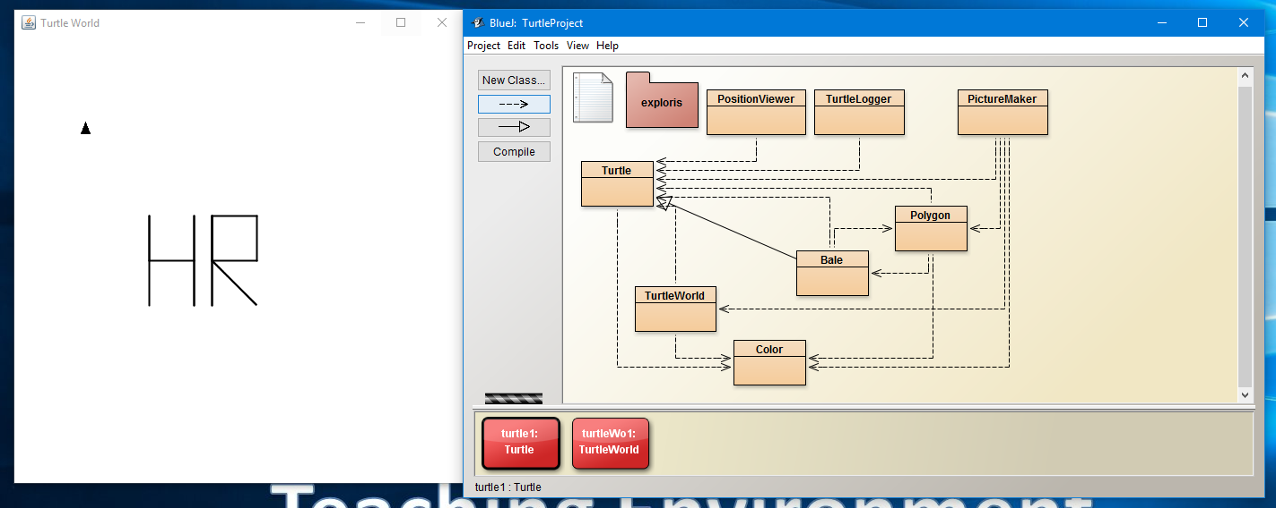

Figure - drawing my initials

3. Level 1 – Task 3 – Stating class details.

* I created an instance of a labClass and through the methods written, specified the time of meeting, room of meeting, teacher and the capacity of the classroom.
* I then created several instances of students (specifying their name and student number) and I added each student to the instance of the labClass I had created. When the capacity of the labClass was reached – this was output to the user. (This is in figure 4.)
* Using an already specified method, I was able to output the details of the class including all the details I had specified as well as the students I had enrolled to the labClass. (This is in figure 5.)

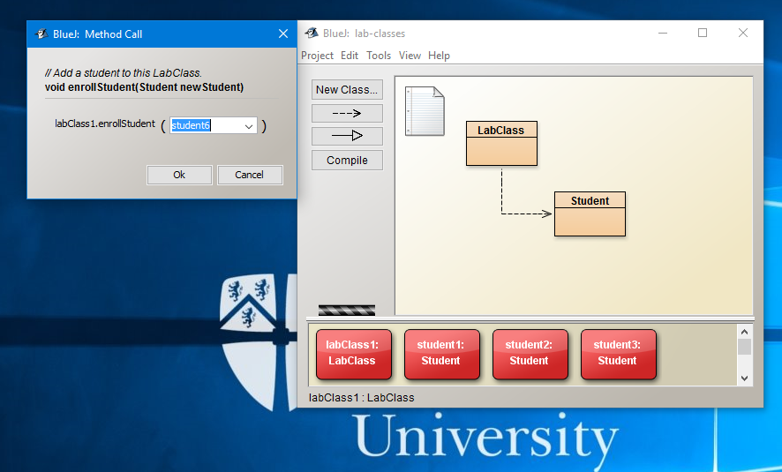

Figure - enrolling students to a class.

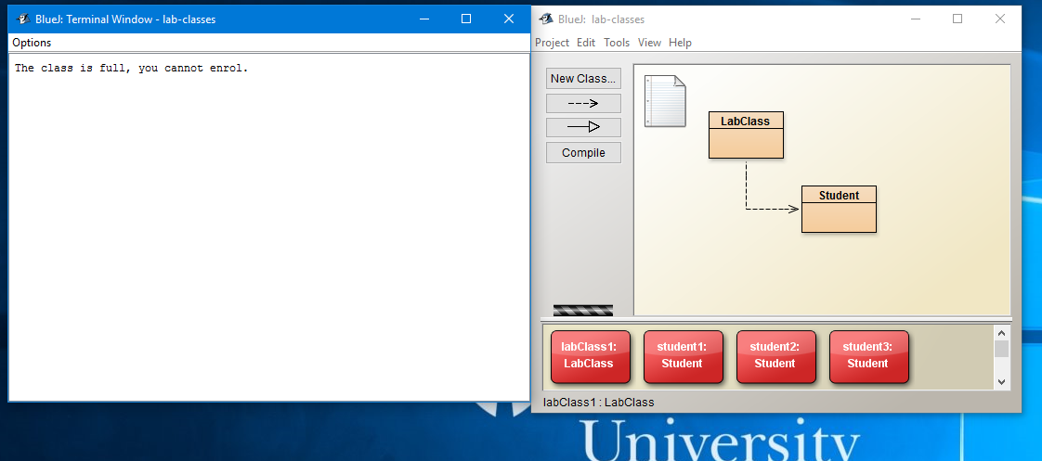

Figure - when the capacity of the class is reached.

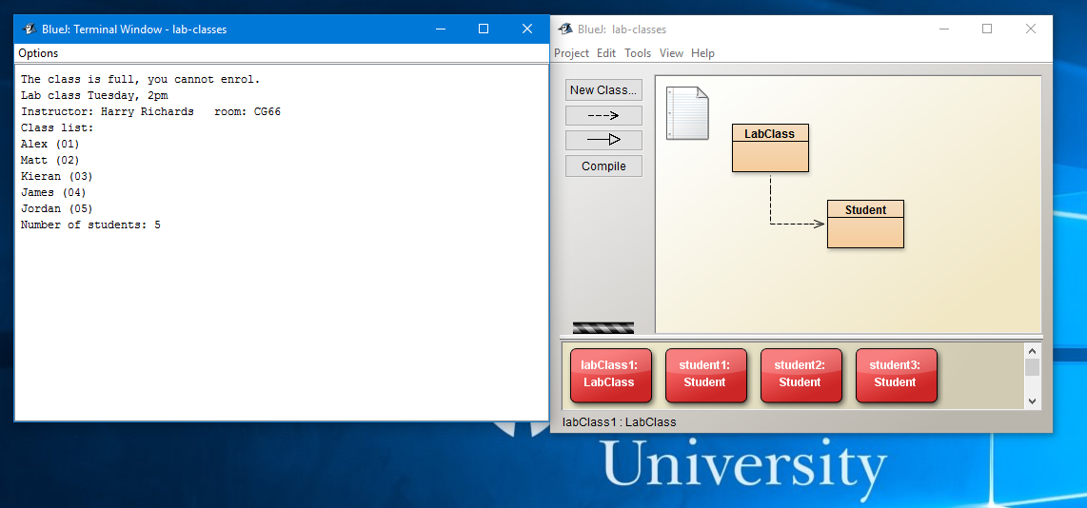

Figure - when the class details are output using the pre-written method.

2.

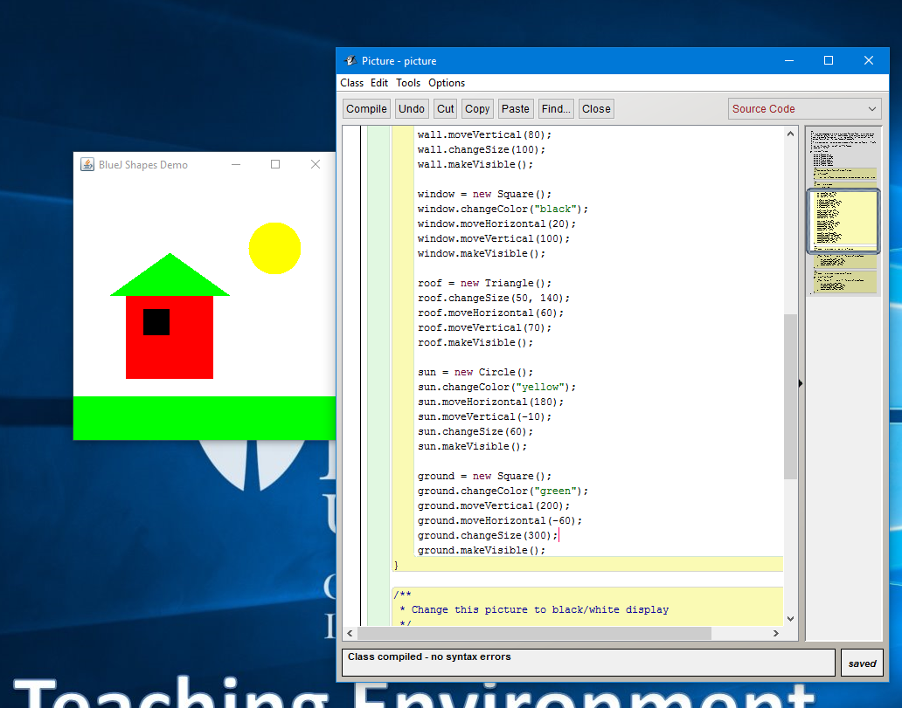

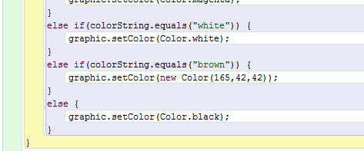

Created a new colour for the tree.