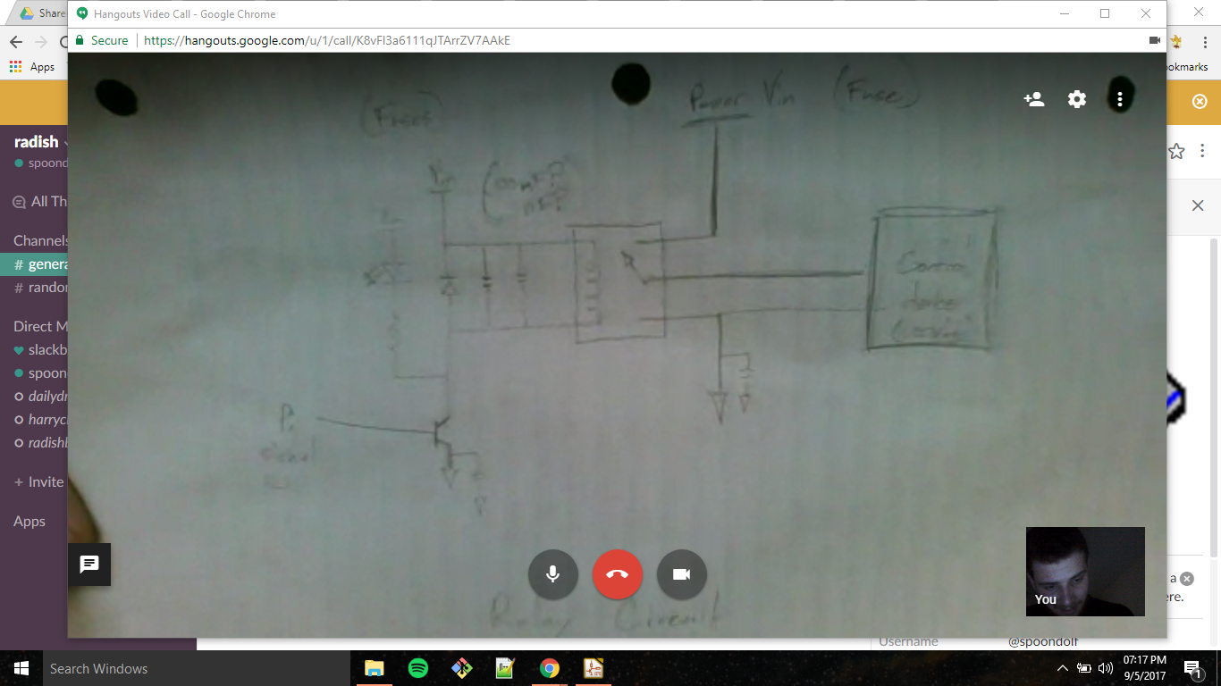

10 motors
16 sensors
low wattage – most motors → 8 for parastaltic pumps
60W – single (?) pump → prep for 2

characterize parameters

